2026 Potomac District Klondike Derby  Webelos/Arrow of Light Invitational  Saturday, January 24, 2026 - 1:00 PM to 4:00 PM  Little Bennett Regional Park - 23701 Frederick Road, Clarksburg, Maryland 20871 | 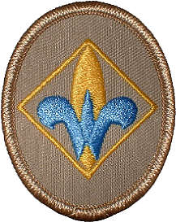  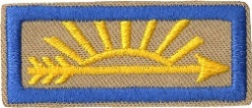

Bring this Form to Check-In at the event.
Pack Number: |  | Cubmaster: | Mobile:
Cubmaster’s Email:
Adults attending Invitational * |  |  |  | Mobile
1
2
3
4
Total Adults

* Your Adult registration means you are responsible for ensuring that your Webelos will be dressed and prepared for cold weather at this cold weather event.
Webelos Names
1 |  |  |  | 14
2 |  |  |  | 15
3 |  |  |  | 16
4 |  |  |  | 17
5 |  |  |  | 18
6 |  |  |  | 19
7 |  |  |  | 20
8 |  |  |  | 21
9 |  |  |  | 22
10 |  |  |  | 23
11 |  |  |  | 24
12 |  |  |  | 25
13 |  |  |  | 26
Total no. of Adults |  |  | + Total no. of Webelos/Arrow of Light |  |  |  | = Total Participants

For Klondike Derby Staff Use Only:

x $10.00 each = Total Fees

- Prepaid Online $ Number of Patches Given
- Cash $
- Check $ Check No. Name on Check
- Credit Card $

