2026 Mattaponi IOLS Training Participant Guide

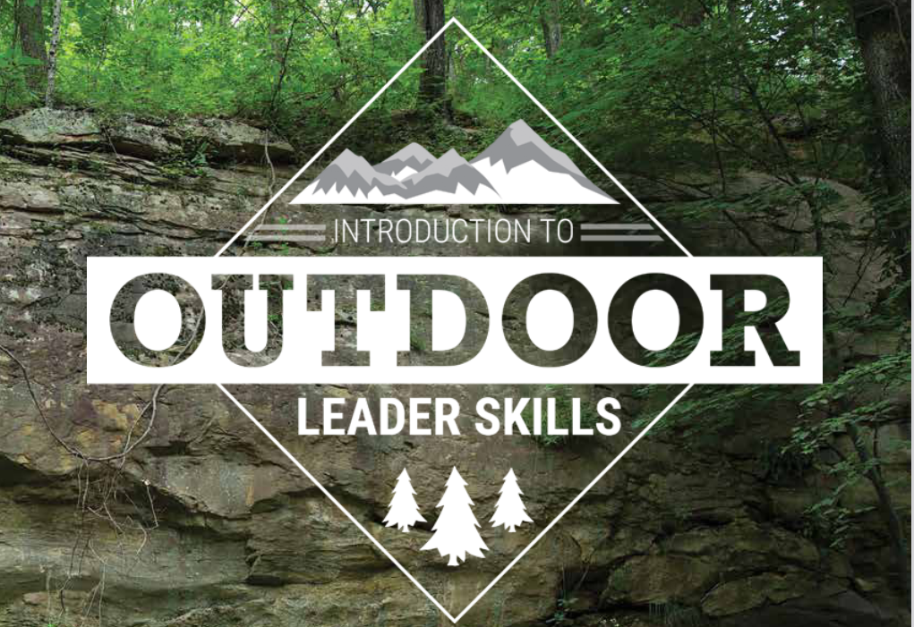
The Introduction to Outdoor Leader Skills (IOLS) course builds and expands on the concepts and themes introduced in Scoutmaster Position-Specific Training and provides Scouters with the confidence to take youth into the outdoors.

Specifically, this hands-on program gives adult leaders a practical introduction to the patrol method of a Scout-led troop by teaching many of the practical outdoor skills they need to lead Scouts in the out-of-doors. In addition, the teaching methods, activities, and games model the variety of teaching used in effective and engaging Scouting programs.

Completion of IOLS and Scoutmaster Position-Specific Training (in-person or online) will earn the Trained patch for Scoutmasters and Assistant Scoutmasters.

Date: 18 April 2026 at 7:30 am – 19 April 2026 at 11:30 am
Location: Fredericksburg-Rappahannock Area Chapter of the Izaak Walton League- 12432 Herndon Rd, Spotsylvania Courthouse, VA 22553
Map- https://goo.gl/maps/4vJRvZ1AJbX4WqMeA
QR Code for Map
(Open your phone’s camera app and point it at the below image)


Izaak Walton Chapter Website- https://iwlafred-rapp.org/

Registration
Participants must register online prior to the event (https://www.scoutingevent.com/082-Spring26MattaponiIOLS)

Please contact the IOLS Course Director, Grant Cauthen (gscengr@gmail.com), with any physical limitations or special dietary or medical needs ahead of the course.

Training includes: Lunch Saturday, Dinner on Saturday, Breakfast on Sunday, Cracker Barrel and training materials (see “menu” below).

Check-In
7:30 am – 8:00 am Saturday 4/18/25. Please eat breakfast before you arrive and allow yourself time to set up your tent. Training will begin promptly at 8:45 am. We will be collecting BSA Med Forms (A/B) and the Pre-Event Screening Checklist at this time so please come prepared.

Please do not show-up earlier than 7:30 as the gate will be locked and there is nowhere to park outside the gate.

Paperwork To Bring With You
⃞ BSA Annual Health and Medical Record Parts A and B only- Completed and signed (https://bit.ly/3iBx8QY)

⃞ A photocopy of your Health Insurance Card
⃞ BSA Pre-Event Medical Screening Checklist- Completed (http://bit.ly/3GKUSKD)


Dress Code
Please arrive at the course in your Field Uniform (“Class A”). Field Uniforms will be worn during check in and the opening and closing ceremonies.

Activity Uniforms (“Class B”) will be worn during the day on Saturday.

NOTE: While uniforms are one of the eight “Methods of Scouting” and are an important part of BSA’s program, Registered Adult Leaders will not be turned away if they do not have a Field Uniform. “Do Your Best”.

Meals / Menu

Saturday | Breakfast | Eat a good breakfast before you come to course on Saturday.
 | Trail Lunch | Ritz Crackers, cheese stick, peanut butter, tuna lunch-to-go kit, fruit, candy bar
 | Dinner | One pot meal (chicken and rice)
 | Cracker Barrel (evening snack) | Dutch Oven Cobblers and foil baked apples
Sunday | Breakfast | Mountain Man Dutch Oven Breakfast (sausage, eggs, hashbrowns, cheese, plus biscuits on top)

Feel free to bring your own snacks. We will store personal food items in vehicles or critter-proof containers after lights-out.

What to Bring
Suggested IOLS Training Gear List
Outdoor Essentials | Personal Extras (Optional)
Tent  Sleeping bag, or two or three blankets  Sleeping pad or mattress  Ground cloth  Sturdy shoes  Change of clothes  Sleeping attire  Clothing for the season (warm or cold-weather)  Sweatshirt or jacket  Rain cover for backpack  Daypack containing the following:  *First-aid Kit *Compass  *Water Bottle *Flashlight  *Sunscreen/Hat *Whistle  *Trail Food/Snacks *Scout Handbook  *Matches/Fire starters *Rain gear  *Pocketknife (no sheath knives) | Watch  Notebook or paper  Pencil or pen  Sunglasses  Gloves  Battery Phone Charger  Coffee mug  Walking stick  Easily Portable Folding Chair (all sessions will be outdoors so a chair will be important for your comfort)  Snacks/Water Flavor Pouches
Cleanup Kit | Eating Kit
Soap  Toothbrush/Toothpaste  Dental floss  Comb/brush  Washcloth  Towel | Spoon  Plate  Bowl  Cup

Schedule

**The schedule is subject to change based on instructor availability as we approach the course start date.

Course Site
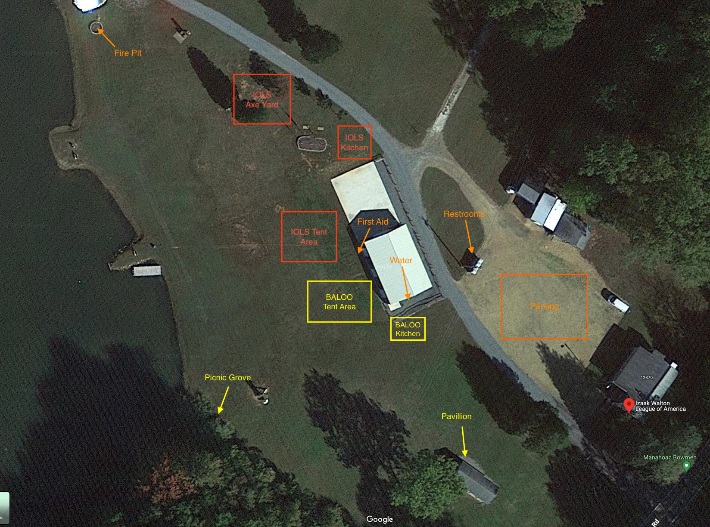

Check-Out

11:30 am Sunday, April 19, 2026

Prior to check-out, Patrols will be responsible for cleaning the pavilion and campsite. Clean-up checklist as follows:

• Leave No Trace
• Sweep pavilion
• Take trash with you

Note: If you need to leave the event at any time prior to Sunday’s check-out, please inform the Course Director.

Rules
The Scout Oath and Law is the camp code at all times. Violations to following the Scout Oath and Law may result in attendees being asked to leave the event.

Alcohol, drugs, cigarettes (to include “e-cigarettes”), firearms, fireworks, sheath knives, camper trailers, recreational vehicles, all-terrain vehicles/golf carts, and pets are prohibited at this event.

Course attendees are not permitted to build/manage their own campfires. Heat sources (non-battery powered lanterns, candles, etc) are not permitted in tents.

Food should not be left out in the open and unattended. Food should not be kept in tents. Store food in vehicles or other containers designated by course staff.

All attendee vehicles will be parked in the designated parking area.

Health and Safety

Nearest Medical Facility | Next Care Urgent Care- 5825 Plank Rd #105, Fredericksburg, VA 22407 - +1-540-785-3448 - Open 8am-4pm
Nearest Hospital | Mary Washington Hospital- 1001 Sam Perry Blvd, Fredericksburg, VA 22401- +1-540-741-1100
Poison Control Hotline | 800-222-1222

Bring your BSA annual Health and Medical records (med forms) parts A and B. Include any allergies, meds, and a copy of your insurance card.

During course, report any injuries or first aid needs to the Camp Health Officer.

We ask that you practice good handwashing and bring hand sanitizer to keep on you or near you. We will also have hand sanitizer available if you forget.

Course attendees will inform the camp health officer or designee of limitations, special needs or life-threatening circumstances that could require special monitoring or assistance during the event.

The camp health officer will, at check-in, review their health record and note any special needs. The camp health officer will not administer any medication of any kind.

First Aid
FIRST AID is the immediate and temporary care given to the victim of an accident or sudden illness until the services of a physician may be obtained. The camp will have a primary Camp Health Officer to assist with any camper that becomes ill or is injured during camp. Staff are all trained to recognize emergencies and will immediately notify the camp health officer.
The Health Officer and Camp Director will decide if, and when, a camper should go home or to a medical facility. First Aid personnel will supervise the cleaning and bandaging of minor cuts and scrapes and will apply ice to stings, bumps, and bruises.
ALL INJURIES must be reported to the Camp Health Officer and logged into the medical logs required by BSA. This applies to everything from a minor injury, such: as a scraped knee or fishhook caught in a finger, to the more serious injuries.

Disease prevention procedures
The course will follow the NCAC Virus Risk Management Plan, specific details can be found on https://www.ncacbsa.org/covid-19/. The VRMP requires events to follow county disease prevention guidance. A few highlights (not inclusive) include:
All participants will be screened, prior to upon arrival for any signs of illness. Sick participants should not attend. Specific guidance on masking and social distancing will depend on the infection level at the time of the event, currently (Jan 2024) the infection level in Spotsylvania County is low which does not require masking. Updates to this policy will be provided via email to participants.

Emergency Procedures

General Emergency Plan and Communication
In case of an emergency, a signal of three blasts from an air horn or a whistle [Blast, Blast, Blast, pause, Blast, Blast, Blast] will be sounded. This signal will be repeated until all scouts and adults reach the Safety area.
Upon hearing the signal, participants will calmly proceed to the designated emergency area. In fair weather, all personnel move to the Gathering area where Opening and Closing Ceremonies are held. In bad weather, move to the bad weather Safety area (covered pavilions or building depending on severity) After gathering the unit’s adult leader will check attendance, and account for any scout or adult not present to the program director.
While gathered for an emergency, please remain quiet and orderly. Everyone must follow directions for the safety of the whole group. Once everyone is assembled and accounted for the nature of the emergency will be explained and the next course of action will be determined. The emergency signal may be used in the event of a lost scout, weather emergency, fire, etc.

Specific Procedures
Light shower or drizzle: The program continues as planned. Participants are expected to be prepared with appropriate ponchos, jackets, or equivalents.

Heavy wind, heavy rain, tornado alerts or lightning: The Camp Director or Program Director will declare “Rain Program.” All outdoor activities will close and the following three things will happen.
1. Participants will move to the bad weather Safety area and check in with the Program Director. Specific safety areas will vary by type of weather from pop-ups, tents, and covered pavilions for moderate weather, to the enclosed buildings for more extreme weather.
2. Program areas will confirm with the Camp Director by radio that the participants are moving and who is left at the site.
3. Program staff will move equipment to safety, under cover, to prevent damage to equipment and paperwork. When areas are secure, the staff will move to the Safety area.

Active Shooter Procedure:
Mattaponi District Camps will employ the Department of Homeland Security Active Shooter Protocol. Participants are generally spread throughout the venue for the majority of the day with the exception of the camp opening and closing formations, and lunch. The layout of the camp and its outdoor setting allow for rapid disbursal of potential targets.
In the event that the Camp is the target of an active shooter, Camp Emergency Procedures are modified as follows:

DO NOT WAIT FOR AN EMERGENCY SIGNAL, IF YOU HEAR OR SEE SOMEONE ACTIVELY SHOOTING IN CAMP. DO NOT MOVE TO THE FLAGPOLE AREA or consolidate in one location. A large group provides an easy target.

If you are not in immediate danger, call 911 – The Izaak Walton League is not located near law enforcement facilities. There will be a reaction time to bring law enforcement to the scene.

Run – If an active shooter enters the camp. Identify the direction and distance to the shooter. Leave all your belongings and in an orderly and swift manner move in the opposite direction from the shooter seeking cover and or concealment. (Cover is something you can hide behind that will protect you from bullets. Concealment is something that prevents the shooter from seeing you but may not protect you from bullets.)

Hide – Hide in a location that prevents the shooter from seeing / hearing the scouts and staff. Do not select a hiding site that has only one way in or out, such as a closet or a shed. If you hide in a building or room, lock the doors/windows. Staff must keep the scouts low to the ground, calm and quiet in their hiding place, while keeping a look out for the approach of the shooter. Have an adult take accountability of the scouts and staff at your location. If you have a camp radio and cell phones, turn the volume down or ringtones off while hiding. If necessary, move to a new hiding place.

Fight – Only if there is no other option.

When Law Enforcement arrives, they will direct your actions. Remain calm and follow instructions. Put down any items in your hands (i.e., bags, jackets). Raise hands and spread fingers, keeping hands visible at all times. Help any Scouts to avoid quick movements toward officers, such as holding on to them for safety. Do not point, scream, or yell. Do not stop to ask officers for help or direction when evacuating.
Adult and youth staff should try to maintain accountability of any Scouts during evacuation or movement to a reunification site. It will be tough after experiencing such a traumatic event but maintain focus on the Scouts until you are relieved of responsibility.

Lost Adult or Staff Member:
If an adult becomes lost, with or without other volunteers or scouts, immediately do the following:
1. If you become lost, stay calm.
2. Try backtracking a short distance. If you cannot find a recognizable landmark or are unsure of your direction, STOP and WAIT for help.
3. Keep your party together.
4. Conserve your energy.
5. Make your group as comfortable as possible.
6. Every five minutes or so, shout HELP three times in a row. If you have a whistle, give three sharp blows, then a pause, then give three more sharp blows. Repeat this procedure every few minutes.
7. Be patient. Help may take a little time in reaching you. HELP WILL COME.
8. Respond vocally or with your whistle to any shout or whistle you hear.

First Aid/Incident/Near Miss Reporting:
The event will follow national procedures for medical logs and reporting, following the incident reporting decision tree published by Scouts BSA and shown in Figure 1. This includes both logging any minor first aid intervention that occurs on site (e.g., bandage for minor cut, logged in onsite medical log), as well as for more serious incidents and near-misses that will be formally reported.
The site has good electronic and telephone access to allow for online reporting, but paper copies of the reporting forms will be kept as a backup.
Council reporting via NCACs main phone number: 301-530-9360
