*Lab 239*



# *Presents:*

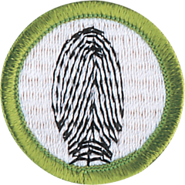

**Sustainability Reading Fingerprinting**

## Sep. 17 or

Dec. 17

Pre-reqs: 1, 4, 8, 9

## Oct. 15

Pre-reqs: 2a, 3, and 6.

## Nov. 19

No Pre-reqs



STEM Scouts Lab 239 is hosting Merit Badges at the Howell Library, 806 Lyons Blvd. Fredericksburg, VA 22406

Registration is free, bring a non-perishable food item for donation All sessions are 6 - 7:30 pm.

# *2025*

Space is limited! Register for Sustainability and Reading now!

Registration opens Nov. 1 for Fingerprinting and Sustainability



