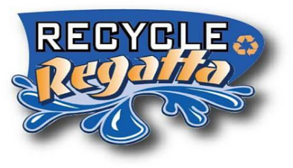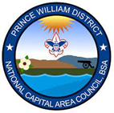

**Recycled Raingutter Regatta**

“A Scout is Thrifty”

**Boat Building Guidelines**

**Construction Materials:** Boats must be made from trash, recycled, and/or scrap items **provided by the scout.** Materials such as scrap plastic, foam, wood, cardboard, are all applicable. Get creative! There are many ideas for boat builds on the internet if you need some design inspiration! Here are some ideas for scout-provided materials:

* HULLS: juice boxes, slabs of foam insulation, water or soda bottles, small milk jugs or cartons, food containers or trays, Capri Sun pouches, pool noodles, aluminum foil, popsicle sticks (for raft designs).
* MASTS: straws, skewers, small dowels, pencils.
* SAILS:construction paper, index cards, cut-up cereal boxes, small chip bags, Capri Sun pouches, foam craft sheets, aluminum foil

Try to avoid newsprint or other materials that will get waterlogged, thick foam that could get caught on the gutters, or Styrofoam that will be messy when broken.

**Ship Size Specs:** The following specs **MUST** be adhered to – all finished boats must fit within these parameters, mainly so that they will fit in the rain gutters and to reduce the chances of capsizing.

* Length – The finished boat must be no longer than 8″ max.
* Width – The finished boat must be less than 3-1/2″ wide. Any outriggers must fit within the overall width of 3-1/2”
* Depth – The gutters are 3” deep, so your boat must float and fit accordingly. Keels and dagger-boards are acceptable just make sure they won’t drag the bottom.
* Mast Height – the mast may not be higher than 7” from the deck. The “deck” is the flat part of the boat, where the mast is attached. Multiple masts on a single boat are allowed.
* Sails – The sail should also not extend beyond the overall width of 3-1/2” for it may hang up on the rain gutter.

**Ship Name:** BE SURE TO PUT A NAME ON YOUR BOAT (and the Scouts’ name). A boat without a name is bad luck – plus, we need some means of identification for the race. “S.S.” denotes “sailing ship” – other historical or military designations (“U.S.S.” or “H.M.S.”) are also allowed so have fun with it!

**Decoration:** Decorations such as sailors, cannons, Lego figures, stickers, etc. may be added as long as they are firmly fastened to the boat and do not change the boat dimensions. Please bring any items you would like from your craft bins at home. Pack 108 will provide a limited supply of craft sticks, skewers, pencils, construction paper, cardstock, foam craft sheets, markers, crayons, sharpies, stickers, tape, duct tape, hot glue gun & glue sticks (for adult use only), and bendable straws for building AND blowing. All paint and glue must be completely dry before race time. Pack 108 will gladly accept any donations of craft items.

**Raingutter Regatta**

**Building a Better Boat**

The following tips are provided to help you get the best performance from your boat. Make sure you also follow the size guidelines in the official rules.

1. a. **Hull shape:** A less rounded hull is more stable than a more rounded hull. Try to find material that is basically flat on the bottom. If your hull is round, you will need to put weight in the bottom of your boat. Be careful not to put too much weight or your boat may sink! Make sure the material you choose for your hull will float and will not soak up water or fall apart when it gets wet.
2. b. **Mast:** Tapering the top of the mast will make it less heavy on top and reduce the chance your boat will tip over. Position your mast in the back half of the hull centered side-to-side. Secure it with waterproof tape or glue if needed. Select material that is lightweight for your mast.
3. c. **Sail:** Position the sail on the mast close to the hull. If the sail is too high, the boat will be top heavy and may tip over. If you have a square sail (sheet sail), attach it about ½ inch above the hull so it does not dip in the water or hit the sides of the rain gutter. If you have a cone shaped sail you may attach it lower on the mast. Attach your sail to the mast with waterproof tape or glue. Select material for your sail that will not soak up water or fall apart if it gets wet.
4. d. **Decorations:** Do not use water soluble paints or markers. Stickers, decals, and other objects added to customize your boat should not fall apart in water. Attaching objects to the top of your mast may make your boat tip over.

Mast

Mast

Sail (Sheet)

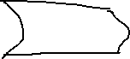

Hull

Hull

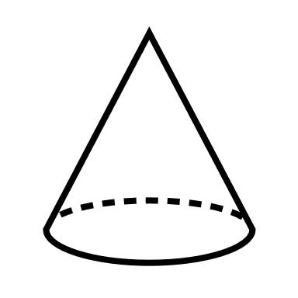

Sail (Cone)