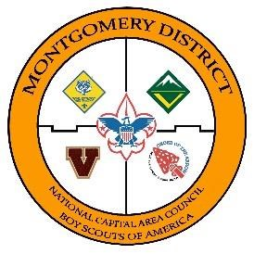
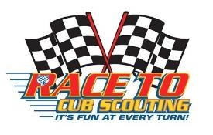
2017 POTOMAC DISTRICT

PINEWOOD DERBY (PWD) RULES
- FOR ALL PACKS –

The Potomac District Race will be held on Saturday, May 13, 2017 at Our Lady of Mercy School, 9222 Kentsdale Drive, Potomac, MD. Check-In will open at 9AM and close at 9:50AM. Racing and award presentations are expected to conclude by 1PM. The order of Racing will be Tigers, Speedy Appearance, Wolves, Bears, Webelos I and Webelos II/Arrow of Light. Den-level trophies will be presented at the end of each Den race. Overall District 1st, 2nd and 3rd place trophies will be presented after the Webelos II/AOL heats and Webelos II/ AOL trophies are presented.

The 2017 Potomac District PWD Race will be run on a track with five lanes and electronic timing. Each car will run five times against Den competitors. Each car will run on each of the five lanes. The three fastest average times (of the 5 Den heats) will be recognized with a trophy for 1, 2nd and 3rd in the respective Den. Also, the average time in Den races will be used to determine the Overall District awards for 1st, 2nd and 3rd.

In addition to standard maximum and minimum car dimensions diagramed in these rules, two additional dimensions are established for this race due to the design of the track:

- Vertical clearance below the electronic Finish Line is only 5 inches; cars that compete for speed (Den or Speedy Appearance) must be 5 inches or less in height;

- The track Starting Pins extend only ¾ inch above the surface of the track; to ensure that the nose of a car does not extend beyond the starting pin, the maximum clearance between the tract and forward edge of “nose” cannot exceed ¾ inch. Generally, this requirement only applies to cars constructed with a “fast start” feature, such as a beveled nose.

RACE ELIGIBILITY

- Each pack is allowed to enter the first place car for each rank (Tiger, Wolf, Bear, Webelos I, and Webelos II/AOL).

- EACH PACK MAY ALSO SEND ONE CAR FOR THE “APPEARANCE”
COMPETITION. The pack will determine the criteria for selection of their entry. These cars may compete also in a Speedy Appearance competition with other Appearance entries.

- The Scout must be present to race his car. If a qualifying scout cannot attend the race, the pack may elect to send a substitute Scout and his car to the race.

- Each car must pass inspection and weigh-in before it can compete. The Inspection Team has the right to disqualify cars that do not meet these rules. Car owners will be informed of any violations and given the opportunity to modify the car to meet the rules prior to the start of the race (if time permits).

- Any participant (including the parent of the participant) has the right to appeal the decision of the Inspection Team to the Potomac District Pinewood Derby Race Chairman.

- Each Pack MUST provide the name of one person who, if necessary, can be called upon to assist with Derby Day jobs. If no volunteer is shown on the registration form, the pack official signing the registration form will be the individual contacted prior to Derby Day for job assignments.

- By signing the Potomac District Pinewood Derby Registration Form or registering online, the unit leader acknowledges that his/her Pack's cars meet these rules.

DESIGN/CONSTRUCTION
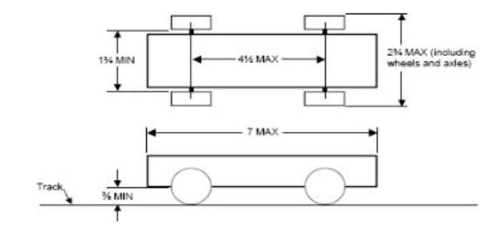

Length, Width, and Clearance

- Maximum overall width including wheels and axles = 2¾ inches.

- Maximum overall height = 5 inches (not shown in the diagram).

- Minimum width between wheels = 1¾ inches.

- Minimum clearance between bottom of the car and track = 3/8 inches. If you put weights under your car, recess them into a hole in the underside of the car’s body.

- Maximum clearance of the front edge of the nose of a car above the tract = ¾ inch; generally applies only to cars that have a beveled nose or other “fast start” design feature (not shown in the diagram).

- Maximum car length = 7 inches. This measurement includes any decorations added to the car such as wings, spoilers, bumpers, exhaust pipes, etc.

- Wheelbase (distance between front and rear axles) must not be more than 4½ inches.

- Commercially precut Pinewood Derby car kits may be used if they meet the above specifications. Only official Cub Scout Pinewood Derby wheels and axles may be used. The solid metal axles (one axle for two wheels), wheels and end caps found in some commercial kits may not be used.

Weight and Appearance

- Weight ≤ 5.00 ounces. 5.009 is acceptable but 5.010 is too heavy, as measured by the Inspection Team’s scale. The car may be hollowed out and built to the maximum weight by the addition of wood, metal, plastic, paint, or decals only, provided each is built into or securely affixed to the body.

- No loose materials of any kind are permitted in or on the car.

- Details and additions such as steering wheel, driver, spoiler, and decals are permitted as long as they do not cause the car to exceed the specifications identified above.

- Cars with wet paint or glue will not be accepted at inspection/weigh-in.

- Mercury shall not be used in adding weight to the car.

Wheels, Axles, and Lubrication

- Wheels - Only the wheels and axles provided with an official Cub Scout Pinewood Derby Car Kit can be used. Official Cub Scout Pinewood Derby wheels and axles that are sold separately (i.e. colored wheels) may also be used. If official Cub Scout Pinewood Derby Wheels and Axles are included in a precut car kit, they may also be used.

- Four wheels must be used, one per axle – no more, no less.

- Axles on the car may be polished.

- Mold projections on wheel tread - Mold projections on a wheel’s tread may be removed, but the wheel should not be otherwise sanded or altered.

- Bearings, spacers, etc. prohibited - Use of bearings, bushings, spacers, or the like between the wheel and car body are prohibited. Wheels must come in direct contact with the car body.

- Wheel r im coverings prohibited - A covering placed on a wheel rim that might hold graphite or lubricant around a nail axle head is not permitted.

- No mechanical propulsion - The car must be freewheeling with no starting assistance, springs, or other methods of propulsion. No magnets are permitted anywhere on the car.

- Only dry lubricants, such as graphite, may be used. Oils and silicone sprays are prohibited.

- Wheel alteration prohibited - use of any type of beveled, tapered, thinsanded, wafered or lathe-turned wheels is prohibited. Any attempt to reduce the running surface of the wheel will disqualify the car.

INSPECTION

- Each car must be registered, numbered, and pass inspection and weigh-in before it can compete in the Derby.

- The Inspection Team, appointed by the Chair, may disqualify those cars that do not meet the 2016 Potomac District Pinewood Derby Rules.

- The Scout will be informed of the violations and given an opportunity to modify the car to meet these Rules before the start of the race (if time permits).

- Once a car is inspected and registered, only Derby Committee officials will handle the car.

- Be sure to lubricate the axles and make any last minute repairs before you present your car for Registration and Inspection.

RACING RULES

- Cars must be made for the 2016 Pinewood Derby. Derby cars or axles and wheels from cars raced in prior year competitions are not permitted.

- All Scouts and Leaders must wear uniforms to the Derby in accordance with their pack’s uniform guidelines.

- Only Derby officials will be permitted into the track, registration, judging and car staging areas. This rule will be strictly enforced. Failure to comply may result in disqualification.

- Each car will participate in five heats, running once in each of the five track lanes.

- The average time to complete the five heats will determine the fastest cars in each Den and the Overall District.

- The following rules apply:

  - If a car comes off the track during a heat, a “No Race” will be
declared and the heat will be run again. If the same car jumps off the track a second time, that car’s time for that heat will default to 4 seconds.

  - If a car leaves its lane and interferes with another car, a “No Race” will be declared and the heat will be run again. If the same car leaves its lane a second time and/or interferes with another car, the interfering car will be removed from the heat and assigned a time of 4 seconds for the heat.

  - If a car suffers a major mechanical problem, a “No Race” will be declared and the Scout with a sponsoring adult will have five minutes to accomplish repairs. If the car is unable to compete, the damaged car will be assigned a time of 4 seconds for the heat and any remaining heats.

  - If a car or cars do not make it to the Finish Line, the car(s) will be assigned a time of 4 seconds for the heat.

DISQUALIFICATION AND DISPUTES

- The Scout owner of a disqualified car will be given the same general award as received by other Scouts at the Derby and will be given an opportunity to participate in the Derby in some other way.

- At the discretion of the Chair, the Scout owner of a disqualified car may do one or more of the following:

  - The disqualified car can act as a pace car during testing of the track;

  - A duty deemed appropriate and beneficial for the Scout by the Derby Chair and parent or sponsoring adult of the Scout.

- Any Scout competitor (including the parent or sponsoring adult of the Scout) can
appeal to the Chair for an interpretation of these Rules.

- Decisions of the Chair are final.

- Decisions of the Judges during all heats and races are final.

AWARDS

- Five Appearance (non-racing) Awards will be presented; one each for Best In Show, Judge’s Favorite, Most Unusual, Most Humorous and Most Colorful.

- 1st, 2nd and 3rd place Speedy Appearance trophies will be presented to the cars that race and have the fastest average times in the separate Speedy Appearance racing.

- 1st, 2nd and 3rd place trophies will be presented to the scouts with cars that finish with the fastest average times (average of the five heats) in their Den.

- 1st, 2nd and 3rd place trophies will be presented to the scouts with cars that finish with the 3 fastest average times in the Derby.

- Scouts who do not receive a competitive award will receive a Participation Award.

Questions concerning these rules or the Potomac District Pinewood Derby race, may be addressed to the Potomac District Chair, Jim Schleckser, at jschleckser@verizon.net.

