**Loudoun District (formerly Goose Creek District)**

**2025 Spring Camporee**

**May 2 to 4, 2025**

Camp Highroad

Middleburg VA

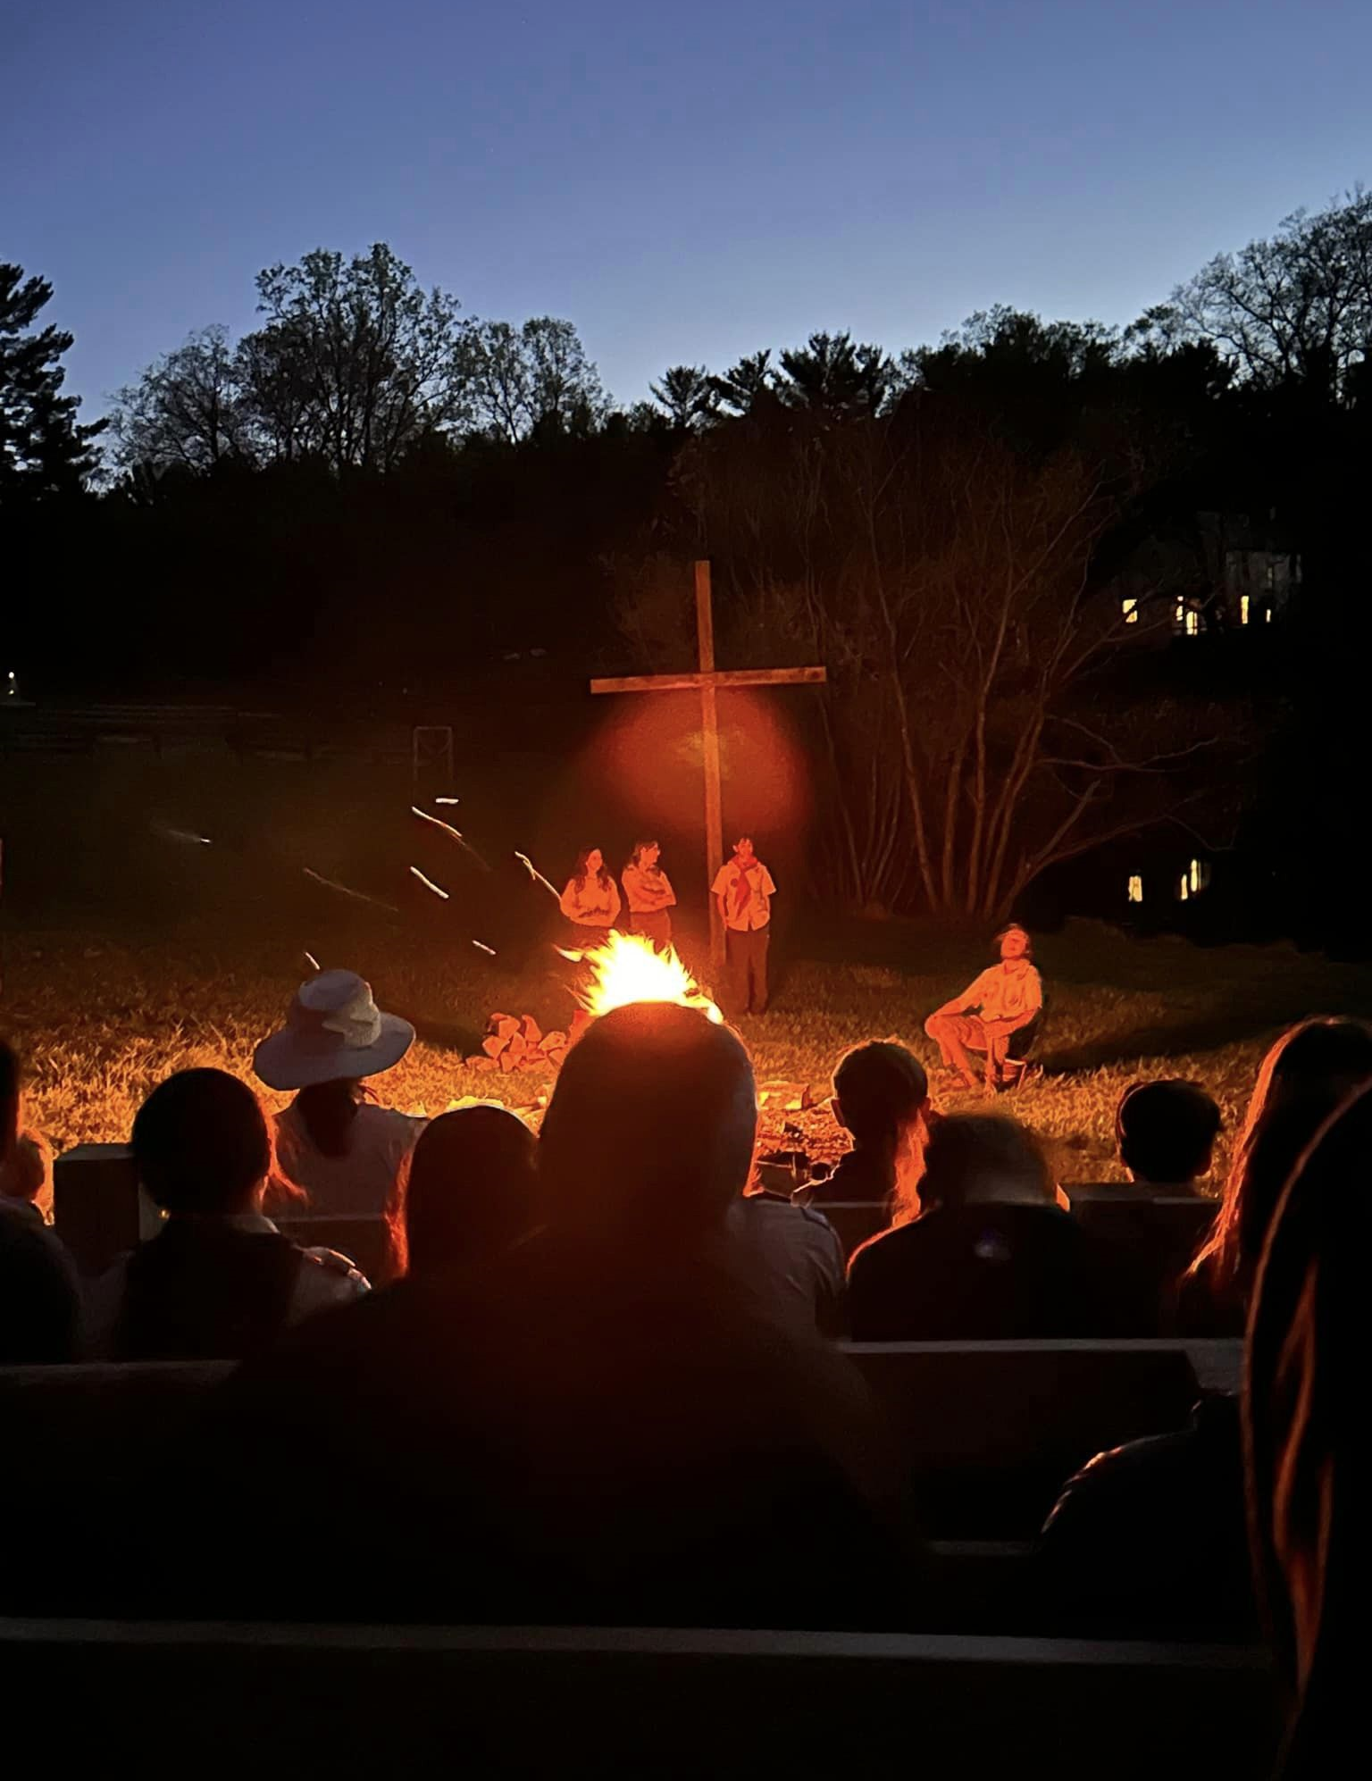

***Camporee Leader Guide***

*version 3/3/25*

*Table of Contents*

Introduction 3

Registration 3

Camporee Administrative Details 3

What to Bring and Not Bring 4

Camporee Safety Requirements 4

Scouter Responsibilities……………………………………………………………………………………………………………,,…….. 5

Barriers to Abuse – Scouting America………………………………………………………………………………,,,…………….5

Check-In Procedures 6

Camporee Leaders Briefing/Cracker Barrel 6

Camporee Daily Schedule 6

Patrol Challenge Event 6

Adventure Choice Activities 7

Camporee Rules 8

Special Program Features 8

Check-Out Procedures 9

Additional Information 10

Emergencies 11

Camporee Staff 11

Camporee Site Map 12

Directions to the Camporee Site 12

Patrol Challenge Stations…………………………………………………………………………………………………,,……………..13

## Introduction

Get ready for an adventure, Scouts! The 2025 Loudoun District Spring Camporee is here and it's going to be EPIC! Join us at Camp Highroad, Middleburg VA, from Friday, May 2nd to Sunday, May 4th, 2025, for a weekend packed with thrilling outdoor patrol competitions, games, challenges, high-adventure activities, and unforgettable memories. https://scoutingevent.com/082-97040

The theme for this year's Camporee is "Survivor!!" You’ll have the opportunity to earn points in this theme category, plus gather other point totals competing in Patrol Challenges, patrol flag and yell contest, and final points performing skits and songs at the Saturday evening campfire.

This Leader Guide has the latest information about all Camporee activities, schedules, and requirements. Minor updates may be made in the days and weeks leading up to the event as we fine-tune the contests. The Friday Night Cracker Barrel will review updates and changes for the camporee.

Saturday presents the option to participate in a variety of Adventure Choice activities which must be selected at registration. These include a High Ropes Course, Mountain Boarding, Rock Wall climbing, Zip Line, and a Team Challenge Course (possible). In addition to Adventure Choice Activities we will offer Archery, and we aspire to offer Monkey Bridge and a cross cut saw competition.

Saturday there will be focus on patrol competitions under the Survivor!! challenge. Compete in each session to earn the most points and come out on top! See events starting on page 13.

We'll end the day with a campfire where you'll get to show off your patrol's creativity with skits and songs. Campfire will also feature announcement of the winning patrols from the day’s activities.

This event is designed for Scouts BSA Troops and Venturing Crews, so rally your patrols and get ready to conquer the great outdoors! See you at Camp Highroad in May!

**Please share with all your Unit Leaders (Adult and Youth) and parents.**

## Registration

Prior Registration is required from all Units for all parts of the Camporee. The process is consolidated on this NCAC website:

**https://scoutingevent.com/082-97040**

1. **All participants must register and pay the Camporee Fee of $35 each** (all Youth and Adults) **online thru this website.** This fee includes all campsite and facility support costs. Food and camping gear are NOT included. Units must bring their own equipment.
2. **Registration and payment for all Adventure Choice activities** (optional) hosted by Camp Highroad **will also be processed thru this same NCAC website.** Adult Advisors will not be charged. They cannot be selected and paid for on-site at the camporee.

## Camporee Administrative Details

* Check-In will be conducted from 4:00 to 8:00 pm on Friday, May 2nd, and open again from 7:00 to 8:00 am on Saturday, May 3rd. Please arrive early! Flag Raising is at 8:30 am.
* Units may bring trailers. Trailer parking will be adjacent to the campsites, but not inside the camping areas.
* Individual vehicles will be parked adjacent to the campsites, but not inside the camping areas.
* Units will receive their Scouts and Scouter Adventure Choice wrist bands at Check-In.

## What to Bring and Not Bring

**Be sure to read the Patrol Challenge and Survivor!! rules and bring what you need for completing those events.**

**Tents:** Units will camp in one of three campsite areas at the southern end of Camp Highroad. Bring your own tents and equipment. Tents larger than 4-person are discouraged. Leave No Trace principles apply (no trenches, digging, etc.).

**Water:** Water is available but not in each campsite. Units should bring their own FILLED water containers from home which may then be refilled at the Camporee.

**Firewood**: Units MAY BRING THEIR OWN firewood (encouraged). It is also available for purchase from Camp Highroad but must be reserved prior to arrival through the registration site. Cost of firewood purchased from Camp Highroad is $25 per bundle.

**Unit Gear:** See the Scouts BSA Handbook if you need guidance on Unit Gear. Bring your Unit and patrol flags. Be sure to read the Patrol Competition and Survivor!! rules and bring any equipment needed for the competition.

**Personal Gear:** The Scouts BSA Handbook also contains a checklist for personal camping gear.

## Camporee Safety Requirements

* Wood or charcoal fires are permitted in designated fire rings and elevated cooking surfaces.
* Potable water is available but must be hauled to your campsite area.
* Participants should always carry their 10-Essentials. Water is a must.
* Patrol Challenge: Troops require two Adult Advisors to be present at all times.
* The Buddy System is always in effect for safety.
* All participants must remain in designated Camporee activity areas. All Lodge, Cabin, and Personal Residence areas are off limits.
* Weather: May temperatures will still be chilly, especially in the evenings. Participants must have appropriate layered clothing and a winter sleeping bag. Check the weather forecast before departing from home.
* Campsites must be arranged to separate genders adequately.  This separation could be achieved through natural barriers, physical distance, or by the campsite being divided, so long as the separation achieves privacy for both adults and youth, as well as by gender.  Adult leaders are responsible for establishing the barriers and reminding Scouts that members of one gender must not enter the tent/housing of another.

***Scouter Responsibilities***

* Leaders must ensure that all participating in Scouting activities abide by the Scout Oath and Scout Law.
* Adult leaders and youth members share the responsibility for the safety of all participants in the program, including adherence to Youth Protection and health and safety policies.
* Adult leaders are responsible for monitoring behavior and intervening when necessary.
* Physical violence, sexual activity, emotional abuse, spiritual abuse, unauthorized weapons, hazing, discrimination, harassment, initiation rites, bullying, cyberbullying, theft, verbal insults, drugs, alcohol, and pornography have no place in the Scouting program and may result in revocation of membership.
* All leaders are required to adhere to the Scouter Code of Conduct.

***Barriers to Abuse – Scouting America***

Scouts BSA has adopted policies for the safety and well-being of its members. These policies primarily protect youth members; however, they also serve to protect adult leaders. Registered leaders must follow these guidelines with Scouting youth outside of Scouting activities.

* One-on-one contact between adult leaders and youth members is prohibited both inside and outside of Scouting, either in person, online, over the phone, or via text. Two-deep adult supervision by registered adult leaders 21 years of age or over are required for all Scouting activities. This includes patrol activities, meetings, and service projects. These enhanced requirements have been in effect since 2018.
* Adult leaders and youth members share the responsibility for the safety of all participants in the program, including adherence to Youth Protection and health and safety policies. In addition, adult leaders are required to adhere to the Scouter Code of Conduct.
* Separate accommodations for adult males and females and youth males and females are required for tenting, lodging, and restroom facilities. Youth sharing tents must be no more than two years apart in age. In addition, Adult participants age 18-20, are treated as Adults and cannot share tents with youth participants.
* Adult leaders are expected to emphasize the buddy system in unit planning, and training activities. Buddies must stay together during activities. Scouting is a transparent program with parental involvement.
* As in all Scouts BSA events Adult leaders and youth members have a responsibility to recognize, respond to, and report All Youth Protection violations and abuse. This includes mandatory reporting to law enforcement. Initially report within your troop, but during the Spring Camporee please also report to the camporee staff and the District Executive.
* As part of its “Scouts First” approach to the protection and safety of youth, the BSA has established 844-SCOUTS1 (844-726-8871), a dedicated 24-hour helpline to receive reports of known or suspected abuse or behavior that might put a youth at risk.
* [Navigating Incidents: Guide for Units | Boy Scouts of America (scouting.org)](https://www.scouting.org/health-and-safety/incident-report/navigating-incidents-guide-for-units/)

## Check-In Procedures

Regular Check-In is between 4:00 pm and 8:00 pm on Friday and 7:00 to 8:00 am on Saturday morning. Upon arrival at Camp Highroad, have your Unit Adult Advisor and Unit Youth Leader Check-In at the Registration Tent near the Archery Range. Registration packets will include individual wrist bands, patrol challenge passports and further instructions. **Please pick up these Check-In packets before unloading gear or leaving for your parking area.**

Check-In will include verifying the following information:

* All Payments are Paid in Full. Please make all your Unit’s Adventure Choice payments online prior to the deadline of April 29th, 2025. **On-site registration is NOT available**.
* BSA Permission Forms are required for each Scout. These forms will remain with the Unit (will not be collected by camporee staff) but must be shown to the Loudoun registration staff at Check-In.
* Complete and current BSA Health and Medical Records (Form 680-001_AB) must be on-hand for ALL Camporee participants at Check-In. All forms will remain in the Unit Adult Advisors’ possession. In case of emergency, the Camporee Health Officer may request these forms from the Unit Adult Advisor.

## Camporee Leaders Briefing/Cracker Barrel

Senior Patrol Leaders/Crew Leaders and Unit Adult Advisors are invited to a Camporee Leader Briefing and Cracker Barrel on **Friday night, May 2nd at 21:00 hrs. (9 PM)**. We will provide updates on Camporee events and facilities, weather, and scheduling. Last minute changes and information may be handed out. Your top leadership should attend but please, NOT your entire Unit.

## Camporee Daily Schedule

*Note: Schedule is subject to change. Updates will be provided as necessary.*

|  |  |  |
| --- | --- | --- |
| **FRIDAY – May 2, 2025** | | |
|  | | |
| **Time** | **Events** | **Notes** |
| 16:00 – 20:00 | Check-In | Registration Tent |
| 21:00 – 22:00 | Leaders Briefing/ Cracker Barrel | High Ropes Shelter |
| 23:00 | Taps | All Campsites |
|  |  |  |
|  | | |
| **SATURDAY – May 3, 2025** | | |
|  | | |
| **Time** | **Events** | **Notes** |
| 7:00 – 8:00 | Check-In for Arriving Units | Registration Tent |
| 7:00 | Reveille for Encamped Units | |
| 7:00 – 8:30 | Breakfast and Clean-up | Campsites |
| 8:30 – 9:00 | Opening Assembly  Plan of the Day | Flagpole |
| 9:00 – 12:00 | Adventure Choice | |
| 12:00 – 13:30 | Lunch | |
| 13:45 – 14:00 | Mid-day Assembly | Flagpole |
| 14:00 – 17:00 | Patrol Challenge events | |
| 17:00 – 18:30 | Dinner by Patrols | Campsites |
| 18:30 – 19:30 | Cleanup |
|  |  |
| 19:30 | Gathering | Flagpole (sunset 7:47 PM) |
| 19:35 – 21:00 | Campfire: Patrol Skits & Awards | The Pond Fire Ring |
| 23:00 | Taps | Campsites |
| **SUNDAY – April 14, 2024** | | |
|  | | |
| **Time** | **Events** | **Notes** |
| 7:00 am | Reveille | |
| 7:00 – 8:30 | Breakfast & Clean-up | Campsites |
| 8:30 – 9:00 | Scouts Own Service | Flagpole |
| 9:00 – 11:00 | Break Camp and Check-Out | Camp Site Inspection |
|  |  |  |

## Adventure Choice Activities

***NOTE: All Adventure Choice Activities require registration and payment in advance. Be sure to specify these choices when registering online.***

**NOTE: Campsite and facility support costs are included with the registration fee of $35 per participant. Adventure Choice Activities are optional, with fees described below:**

The following no- or low-cost activities are offered to ensure all Participants can engage in some form of fun event during the Adventure Choice period:

**Archery Range**: Open Ranges available for all Participants. Range Safety Officers have absolute control of the Ranges at all times. Units will be limited in time at the range according to the number of those waiting. A Safety Briefing is required. **No cost**.

**Monkey Bridge:** A Monkey Bridge may be erected courtesy of Troop 962 and is available for use by all Units.Two Adult Advisors must be present while Youth are climbing**. No cost**.

The following **Adventure Choice Activities** are offered at various (heavily-discounted) fees. Participants MUST REGISTER for these events during your Camporee online registration.

**Mountain Boarding**: A unique sport using skateboards with big, knobby tires to slide down a grassy hill. Go “off-road” on an all-terrain/high-performance board or jump and navigate a cone course. Instruction, boards and safety equipment are provided. 1-hour. **Cost: $12 each**

**Rock Wall**: Learn the basics of climbing and enjoy the challenge! Safety equipment is provided, closed-toed shoes are required. NOTE: This activity is at the northern Main Camp and will require car transportation by Unit. 1-hour. **Cost: $12 each**

**Zip Line**: This high-flying adventure activity is 40’ tall and 400’ long. 1.5 hours. **Cost: $18 each**

**High Ropes Course:** Three levels of challenges at 20′, 35′, and 45′, an 800′ long zip line, a pamper pole, and a giant swing! Each level includes four challenges, or “bridges”, that the participants must overcome before moving to the next challenge. **Cost: $36 each**

## Patrol Challenge Event

**Organizing Your Patrols**

Form the participating Youth from your Unit into patrols. 6 to 10 (max) Scouts each is the best size and provides a fair chance of succeeding for all Scouts. If possible, organize your Patrol before arriving at the Camporee. Small patrols will be combined with others on Saturday.

Patrols participate in a number of Challenge events. Each Patrol carries a Passport to have their score recorded at the completion of each game station. We will not provide a rotation order for challenge stations, allowing patrols to participate in whichever challenge station has the shortest line.

## Patrol Competition

Competition guides and rules are found at the back of this Leaders Guide.

## Special Program Features

**Evening Campfire –** a chance to gather, celebrate Scouting traditions, and have fun. Patrols are encouraged to perform skits or lead songs and will be awarded 10 extra points. Results from the day’s Patrol Challenge will be announced and awards given.

**Scout’s Own Service -** We will have one large non-denominational chapel service Sunday morning by the Flagpole. All Units are invited to the service. In respect for our Duty to God, please avoid interruptions or loud noises in the vicinity during this time.

## Camporee Rules

The following rules are to help us have a fun and safe camping experience. It is the responsibility of the Unit Adult Advisor in Charge and the Unit Youth Leader to see that all Scouts know and understand these rules. Please don’t put us in a no-win disciplinary situation.

1. Participant Behavior: All participants, both Scouts and Adults, will use the Scouts BSA Oath, Law, Motto, and Slogan to guide their actions. Everyone here is for a fun and safe outdoor adventure. Your actions impact the fun of others. Be a positive impact.
2. Two-Deep Leadership: All Units attending the Camporee must comply with the BSA policy requiring “two registered Adult Advisors or Adult and a parent of a participating Scout, one of whom must be at least 21 years of age or older, for all trips and outings.” Advisors must have current Youth Protection Training.
3. Buddy System - All Scouts are expected to always be in the presence of a buddy. At no time should a Scout be more than 30 feet from another Scout. This goes for Adults as well.
4. Vehicles: Speed limit is 10 mph on Camp Highroad grounds. No passengers in the back of an open truck or trailer. Vehicles are limited to the main road or parking areas only. No parking in campsites.
5. Fires: Open fires (wood/charcoal) are permitted, but only in designated fire rings. All fires and active (lit) stoves must be always attended.
6. Firearms: Personal firearms, explosives, and fireworks are prohibited.
7. Tobacco: The entire Camporee is tobacco free per BSA policies on tobacco use.
8. Conservation: Please conserve our natural resources. No digging, trenching, or raking is allowed. Use Leave No Trace principles. Adhere to the Outdoor Code.
9. Knives: No straight or fixed bladed knives are permitted. (BSA policy)
10. Lights out: Scouts are not allowed out of their campsite after lights out except to use the portable toilets. ALL QUIET PLEASE from 11:00 pm to 6:00 am.
11. Electronic devices: No electronics of any type, including cell phones, are to be in Scouts’ possession during the day. At the Unit’s discretion, devices may be permitted in the evening within the Unit’s campsite. Adult public use of cell phones should be restricted to ONE Adult who monitors essential Camporee communications and emergency use only. Adults: Do NOT set a poor example, please exert self-control and read personal texts and email in camp only.
12. Other vehicles: No personal ATV’s, etc., are allowed at the Camporee.
13. Pets: Pets (except for trained service dogs) are not allowed at the Camporee.
14. Portable Toilets: Portable toilets will be on site. Please keep them clean and useable for others. If you see a mess, please take a moment to clean it up. There is no cleaning crew.
15. Campsite Etiquette: Advisors should remind (and enforce) that Scouts DO NOT cut through other Units’ campsites enroute to their own campsite. “A Scout is Courteous.”
16. Off limits area: All participants must stay within the Camporee camping and activity areas only.
17. Range Safety: When on the archery range, Scouts and Scouters must adhere to all rules governing the range. The Range Safety Officer (RSO) is always in charge. Disobeying the RSO is a safety hazard and is cause for removal from the range.

## Check-Out Procedures

* Regular Check-Out is Sunday morning after the Scout’s Own Worship Service.
* Final Campsite Inspection: Ensure that all your gear is packed and taken with you and the campsite is patrolled for trash. Bag all trash in sturdy bags and leave them at the entrance to your campsite.
* Camporee Evaluation. Please help the Loudoun District volunteers by providing feedback using the online Survey Monkey evaluation. Details coming soon!

## Additional Information

**Uniforms**

The minimum uniform for all Scouts throughout the Camporee will be the Activity Uniform (a.k.a., “Class B”) with Scout pants and a Unit t-shirt or a Scout-themed shirt.

The Scout Field Uniform (a.k.a., “Class A”) is the official dress uniform and is to be worn at the Saturday Night Campfire assembly.

**Meals**

**Units are responsible for all their own meals**. Each Scout and Advisor provides their own eating utensils/kit; units bring their own cooking and cleaning supplies.

**Cooking**

Each Unit must furnish its own food, ice, stove, fuel, or charcoal. ABSOLUTELY NO UNATTENDED LIT COOK STOVES! Check stoves and fuel lines for leaks before using**.**

**Medical Forms**

All participants in all Scouting activities complete Part A and Part B. Give the completed forms to your unit leader. Please have the Unit’s Health and Medical Records for each person in an accessible place known to all Unit Advisors. This applies to all activities, day camps, local tours, and weekend camping trips for less than 72 hours. Update at least annually.

Part A is an informed consent, release agreement, and authorization that needs to be signed by every participant (or a parent and/or legal guardian for all youth under 18).

Part Bis general information and a health history.

**First Aid**

Minor first aid injuries should be handled at the Unit level. The Camporee Health Officer and the Camp Highroad staff are trained to help with medical emergencies. Report major injuries to the Camporee Health Officer and Camp Highroad Staff immediately. If you are unsure of the level of injury, consider it major and notify these trained personnel.

**Medications**

Units shall maintain all their Scouts’ medications and supervise their use. Taking prescription medication is the responsibility of the individual taking the medication and/or that individual’s parent or guardian. A leader, after obtaining all the necessary information, can agree to accept the responsibility of making sure a youth takes the necessary medication at the appropriate time, but Scouts BSA does not mandate or necessarily encourage the leader to do so.

**General Comment on Nature on Camp Highroad**

The Spring Camporee occurs in the out of doors where we are the visitors and the animals, insects, and other creatures are at home. Know that many animals and insects spread diseases that may not produce immediate symptoms. Parents and guardians should be aware of possible exposures before and after an event when youth are at risk. Encourage and teach avoidance of all wild animals. This can also mean domesticated animals that are not familiar. Reminding youth to be mindful of warning signs posted in hazardous areas is an important aspect of a safety minute on arrival. Bring repellents and set a good policy around checking for ticks and bites. Make sure repellents are used and reapplied.

**Toilets**

There are portable toilets in the campsites and program areas. Please keep them clean.

**Trash/Sanitation**

Please keep your campsite clean and use your own trash bags. Bag all trash in sturdy bags and leave them at the entrance to your campsite by 7 pm on Saturday night and again at check out on Sunday morning. NO FOOD IN TENTS (unless you want raccoons and other critters making holes in it … and they will!).

**Flags**

Each Unit should bring their flags to the camporee. Each patrol should have a patrol flag displayed during the Patrol Challenge and at all Camporee activities.

## Emergencies

If severe weather, Lost Scout, or another emergency situation occurs at the Camporee, all Scouts and Advisors will be notified and assemble at the Flagpole. All participants will be accounted for and await further instructions from Camp Highroad and Camporee staff. An emergency recall signal procedure will be announced and demonstrated Saturday morning.

## Camporee Staff

Here are names and contact info for the principal Camporee staff for this event:

|  |  |  |
| --- | --- | --- |
| Charles Thornton | Camporee Director | scouterchalis@gmail.com |
| Steve Wolfson | Loudoun Program Chair | stevewolfson@verizon.net |
| Rob Winter | Loudoun Comms Chair | rob.winter@goosecreekdistrict.org |
| John Blackwell | Event Registration/Guide Editor | john.blackwell@goosecreekdistrict.org |
| Dan Golding | OA Chapter Advisor | dan.golding@goosecreekdistrict.org |
| Allon Stern | Deputy Camporee Director | allon@radioactive.org |
| Kymber Weese | Camporee Health Officer | kmweese@gmail.com |
| Joe Kotch | Patrol Challenge Coordinator | joe.kotch11@gmail.com |
| John Witek | Shooting Sports | john.witek@goosecreekdistrict.org |
| Alan Steiner | Artwork, Advancements | alansteiner15@gmail.com |
| Melainie Leitert | Loudoun District Executive | melainie.leitert@scouting.org |

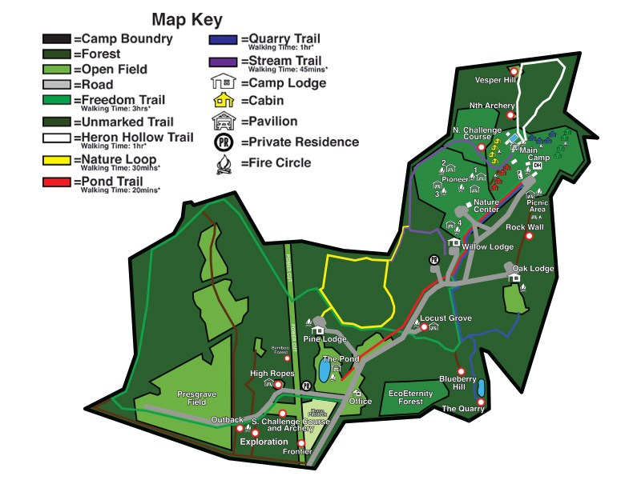Camporee Site Map

## Directions to the Camporee Site

The Camporee site is Camp Highroad in Middleburg VA.

**Camp Highroad**

**21164 Steptoe Hill Road**

**Middleburg VA 20117 (540) 687-6262**

**Directions from Leesburg:**

Take US-15 south from Route 7, for 4.5 miles, turn right onto State Route 733 and go 4.8 miles, turn right onto State Route 763 and go 0.7 miles, turn right and follow signs into the camp.

21164 Steptoe Hill Rd, Middleburg VA 20117

Patrol Challenge Station #1

Passing Condiments – Patrol Level Competition

**Scenario:** Your patrol is in the back country. The Troop Grubmaster accidentally gave your patrol the ketchup and another patrol the mustard. Your patrol needs mustard, and the other patrol needs ketchup. Unfortunately, between the patrols is a swiftly flowing river with hundreds of birds so that nothing can be floated or thrown across it. You must construct a long pole/ extension, with equipment provided, to pass the ketchup across and have the mustard returned to you to win an immunity.

None of your personal gear is available. What you have are four poles/ spars, ropes for lashings, extra rope, ketchup, and a can with a wire. The other side has mustard. Scout Handbook may be used.

After given the command: “Three, Two, One, Pass the Condiments”, your time will start. Your patrol will construct an extension using the poles/ spars provided with round lashings. Place the can with the wire on the extension. Place the ketchup container in the can. Pass the ketchup to the other side of the swiftly flowing river. Bring the mustard back to your side. Once you remove the mustard your time will end and will be recorded. You will have two minutes to plan.

**Scoring:** Lowest recorded time earns five points. Second lowest recorded time earns four points. Third lowest recorded score earns three points. All other patrols earn one point. If you touched the water with the can you have failed to pass the condiments and your patrol will receive only one point.

Do you have any questions?

After any questions are answered say, “You now have two minutes to plan.” Then say: “Three, Two, One, Pass the Condiments.”

**Conduct of the Competition:**

**Inspection Tips:** 1) If the Extension remains rigged throughout, “Congratulate Them”, and reduce their total time by five seconds.

2) If they use a rope to stabilize their Extension, separate from their lashings, reduce their total time by five seconds.

3) If their extension fails, but not in the river, allow them to try again while time keeps running.

4) If any part of their completed extension touches the river it is swept away and they receive only one point.

5) If a pole or rope, not yet tied to anything else, touches the river, they lose that pole or that rope.

6) Record the total time after the mustard is removed from the can.

Patrol Challenge Station #2

Improvised Stretcher – Patrol Level Competition

**Scenario:** Your patrol is in the back country. An accident occurs and your tallest Scout is knocked unconscious. You must carry him to your Scouter’s vehicle so the Scout can be taken to a treatment facility. Fastest time will win an immunity and score points.

None of your personal gear is available. What you have are two poles, two jackets, and a sleeping pad. The Patrol Leader will select the tallest Scout for this competition.

After given the command: “Three, Two, One, Improvise a Stretcher”, your time will start. Your patrol will construct an improvised stretcher using equipment provided and have it inspected by the competition supervisor. Once approved place the limp tallest Scout on it, carry the Scout on the improvised stretcher by walking to the Pointed out half way marker in the field with the entire patrol walking together, walk around the half way point, and then walk back to the start point. If the Scout touches the ground before the finish line, you must fix the improvised stretcher and have it reinspected before continuing. 30 seconds will be added to your patrol score. Once your entire patrol finishes walking across the start line and calls out your patrol motto your time will end and will be recorded.

**Scoring:** Lowest recorded time earns five points. Second lowest recorded time earns four points. Third lowest recorded score earns three points. All other patrols earn one point.

Do you have any questions?

After any questions are answered say: “Three, Two, One, Improvise a Stretcher.”

**Conduct of the Competition:**

**Inspection Tips:** 1) Make certain poles are inserted through jacket arms.

2) Make certain jackets are zipped or buttoned closed.

3) Make certain sleeping pad is laid on top of the jackets to more evenly distribute the Scout Cook’s weight.

4) Do not allow the patrol to place the Scout Cook on the improvised stretcher until you have inspected and approved their construction.

5) If the Scout Cook touches the ground stop the competition, reinspect the improvised stretcher and allow them to continue only after the stretcher is properly reassembled.

6) Record the total time after the command is given to the crossing of the line. Include any penalty time for the Scout Cook touching the ground.

How to improvise a stretcher with poles and jackets - Bing video

Patrol Challenge Station #3

Roman Chariot – Patrol Level Competition

**Scenario:** Your patrol is in the back country but to win amnesty they must win this competition.

**Instructions:** At this station your patrol will construct a Roman Chariot using the three wooden spars and the rope located here. The Chariot is to be built using two square lashings and one diagonal lashing. You will finish the work, place a member of your patrol on the chariot, and the rest of the members of the patrol will carry the chariot and rider from the start line to around the marked point and back to the finish line. Time will stop when you sound off with your patrol motto. You will receive two negative points for each improperly tied lashing. Additionally, the low patrol time is awarded 5 points, second lowest four points, third three points, fourth two points. You have one minute to organize your patrol. Any questions?

**Conduct of the event:** Ensure the lashings are tied securely before allowing the patrol to carry the chariot over the course. The course should be clear of obvious obstructions. When they cross the finish line again verify the lashings are correctly tied. Total the scores and assign points at the end of the overall competition.

After given the command: “Three, Two, One, Construct a Chariot”, your time will start. Your patrol will construct a Chariot using provided equipment only. Once constructed, have it inspected by the competition supervisor. Once approved place the Scout to be carried on the chariot, all other members of the patrol will lift the chariot and carry it over the course. If the Scout touches the ground before the finish line, you must fix the chariot and have it reinspected before continuing. 30 seconds will be added to your patrol score. Once your entire patrol finishes walking across the finish line your time will end and will be recorded.

**Scoring:** Lowest recorded time earns five points. Second lowest recorded time earns four points. Third lowest recorded score earns three points. All other patrols earn one point.

Do you have any questions?

After any questions are answered say: “Three, Two, One, Construct a Chariot.”

Patrol Challenge Station #4

Everyone on the Tripod – Patrol Level Competition

**Scenario:** Your patrol is in the back country but to win amnesty they must win this competition.

**Instructions:** You have two minutes to organize your patrol. Any questions?

**Materials required for each patrol:**

* three 8-foot x 3 to 4-inch tripod leg spars
* three 6-foot x 3-inch tripod support spars
* six 15-foot x 1/4-inch lashing ropes
* one 20-foot x 1/4-inch lashing rope

**Conduct of the event:** Ensure the safety inspection is conducted before allowing the patrol to proceed.

On signal, patrol members lash the three 8-foot spars into a tripod, using the 20-foot rope.

Lashing on the Support Spars

When finished, they set up the tripod and using six square lashings, lash a 6-foot spar between each of the legs.

When all lashings are completed and the tripod is strong and secure, all the patrol members stand on the 6-foot spars, making sure their weight is evenly distributed. To be complete they must all be on the tripod and sound off with their patrol motto.

**Scoring:** Lowest recorded time earns five points. Second lowest recorded time earns four points. Third lowest recorded score earns three points. All other patrols earn one point.

Do you have any questions?

After any questions are answered say: “Three, Two, One, Initiate Everyone on the Tripod.”

Patrol Challenge Station #5

Cross-Cut Saw – Patrol Level Competition

**Scenario:** Your patrol is in the back country but to win amnesty they must win this competition.

**Instructions:** At this station your patrol will cross-cut the provided log using the equipment provided here.

Additionally, the low patrol time is awarded 5 points, second lowest four points, third three points, fourth two points. You have one minute to organize your patrol. Any questions?

**Conduct of the event:** Ensure the safety inspection is conducted before allowing the patrol to carry execute the challenge over the course. The course should be clear of obvious obstructions. Saws will be provided by the Camporee staff. A log will be resting on support salong with a saw. On the starting signal, time begins. The first two Scouts will run to log and saw for 30 seconds. The person timing the event will call out when 30 seconds have elapsed. After 30 seconds, Scouts will return to the starting line where they will be replaced by the next two Scouts who will repeat the process. Patrols will continue tag teaming until a log has been cut through twice. Scoring will be based on time.

**Scoring:** Lowest recorded time earns five points. Second lowest recorded time earns four points. Third lowest recorded score earns three points. All other patrols earn one point.

Do you have any questions?

After any questions are answered say: “Three, Two, One, Cut the log with the Cross-Cut Saw.”

