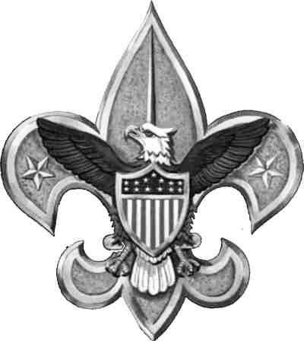
2017 Potomac District Klondike Derby

Webelos Invitational Open to all Webelos

Saturday, January 28, 2016 - 1:00 PM to 4:00 PM

Little Bennett Regional Park - 23701 Frederick Road, Clarksburg, Maryland

Great Reasons to Attend:
- See more than 40 Boy Scout Troops in action, solving problems and displaying Scouting skills.
- Satisfy Requirement #4 for the Arrow of Light Adventure: Scouting Adventure by participating in an outdoor Boy Scout activity using the patrol method.
- May fulfill partial Webelos Adventures Requirements for:

- Cast Iron Chef
- First Responder
- Webelos Walkabout
- Aware and Care
- Castaway
- Into the Wild

A special area at the Klondike Derby will be set up for Webelos Dens to try out several Derby stations similar to the Boy Scout competition. These stations will not require special equipment or skills, but will be fun challenges to help the Webelos work as a team and solve problems while burning off some steam. After trying their hands at these stations, the Webelos may go to the main competition areas and observe the older Scouts as they try solving similar problems while demonstrating their Scout skills, including fire-building and knot-tying. Everyone should be mindful of the weather and dress appropriately. The boys will be outdoors the entire time they are at the Derby. There is a warming station with hot chocolate.

Check-In: Begins at 12:45pm at the Gatehouse to Little Bennett. To reduce confusion, check in as one large group rather than individually. Lines are shorter later in the day – consider arriving after 2pm.

Directions: Exit 18-Clarksburg from I-270, travel NE on Route 121. Turn left onto Frederick Road (355) and proceed N until you see signs for the Klondike Derby. Little Bennett will be on right, parking on left at High Point Farms.

Parking: Parking is available across from the main entrance at High Point Farm or in the Little Bennett Maintenance lot. Once you are in the park, follow Webelos signs to find the Webelos activities, which will be fairly close to entrance. Because parking is limited, carpooling is strongly suggested. Parking is free.

Clothing: The Scout Uniform is to be worn at all events. Supplement the Scout uniform with additional layers of clothing. Leaders must review the importance and principles of winter dressing with all participants. No tennis shoes will be permitted. Any attendee not properly prepared for the weather will be unable to participate in the activities. Everyone MUST know how to keep warm and dry. Winter weather, with changing conditions, necessitates being prepared for almost any condition. It requires adequate, layered clothing (no cotton) and waterproof boots for protection yet must be versatile enough to prevent sweating during activities and to retain warmth during idle periods. A winter cap or hat and gloves or mittens are necessary during the day. If you are an adult accompanying Webelos, your registration means that you are responsible for ensuring that you and your Webelos will be properly dressed at this cold weather event.

Registration: Cost is $5 per attendee (including all adult attendees), which includes the Klondike Derby patch, administrative items and insurance. Register online: https://scoutingevent.com/082-10603 to save time at Check-In, but registrations are also accepted on the day of the event. Provide Webelos Invitational Registration Form at Check-In. See link online.

For more information, e-mail KlondikeDerby@gmail.com

