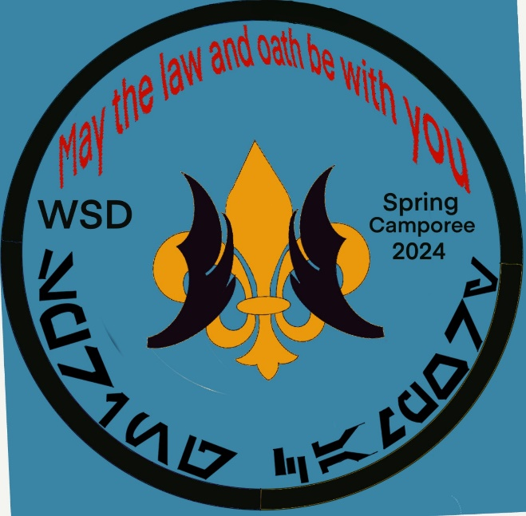
Western Shore
District
Spring Camporee
2024

March 15th, 2024, 5:00 pm
March 17th, 2024, 9:00 am

Kings Landing Park
3255 Kings Landing Rd
Huntingtown, MD 20639

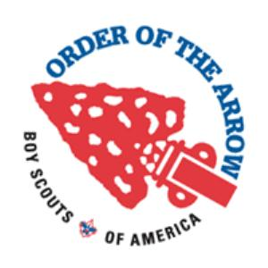

Hosted By:

Western Shore Chapter Order of the Arrow

Contact Information:
Jacob Elliott, OA Chapter Chief (Youth)
westernshorechapter@wipit470.org
Dawn Elliott, OA Chapter Associate Advisor (Adult)
Dandelliott2406@gmail.com or 240 216-24741
Blaine Caracter, OA Chapter Advisor (Adult)
Bcaracter@yahoo.com or 301 801-6106

Registration Link: https://scoutingevent.com/082-wsdspringcamporee

Cost: Youth - $15.00/Adults $10.00

Registration closes on Tuesday, March 12th, 2024, at 11:59 pm
Camporee Schedule:
Friday, March 15th:
5:00 p.m. - 8:00 p.m. - Check-In/Registration/Set up Camp.
8:30 p.m. - 9:00 p.m. - SPL/Scoutmaster Leader meeting OA pavilion
9:00 p.m. - 9:30 p.m. - OA Cracker Barrel – for SPL’s, Scoutmaster’s and Any/All 2024 OA dues paid members, wear your OA sash.

10:00 p.m. - TAPS (Lights Out)

Saturday, March 16th:
6:30 a.m. - Wake-up/Breakfast
8:00 a.m. - 8:30 a.m. - Flag Up, Morning Roll Call & Announcements; OA Pavilion
9:00 a.m.-12:00 p.m. - Morning Program
12:00 - 1:30 - Lunch
1:00 - 1:30 p.m. - Brotherhood Conversion Class – all- participants must have paid their 2024 OA dues.
1:30 - 4:30 afternoon program
4:30 p.m. - 7:00 p.m. - Dinner/Free Time-Skits will be collected during dinner.
5:00 p.m. - WEBELOS & Arrow of Light check in
7:00 p.m. - 7:15 p.m. – Scouts Own Service – OA Pavilion
7:15 p.m. – 7:30 p.m. – Dutch Oven Cook Off due – OA Pavilion – “Dessert.”
7:30 p.m. - Get ready for campfire, practice skits.
8:00 p.m. - 9:30 p.m. - Closing Campfire, Skits & O/A Callouts, Flag Retirement Ceremony
Brotherhood Conversion immediately following closing campfire…Stay behind at campfire. all participants must have paid their 2024 OA dues.

10:00 p.m. - TAPS (Lights Out)
May The Oath & Law Be with You!

Sunday, March 17th:
7:00 a.m. - Reveille and Breakfast
8:30 a.m. - Closing Flags/Ceremony
9:00 a.m. - Check Out

Camporee Contact:

Jacob Elliott
Chapter Chief (Youth)
westernshorechapter@wipit470.org

Blaine Caracter – 301 801-6106
OA Chapter Advisor (Adult)
bcaracter@yahoo.com

Dawn Elliott - 240 216-2471
OA Chapter Associate Advisor (Adult)
Dandelliott2406@gmail.com

Station Descriptions:
Make a Light Saber
- Pool noodles, duct tape and black and orange electrical tape
- Individuals will use the tape to decorate the bottom of the pool noodle to resemble a Light saber.
Light Saber training
- Light saber, and glow in the dark necklaces
- Each Patrol will get 5 necklaces that they will toss to the scout holding the light saber, and try to get it on
Trapped Spaceship
- Slinky (regular size) and ping pong ball
- 2 scouts will hold the ends of the slinkies, while the rest of the patrol tries to get a ping pong ball from one end to the other, without it falling to the floor.
Defeat the Darkside
- 2 patrols will be tossing an inflatable ball back and forth, but only using light sabers to touch the ball. If the ball falls on your side the opposite side gets a point
Moving Planets
- String and various size balls.
- The patrol will need to work together to move the planets (balls) from point a to b.
Obstacle Course
- Jedi Balance Practice – Don’t fall into the Lava
  - Red twin sheets (x2), thick paper/cardboard
  - Object is to go from one side to the other only touching the plates one time.
- Dodge the Storm Trooper Laser Blast
  - Paracord and a place to tie it up.
  - The scouts need to make it through without touching the beam
- Bean Bag Toss
  - Toss bean bags into holes for extra points.
Steal the Death Star Plans
Galactic Ball – Gaga Ball

Program Descriptions:

Check In:
Scoutmasters will check in at the at the Leaders meeting and provide a completed roster of their units, identifying youth and adult. All units should have a copy of the BSA Health Form for all Scouts/Scouters at their campsite.

Ground Fires Are Not Permitted - Only Leave No Trace Fires. Please bring an elevated fire pit. Only Fires contained completely above the ground will be permitted. DO NOT DISTURB THE GRASS. FIRES MUST BE ATTENDED AT ALL TIMES! Charcoal grills and/or propane stoves, with proper supervision, are recommended for cooking. Firewood is not available at the Camporee site.
DO NOT DUMP ANY ASHES IN THE WOOD LINE!!

Equipment:
Be prepared. Bring what you need!!

Spring Camporee Trophy:
The Patrol with the most points will take home the Western Shore Spring Camporee Trophy currently held by Troop 2819.

Food:
Patrols are expected to plan, pack and prepare their own food, no food will be provided for units.

Uniforms:
Field Uniforms (Class A) and OA sashes are required for the Opening, Campfire, Scout’s Own and Closing ceremonies. Activity Uniforms (Class B) are suggested for all other activities. Don’t forget to dress for the weather.

Electronics:
Please put away your cell phones. There will be NO charging stations available.

Trash:
All trash must be placed in appropriate containers and removed from the Camporee site at the conclusion of the event. Cooking grease must be placed in a covered container and discarded with the trash. Wastewater used for clean-up is to be scattered well away from any inhabited campsite, preferably along a tree line.

Lost & Found:
Items found should be turned in at the OA pavilion. Items may be claimed at any time during the Camporee. Any items that are not claimed will be donated to a local thrift store.

Camp Sites:
Will be assigned based on your registration numbers.
Vehicles:
No cars are allowed to unload at the campsite, only the troop trailer and the tow vehicle will be allowed at the campsite. We will have an established unloading system set up on Friday evening where vehicles will unload their passengers and their gear. Upon unloading, the driver will leave and park in the parking area by the pool.
SPL/Scoutmaster Leader’s Meeting:
This is when the SPL and Scoutmaster (for each Troop) will come for information about the Camporee. Any changes for the Camporee will be given to the Senior Patrol Leader for them to give to the Patrol leaders. All Arrowmen will be given the opportunity to volunteer to be runners for the call out ceremony.

Morning Announcements and Roll Call:
Troops will line up in front of the flagpole. Troops will check in for attendance and will then proceed with Flag Ceremony. The pledge of allegiance, scout oath, and law will then be recited. The tidiness of lines, enthusiasm of the scouts, and preparedness of the troop (whether they make the effort to arrive on time and have brought their troop flag) will be noted for the extra points. After the attendance has been called, announcements will proceed so that all presents may be knowledgeable of changes to the program.

Closing Campfire:
OA campfire is located near the camp sites…please be respectful of Troops that are camping in that area and use the walkways. Announcements, skits, and OA callouts will take place during campfire.

Special events!!!
- Cheerful Service: We have an opportunity to do service work for Kings Landing Park. Troops will be awarded Points based on their efforts at the service project.
- Wanted – Droids: The OA Chapter members have hidden droids throughout the park, (In the areas we are using only) If found please bring to the OA pavilion for a reward (points to be added to the troop/patrol)
- The Troops inner Yoda – At opening ceremony each troop will take their SPL and make him into a Yoda. The first Unit to finish will receive 25 extra points.
- Theme Spirit – The OA would love to see the units incorporate the spirit of the theme, come dressed in your favorite Star Wars T-shirts, the unit that shows the most Star Wars spirit will receive an extra 25 points.
- Adult Participation - Each Troop who provides two or more adult volunteers for Saturday stations will receive 5 extra points/adult.
- Dutch Oven Dessert Cook Off - the theme for Saturday’s cook off is “dessert”. Patrols prepare dessert for Saturday night and bring a portion/sample to OA pavilion for judging after Scout’s Own.

Gate Access & Lock:
We understand that campers may need to enter or exit Kings Landing Park during our closing hours. Please follow these rules to ensure the sanctity of our park and the safety of your campers.
1) Both swinging ‘gates’ of the front entrance must remain closed during closing hours. Do not leave one gate open and the other closed (We know one side has a sign stating ‘park closed’ but many visitors ignore it and drive around the gate!) Even if someone is driving in to ‘quickly’ pick up a camper, then driving right back out, they must close the gate behind themselves! People WILL DRIVE IN AROUND THE GATE IF IT IS LEFT OPEN.
2) Do not ‘dummy lock’ the lock at the front gate. (Dummy lock means the lock appears closed, but is actually open to allow people in.) We have had locks stolen when they aren’t locked!
3) The Gate Lock is Yellow…The combination code-will be emailed out to Scoutmasters as soon as we receive it. Scoutmasters will be responsible for letting their late arriving/early departures in and out of the gate.
4) PLEASE DO NOT LOCK OUT OTHER LOCKS: Make sure to maintain the daisy-chain of locks so that none of the locks are rendered useless to other users.

