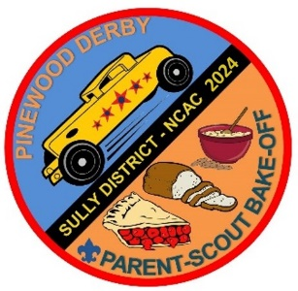
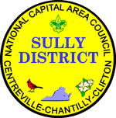
Saturday, 16 March 2024
Sully District
Pinewood Derby
& Bake-Off
G&C Tire and Auto Service, 14008 Willard Rd, Chantilly, VA
Pinewood Derby Fee $10.00 Bake-Off Fee $10.00 POC: david.weisz@verizon.net
Register Online at: https://scoutingevent.com/082-SullyPinewood2024
https://scoutingevent.com/082-SullyBakeoff2024
Race Times: 8:30AM to NOON Bake-Off Schedule:
8:30 – 9:00 Lion Check-in Check-in: 8:30 - 10:00AM
9:00 Lion Racing & Awards Judging: 10:30AM
9:00 – 9:30 Tiger Check-in Awards: 11:30AM
9:30 Tiger Racing & Awards Bake-Off Categories: Cakes
9:30 – 10:00 Wolf Check-in Breads
10:00 Wolf Racing & Awards Cookies
10:00 – 10:30 Bear Check-in Pies
10:30 Bear Racing & Awards Decorative / Creative
10:30 – 11:00 Webelos Check-in
11:00 Webelos Racing & Awards
11:00 – 11:30 Arrow of Light Check-in
11:30 Arrow of Light Racing & Awards
12:00 District Championship Racing & Awards

PWD Race Eligibility: Scouts finishing 1st, 2nd, & and 3rd place for their rank (Lion, Tiger, Wolf, Bear, Webelos, Arrow of Light) in a Pack race qualify for the District PWD and are encouraged to participate. Arrow of Light Scouts who have already crossed over to Scouts BSA are still eligible for this event if they placed at the Pack level while still a Cub Scout. (NOTE: If any placed scouts cannot participate, please choose another scout to compete to encourage maximum participation.)

Bake-Off Eligibility: Scouts finishing 1st, 2nd, and 3rd place (for each bake-off category) in their Pack competition, qualify to compete at the District level bake off. Arrow of Light Scouts who have already crossed over to Scouts BSA are still eligible for this event if they placed at the Pack level while still a Cub Scout. (NOTE: If any placed scouts cannot participate, please choose another scout to compete to encourage maximum participation.) This is not a rank-level competition.

