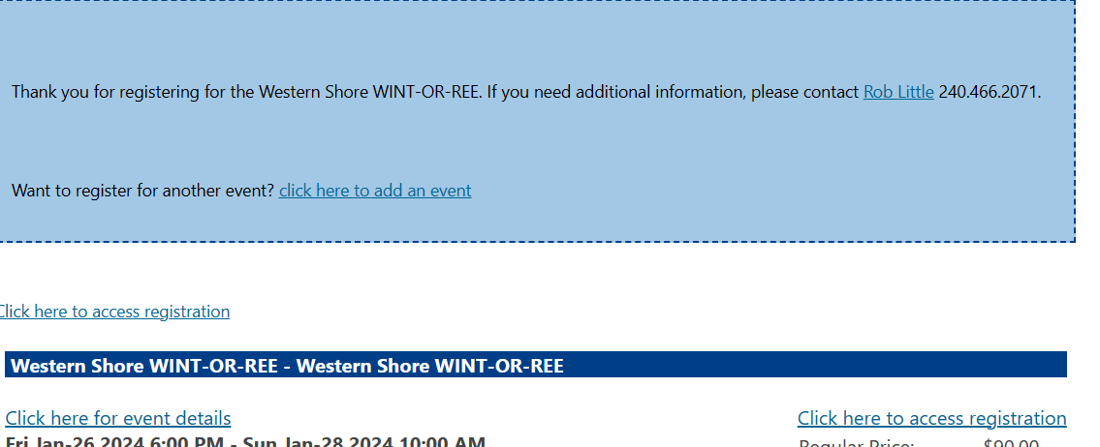

Hi Jon. Above is part of the receipt each and every person who registers for any BlackPug event receives in the email, as long as they put in an email address. So, to get to the area where they could print out their class scheduled:

- Find the copy of the receipt you received from the National Capital Area Council.
- Click on the link that states “Click here to access registration”
- Once your registration page appears, click on the tab that says “Reports”
- From the reports page, click on the button that says “Class Schedule” and then click on the “Preview” button.
- Your class schedule will appear in .PDF format and can be printed out using your web browser.

So, as long as they can find their copy of the receipt, they are good to go.

Vr
Bob

