2023 Patriot & Old Dominion District
Cub Scout Summer Day Camp
OFF TO THE RACES - June 26th- 30th
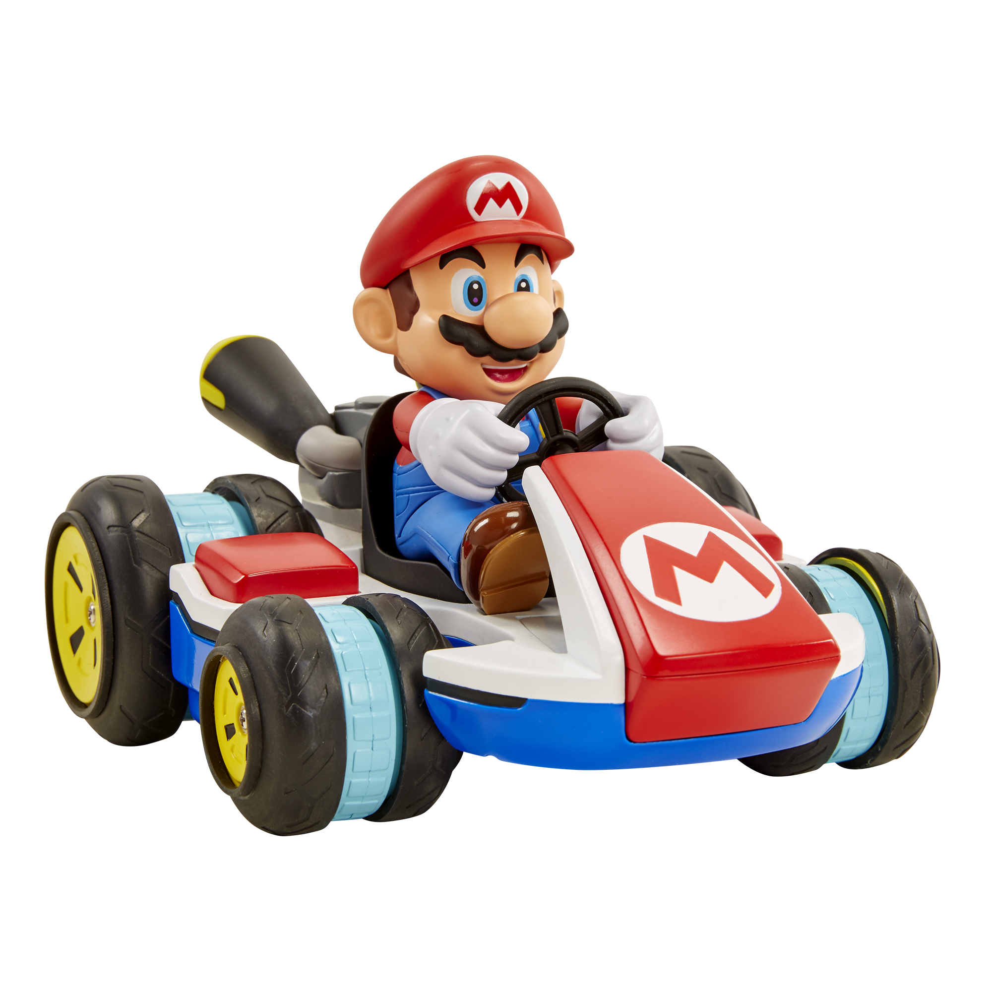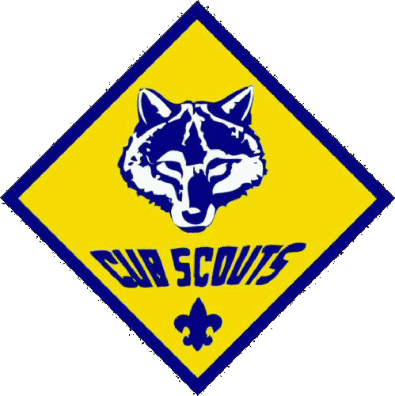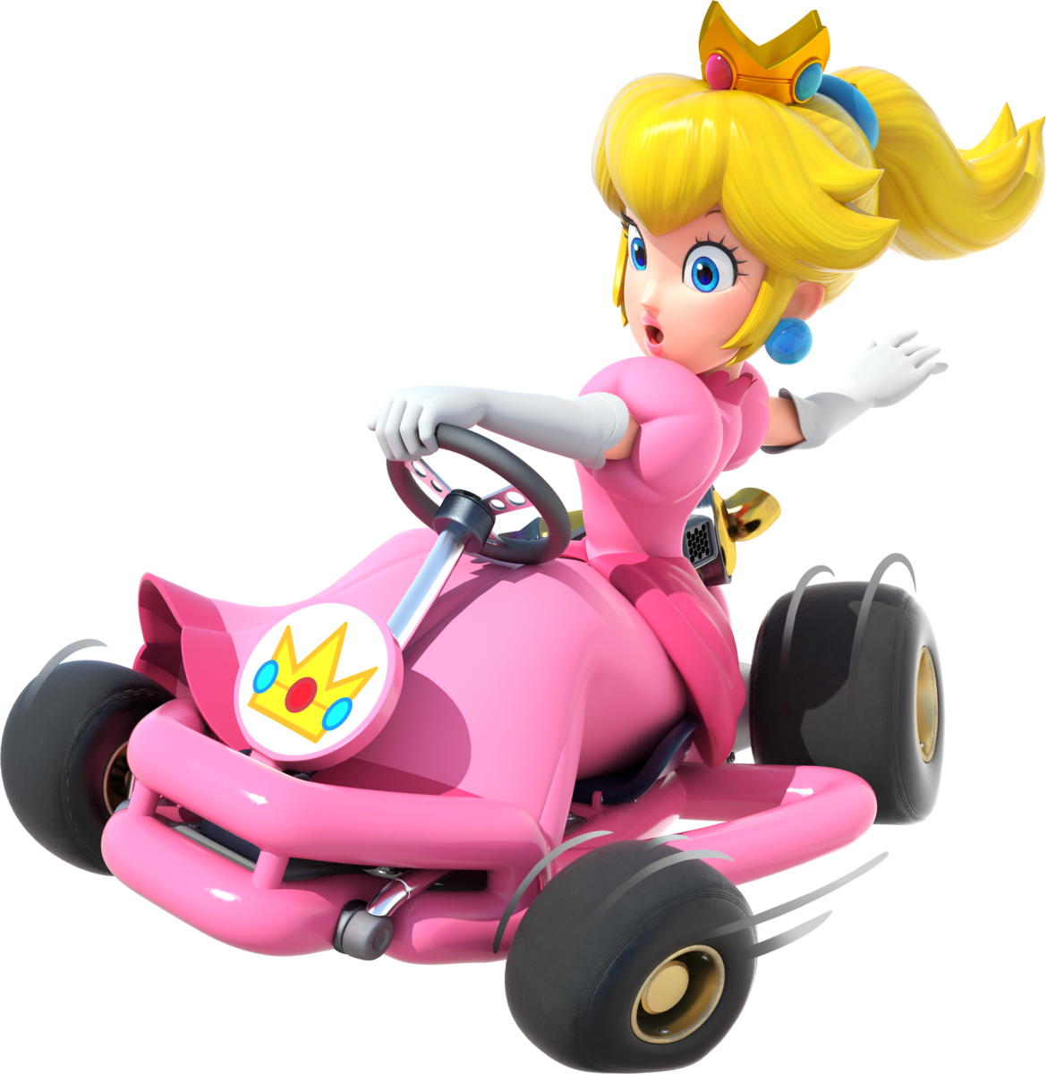

Join us as we set out on a five day High Speed Adventure!
We will race to Archery, Sling Shots, S.T.E.M. Scout Skills, Climbing Wall, Arts & Crafts
& so much more FUN.
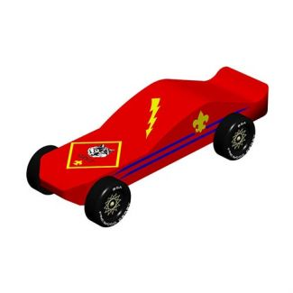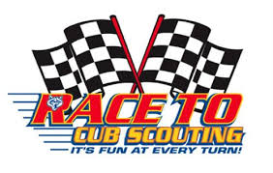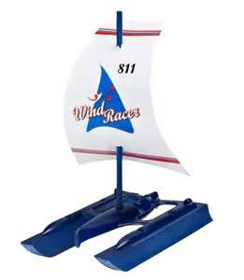
Cub Scouts love to go to Camp! The number one reason boys and girls join Scouting is to go to camp. Let’s help them do that by having your scouts attend the Patriot & Old Dominion District Day Camp.
Day Camp is for registered Cub Scouts entering the 1st -5th grades the following school year. Those entering the 1st grade must be accompanied by an 'adult partner' during their participation.
The camp will again be held at the Occoquan Regional Park, Lorton, Virginia. A one adult to five scout ratio is required to guide our “racers” through camp,
Camp Dates: Monday, June 26th – Friday, June 30th
Registration Fee: $200 per Cub Scout
SIGN UP HERE: https://scoutingevent.com/082-65238
Adults: If you have a full week of free time available, why not be a full time staff member. Your scout (one scout only) will attend camp for FREE!
Cubmaster & Committee Chairs: If you would like an individual Summer Day Camp Presentation at your Pack Meeting, please contact us at: patriotdistrictdaycamp@gmail.com

The only thing needed for this adventure is YOU!
Zohra Sharief, Patriot District Day Camp Director

