Knights of the Cub Table
A Medieval Crazy Cub Campout Adventure
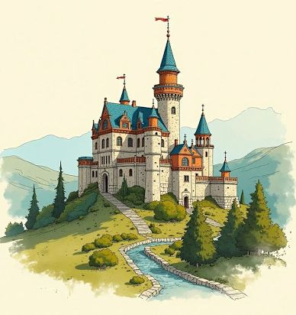
Hear ye, hear ye!
Prepare for a
Weekend of fun, epic
Quests, And noble deeds!
All cubs are welcome!

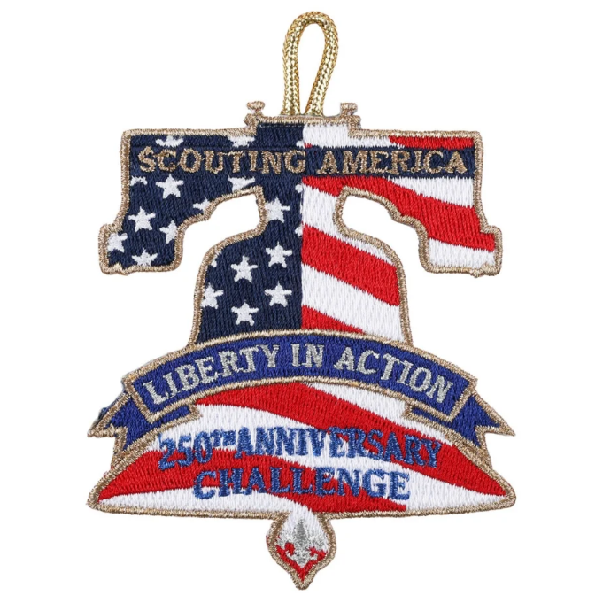
A unique opportunity to earn
A patch for america’s 250th
Anniversary is part of the
Medieval adventure for
Cubs, scouts and adults!

Join us at castle strang (Camp Strang)
278 west side road, goshen ct
September 25-26, 2026
Register here

