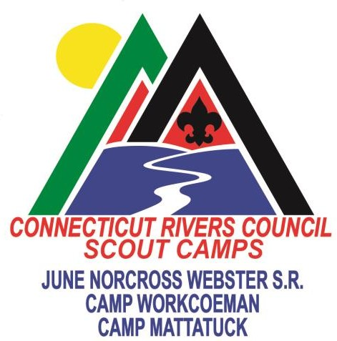

2021 SUMMER CAMP RESIDENT FEES

Early Fee - $450
A $50 deposit per Scout camper is due no later than Wednesday March 15th, 2021 If paid in full by May 1, 2021 the fee will be $450, payments received after May 1, 2021 will be charged the regular rate of $475.

Discounts for Scouts
Encore (2nd week of camp) $350. The registration process will require the Scout’s other camp/week to be identified. To qualify a scout must have already spent a week in a Boy Scout Camp or National High Adventure Base and the discount applies to a second (or more) week at one of the CRC’s camps.

Sibling Discount: a $25 discount will be given to help out those families with siblings attending Resident Camp. The discount will apply to each sibling from the same family.

Leader Fees
Fees for extra leaders are calculated at $20 per day or $120 for the full week. Names of leaders are not required until May 15. Two leaders are free. Additional leaders may be free according to the schedule below:
# of youth per program | # of free leaders | All additional adults
5-10 | 2 | $120
11-20 | 3 | $120
21-30 | 4 | $120
31-40 | 5 | $120

Webelos Crossovers & New Scouts Fee - $450
These Scouts are always afforded the lowest possible camp fee rate. Because many troops don’t know what Webelos will be joining their troop until after the March 15th deposit date, a special registration category will be established for them. This will also include any boys who join the troop as new Scouts between March 15th and the beginning of the troop’s week at camp.

Camperships
The Connecticut Rivers Council will continue to award camperships to assist Scouts in need of funds to attend camp who might not otherwise do so. The annual campership fund is limited and fluctuates from year to year. Similar to Webelos crossovers and new Scouts, campership Scouts will also be afforded the lowest possible rate to attend camp. The unit process for paying for these Scouts is to be determined.

Specialty Camp Programs
Registration for all Specialty Camp programs will be accomplished by the individual. These programs will include Trail to Eagle, ATV, NRA Shooting Sports, Robotics & Technology, plus many more.

FAQs
Question I don’t know what Scouts in my troop are going to attend camp by the March 15th Early Fee deposit date. Why should I make a deposit for the “unknown”?
Answer Camp promotion is a year-round process. The unit’s camp plans should already be on
family’s calendars. Units also should have a pretty good idea of the percentage of Scouts in the troop that attends camp. Register and make deposits for that number of Scouts you think will be attending. Deposits may later be transferred between Scouts.

Question We know our troop has Scouts that need Campership assistance in order to attend camp. Should we register them with a $50 deposit by March 15th?
Answer Yes, as stated above, campership applicants are always afforded the lowest possible camp fee. Naming them by March 15th helps the Camp Directors in planning for a great summer program.

Connecticut Rivers Council Summer Camp Refund Policy

The Connecticut Rivers Council must commit financial resources to purchase equipment, hire staff, and otherwise prepare to provide the high-quality programs in
our camps well in advance of the camps opening for the summer. Participants therefore must be prepared to make a financial commitment to attend.
Refund requests made before June 15th will be reimbursed the fee minus the cancellation fee of $75. Requests after June 15th will be reimbursed the fee minus the cancellation fee of $150.
In the event of illness we will process a refund if you can not attend camp. If a camp attendee presents signs of illness while at camp, we reserve the right to send them home without a refund.
In the event the State of Connecticut closes camp or we are unable to operate camp, we will process a full refund to the pack/troop, not individual Scouts (unless Scouts signed up as individuals for day camp, provisional, or other specialty programs).

All requests for refund consideration are to be in writing and sent either in the form of a letter or email to:
Connecticut Rivers Council Attn: Mike Brown
60 Darlin St, East Hartford, CT 06108 860-913-2750 michael.brown@scouting.org

