2020 HAUNTED WOODS
DRIVE-THROUGH
J.N. WEBSTER Scout Camp
FRIDAY, OCT. 23, & SATURDAY, OCT. 24
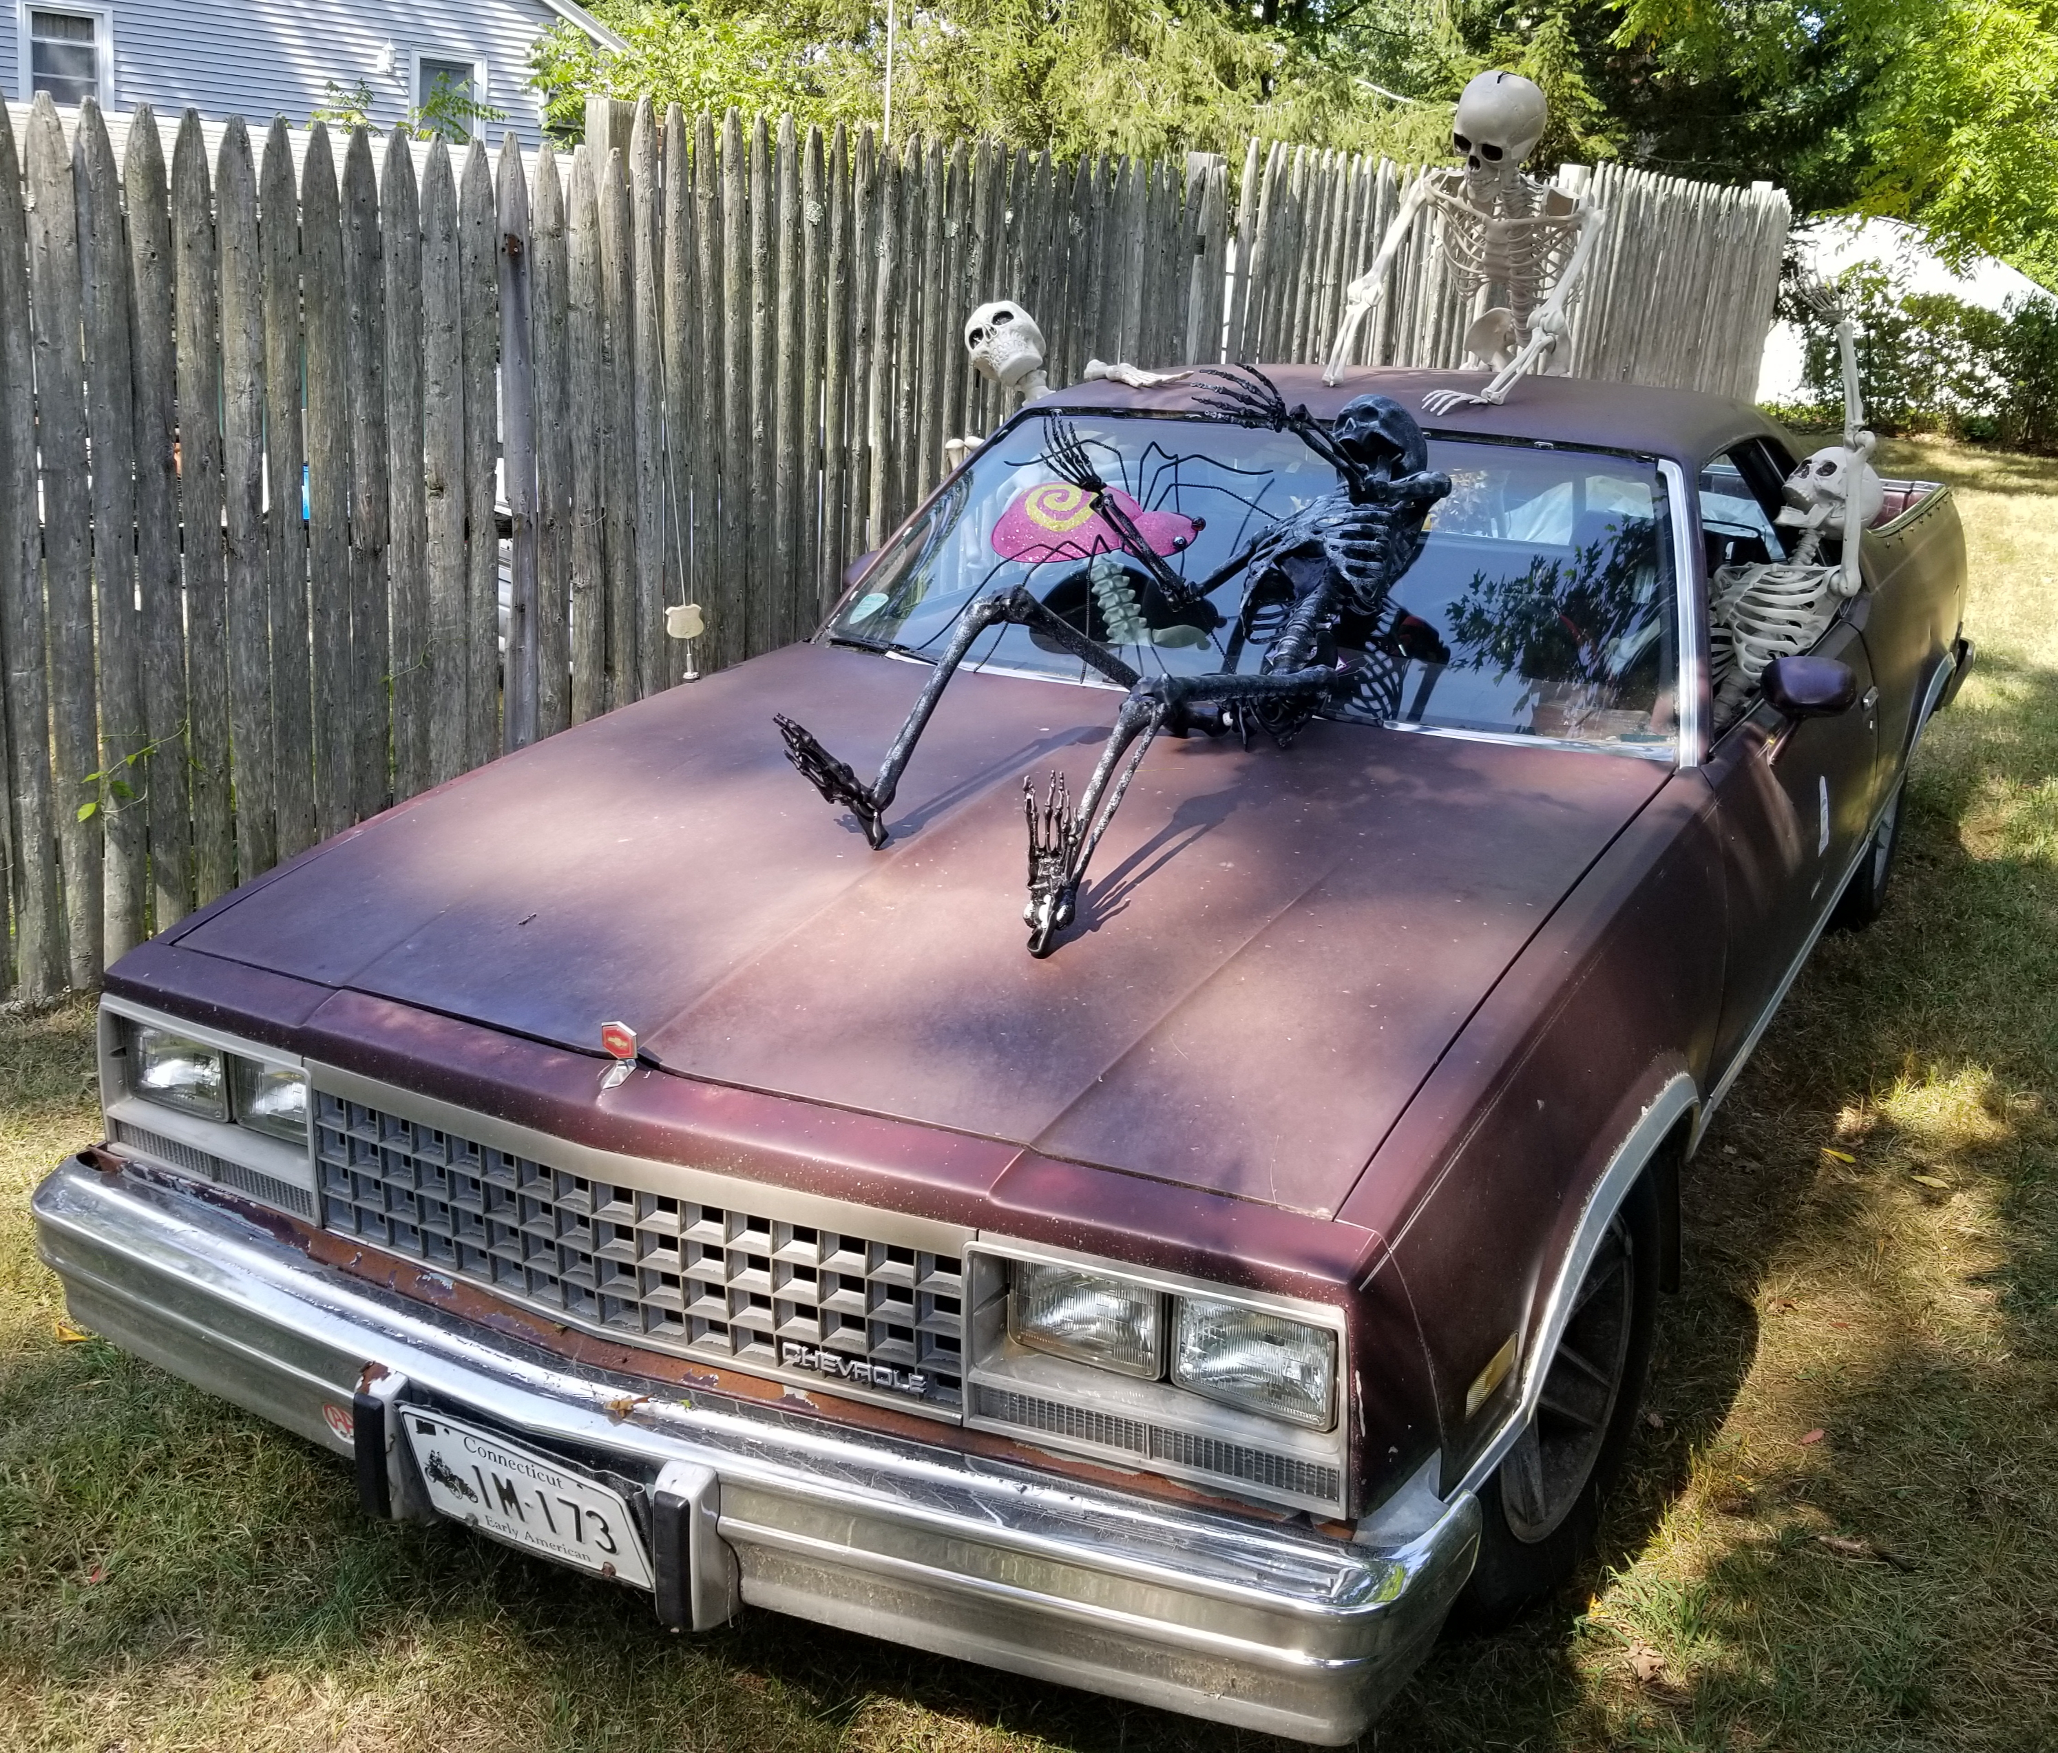

A no-contact event, you stay in your car!

$15 PER CAR LOAD, PLEASE BRING E-MAIL RECEIPT, OR BRING EXACT CHANGE

TIMES: FRIDAY - 6:30PM TO :10:30PM
SATURDAY - 6:00PM TO 10:30PM
231 Ashford Center Road, Ashford, CT
REGISTER HERE:

