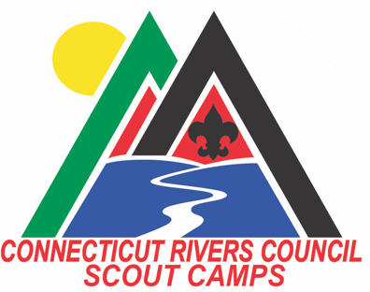
A SCOUT IS LOYAL, GET REWARDED FOR IT!
Make your job easy; return to a Connecticut Rivers Council Summer Camp in 2021 and receive the benefits of our loyalty program for returning Troops.

BENEFITS OF REGISTERING for 2021 before october 1st, 2020 AS A PREFERED CUSTOMER INCLUDE:
- The $50 Campsite Reservation Fee is waived
- $100 Trading Post Credit for the Troop if you pay the per Scout deposit by March 15th
- Preferred discount pricing on Off-Season paid programs. (Certain programs apply)
- A free weekend tent camping site at ANY of the Connecticut Rivers Council Camps before the 2021 Season. (some blackout dates apply).
- Exclusive free leader pricing for 2021
- A personal visit from a Camp Staff Member who will come to your Troop meeting in the 2020-2021 offseason to talk about 2021 Summer Camp.

Exclusive Free Leader Pricing - DRAFT
Bring ten (10) Scouts to summer camp, qualify for two (3) free leaders. For every additional ten (10) Scouts, qualify for an additional one (1) free leader.
Number of Scouts | Number of Free Leaders
10 Scouts | 3 free leaders
20 Scouts | 4 free leaders
30 Scouts | 5 free leaders
40 Scouts | 6 free leaders

