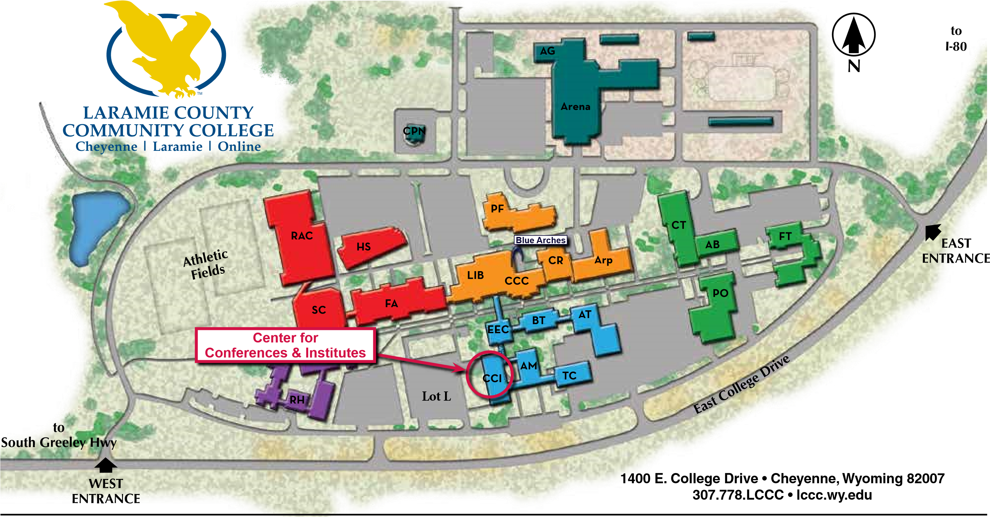
Administration (AM)  Business Services  Human Resources  President’s Office  Agriculture (AG)  Andrikopoulos Business &  Technology (BT)  Arena (Aren)  Arp (Arp)  Children’s Discovery Center | Auto Body (AB)  UW Manufacturing-Works / PTAC / SBDC  Auto Tech (AT)  Career & Technical (CT) ACES  Center for Conferences & Institutes (CCI)  Central Plant North (CPN) | Clay Pathfinder (PF)  Admissions  Student Planning & Success Advising / Career Center /  TRIO SSS  Bookstore  Cashier / Student Accounts  Counseling & Campus Wellness  Disability Support Services  Exam Lab & Testing Center  Student Hub  Financial Aid / Student Records  UW LC Extension /  Outreach School / UW TRIO | College Community Ctr (CCC)  Dining Room  Playhouse  Student Life  Student Lounge  Crossroads (CR)  Campus Safety  Education & Enrichment Ctr (EEC)  Fine Arts (FA)  Esther and John Clay Art Gallery  LCCC Foundation  Student Computer Center/Help Desk  Flex Tech (FT) | Health Science (HS)  Ludden Library (LIB)  Modular (MA)  High School Programs  Plant Operations (PO)  Recreation & Athletic Ctr (RAC)  Residence Halls (RH)  Science Ctr (SC)  Training Ctr (TC)
PRS MapC 1/17

