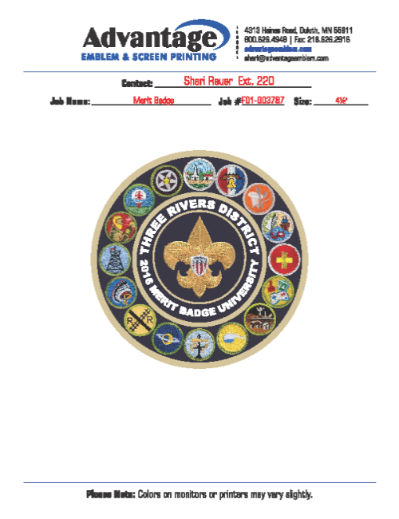
2025 Merit Badge University
February 1st & March 1st
Location: Frontier Academy
6530 W. 16th Street Greeley, CO

^{Check in Starts – 7:00am}  ^{Flags / Welcome – 7:55}  ^{Class #1 8:20 – 9:20}  ^{Class #2 9:30 – 10:30}  ^{Class #3 10:40 – 11:40}  ^{Lunch 11:40 – 12:40} | ^{Class #4 12:40-1:40}  ^{Class #5 1:50 – 2:50}  ^{Class #6 3:00- 4:00}
- Classes Will Be held all Day - 15 Different Class Offerings
- ^{Session #1 February 1st}
- ^{Session #2 March 1st}
- Scouts will have the opportunity to take up to 6 Classes
- Registration fee: $25.00 per scout
- Registration Closes January 31st, 2025.
- Needing a few volunteers, to help in classrooms and monitoring hallways
- Scouts are not required to bring Blue Cards. After final data is put on the registration tab. All Scout Leaders can go on and check all requirements fulfilled in each Class. Then print out Blue Cards at your Troop Meetings.
- Scouts must always be in full uniform. No food in the classrooms please. Be Courteous and trustworthy in this school.
- Please print and bring your own Workbook for each class taken. Merit Badge books can be found online, if needed.

^{Merit Badge Offerings}
^{Citizenship in the Community*} ^{Citizenship in World} ^{Truck Transportation}
Emergency Preparedness* (2 periods) ^{Orienteering} ^{Entrepreneurship (2 periods)}
^{Pioneering (2 Periods)} ^{Disabilities Awareness} ^{Traffic Safety}
^{Wood Working} ^{Animal Science} ^{Fire Safety}
^{Safety} ^{Weather} ^{Finger Printing}

^{Please sign up on Black Pug}
1 slice of pizza, 1 bag of chips, and soda will be available for purchase during lunch periods for $6.00
You can also Per pay for your lunch on Black Pug with sign up.

Not all classes are offered all day. Please sign up early.
Please send questions to Darwin Brady at darwin@gogreenpalletco.com

