WAPITI DISTRICT

ADVENTURE WEST COUNCIL

2024

KLONDIKE DERBY

February23 - 25, 2024

Reverend’s Ridge Campground

Golden Gate Canyon State Park

<[https://scoutingevent.com/062-78889](https://scoutingevent.com/062-65947)>

Hosted By:

Wapiti District, Adventure West Council

Alpha Phi Omega – Gamma Theta Chapter

and

Chipeta Chapter, Order of the Arrow

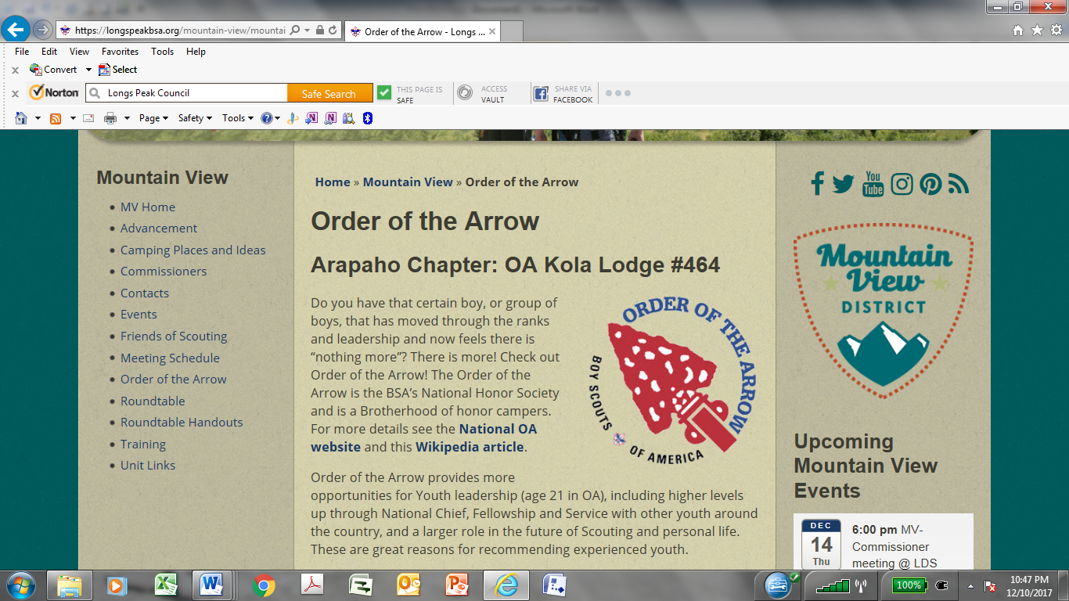 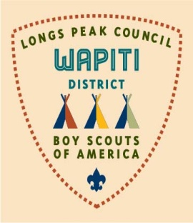

*Walter “Butch” Josh*

Wapiti District Camping and Outdoor Activities Chair

email: [josh_walter@comcast.net](mailto:josh_walter@comcast.net)

720-934-0497 (Voice/TXT)

*Matt Nieberger*

Event Host and Commissioner

email: [ftcnative@gmail.com](mailto:ftcnative@gmail.com)

303-746-3845 (voice/TXT)

- 1 -

Packet Contents

**Klondike Overview** **page 3**

**Registration Procedures** **page 5**

**Unit Roster** **pages 7-10**

**Arriving at Klondike** **page 11**

**Schedule of Events** **page 12**

**Klondike Derby Competition** **page 13**

**Sled Information** **page 14**

**Patrol Scoring** **page 15**

**City Competition** **page 15**

**Health and Safety** **pages 16-20**

**Directions and Maps** **page 21-24**

General Klondike 2024 Information!

* Klondike 2024 will be February 23 through 25, 2024.
* Location: Reverend’s Ridge Campground, Golden Gate Canyon State Park
* Check-in begins at 2:00 PM on Friday, February 23rd.
* All registration will be done online. <[https://scoutingevent.com/062-78889](https://scoutingevent.com/062-xxxxx)>
* Scout Master/Senior Patrol Leader meeting and cracker barrel will be held on Friday evening at 9:15 pm.
* The traditional adult leader Smorgasbord/potluck will be held at lunch on Saturday. Come share your favorite camp meal with other leaders (prizes will be awarded).
* Awards Campfire will be held at 6:30 pm Saturday Evening. We encourage all troops to stay for the Awards Campfire.
* “Leave No Trace” camping will be emphasized.

**2024 Key Dates and info**

City Host Signup Deadline: **January 26**

City Meeting Date: **February 3 OR 4**

Participation/Registration Deadline  **Thursday, February 8**

Klondike Start Date: **February 23**

Klondike End Date: **February 25**

**NOTE**: **Registration cutoff date is sooner this year**, due to Colorado State Parks Fee increases and the requirement to Pre-pay for reservation dates and facilities.

After Feb 8, contact the CCouncil Office before Feb 16;

<[jeanene.gage@scouting.org](mailto:jeanene.gage@scouting.org)> 970-584-2202

<[stacy.summerton@scouting.org](mailto:stacy.summerton@scouting.org)> 307-234-7329

What’s the cost for 2023 Klondike?

* $30.00 per Scout and Adult Leader
* $25.00 per Staff, City Staff hosting a city, or OA* member (if not on sled, see rules later)
* $10.00 per Webelos And Webelos parents attending on Saturday
* $ 5.00 Late Fee (Each), Feb 9, 2023, No registrations after Feb 16.

2 -

Klondike Overview

The Klondike Derby is a three-day winter camping event that brings together Scouts, Webelos, and Ventures from the Wapiti District. Activities featured in the Klondike Derby include an all-day sled race between "cities" with a "gold-rush" days flavor sporting names such as Ft. Yukon, Fairbanks, Dawson, etc. Each city has a competitive specialty in Scout craft skills such as cooking, pioneering, first aid, teamwork, nature, and others. By combining the winter camping experience with the Scout craft competitions, the Klondike Derby provides an opportunity for Scouts to experience new challenges while having a great time. All troops are encouraged to participate in all seasons activities!

Register at: <[https://scoutingevent.com/062-78889](https://scoutingevent.com/062-XXXXXXX)>

This year the Klondike Derby will again be at the Reverend’s Ridge Campground in Golden Gate Canyon State Park. Please note the instructions included in this publication carefully. Make sure your Scouts are well prepared, well equipped, and most of all, there to have fun.

**SAFETY CONCERNS**

From our past experience with hypothermia and a subsequent cancellation of the event in a previous year, we want to ensure all participants are adequately prepared for cold winter weather. Please follow the guidelines for clothing and winter preparedness provide with this packet. Contact us if you have questions or need assistance.

**Please review all the safety guidelines found in this publication thoroughly with your troop.**

**WEBELOS/AOL PARTICIPATION**

The Klondike is an important element in continuing the interests of Webelos/AOL and their parents in the Scouting Program. Often it is the first major outdoor Scouts BSA event experienced by a Webelos/AOL with a troop they are considering joining, so the importance of having a positive experience cannot be over-stated. Each troop is strongly encouraged to host a Webelos/AOL Den. If your troop does not have an affiliate Den or Pack, please contact your Troop Commissioner, Wapiti District Committee member, or the District Executive .

Note the following:

●

●

●

●

Please be sure to have an adult or Senior Scout prepared to meet at headquarters on Saturday morning to escort your Webelos/AOL guests to your Troop’s campsite.

Be sure to invite the Webelos/AOLs to participate at your Troop’s pre-Klondike training meetings. This will give them more incentive and skills to help your patrols during the actual Klondike. Because parking space is limited, please car-pool as much as possible.

Remember that Webelos/AOL are NOT generally allowed to camp overnight with the Troop. Special arrangements may be made if a Webelos/AOL parent is willing to camp with their scout, but such arrangements must be made in advance with their hosting Troop, and all must follow the Guide to Safe Scouting and any additional Troop rules.

Sincerely yours in Scouting,

***Walter “Butch” Josh***

Wapiti District Camping and Outdoor Activities Chair

Email: [j](mailto:bdhanzon@comcast.net)osh_walter@comcast.net

720-934-0497 (Voice/TXT)

- 3 -

**PREPARING FOR KLONDIKE: EQUIPMENT SHAKEDOWNS AND BEST PRACTICES**

If you haven’t already planned to do so, it’s a good idea to have a Pre-Klondike campout prior to the actual Klondike Derby. **The Pre-Klondike Campout should include any Webelos/AOL who will be participating in the** **Klondike Derby.** This will let your Scouts get a feel for what to expect, see what equipment and clothing theyneed to improve on, and check out their Scout craft skills, sled-running abilities, etc.

It is strongly recommended that you hand out the list of required equipment early (i.e. by mid/late-January) and have a “demo” night to make sure all Scouts and parents understand what clothing and equipment are necessary to have a good experience. Then, after the Scouts have had a chance to put together their equipment and clothing, have a mandatory “pack check” inspection meeting where each Scout is required to bring all equipment and clothing they plan to use at the pre-Klondike campout And/or the Klondike Derby. Make sure any deficiencies are corrected well before Scouts leave for the Klondike Derby. This is probably the best way to make sure each Scout and Webelos has a good experience that will make them want to come back again and again. If you need help with such demos, contact the Scout Office or Klondike Staff to arrange for a presentation.

**CITY HOSTS (need 6 or 7)**

If your troop has older Scouts who would like to host a Klondike City or assist with operating a city, please have them contact us right away. This is a great opportunity for older scouts to serve the scouting program while they learn and develop leadership skills. **We need to have all city hosts selected by January 26, 2024.** Choice of city theme is on a “first come - first save” basis.

A City staff meeting will be held on **Saturday, February 3, OR Sunday, february 4, 2024** (time & location later to city members) to review city preparation status and ensure city hosts have well planned and appropriate competitions. **“ Time & Date contingent on Event Staff & City Staff preferences “**

**COMMISSIONER’S LEADER DUTCH OVEN LUNCH SATURDAY NOON**

All Klondike participating adults are invited to prepare (or sample) a dutch oven entre or desert to share during the commissioners Adult Lunch at the ampitheater, while their Scouts are out on the Race Trail. This is a time to relax, meet other leaders, enjoy a variety of good foods, and possibly be aware of upcoming activities & events

**FURTHER QUESTIONS**

If you have any questions or concerns, please feel free to contact Butch Josh, Wapiti Camping Chair, or a member of the Klondike Staff for assistance. (see below)

We want to make this a positive and uplifting experience for all scouts and scouters.

**FOR UPDATES/INFO SEE KLONDIKE WEB PAGE ON THE INTERNET AT:**

<https://scoutingevent.com/062-78889>

- 4 -

Registration Information

**COST:**

$30.00 per Scout, Venture, and Adult Leader.

$10.00 per Webelos/AOL And Webelos Leaders/Parents (for Saturday day & campfire).

$25.00 per City Staff if hosting a city. (scouts & adults)

$25.00 per OA member ONLY if: 1) they are working Staff at Klondike for the Chapter, 2) their 2024 OA dues are paid, and 3) they are not competing in a patrol on a sled.

**REGISTRATION PROCEDURE:**

Klondike registration involves the following four (4) steps:

**Step 1 – Download Forms**

Go to Wapiti District/ Klondike web page and download the 2024 Klondike Packet (this packet).

Print out 2 copies of the Roster pages. You will need separate rosters for:

* City Staff and OA Event Staff
* Adult Leaders and Webelos/AOL & Parents
* Patrol Roster(s) - one for each sled entered in the Derby
* Enter the names of all participants, both adults and scouts! On the Patrol Sled rosters, enter the names of all Scouts and their ages and then calculate the average age of the Scouts, for each patrol, so they will be assigned to the correct division. Use the scouts’ ages (in years) as of the start date of the Klondike Derby (February 23, 2024). Add the names of the Webelos Scouts that will participate with each patrol, but do not include them in the average age calculation.
* Print out an *Annual BSA Health and Medical Record (Part A & B)* and bring one filled out Record **for** **every youth and adult attending the Klondike**. Be sure the waiver (in part B) is properly signed oneach Record.

**Step 2 – Register Unit**

Registration will only be done on-line. To access the on-line registration click on the “Register for Klondike” link on the Wapiti district’s Klondike web page. Or you can click on the Black Pug register link on the Council calendar entry. <[https://scoutingevent.com/062-78889](https://scoutingevent.com/062-XXXXXXX)>

Complete and submit your Unit’s Klondike Registration form(s) on-line. You can choose to pay online at the time of registration or Send a check to the Council office (See Step 3). Retain two (2) copies of your registration.

Registration (& confirmation) is not complete, Until payment has been made (completed)

There will be no in-person registrations at Council Office.

**Step 3 – Make Payment**

There are 2 ways to pay:

1. You can pay online with a credit card (or Troop account) at the time of registration.
2. You can mail a check payment to the Greeley Council office (please include a copy of the registration).

**Payment must be received by Registration Deadline of Thursday, February 8, 2024, Or a Late Fee will be assessed.**

* + 5 -

**Step 4 – Check-in at the Klondike Derby**

This step occurs when you check-in at Klondike on Friday, February 23, 2024. You will submit your Unit Roster, Patrol Rosters and all 2024 Klondike Participant Forms when you check-in. This paperwork must be complete and correct!!

**BE ABSOLUTELY SURE EACH PERSON (adults and scouts) WHO ATTENDS KLONDIKE HAS A (current) SIGNED “*Annual BSA Health and Medical Record (Part A & B)”*  !**

**REGISTRATION DATES:**

**Online Registration is open now and continues through Thursday, February 8, 2024.**

**NOTE 1: The Klondike begins two weeks after the Registration Deadline.**

**NOTE 2: No Late Registrations! Due to State Park Reservation & fee Pre-Pay requirements,**

**NOTE 3: A late fee will be assessed if payment is made after February 8, 2024**

**REFUNDS:** Refunds will be made only in cases of extreme illness or emergency. Refunds will be handled bya District Executive, or their designate, on a case by case basis, after contact & approval by Butch Josh, Event Chair <josh_walter@comcast.net>

**CHANGES OR CANCELLATIONS:**

contact the Council Office before Feb 16:

Greeley - <[jeanene.gage@scouting.org](mailto:jeanene.gage@scouting.org)> 970-584-2202

Casper - <[stacy.summerton@scouting.org](mailto:stacy.summerton@scouting.org)>[3](https://scoutingevent.com/062-53543)07-234-7329

- 6 -

**2024 UNIT ROSTER**

UNIT Type and Number: Troop / Crew / # ______________

**ADULT ROSTER**

|  |  |  |
| --- | --- | --- |
| **No.** |  | **Webelos** |
| **LAST / FIRST** | **?** |
|  |
|  |  |  |
| 1. |  |  |
|  |  |  |
| 2. |  |  |
|  |  |  |
| 3. |  |  |
|  |  |  |
| 4. |  |  |
|  |  |  |
| 5. |  |  |
|  |  |  |
| 6. |  |  |
|  |  |  |
| 7. |  |  |
|  |  |  |
| 8. |  |  |
|  |  |  |
| 9. |  |  |
|  |  |  |
| 10. |  |  |
|  |  |  |

- 7 -

2024 UNIT ROSTER (cont’d)

UNIT Type and Number: Troop / Crew / # ______________

**If your unit is hosting a city or has OA members not on a sled, enter their names below**

|  |  |
| --- | --- |
|  | **CITY/OA STAFF ROSTER** |
|  |  |
| No | **CITY (Y/N) LAST / FIRST OA (Y/N)** |
|  |  |
| 1 |  |
|  |  |
| 2. |  |
|  |  |
| 3. |  |
|  |  |
| 4. |  |
|  |  |
| 5. |  |
|  |  |
| 6. |  |
|  |  |
| 7. |  |
|  |  |
| 8. |  |
|  |  |
| 9. |  |
|  |  |
| 10. |  |
|  |  |
| 11. |  |
|  |  |
| 12. |  |
|  |  |
| 13. |  |
|  |  |
| 14. |  |
|  |  |

- 8 -

2024 UNIT ROSTER (cont’d)

UNIT Type and Number: Troop / Crew / # ______________

|  |  |
| --- | --- |
| **Patrol Name:** | **Sled Division:** |
|  |  |

**Scout Roster by SLED TEAM**

**For Webelos, put “W” in “AGE” column**

|  |  |  |  |  |  |  |  |  |  |  |  |  |
| --- | --- | --- | --- | --- | --- | --- | --- | --- | --- | --- | --- | --- |
|  | No. |  | LAST / FIRST | |  | |  | | AGE | | | |
|  |  |  |  | |  | |  | |  | |  | |
|  | 1. |  |  | |  | |  | |  | |  | |
|  |  |  |  | |  | |  | |  | |  | |
|  | 2. |  |  | |  | |  | |  | |  | |
|  |  |  |  | |  | |  | |  | |  | |
|  | 3. |  |  | |  | |  | |  | |  | |
|  |  |  |  | |  | |  | |  | |  | |
|  | 4. |  |  | |  | |  | |  | |  | |
|  |  |  |  | |  | |  | |  | |  | |
|  | 5. |  |  | |  | |  | |  | |  | |
|  |  |  |  | |  | |  | |  | |  | |
|  | 6. |  |  | |  | |  | |  | |  | |
|  |  |  |  | |  | |  | |  | |  | |
|  | 7. |  |  | |  | |  | |  | |  | |
|  |  |  |  | |  | |  | |  | |  | |
|  | 8. |  |  | |  | |  | |  | |  | |
|  |  |  |  | |  | |  | |  | |  | |
|  | 9. |  |  | |  | |  | |  | |  | |
|  |  |  |  | |  | |  | |  | |  | |
|  | 10. |  |  | |  | |  | |  | |  | |
|  |  |  | |  | |  | |  | |  | | |
|  | | | |  | |  | |  | |  | | |
| **Do NOT include Webelos in the age calculations** | | | |  | |  | |  | |  | | |
| **Patrol Total Age:** | | | **Number of patrol members:** | | **=** | | **Avg. Age:** | | | | |  |
|  |  |  |  | |  | |  | |  | |  | |

- 9 -

2024 UNIT ROSTER (cont’d)

UNIT Type and Number: Troop / Crew / # ______________

|  |  |
| --- | --- |
| **Patrol Name:** | **Sled Division:** |
|  |  |

**Scout Roster by SLED TEAM**

**For Webelos, put “W” in “AGE” column**

|  |  |  |  |  |  |  |  |  |  |  |  |  |  |  |  |  |  |
| --- | --- | --- | --- | --- | --- | --- | --- | --- | --- | --- | --- | --- | --- | --- | --- | --- | --- |
|  | No. |  | LAST / FIRST | | | |  | | |  | | | AGE | | | | |
|  |  |  |  | | | |  | | |  | | |  | |  | | |
|  | 1. |  |  | | | |  | | |  | | |  | |  | | |
|  |  |  |  | | | |  | | |  | | |  | |  | | |
|  | 2. |  |  | | | |  | | |  | | |  | |  | | |
|  |  |  |  | | | |  | | |  | | |  | |  | | |
|  | 3. |  |  | | | |  | | |  | | |  | |  | | |
|  |  |  |  | | | |  | | |  | | |  | |  | | |
|  | 4. |  |  | | | |  | | |  | | |  | |  | | |
|  |  |  |  | | | |  | | |  | | |  | |  | | |
|  | 5. |  |  | | | |  | | |  | | |  | |  | | |
|  |  |  |  | | | |  | | |  | | |  | |  | | |
|  | 6. |  |  | | | |  | | |  | | |  | |  | | |
|  |  |  |  | | | |  | | |  | | |  | |  | | |
|  | 7. |  |  | | | |  | | |  | | |  | |  | | |
|  |  |  |  | | | |  | | |  | | |  | |  | | |
|  | 8. |  |  | | | |  | | |  | | |  | |  | | |
|  |  |  |  | | | |  | | |  | | |  | |  | | |
|  | 9. |  |  | | | |  | | |  | | |  | |  | | |
|  |  |  |  | | | |  | | |  | | |  | |  | | |
|  | 10. |  |  | | | |  | | |  | | |  | |  | | |
|  |  |  | | |  | | |  | | |  | | |  | | | |
|  | | | | | |  | | |  | | |  | | | | |  |
| **Do NOT include Webelos in the age calculations** | | | | | |  | | |  | | |  | | | | |  |
| **Patrol Total Age:** | | | | **Number of patrol members:** | | | **=** | | | **Avg. Age:** | | | | | |  | |
|  |  |  |  | | | |  | | |  | | |  | |  | | |

- 10 -

ARRIVING AT KLONDIKE

**CAMP SET-UP**

Your troop will be assigned a camping area based on the number of paid and registered scouts and scouters. Do not arrive prior to 2 PM on February 23rd. Your troop must use the assigned campsite(s) only. If you set up in the wrong campsite, you will be required to move. Maps will be provided upon arrival.

**PARKING:**

Parking will be highly controlled due to campground regulations. When you arrive you will be able to park at your designated campsite, (as far right as possible on the road). After parking in your area is full, vehicles will be redirected to other parking areas. **It is very important that parking and** **unloading/loading is done so the right-of-ways remain open for emergency vehicle access on all roads at all times.** Failure to doso may result in your vehicle being towed at the owner’s expense!

**CHECK-IN AND CAMP SET-UP**

Unit check-in will be conducted between the hours of 2 PM to 8 PM on Friday, February 24th. The first person to arrive from each unit should be the person to check-in. Unit Roster, Patrol Rosters and all 2018 Klondike Participant Forms are required when you check-in. This paperwork must be complete and correct!!

BE ABSOLUTELY SURE EACH AND EVERY PERSON ( scouts and adults ) WHO ATTENDS KLONDIKE HAS MEDICAL AND SIGNED WAIVER (parts A & B) ! !

**REQUIRED MEDICAL & RELEASE FORMS**

The Medical Forms from National (Both Parts A & B) must be submitted for all attendees at check-in.

These forms are available at the link: [http://www.scouting.org/filestore/HealthSafety/pdf/680-001_AB.pdf.](http://www.scouting.org/filestore/HealthSafety/pdf/680-001_AB.pdf)

ONLY these forms, or a later revision, will be accepted.

(No troop will be admitted to their campsite until the unit has checked in and all paperwork has been verified)

A major theme of EVERY Klondike is **“Leave No Trace”** Camping.

Therefore, it is **REQUIRED THAT**:

* THERE WILL BE NO TENTS, TARPS OR OTHER EQUIPMENT TIED TO ANY TREES OR STRUCTURES.
* ALL FIRES MUST BE IN CONTAINERS THAT ARE OFF THE GROUND OR IN ESTABLISHED FIRE RINGS AT THE CAMPSITES, (BRING YOUR OWN FIRE-BARRELS & FIREWOOD).
* ALL ASHES AND TRASH MUST BE REMOVED AND TAKEN OUT OF THE CAMP WITH YOU WHEN YOU LEAVE.
* FIREWOOD AND WATER **ARE NOT AVAILABLE** IN THE CAMP; YOU **MUST** BRING YOUR OWN.
* DAMAGE TO THE CAMP AREA (INCLUDING COMPETITION SITE) WILL RESULT IN DISQUALIFICATION FROM COMPETITION AND THE UNIT BEING CHARGED WITH RESTORATION COSTS.
* AS ALWAYS, THERE MAY A POSSIBILITY THAT THERE WILL BE LITTLE OR NO SNOW ON THE GROUND. PATROLS SHOULD PREPARE THEIR SLEDS ACCORDINGLY SO NO DAMAGE IS DONE TO THE GROUND BY THE SLEDS. *IT IS REQUIRED THAT ALL SLEDS HAVE OPTIONAL 4 DETACHABLE WHEELS SO THE SLEDS* *CAN BE MOVED EASILY OVER THE GROUND WITHOUT CAUSING DAMAGE.* UNPREPARED SLEDS WILL NOTBE ALLOWED TO COMPETE. IF THERE IS AMPLE SNOW COVERAGE, WHEELS WILL NOT BE REQUIRED.
* WHEEL REMOVAL, IF APPROPRIATE, WILL BE ANNOUNCED AT SPL/SM MEETING ON FRIDAY NIGHT.

- 11 -



|  |  |  |  |  |
| --- | --- | --- | --- | --- |
|  |  | Schedule of Events | | |
| **Friday (February 23, 2024)** | | | | |
| 2:00 p.m. | Units begin arriving and setting up camp; Mayors and "Cities" set up locations only after checking in with | | | |
|  | Staff to confirm positions and arrangements, no exceptions. | | | |
| 8:00 | Check-in closes. | | | |
| 8:15 | City Staff Meeting. This is for City Mayors and adult advisors only. | | | |
| 9:15 | Troop leadership staff meeting (Cracker Barrel) for adults and Senior Patrol Leaders. SPLs must attend to | | | |
|  | get important information. Leave scouts at camp. “***Bring your own cup.”*** | | | |
| 10:30 | Taps: Quiet until 6:30 a.m. | | | |
| **Saturday (February 24, 2024)** | | | | |
| 6:30 a.m. | Reveille ! ! | | | |
| 7:30 | Mayors, Judges, OA staff, and City Crews, check in at race start. | | | |
| 8:00 | Cities prepared for sled arrival, & Check-in at start line. | | | |
| 8:30 | First starting time: Division III (ARRIVE NO EARLIER THAN 8:00 AM) | | | |
| 9:00 | Second starting time: Division I | | | |
| 9:30 | Third starting time: Division II | | | |
| 4:00 p.m. | Cities stop accepting new sleds, process sleds already in line. | | | |
| 4:30 | Cities may close only after contact with Headquarters command. | | | |
| 4:45 | Bring all remaining scorecards to the Sled Race/Start line. | | | |
| 5:00 | Dinner (at individual camp sites) | | | |
| 6:30 | Campfire and awards presentations at campfire ring. ***Scouts are encouraged to prepare skits and songs*** | | | |
|  | ***for campfire.*** Entire Troops /Units are invited. | |  |  |
|  |  |  | | |
| 10:00 | Taps: Quiet until 6:30 a.m. | | | |

**Sunday (February 26, 2023)**

7:30-12:00 Check-out - Troops may leave only after checking-out and inspection of their campsites has been completed.

***CONFLICT RESOLUTIONS***

The Local Area/City Judge from Alpha Phi Omega will arbitrate disagreements between City Staff and the Derby participants. The Judge’s decision is final.

***CHECKOUT AND RECEIPT OF PATCHES***

Troops inspect your campsites to ensure it’s clean before you leave. All equipment must be removed from campsite before check-out.

Checkout by picking up your patches and score sheets at Headquarters cabin before leaving camp. Check-out hours are: Saturday,

4:30 pm until 8:00 pm, and Sunday 7:30 am until Noon. Your unit must checkout and leave the camp Sunday by Noon or you may be

charged extra.

***CAMP CLEANUP***

**Be sure you leave your campsite cleaner than you found it.**

**ALL ASHES AND TRASH MUST BE REMOVED AND TAKEN OUT OF THE CAMP WITH YOU WHEN YOU LEAVE.**

- 12 -

KLONDIKE DERBY COMPETITION

***GENERAL INFORMATION: The race will Begin and End at the Sled Race Start Line.***

***STARTING TIMES***

Starting times are:

8:30 (Division III)

9:00 (Division I)

9:30 (Division II)

***COMPASS SKILLS WILL BE REQUIRED FOR PATROLS TO TRAVEL FROM ONE CITY TO THE NEXT! (USE OF GPS DEVICES TO ASSIST WITH NAVIGATION IS PROHIBITED.)***

**AS ALWAYS, THERE IS A POSSIBILITY THAT THERE MAY BE LITTLE, OR NO, SNOW ON THE GROUND. PATROLS SHOULD PREPARE THEIR SLEDS ACCORDINGLY SO THEY WILL NOT DAMAGE THE GROUND.**

***IT IS* *REQUIRED THAT ALL SLEDS BE EQUIPPED WITH 4 DETACHABLE WHEELS SO THE SLEDS CAN BE MOVED EASILY OVER THE GROUND WITHOUT CAUSING DAMAGE.***

**UNPREPARED SLEDS WILL NOT BE ALLOWED TOCOMPETE. IF THERE IS AMPLE SNOW COVERAGE, WHEELS WILL NOT BE REQUIRED. FINAL DETERMINATION OF THE WHEEL REQUIREMENT WILL BE ANNOUNCED AT SPL MEETING ON FRIDAY EVENING, NOT BEFORE.**

Please arrive at the start line early (“If you’re not early, you’re late!”). There will be specific check-in lines for each division; PLEASE enter the correct line! An inspection official will inspect the sleds. At the start line, each patrol will be given a race scorecard. DO NOT LOOSE IT! At the Derby start, the Starting Official will enter the Patrol name, Troop number, number of Scouts and Webelos/AOL, and the Division on Scorecard. The Official will then record starting time and release the sled onto the course. Unless there is an emergency, adults are asked ON THEIR SCOUT HONOR, not to assist any Derby participant. **POINTS WILL BE** **DEDUCTED IF ADULTS HELP (2 POINTS MAXIMUM PER INFRACTION).**

**SLED RACE AFTER THE DERBY (TIE-BREAKER, SO PLAN TO COMPETE!)**

After the Derby, and, if time allows, there will be an optional sled race conducted by the staff. Patrols who participate will gain additional points. If necessary, the race will be used to break tie scores.

**Be sure to arrive back at the starting line (which is also the finish line) before the competition ends. ALL RACE SCORE SHEETS WILL BE COLLECTED AT THE FINISH LINE. IF A PATROL’S SCORE SHEET IS NOT TURNED IN AT THE FINISH LINE, THE PATROL WILL NOT BE ELIGIBLE FOR AWARDS.**

***PATROL INFORMATION***

Again this year, we will ONLY accept patrols with a minimum of 4 to a maximum of 10 Scouts (excluding Webelos). Failure to meet the requirements will disqualify the patrol. Patrols with more than ten members due to Webelos participation WILL be allowed.

DO NOT average in the age of the Webelos in the patrol average age. Please note the age categories. Units that do not have the minimum number of four (4) Scouts may join with another unit to make a “super” patrol.

**AGE DIVISIONS**

Make sure to have the number of patrols and each patrol average age calculated before check-in at registration. Use the registration forms at the end of the Klondike User Guide. Ages are as of February 24, 2023. (Webelos ages are NOT to be included in the average age calculation.) The age divisions are as follows:

Division I Average scout age less than 12.5

Division II Average scout age greater than or equal to 12.5 but less than 13.5

Division III Average scout age equal to 13.5 or greater

|  |  |  |  |
| --- | --- | --- | --- |
| Example A: Patrol’s average scout age 12.49 | | | Division I |
| Example B: | Patrol’s average scout age 12.51 | Division II | |
| Example C: | Patrol’s average scout age 13.50 | Division III | |

- 13 -

Sled Information

***SLED DESCRIPTION AND SPECIFICATIONS***

Sleds must be constructed entirely by patrols. Shopping carts, 55-gallon drums, wheelbarrows, etc. are not considered to be constructed by the scouts. ***For reference on how to construct Klondike Sleds see the Klondike Website, Boy's Life reprints, other*** ***winter camping resources, or call the Scout Office.***

***Each Scout should have their own 10 essentials & water Bottle.***

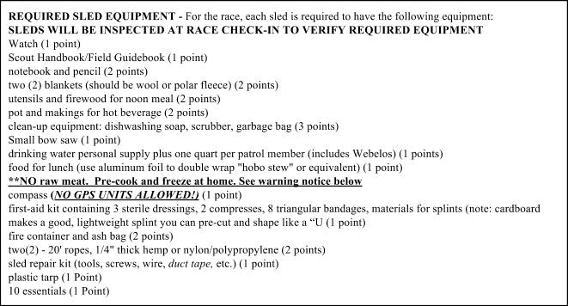

***SLED SAFETY: MAKE SURE YOUR SLED IS SAFE FOR SCOUTS TO USE***

In past years, the biggest safety problem has been protrusions, like a "push bar" at the rear of the sled, accidentally striking a scout. We ask that you examine your sled for any potential safety problems. The push bar should not protrude more than 6" on each side of the sled. We also ask that no "temporary" additional push bars be placed on the sled during the race. If any member of the Klondike staff notices an illegal protrusion, your sled will be subject to an immediate modification at Headquarters. You can "pad" handles and sharp corners with neoprene foam rubber pipe insulation secured with duct tape, available at hardware or lumber stores. ***USE BOLTS OR SCREWS WHEN BUILDING SLEDS SO THEY DON'T COME APART ON THE TRAIL. NAILS*** ***ARE NOT RELIABLE.***



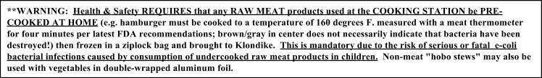

- 14 -

PATROL SCORING

Patrols can be awarded up to 25 points (maximum) per city, divided as follows:

|  |  |  |  |
| --- | --- | --- | --- |
| ❑ | Arrive in proper order (unless approved by mayor to change) | | 1 point |
| ❑ | Give Patrol Cheer when requested | | 1 point |
| ❑ | Present Patrol flag at city | | 1 point |
| ❑ | Display of one of the 10 essentials by every patrol member  to check-in person. (They will ask to see one of the 10) | 2 point | |

❑ City Scoutcraft skills competition/performance/teamwork 20 points

**\*Total possible maximum points: 25 points. Only skills found in the scout handbook can be used as grading criteria in city activities. *No “bonus” points may be added by city mayors. No “fractional” scores may be awarded (that is, No “half points”, etc.).**

**AWARDS**

**PATROL PARTICIPANTS**

First, second, and third place awards will be given to the patrols with the first, second, and third best scores in each division. Patches will be awarded to all troop participants, and a participation ribbon will be given to each participating troop.

**SCORING TABULATIONS AND AWARDS CAMPFIRE CEREMONY**

Scores will be calculated as they are called in to the headquarters area by radio. Score tabulations will be finalized at the close of competitions, and awards and ribbons will be given at the campfire. Troops leaving early, or not attending the campfire, may receive their awards at the next roundtable or from the Scout Office. A copy of scoring tabulations for all patrols will be made available at the roundtable or at the Scout Office and will be available on the Klondike Website.

CITY COMPETITION

Each City will be judged based on the following criteria:

* Weight 25%: City Design/layout/organization/operation: (located in correct area; start operations on time; ***enough*** ***stations to avoid "back-ups" or delays; good coordination and routing to stations, adequate materials/aids).***
* Weight 10%: Courtesy to Scouts (follow the Scout Oath and Law!).
* Weight 15%: Fairness of Judging (***following the guidelines consistently for awarding points accurately).***
* Weight 15%: Quality and creativity of event/competition (Was it FUN? Did everyone get to participate? Was the activity unique and an effective approach to skill competition?)
* Weight 35%: Teaching/Learning value of event presented: (DID THE COMPETITION TEACH SCOUTS A SKILL? DID THE STAFF CRITIQUE THE MATERIAL WITH THE SCOUTS AFTERWARD TO BE SURE THEY LEARNED FROM THE EXPERIENCE AND UNDERSTOOD IT?).

The City Judging Team will be composed of at least 3 members of Alpha Phi Omega. Awards will be given for 1st, 2nd, and 3rd place. Klondike Derby Award of Honor and Merit ribbons will be awarded to all other cities. Ties will result in duplicate awards.

- 15 -

Health and Safety

***USE THE "BUDDY SYSTEM" AT ALL TIMES. AT LEAST TWO SCOUTS TOGETHER. NO ONE IS ALLOWED TO GO OUT ALONE WITHOUT HIS 'BUDDY'. PATROLS MUST STAY TOGETHER THROUGHOUT THE EVENT.***

***LOST PERSONS/ SEARCH AND RESCUE PROCEDURE:***

* First, re-count all personnel; identify specifically who is missing; determine last known location.
* Send runners to nearest Klondike Staff Person or to Headquarters.
* Keep remaining personnel in camp until further notification.
* Let the HEALTH AND SAFETY Klondike staff coordinate search or rescue operations.

1). All Klondike Staff assemble at location determined by APO advisor.

2). Klondike Staff will search for a maximum of 60 minutes, and then turn over operation to the Sheriff.

***NO SLED RACING ALONG THE MAIN ROADS!***

Sled racing along the main road near campsites or competition areas is strictly prohibited! The penalty is soooo severe it can't be mentioned in print. Please cooperate and keep your troops from racing along the main road.

*Racing in any other area is permitted. Be sure to have an adult leader present for safety. Have fun and be safe*!

***NO SLED BASHING***

Sled “bashing” or deliberate collisions with other sleds are dangerous and have caused injuries in the past. Anyone engaging in this activity will be immediately disqualified, removed from the event, and sent home; NO EXCEPTIONS!

***NO SNOWBALL FIGHTS.***

In 1993 a twelve-year old scout was taken off the mountain in full spinal restraint due to a slip on the snow while engaged in a snow ball fight. Others have been hit in the face and eyes causing serious injury. Don't ruin a Scout's experience at Klondike by hurting him in a snowball fight. The staff will be out in force and will **expel** scouts from the Klondike for throwing snowballs.



***PROHIBITED ITEMS (THE "NO-NO" LIST)***

**We list here, without reservation, forbidden items, equipment, or activities. Remember that violations of these guidelines could result in injury to Scouts, violation of Camp regulations, violation of State or Federal Laws, or violation of Klondike rules. If the violation is serious enough, the penalty may be expulsion from the Klondike. *Guide to Safe Scouting* will be followed. Follow the Scout Oath and Law! Violations may lead to disqualification and removal from the event.**

* No Ground Latrines!! Use the camp latrines and/or porta-potties.
* No ground fires. All fires must be in fireproof, off the ground, portable containers or in established fire rings; all ashes must be taken with you.
* No cutting or gathering of any trees or limbs, dead or alive. Bring your own wood supply.
* No Axes.
* ***No GPS (Global Positioning System) devices on the trail -- Compass only!***
* Using liquid fuels for starting fires; including lighting damp wood, charcoal, and campfires or displays is prohibited. †
* No stoves or lanterns on the trail. **No flames/heaters in any tents or snow structures.** This includes burning any solid, liquid, gel, or gas fuel; and any chemical-fueled equipment or catalytic heaters. † (Use only battery powered lights in tents/structures).
* No smoking at camp sites, public events, or in any public area. Set a good example.
* No Alcoholic beverages, marijuana, or illegal substances anywhere on Camp land. †
* No snowmobiles except as provided by the Klondike Staff.
* No Skis for the race participants on the course. Non-participants may have skis.
* ***No athletic shoes and NO COTTON CLOTHING: checks will be made at the start line; improperly dressed Scouts and Webelos will be sent back to camp!***
* No firecrackers or other devices that go "pop" in the night.
* No pooches or pets; leave Fido at home.
* No AM/FM radios or ANY music/audio/video players or ANY electronic games. (This is an UN-PLUGGED event).
* NO GROUCHES!! (We are here to have FUN!)
  + from: ***Guide to Safe Scouting*** online at: [ttp://www.scouting.org/scoutsource/HealthandSafety/GSS/toc.aspx](http://www.scouting.org/scoutsource/HealthandSafety/GSS/toc.aspx)

- 16 -

***WINTER CLOTHING IS MOST IMPORTANT!***

During past Klondike Derbies, some Scouts have been observed with inadequate or improper clothing for weather conditions that resulted in cases of frostbite and/or minor hypothermia.

***FOOTWEAR-- SOCKS (MUST BE POLYPROPYLENE, HIGH BULK ACRYLIC (THORLO), AND WOOL OR POLARFLEECE --ABSOLUTELY NO COTTON SOCKS ALLOWED!!***

On the feet, start off with a pair of polypropylene inner socks. Their purpose is to wick away moisture from the skin in order to keep the feet dry. One or two pairs of WOOL or synthetic/wool blend outer socks are then worn over the polypropylene socks. Absolutely NO COTTON SOCKS ALLOWED! Another option is high bulk acrylic or polar-fleece ski socks such as those made by THORLO. Make sure Scouts bring several extra pairs of polypropylene and synthetic/wool socks. Be sure socks are not too tight. Wearing too many socks in tight boots may cut off circulation and cause frostbite! Do NOT use plastic bags underneath socks.

***FOOTWEAR--BOOTS: MUST HAVE WOOL FELT OR FOAM LINERS ("SORELS" OR MOON BOOTS)***

It is strongly recommended that Scouts be equipped with "moon boots" or insulated wool felt pack liners. (Sorrels or similar boots) Long term exposure to cold weather conditions has proven that ordinary leather or fabric hiking boots are NOT adequate protection against the cold, even with wool socks. ***Be sure to take your wool felt boot liners out of your boots and put them in your sleeping*** ***bag at night so they will dry out and be warm for you in the morning! Absolutely NO tennis shoes or athletic shoes will be allowed at the Klondike! Plan accordingly.***

***"LONG-JOHN" UNDERWEAR (POLYPROPYLENE OR WOOL ONLY)--NO COTTON LONG UNDERWEAR!!*** It is strongly recommended that each scout have several pairs of polypropylene or wool long underwear.

**PANTS: (HEAVY WOOL MILITARY TROUSERS OR POLAR FLEECE WITH NYLON WINDPANTS/SKI PANTS.)** Absolutely NO COTTON JEANS ALLOWED!! Heavy WOOL military type trousers or polar-fleece worn under nylon or Gore-Tex wind pants, or waterproof insulated ski pants are strongly recommended. These products can be inexpensively purchased at a military surplus store or local outdoor/recreation stores.

***GLOVES/MITTENS: (SKI GLOVES/MITTENS OR WOOL/POLAR FLEECE LINERS WITH NYLON/GORTEX SHELLS)*** Insulated ski gloves are acceptable but must be WATERPROOF. Mittens are preferred as they maintain greater warmth than gloves. WOOL or polar-fleece liners provide warmth when wet. Each person should carry an extra pair of mittens while on the trail. Extra wool or polar-fleece socks will also work as temporary emergency mittens.

***HEADGEAR: WOOL OR POLAR FLEECE HAT OR BALACLAVA (FULL COVERAGE FOR HEAD/NECK)***

Heavy wool or polar-fleece/polypropylene hats or full-coverage balaclavas are mandatory, and should be worn at all times to minimize heat loss especially while sleeping. Remember, a great deal of heat loss occurs from the head and neck areas, so a warm hat will help keep your fingers and toes warm and will reduce the risk of frostbite. NO BASEBALL CAPS unless it is warm!

***WINDBREAKER/SHELL WITH HOOD: (NYLON/GORETEX RECOMMENDED)***

High winds have been known to occur at Golden Gate Canyon State Park. Reduce the chance of frostbite by wearing a nylon windbreaker or shell over your warm clothes. A balaclava or a face-guard could prevent a numb nose or frostbite!

***DAY PACK OR "FANNY" PACK***

A small day pack or fanny pack is useful to carry personal items, food, water bottles, cameras, etc.

***GENERAL CLOTHING TIPS: DRESS IN "LAYERS"***

The key word here is LAYERS: again don't use cotton clothing for any reasons. Cotton holds moisture and makes you cold! Over polypropylene long under ware, wear a wool shirt or turtleneck, polar-fleece or wool sweaters, and if it's really cold, an insulated waterproof winter coat (e.g., down or Hollofill II). A hood for the coat adds greater warmth. Remember to remove one or more layers of clothing, as required during periods of physical exertion. Also remember that wet clothing (except wool and synthetics such as polar fleece) has little insulation value and will accelerate heat loss.

- 17 -



***SLEEPING BAG:*** It is not necessary for a Scout to have an expensive, low-temperature sleeping bag. Experience has shown that amedium weight bag of synthetic insulation such as hollofil, quallofil, or thermal may be preferable to down, and insulates even when wet. When used with liners, bags need not be rated lower than 10 degrees F. This allows the Scout to use the same bag throughout four seasons, and by merely adding additional insulation internally or externally with low cost liners or bag covers, the effective insulating value can be increased to -20 degrees F. If liners are not used, then bags should be rated for the lower temperatures. Be sure the bag can be drawn up as a hood around your head to minimize heat loss. A terrycloth towel, balaclava, or face mask will keep your face warm in the coldest weather.

***SLEEPING BAG LINER: (WILL MAKE YOUR BAG WARM)*** A sleeping bag liner can be inexpensively constructed of "Polar-fleece" and slipped inside the bag to increase insulating value by 20 degrees or more. Polar-fleece can be purchased from local fabric shops. Wool or polar fleece blankets are the next best option.

***SLEEPING BAG COVER: (EVEN MORE WARMTH.):*** An external sleeping bag cover can be inexpensively constructed from1/4" open-cell polyurethane foam covered with nylon. This also serves as a sleeping pad, but should be in addition to a regular sleeping pad to minimize heat loss to the ground. Plans for construction can be found in the "Scout Field Book".

***FOAM PADS OR "THERMAREST" PADS (NO AIR MATTRESSES)***:Closed cell "ensolite" pads are inexpensive, comfortable,and have high insulating value. When placed inside the bag cover, the pad won't creep away with normal tossing and turning during sleep. A more expensive alternative is a “Thermarest”-type inflatable pad. Air mattresses are NOT recommended as they do not insulate well.

***CLOTHING FOR SLEEPING WARM:***

Wear a wool or polar-fleece hat or balaclava, particularly when the cold is intense. Polypropylene or merino wool "long Johns" will also help greatly. Other possibilities are a hooded polyester sweatshirt (not cotton) or track/jogging suit with hood (again, not cotton). Sleeping with nylon hose on your legs may also increase warmth and dryness. ***Put your wool felt boot liners inside your***

***bag at night so they will dry out and be warm the next day.***



***PERSONAL WATER/ SPORTS DRINKS: DRINK OFTEN FOR WARMTH & ENERGY (AVOID DEHYDRATION)! TAKE FREQUENT WATER AND SNACK BREAKS AT EVERY CITY AND ALONG THE TRAIL***

Each participant should carry or have immediate access to a 3 liter “camelback-type” water container or 2 - 1 liter water bottles. Gatorade or equivalent sports drink is preferable to plain water to maintain electrolyte balance and provide energy. IN ADDITION, have a patrol supply on the sled of AT LEAST ONE QUART per person. Dehydration occurs rapidly in cold weather due to respiration and exertion, and results in greater susceptibility to frostbite, hypothermia, and exhaustion. Participants should drink frequently, even if not thirsty (more than one quart during exercise, and at least two and one-half quarts per day). Signs of dehydration are fatigue, chest pain, aches, headaches, cramps, dark-colored urine and infrequent urination. Cold weather masks symptoms of thirst, and you can be one or more quarts "low" on fluids without even feeling thirsty. These symptoms will respond quickly to fluid intake. Artificial sweetener or “diet” beverages without sugar such as NutraSweet products should be avoided.

**NO SODA/SOFT DRINKS or ENERGY DRINKS**!

***TRAIL FOOD OR "GORP" (MUNCHIES KEEP YOU WARM AND ALSO KEEP UP YOUR ENERGY!***)

Each participant should carry a personal high-carbohydrate food supply in a "zip-lock" freezer bag or a "stuff sack” to snack on between meals. Mixing cheese, nuts, raisins, and dried fruit makes trail mix or "Gorp". Candy rich in fruit sugars or fructose are good while exercising on the trail. Avoid high fat products such as chocolate, cheese, etc., until evening just before going to bed. Carbonated beverages should be avoided. Frequent food consumption is vital to maintain energy and heat levels. Cheese and nuts are also good to eat before sleeping since they have a high calorie level, digest slowly, and release energy to help maintain warmth during sleep.

***EAT NUTRITIOUS MEALS WITH HIGH CARBOHYDRATE CONTENT (PASTA, POTATOES).***

You’ll be using a lot of calories to stay warm so it’s important that you eat a good breakfast, lunch, and dinner. Nutritious high carbohydrate foods such as pasta provide a “timed release” source of energy your body needs to maintain heat and provide energy for all the hiking and exercise you’ll be doing during the competitions.

- 18 -

**FROSTBITE (DON'T LET YOUR FEET, FINGERS, EARS, AND FACE GET FROSTBITE!)**

The first signs of frostbite are reddening or whitening of the skin exposed to cold. Fingers, toes, noses, ears, and cheeks are likely spots. The next, more dangerous stage is if your skin, toes, fingers, hands become numb and cold.

**PAY ATTENTION TO EARLY WARNING SIGNS AND TREAT THEM IMMEDIATELY!!**

**FROSTBITE IS A SERIOUS PROBLEM THAT CAN RESULT IN PERMANENT DAMAGE TO SKIN, ESPECIALLY FEET AND HANDS. THE POTENTIAL FOR FROST BITE IS ESPECIALLY HIGH IF IT IS WINDY AND COLD.**

**MOST FROSTBITE IS PREVENTABLE. REMEMBER “IF YOUR HANDS AND FEET ARE COLD, IN ADDITION TO WEARING GOOD DRY GLOVES OR MITTENS AND SOCKS, PUT ON A WOOL CAP OR BALACLAVA”. (SUBSTANTIAL HEAT LOSS OCCURS THROUGH THE NECK AND HEAD, AND INSULATING THE HEAD WILL ALLOW THE BODY TO REWARM FEET AND HANDS). OF COURSE GOOD, DRY MITTENS (OR GLOVES) AND FOOTWARE ARE ALSO IMPORTANT**

Watch each other and if frostbite becomes apparent, treat it immediately as described in the Boy Scout Handbook. ***Get out of the*** ***wind, and cover up exposed skin with dry clothing. GET MEDICAL HELP RIGHT AWAY. GO TO A COMPETITION CITY STAFF MEMBER, OR CONTACT A TRAIL ROVER WITH ORANGE VEST AND RADIO. TELL THEM YOU ARE COLD. THEY WILL HAVE WARM DRINKS AND A SHELTER FOR YOU TO WARM UP IN, OR THEY MAY TAKE YOU TO THE HEALTH CENTER TO REWARM. DON’T WAIT TO TAKE CARE OF THESE PROBLEMS.***

**COLD FEET SHOULD NOT BE IGNORED**

In an emergency, the best way to warm frostbitten toes is to place the cold toes on the abdomen of another person (brrrrr!!). Cold fingers can be placed in armpits. Warm fingers then can be used to warm face or ears. If you are wet, or even damp, put on dry clothing. Remember that each city will have radio communications. Don't hesitate to ask for assistance. Help is also available at any of the first-aid tents or at the Klondike Headquarters.

***HYPOTHERMIA (LOSS OF CORE BODY HEAT IS A SERIOUS EMERGENCY!)***

Hypothermia (sometimes called exposure) is a serious, possibly life threatening condition that is easily prevented. BUT you have to be aware of the signs. Hypothermia is caused by loss of body heat due to exposure to cold and wind. It is greatly enhanced by wet clothing.

**SIGNS/SYMPTOMS:**

Early signs are being very tired, cold, shivering, not being alert or responding when someone is talking to you, being angry, or being grouchy. If you notice someone who is showing these signs, take a break, get them to drink water or Gatorade, warm if possible. Get them to eat high-energy food such sugar candy and to exercise by walking or moving to generate more body heat. If this doesn't work and they are getting colder, get them out of the wind, preferably inside a tent, and get help right away. In serious cases, get them in a sleeping bag with warmed water bottles/canteens or other people to transfer body heat, and get medical attention immediately

***SUN EXPOSURE*: USE *SUNSCREEN & SUNGLASSES*! (*You can get sunburned even if it is cloudy or snowing)***

Sunburn is a very serious problem, especially in winter. Although less skin is exposed, it is possible to get very serious sunburn on the face, ears, neck, *eyes,* and other exposed areas due to high altitude and reflected radiation from the snow. Use a high-strength sunscreen such as SPF-30 or higher and apply it early in the morning before going out. It does little good to wait until the skin is already burned to apply sunscreen. Also protect lips with a sunscreen lip balm such as ‘Chapstick’. Sore sunburned lips are a real "pain." Avoid eye damage and snow-blindness by wearing shatterproof, UV blocking sunglasses equipped with side shields. They should be worn with a strap to prevent accidental loss.

***PORTABLE TOILETS/LATRINES-- USE THEM!***: DO NOT "FIND A TREE" WHEN YOU NEED TO "GO"

This year we will have porta-potties strategically located near the roadways. There are also campsite latrines, but will probably be locked. It is **REQUIRED** that all participants use the porta-potties. Please encourage all troops to use these facilities.

***TRASH/GARBAGE***: PUT IT IN A TRASH BAG AND CARRY IT OUT WITH YOU--LEAVE NO TRACE! All trash and garbagemust be placed in bags and removed when you leave. Police your campsite carefully. Leave it in better shape than you found it!

- 19 -

***If someone is sick or injured:***

SEND A RUNNER TO THE NEAREST CITY OR CONTACT ANY KLONDIKE STAFF MEMBER WEARING AN ORANGE ARM BAND OR VEST. THEY HAVE RADIOS AND CAN CALL FOR ASSISTANCE. DON'T MOVE INJURED PATIENTS, KEEP THEM WARM AND COMFORTABLE.

**DO NOT CALL 911**, EVENT STAFF is Initial Response, they will call if additional assistance id required.

Note AND REPORT the following:

* ***EXACT LOCATION***
* What happened? ***Are they CONSCIOUS and BREATHING?*** Description of injuries. How many are injured?
* Time of Accident.
* Injured person’s name, age, and Troop number if known.
* What first aid has been given?
* Who is with the injured person, and what is their training.

Keep injured victims warm by covering with clothing or sleeping bags, if possible. Remember that the priorities are ***Airway,*** ***Breathing, and Circulation.*** Protect the spine by stabilizing the head, neck and back. ***Do not move or attempt to transport injured victims.*** In the event of broken bones or a head/neck/back injury, try to stabilize the position of the victim until the paramedics arrive.Do not try to splint the broken appendage. The paramedics or other trained personnel will have the final say in health related emergency situations.

**NATURAL HAZARDS PREPAREDNESS:**

**RAPID ONSET OF SEVERE STORMS MAY PREVENT OR INTERFERE WITH PLANNED ARRIVALS AND DEPARTURES. PLAN TO HAVE ENOUGH GEAR AND FOOD TO COMFORTABLY SHELTER SCOUTS AND LEADERS “IN-PLACE” IF TRAVEL IS RESTRICTED DURING A SEVERE STORM.**

**RADIO CONTACT:** *"KEEPING IN CONTACT"*

The headquarters uses a repeater style radio system for communications. For your convenience, we will also be monitoring the following frequencies for emergencies:

FRS Radios (Motorola Talkabouts) Channel 7, Sub channel 7

2 Meter HAM Radio 147.555 – Simplex. Call sign: KE6VYN



**SEVERE WEATHER/CANCELING/MODIFYING KLONDIKE SCHEDULE for health and safety reasons.**

We have an established policy for canceling the Klondike due to extreme winter weather conditions. Any of the following conditions are sufficient to modify or cancel the Klondike:

1). Winter storm or blizzard/high wind warning for the foothills;

2). Wind-chill factor below -32 F;

3). Visibility less than 100 feet;

4). Any other non-weather related conditions which the Scout office, Camp Staff, County Sheriff's office, or the Klondike Staff deem to be unsafe or a potential life/safety hazard.

**In Case of Cancellation or Modification, a message through “Constant Contact” will be updated.**

- 20 -

Directions

Head south from Boulder on Colorado Highway 93 to Colorado Highway 46 (Golden Gate Canyon Road) at the north end of Golden. Turn right (west) on Colorado Highway 46 and continue west on Highway 46 until it intersects Colorado Highway 119. Turn right (north) on Highway 119 and continue to the intersection with Gap Road (County Road 2). Turn right (east) on Gap Road and continue to the intersection with State Park Road. Turn north (left on State Park Road and enter Reverend’s Ridge Campground.

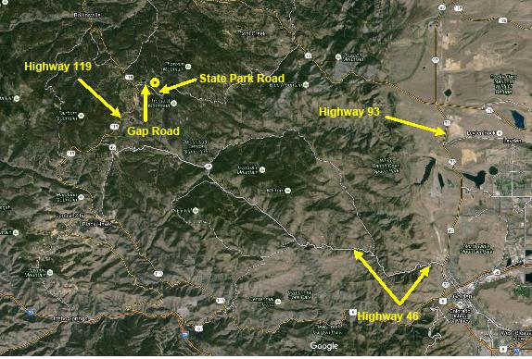

- 21 -

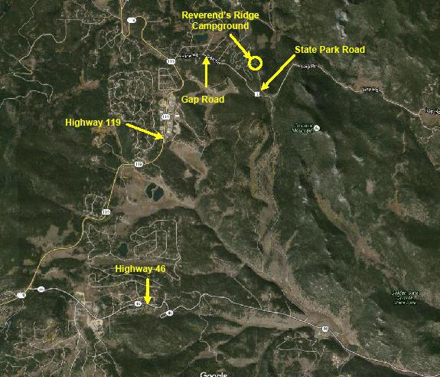

- 22 -

Alternate Directions

From Boulder, travel south on Highway 93 to Highway 72 (Coal Creek Canyon). Turn right (west) onto Highway 72 and continue for approximately 7 miles to Twin spruce/Gap Road. Turn left (south) onto Twin Spruce/Gap Road. You will encounter several forks in the road, always stay to the left. You will enter Golden Gate Canyon State Park at approximately 5 miles. Continue on the main road for another 3 miles until you reach State Park Road. Turn right onto State Park Road, which takes you to Reverend’s Ridge Campground. There is a sign at this intersection of Gap Road and State Park Road indicating the direction to Reverend’s Ridge Campground. At the campground you will be greeted by Klondike Host who will assist you with Klondike check in.

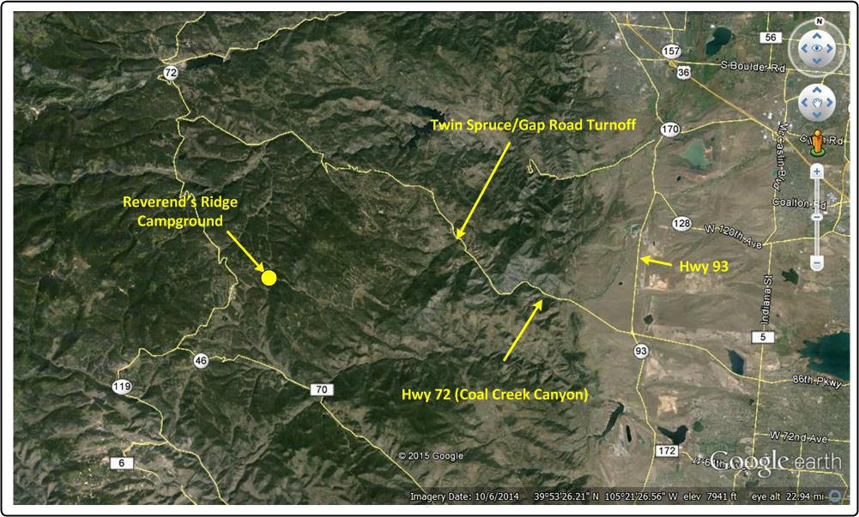

- 23 -

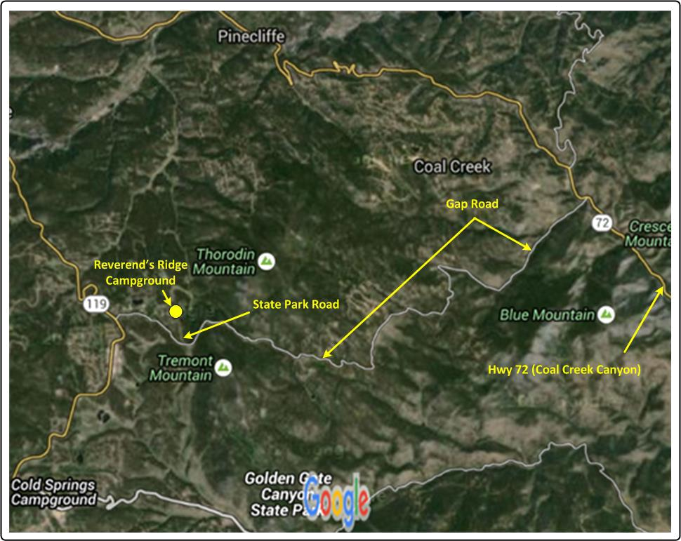

- 24 -