
EVENT
- The 2027 Klondoree Weekend One is open to ALL troops, crews and ships from ANY district, hosted by Centennial and Black Feather Districts of the Greater Colorado Council. The weekend will be centered around a Viking theme as champions of both cold weather living and adventure we will test our skills and endurance as we prepare to go out into the world and spread our knowledge, scouting skills, and influence to the places we will travel. Bonus points to units to embrace themes such as Viking warriors, dragons, trolls, elves, dwarfs, giants, and other creatures of the enchanted age of the Vikings.
DATES
- Friday, January 29, 2027 through Sunday, January 31, 2027
LOCATION
- Reverend’s Ridge Campground within Golden Gate Canyon State Park.
  - 313 Reverends Ridge Road
Black Hawk, CO 80403
    - http://cpw.state.co.us/placestogo/parks/GoldenGateCanyon
COST
- Overnight Campers
  - Register by December 31, 2024 - $30/Person
  - Register by January 15, 2025 - $35/Person
  - Register after January 15, 2025 - $40/Person
- AOL Scouts and Parents (Saturday Only)
  - Register by December 31, 2024 - $20/Person
  - Register by January 15, 2025 - $25/Person
  - Register after January 15, 2025 - $30/Person
- Staff (Scouts BSA, Venture, Crew, Adult) $10/Person
NOTE: Cost will include camp provided lunch on Saturday for all attendees, your camp patch, overnight campsite fees, and participation in the event.
CONTACT
- Andrew Light
Klonderee Chair, Centennial District
Scoutmaster, Troop 317, Foxfield, CO
Email: mr_lightfoot@msn.com
Cell: 303-570-2278

EXECUTIVE SUMMARY
This premier District winter camping event is open for all scouters to demonstrate their Scout skills and show off their patrol and troop Scout spirit utilizing the Patrol method. Arrow of Light Scouts are welcome to join during the day on Saturday along with an accompanying parent.
REGISTRATION
- ONLINE REGISTRATION
- Registration will close on Friday, January 22nd, if you’d like to register after that date please contact the event coordinator, Andrew Light, to see if we can accommodate you.

Please note that all registration fees are typically NON-REFUNDABLE; however, they can be transferred to other participants in the unit. Contact Andrew Light for additional information.
DIRECTIONS
Follow I-70 west to exit 265 for highway 58. Take highway 58 west to highway 93. (Highway 58 turns into highway 6 at this stop light). Follow highway 6 west to highway 119. Go north on 119 through Blackhawk to Gap Road for approximately 11 miles. Turn right on Gap Road to access Reverend’s Ridge campground. From Denver, this route is approx. 27 miles one-way.
ROAD/WEATHER CONDITIONS
Each unit is responsible to monitor the weather conditions and to ensure safe travel to and from the event. To obtain road/weather conditions, starting Friday afternoon, you may call 511 on your smartphone or visit the following website: http://www.cotrip.org/roadConditions.htm
CHECK-IN
Upon your arrival you will be assigned a campsite location based on the number of registered Scouts/Scouters. Once you are set-up, your acting SPL and Scoutmaster should check-in at the Klondoree HQ Cabin. Bring with you the following items:
- Completed copy of your Unit Roster of those attending (Page 20)
- BSA Medical Forms
  - Parts A&B completed for ALL PARTICIPANTS (scouts and adults).
- Adult YPT Certificates
  - They should be attached to their medical forms.
- Payment for any balance due
  - Checks or EXACT Cash.
    - Credit Cards WILL NOT be accepted.
- Number of Patrols & their respective Patrol Names (note that activities are optimized for groupings of eight (8) scouts.
CHECK-IN (Continued)
Due to our volume of traffic, unloading and parking can be a slow process. Please be patient and follow the instructions of our traffic control personnel.
Parking for overnight attendees will be at your campsite. Cars and trailers are to be parked in your assigned camping pullout areas, and along the RIGHT HAND side of the road in your camping loop. This allows for one-way traffic.
Parking for day visitors (including AOL Scouts) on Saturday will be on the main campground road. NOT in the campsite loops. This parking lot is located on the right side as you enter.
Please carpool as parking is very limited. Each vehicle must display a Parking Pass (included at end of this packet).
The purchase of a State Park Pass is not required unless you plan to visit other locations within the park.
CHECK-OUT
Normal check-out is Sunday morning, if you need to depart earlier than anticipated please discuss this with HQ at check-in.
OVENIGHT & DAY USE CAMP SET-UP
No tents, tarps, hammocks, etc. may be tied to any trees or permanent structures within the camp. Participants should be sleeping in tents. No travel trailers, RVs or buses are permitted at this event.
- Any extenuating circumstances please contact Andrew Light to make arrangements prior to arrival.
GUIDE TO SAFE SCOUTING
The Klondoree will follow the Guide to Safe Scouting. You may obtain a copy via the following link: https://www.scouting.org/health-and-safety/gss/toc/
SCOUT ESSENTIALS
All Scouts/Scouters should always bring their Scout Essentials with them.
https://scoutlife.org/outdoors/outdoorarticles/6976/scout-outdoor-essentials-checklist/

MEDICAL ASSISTANCE
Every unit should be able to provide basic first aid to all their participants. However, if additional medical services are needed you are to contact the Klondoree HQ.
If you are experiencing a medical emergency please start with the on-site Medic. If there is an extreme first aid related emergency and you feel you must call 911 for assistance please send a representative from your unit to Headquarters immediately with any details about the situation and the location of the injured individual.
- Payphones are located at the Visitor Center and Reverend's Ridge Campground office.
- The cell phone coverage at Reverend’s Ridge Campground base is poor.
  - Some coverage can be obtained in parts of the State Park dependent on the provider.
- Internet coverage is not available in the camp.
EMERGENCIES
Report any emergency situations to the Headquarters lodge immediately. If necessary they will contact the Gilpin County Sheriff’s Office.
ARROW OF LIGHT SCOUTS
AOL Scouts and their parents/leaders are invited to join in the Saturday activities. For the best experience at this event you are highly encouraged to coordinate your visit with a Scouts BSA Troop, this will ensure that your Cub Scouts have a truly enjoyable experience. Day event participants should plan to arrive no later than 8:30AM on Saturday and must check in at the Headquarters Cabin prior to joining your Troop for the day’s activities. If you don’t have a host Troop connection, please reach out to Andrew Light ahead of time so we can pair you up with one.
To ensure a comfortable and fun introduction to Scouting BSA and per the SAFE GUIDE TO SCOUTING & AGE-APPROPRIATE ACTIVITIES you’ll find that overnight camping by AOL Scouts is NOT PERMITTED during this “CAMPOREE” type event.
It is essential that every AOL Scout is under the supervision of a parent or approved adult at all times while attending this event. Den leaders, pack leaders, and parents are expected to accompany their boys or girls during the KLONDOREE. A “warming” cabin will be available during the day if needed to limit exposure.

FIRES
- No wood will be available at the campsites.
  - Wood gathering within the camp is NOT permitted.
  - Gathering firewood in state parks or state forests requires a permit. Units are required to bring their own wood. Gathering wood at the campground is not permitted.
  - The UNIT MUST bring all the wood and kindling needed for the campout with you.
- Wood fires, if permitted, must be contained in the established fire grates or containers that are off the ground.
  - A final ruling on open fires will be made the weekend of the event. We are subject to notification from the sheriff’s office and State Park authorities.
  - ALL FIRES MUST BE ATTENDED BY THEIR UNIT AT ALL TIMES!
    - No fires should be left burning without someone caring for them.
    - All fire ashes must be removed by your Troop and taken home; do not leave ashes behind in the fire rings/grates.
      - Bring suitable empty containers for this purpose.
      - Practice leave no trace!
- Absolutely NO OPEN FLAMES IN TENTS.
- Absolutely NO COOKING IN TENTS.
- Absolutely NO GATERING OF WOOD.

Water
Due to the time of year that this event takes place there will be no water supply available at the park. Please ensure that your unit bring all water needed for the entire weekend!
Dehydration can occur just as fast in cold weather as in warm weather. Even faster at altitude. Therefore, be sure to bring extra water. A good rule of thumb is 1 Gallon/Person/Day.
Each Scout needs to have a filled water bottle with them on Saturday. Be careful that those water bottles/bladders don’t freeze in cold weather. Leaders too need to stay hydrated!
FOOD
Units are responsible for Friday Dinner, Saturday Breakfast, Saturday Dinner, and Sunday Breakfast. Saturday Lunch will be provided by the camp and will have dietary accommodations for gluten free, dairy free, and vegetarian needs. If you have a specialized dietary need please contact Andrew Light to ensure we’ve got it covered.
A good rule of thumb for cold weather camping is to serve a high protein meal with warm/hot elements. For example, soups and stews to help maintain Scouts/Scouters’ body temperatures.
The use of stoves rather than fires for cooking is strongly recommended.

TRASH
The trash receptacles for the campsites are not to be used. There will be no trash receptacles on site. UNITS are responsible for removing and taking home ALL trash, including food, wrappers, and fire ashes.
- Practice Leave No Trace.

TOLIETS
Port-A-Potty Latrines are available throughout the camp.
Please observe all signage regarding Female Only Port-A-Potty units
Park restrooms will not be accessible during the event.

CAMP RULES
- Mechanized snow removal equipment, included snowplows and snow blowers, are not permitted.
- Driving onto unplowed areas, including unplowed site pullouts, is not permitted.
- Respect wildlife.
  - Do NOT feed or harass any animals.

LOST & FOUND
- Lost and found will be located at the Klondoree Headquarters.
  - Consider labeling all items with a last name and Troop/Pack number with a permanent marker.

EVENT HOSTS
Black Feather and Centennial District members will act as the adult leadership and camp hosts for the Klondoree; however, the event is open to any units. If you have a youth or adult that would like to serve on staff please contact Andrew Light for additional details.
COLD WEATHER CAMPING
Cold weather camping as defined by BSA is "camping in weather where the average daily temperature is below 50 degrees Fahrenheit and conditions are cold, wet or windy." The most important thing to remember about cold weather camping is to keep dry. Moisture will reduce the insulating properties of almost everything. To keep yourself warm, remember the word COLD.
C – Keep yourself and your clothes Clean.
O – Avoid Overheating.
L – Wear clothes loose and in Layers.
D – Keep Dry.
Clothing
- Layer your clothing. Wear several layers of lighter, loose-fitting clothing instead of one heavy layer.
  - If you get warm you can take layers off and add some more clothing layers if you start to get cold.
  - Teach the boys to adjust their layers BEFORE they get too cold or too warm.
- Keep yourself dry, both from the weather and perspiration.
- NO COTTON! NO COTTON!! NO COTTON!!! Synthetic fibers and wool perform much better, especially when damp.
- Wet cold: If your rain gear is waterproof and will not allow perspiration to exit, then during cold, rainy weather change your clothing if it starts to become moist.
- Foot Ware: Wear winter boots that are waterproof, have sufficient insulation and can keep snow out adequately. Athletic shoes and most hiking boots do not provide enough insulation.
  - Waterproof leather boots with the appropriate commercial treatment. Check the care tag that came with the boots for specific water proofing instructions.
  - If you choose to wear rubberized boots, remember they do not allow for ventilation, therefore you may need to change your socks several times a day.
  - Wear a pair of lightweight polyester and a pair of wool or synthetic socks to increase insulation and take the perspiration way from your feet. (NO COTTON SOCKS!!) Pull trouser legs over top of shoes to keep out snow. You may want to use gaiters, or tie or tape them to make sure of the seal.
- Hands: Wear waterproof gloves. Consider waterproof mittens instead of fingered gloves when you do not need independent use of your fingers. This will allow the fingers to help keep each other warm.
- Head Ware: Most heat loss is through the head. Wear a stocking cap or other warm hat. One that covers the ears and neck area is particularly effective. Remember, wearing a warm hat warms the rest of your body, too. Wear a scarf to reduce heat loss around the neck. Use a \ski mask" or scarf over your face for protection from the cold and wind. You can also your neckerchief to cover your ears.

Bedding Down
- Generally, avoid natural fibers (which lose insulating properties when wet). Use a 0°F rated synthetic sleeping bag.
- A mummy style bag is warmer than a rectangular, as there is less space for your body to heat. Also, most mummy bags have a hood to help protect your head.
- You can place one sleeping bag inside another to increase insulation.
- If you only have a rectangular sleeping bag, bring an extra blanket to pack around your shoulders in the opening to keep air from getting in.
- Do not sleep with your face inside your bag. Doing so will increase dampness and reduce the insulation properties of the bag.
- Wear a stocking cap to bed to reduce heat loss.
- Wear a loose fitting hooded pull over type sweatshirt to sleep in.
- Insulate yourself from the ground as much as possible to avoid cold spots at the shoulders and hips.
  - A closed cell sleeping pad of some kind is recommended. A good rule of thumb is that you want 2 to 3 times the insulation below you as you have over you.
  - Use a ground cloth to keep ground moisture from your bag. Your body will warm up frozen ground to a point where moisture can become important.
  - Cold air will be above and below you if you sleep on a cot.
- Put a hand warmer (important: in a sock) at the foot of your sleeping bag before getting into it.
- Some light exercise before bedding down can increase body heat and warm your bag quicker. Be careful not to start perspiring.
- Change from the clothes you are wearing, before bedding down, to dry clothing or pajamas before entering the sleeping bag. Wearing tomorrow's socks to bed is a good idea too.
- If feasible, build a wind break outside your tent by piling up snow or leaves to a height sufficient to protect you when laying down.
- Hang your sleeping bag up or just lay it out, between trips, so the filling will not compress and lose its insulating properties.
- Before you get out of bed bring the clothes you plan to wear inside your bag and warm them up some before dressing.
- Place an empty capped plastic bottle outside your tent door for \night calls." This will reduce your exposure when you must answer that call. If you have a tentmate, do NOT use it inside the tent. Remember to empty the bottle in the port-a-potties in the morning and dispose of it properly.
Odds and Ends
- Organization and proper preparation are very important in cold weather camping. Good meals, proper shelter and comfortable sleeping arrangements make for an enjoyable outing.
- Learn to recognize and treat cold weather health problems. These include frostbite, hypothermia, dehydration, chilblains, trench foot, snow blindness and carbon monoxide poisoning.
- Teach the youth
  - To let adult leadership, know if they are too cold during the night so action can be taken before injury/health problems from cold exposure occur.
  - To use the buddy system to check on each other for cold weather exposure concerns and to notify the adult leadership if symptoms do occur.
  - To gather some wood or do some other type of work. Working will help keep them warm – but avoid perspiration!
  - To hydrate properly. Not to eat ice or snow; eating ice or snow can reduce your body temperature and it is not pure.
  - That snow and ice can be used for drinking water but only after boiling.
  - NO open flames at ALL inside the tents.
  - Keep off ice on streams, lakes, and ponds.
  - To gather your wood and tinder for the morning fire in the evening so that you will be able to start the fire quickly in the morning.
  - To wear dark sunglasses when outside in the snow. The glare of the sun of the snow could lead to strained eyes or even snow blindness.
  - To gather twice as much fuel as they think you'll need for fires.
  - To carry tinder from home. It may be hard to find in snow or wet conditions.
  - To carry a reliable Fire starter kit because the more you need a fire to warm up the less likely you will be able to start one easily.
Cold weather camping references
- OOPIK manual, No. 34040
- BSA Field manual
- BSA Snow Camping Venture manual

Cold weather First Aid guidelines
- See Boy Scout Handbook.
- Additional internet resource for cold weather first aid: http://www.princeton.edu/~oa/safety/hypocold.shtml

KLONDOREE PERSONAL EQUIPMENT RECOMMENDATIONS

Wear
- Class A Uniform
  - Knit or Wool Hat OR Balaclava
  - Winter Jacket (Water & Wind Resistant recommended)
  - Scout Shirt
  - Snow Pants (Water & Wind Resistant recommended)
  - Scout Belt
  - Scout Socks
  - Sock Liners
  - Gloves OR Mittens (Water & Wind Resistant recommended)
  - Snow Boots, e.g., Sorrels, etc.
  - Gaiters (Optional)
Bring
- Duffel Bag OR 50 L + Pack
  - Fleece Sweater OR Jacket
    - Historical Weather: HIGH 50° F and LOW 10° F Elevation: 8,600’
  - Sleep Clothes in stuff sack (plastic zip lock bag will work too)
    - Long-Johns (Shirt & Bottom) AND Wool Socks OR Down Booties
  - Extra Clothes in stuff sack (plastic zip lock bag will work too)
    - Long-Sleeve Shirt (1)
    - Scout Pants (1)
    - Socks (2 extra pair)
    - Sock Liners (2 extra pair)
    - Synthetic Underwear & T-Shirt (1 extra pair)
    - Gloves OR Mittens (2-Pairs total)
  - Mess Kit (Plastic works well!)
    - Cup
    - Bowl
    - Fork & Spoon OR Spork
  - Hygiene Kit
    - Toothbrush & Toothpaste
    - Comb
    - Small towel
  - 0° F or less Rated Sleeping Bag with Stuff Sack
    - If your sleeping bag is NOT rated to zero degrees you may use two sleeping bags (stuff one inside the other) OR add a fleece liner (lowers bag temperate rating by approximately 10 - 20° F) to your sleeping bag’s rated temperature, e.g., 20° F → 10 - 0° F
  - Sleeping Pad (Closed Cell or “high” R value)
- Day Pack
  - Scouts Essentials
    - Headlamp OR Flashlight
    - Compass & Map (Print Out Page 16 of this guide)
    - Water (2-Quarts (32 OZ))
    - Knife (& Totem Chip Card)
    - Rain Gear AND Extra Clothes
      - Waterproof Jacket & Waterproof Pants
        - Ponchos are not recommended
    - Small Personal First Aid Kit (Recommended)
      - Non-Latex Gloves (1 pair)
      - Alcohol Wipe
      - Bandages (Assorted sizes 2 – 3 each)
      - Triple Antibiotic, e.g., Neosporin
      - Moleskin (Blister Prevention/Treatment)
    - Sun Protection
      - Wide brim Hat
      - Sunscreen & Lip Balm
      - Sunglasses
    - Waterproof Matches OR Fire Starter, e.g., Flint & Steel
    - Trail Food, e.g., energy bar, gorp, etc.
- Other Recommended
  - Scout Handbook
  - Watch
  - Pencil & Paper
  - Camp Chair
  - Bandana (Cotton is OKAY)
  - Hand AND/OR Foot warmers (OPTIONAL)
  - Scarf AND/OR Buff (OPTIONAL)

Finally, it is NOT recommended that you bring any electronics, e.g., smart phones, games, chargers, etc. Electrical outlets are not available, as well as winter camping conditions (cold) is not ideal.

SCHEDULE

Friday, January 29
4:00 – 9:00 PM | Arrival & Camp Set-Up
4:00 PM | Registration Opens at Klondoree HQ (Cabin #1)
9:00 PM | Staff Meeting
9:30 PM | SPL & SM Meeting (Cabin #1)
10:00 PM | Taps (Lights Out & Quiet Time)

Saturday, February 1
7:00 – 8:30 AM | Reveille & Breakfast
7:30 – 8:30 AM | Registration Opens at Klondoree HQ (Cabin #1)
8:45 AM | Assembly & Flag Ceremony (Flagpole)
9:00 – 11:30 AM | Skills Based Events – Session 1
12:00 PM – 1:00 PM | Lunch
1:30 – 3:30 PM | Skills Based Events – Session 2
3:30 – 4:30 PM | Viking Iditarod
4:45 – 5:00 PM | Assembly & Closing Flags (Flagpole)
5:00 – 7:30 PM | Dinner
7:30 – 9:00 PM | Campfire & Award Ceremony
10:00 PM | Taps (Lights Out & Quiet Time)

Sunday, February 5
7:00 AM | Reveille, Breakfast & Break Camp
8:00 – 10:30 AM | Check-Out at Klondoree HQ (Cabin #1)
8:30 – 9:00 AM | Scouts’ Own Service/Interfaith Service (Flagpole)

EVENT NAME | BRIEF EVENT DESCRIPTION
Dragons Breath  (Timed Event) | Using materials provided by the Viking leadership council, Scouts must light a fire and bring a small container of water to a boil.
Fires of Muspelheim  (Timed Event) | Scouts must successfully bloom the pop of corn over a fire they have lit before they’re found by the fire giant Surt.
Dragon Pup Rescue  (Timed Event) | Scouts will show off their pioneering skills to craft a device they can use to secure a bucket containing our dragon pup to safety.
Snowy Escape  (Timed Event) | Scouts will show off their pioneering skills to lash together a sled that they will use to safely transport stolen treasure to safety before the elven army catches up to you.
Blizzard Blitz  (Timed Event) | Using materials provided by the Viking leadership council, Scouts  must safely transport an injured member of their party through a blinding snowstorm in the enchanted forest before everyone freezes.
Shelter from the Storm  (Timed Event) | Using materials provided by the Viking leadership council, Scouts will follow their fearless patrol leaders instructions to properly erect a shelter in the enchanted forest before everyone freezes.
Docking the Boat  (Timed Event) | Using the proper First Class required knot(s) Scouts must successfully moor their boat to shore and secure it floating away.
Loki’s Challenge  (Points Event) | Scouts have been challenged by Loki to a game of skill. This game is a combination of horseshoes and ring toss, who can score the highest points? Careful, Loki is a tricky fella!
The Orbs of Niflheim  (Points Event) | Scouts will travel to the realm of Niflheim to collect as many of these special orbs as possible before they’re discovered.
Frost Giant Battle  (Points Event) | Scouts will work as a patrol to defeat a frost giant hoard by hitting targets to score as many points as possible.
Healers Aide  (Timed Event) | Using a sled of their own creation, Scouts must transport their chosen rider and a chalice of sacred serum to Frigga, Queen of Asgard.
Test of Valor  (Timed Event) | Scouts must test their skills of agility and teamwork to balance their sled and their patrol. Two times will be recorded, only one patrol can win.
Traverse the 9 Realms  (Timed Event) | Scouts must successfully navigate through the nine realms of Yggdrasil using specialized footwear designed for travel in pairs.
Ragnar Race  (Timed Event) | Speed is key as Scouts use specialized footwear to traverse through rugged terrain as quickly as they can.
Dreki Iditarod | Final event! Traditional over-land sled race with a staggered start time! Bonus points can be earned for sleds decorated to look like a Viking boat.

PATROL/DEN EQUIPMENT NEEDED for EVENTS
The Scout Motto is BE PREPARED. As a result, Patrols/Dens are expected to have with them the following equipment for the start of their respective event(s).
- Sled
- 10’ or more of Rope
- 10 Essentials (each scout)
- Dress the part, be prepared to show your Viking spirit, patrol yells (channel your inner norsemen/women), and tons of scouting spirit.

EVENT SCORING
- Patrols will earn points based on the following factors:
  - How quickly did they complete the event (Time)
  - How many tasks were completed (Quantity)
  - How well did their patrol live up to the Scout Oath and Scout Law (Quality)
- Patrols will be recognized at our closing ceremony.

EVENT STAFFING
- Adults and older youth Scouts (14+) can “register” as a STAFF member to help with various functions and/or “judge” our events at the KLONDOREE. Examples:
  - CHECK-IN/CHECK-OUT & ADMINISTRATION (2 - 4) Friday – Sunday
  - CHUCKWAGON CREW/COOKING (2 – 3) Friday – Sunday
  - PARKING & TRAFFIC (2 – 4) Friday – Saturday
  - MEDICAL (1 – 2) Friday – Sunday
  - OPENING & CLOSING FLAGS + AWARDS CAMPFIRE (3 – 4) Saturday
  - EVENTS (7+) (Saturday)
    - Please note that if we are unable to get the required number of adults to cover all the events that we will need units to offer an adult to help with the judging and scoring.
- For their services, each STAFF member receives a discounted fee ($20/person). This nominal fee covers all three meals on SATURDAY and SUNDAY breakfast. We have our “Chuckwagon” Crew to handle all our cooking duties! Each registered STAFF member will receive a commemorative patch and permitted to sleep in “heated” yurts for their services.

MAP

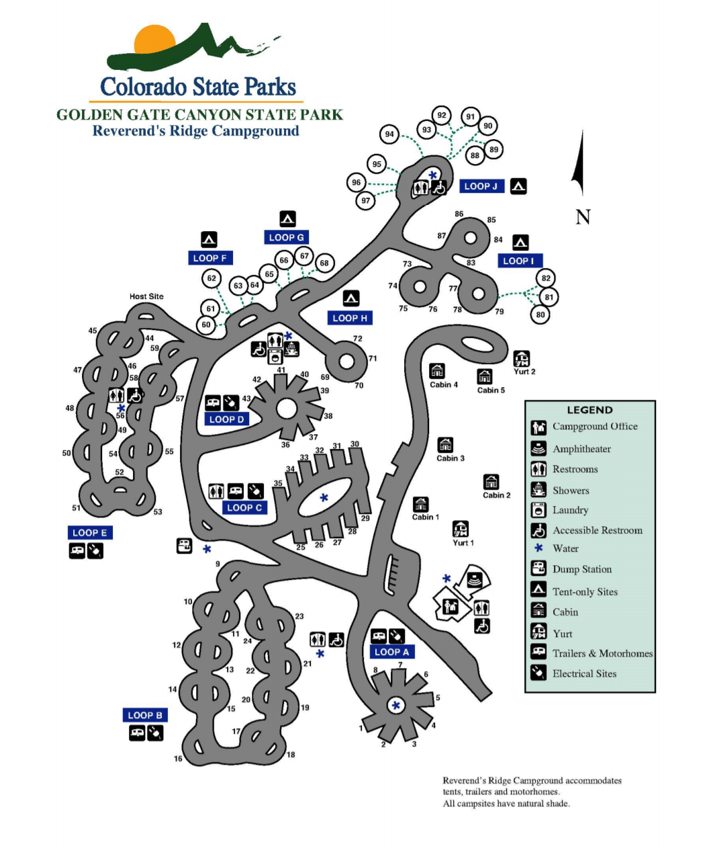
HQ

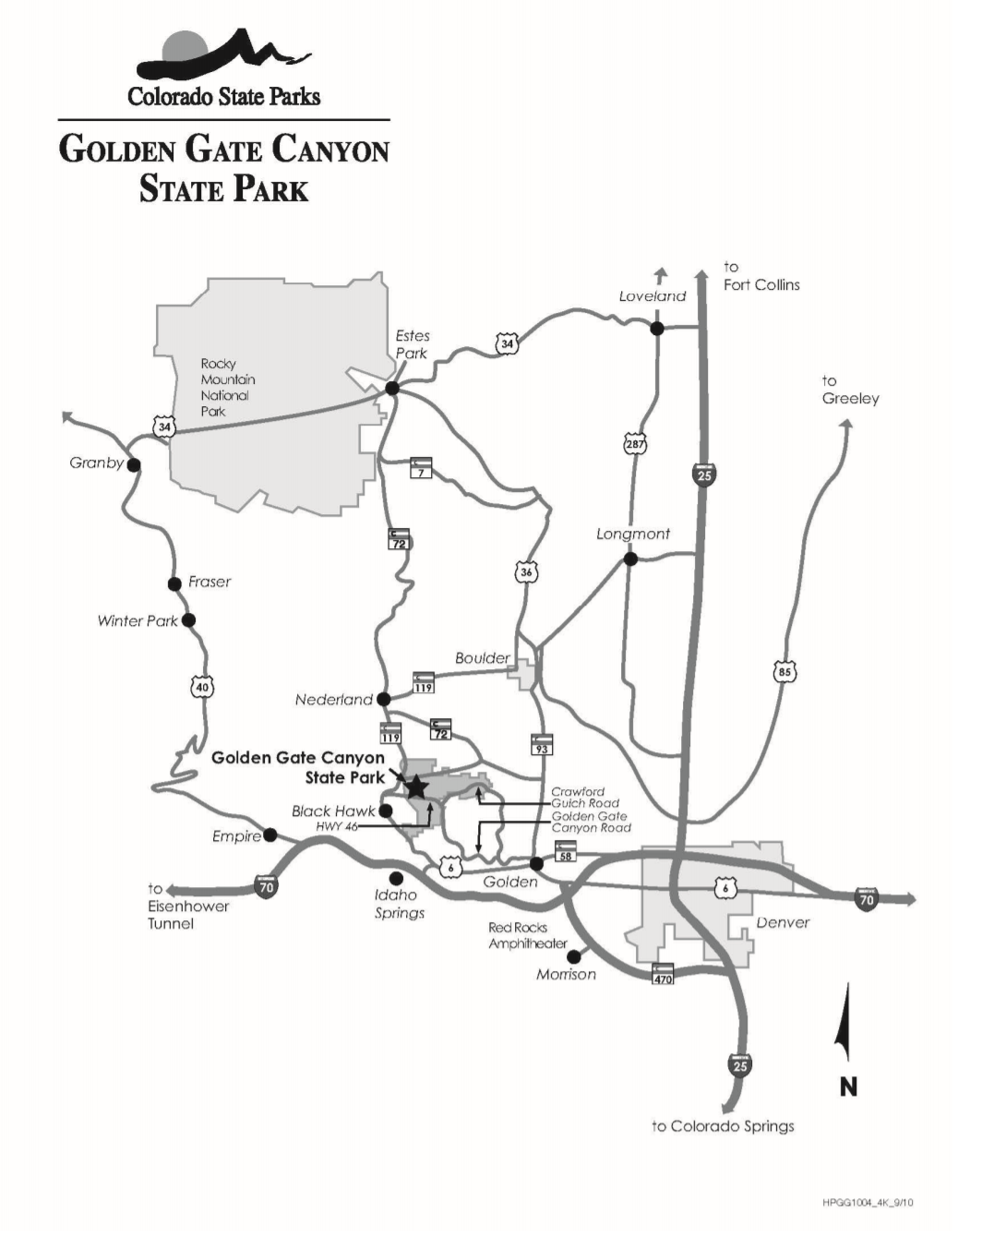
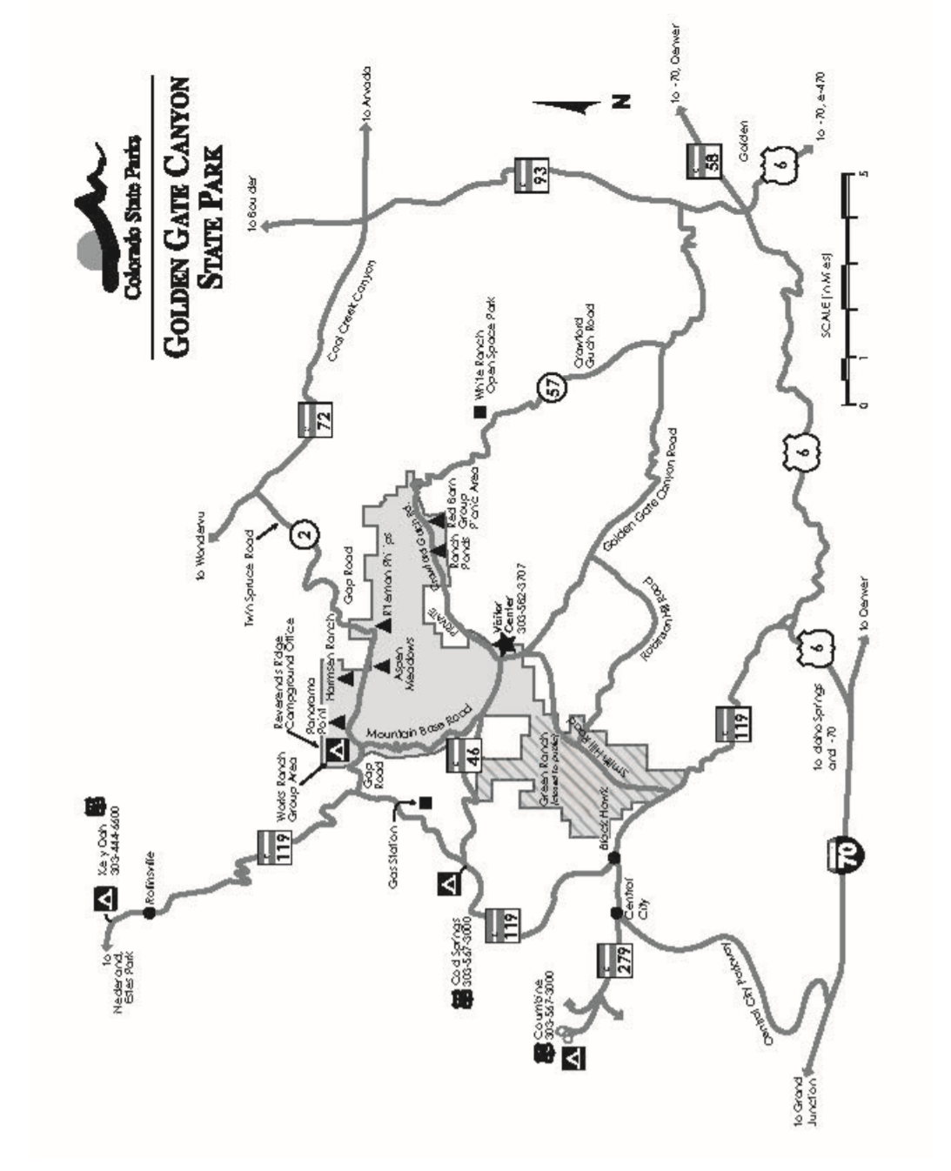
KLONDOREE I – PARKING PERMIT
DISPLAY ON DRIVER SIDE DASHBOARD
UNIT # ________________ CELL PHONE # _____________________________
DRIVER’S NAME __________________________________________________

This pass CANNOT be used in any other part of Golden Gate Canyon State Park.
Valid Friday, January 29 – Sunday, January 31, 2027
PARK REGULATIONS: • No RVs or Campers are permitted. • You must display this permit in LIEU OF A PARK PASS. • FOR TRAVEL IN ANY OTHER AREA OF THE STATE PARK, A PARK PASS IS REQUIRED! • Mechanized snow removal equipment, including snowplows and snow blowers, are not permitted. • Driving onto unplowed areas, including unplowed site pullouts, is not permitted. Parking is only allowed on the right side of the road as you enter the campground.

----------------------------------------------------------------------------- CUT -------------------------------------------------------------------------------------------
2027 KLONDOREE weekend one – viking warrior’s challenge
KLONDOREE I – PARKING PERMIT
DISPLAY ON DRIVER SIDE DASHBOARD
UNIT # ________________ CELL PHONE # _____________________________
DRIVER’S NAME __________________________________________________

This pass CANNOT be used in any other part of Golden Gate Canyon State Park.
Valid Friday, January 29 – Sunday, January 31, 2027
PARK REGULATIONS: • No RVs or Campers are permitted. • You must display this permit in LIEU OF A PARK PASS. • FOR TRAVEL IN ANY OTHER AREA OF THE STATE PARK, A PARK PASS IS REQUIRED! • Mechanized snow removal equipment, including snowplows and snow blowers, are not permitted. • Driving onto unplowed areas, including unplowed site pullouts, is not permitted. Parking is only allowed on the right side of the road as you enter the campground.

2027 Klondoree Check-In Form
Weekend One

Unit Number: __________ Unit Campsite: __________________________________________

Unit Contact Name: _____________________________________________________________

Unit Contact Number: _______________________________________

Youth Campers
1. |  | 16. |  | 31.
2. |  | 17. |  | 32.
3. |  | 18. |  | 33.
4. |  | 19. |  | 34.
5. |  | 20. |  | 35.
6. |  | 21. |  | 36.
7. |  | 22. |  | 37.
8. |  | 23. |  | 38.
9. |  | 24. |  | 39.
10. |  | 25. |  | 40.
11. |  | 26. |  | 41.
12. |  | 27. |  | 42.
13. |  | 28. |  | 43.
14. |  | 29. |  | 44.
15. |  | 30. |  | 45.

Adult Campers
 | Name | YPT Expiration Date
1.
2.
3.
4.
5.
6.
7.
8.
9.
10.

Patrol Names
 | Name | Scouts in Patrol
1.
2.
3.
4.
5.
NOTE: If you need additional space please complete second form

