Golf Merit Badge 2026
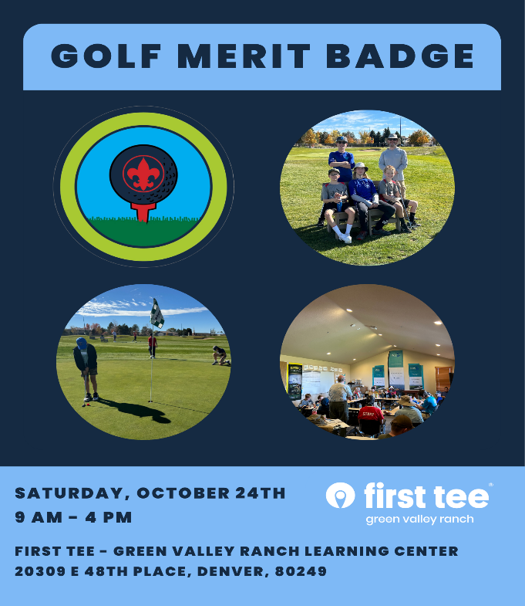
- Saturday, October 24th
- First Tee at Green Valley Ranch 20309 E 48th Place, Denver
- 9 AM to 4 PM. Includes classroom, learning the use of various clubs and 18 holes of par 3 golf. First Tee professionals will provide instruction on club use and techniques.
- No charge for this event
- Maximum class size of 20 Scouts
- Golf clubs, balls and tees to be provided by First Tee. If you desire, you can bring your own golf clubs.
- No experience is needed. Last year, many Scouts who attended had never swung a golf club before.
- Bring a merit badge blue card with you.
- Scouts must review requirements and be prepared to participate in classroom discussions. Use of a workbook to demonstrate your work on requirements is desired.
- Bring your own lunch and fluids. Water is available at the course.
- We will be outside for several hours, so be prepared for weather, temperatures and sunscreen.
- Golf Merit Badge requirements. Option A Golf Merit Badge | Scouting America
- Adults / parents are encouraged to attend. When we are out on the course, there will be groups of 4 Scouts, so YPT/SYT supervision is needed.

