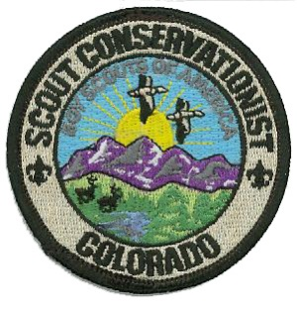

SCOUT CONSERVATION DAY
MCNEIL SCOUT RANCH

The Greater Colorado Council Conservation Committee will provide the opportunity for Scouts to earn the Colorado Scout Conservationist Award at McNeil Scout Ranch. The activities will be on Saturday, August 22nd, 2026.

The award focuses on conservation topics and activities as they relate to the state of Colorado. Topics include the Outdoor Code, Leave No Trace principles, introduction to Colorado ecological zones, travel and camping in the public lands of Colorado, wildfire effects, and water conservation. A conservation service project will be completed.

Activities will begin on Saturday morning at 8:30 a.m. and will end by 4:30 p.m.

Meals are not included.

Overnight camping is available via the normal Camp Dobbins (MSR) unit camping registration process. Please indicate that the unit is participating in the Scout Conservation Day when registering for a campsite.

There is a $10.00 per person registration fee.

Space is limited to the first 50 participants.

