Parent and Leader Guide
Spring Merit Badge Rally
Hosted by Majestic Mesas District
Grand Junction, CO

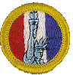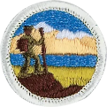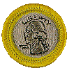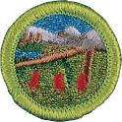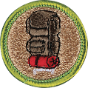

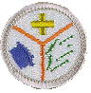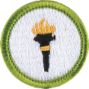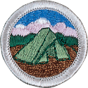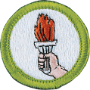
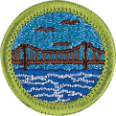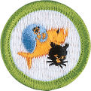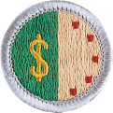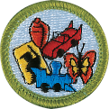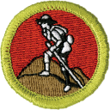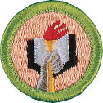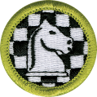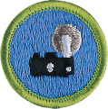

Saturday March 28, 2026
8:00am – 5:00pm
First Presbyterian Church
3940 27 1/2 Road
Grand Junction, CO. 81506

Check in: 8:00-8:30 AM
Class time: 8:30 AM – 5:00 PM
Cost: $20
Cost Includes: Lunch and Event Patch

Materials for Scouts to bring:
Merit Badge Workbooks
Class A Uniform
Med Forms Part A & B
Paper/Notebook/Pen or Pencil
Water bottle (refill available)
Snacks
Class Schedule
8:30am-12:30pm
Camping*
Engineering
Public Health
Wilderness Survival (Camping is available Friday Night at the church)

8:30am-10:30am
Coin Collection
Personal Management* (this merit badge is “Best Suited” for high school aged Scouts)
Pets
Photography

10:30am-12:30pm
Backpacking
Citizenship in the World*
Collections
Hiking

12:30pm-1:00pm: Lunch
1:00pm-5:00pm
First Aid*
Engineering
Space Exploration & Astronomy Bundle

1:00pm-3:00pm
Backpacking Cooking Class**
Chess
Emergency Preparedness*
Law
Scout Heritage

3:00pm-5:00pm
American Heritage
Citizenship in the Nation*
Genealogy
Scholarship
Sports

*Eagle Rank Required Merit Badge
**This class will teach backpacking cooking skills to support cooking requirements for the Backpacking Merit Badge (7c) and Cooking Merit Badge (6). Scouts, Parents, and Scout Leaders are welcome to join this class.
A note to parents and Scoutmasters:
Most Merit Badges have some work to do before and after taking the MB class…please encourage your Scout to look over the prerequisites. These requirements need to be finished before earning the merit badge.

Prerequisites:
American Heritage:
Print and bring the Workbook. Complete requirements 2, 3c, and 5.
http://usscouts.org/mb/worksheets/American-Heritage.pdf

Backpacking:
Print and bring the Workbook. Complete requirement #1 and bring your prevention and treatment actions with you.
http://usscouts.org/mb/worksheets/Backpacking.pdf

Camping:
Print and bring the Workbook. Complete the following requirements: 3, 4, 9-20 nights of camping at designated Scouting activities or events. Follow directions and complete a conservation project. Watch new online videos about the Camping MB.
http://www.usscouts.org/mb/worksheets/Camping.pdf

Chess:
Print and bring the Workbook. Complete the following: Requirement #1-Write or type a brief history of chess that includes origin, a modern-day grand Master and one interesting fact. Write or type 3-4 sentence paragraph about a famous chess player and what accomplishments made them famous.
http://www.usscouts.org/mb/worksheets/Chess.pdf

Citizenship in the Nation:
Print and bring Workbook: Complete the following requirements: 4, 5, 8-Bring Letter to Congressman. Bring a pencil.
http://usscouts.org/mb/worksheets/Citizenship-in-the-Nation.pdf

Citizenship in the World:
Print and bring the Workbook. Complete the following requirements: 2, 3, 4, & 6b before class and be ready to discuss. Bring a pencil.
http://www.usscouts.org/mb/worksheets/Citizenship-in-the-World.pdf

Hiking:
Print and bring Workbook. Requirement 4 (Hikes) and 5 (Hike Reports) must be completed before earning this merit badge. Bring evidence of completion if you have completed any of the hikes.
http://usscouts.org/mb/worksheets/Hiking.pdf

Coin Collecting:
Print and bring the Workbook. Be prepared to participate in the Discussions. Familiarize yourself with requirement #4. Be ready to show and discuss images.
http://usscouts.org/mb/worksheets/Coin-collecting.pdf

Collections:
Print and bring the Workbook. Present report for requirement #1-may include item from collection. Be ready to discuss #2, demonstrate #3 a-d, discuss 4 a-c.
http://usscouts.org/mb/worksheets/Collections.pdf

Emergency Preparedness:
Print and bring the Workbook. Complete requirements: 2-Prepare a family emergency kit (suitcase or waterproof box) for use by your family in case an emergency evacuation is needed. Bring photos of the kit to class and be ready to explain the needs and uses of the contents. 3-Watch videos with family.
http://www.usscouts.org/usscouts/mb/worksheets/Emergency-Preparedness.pdf

Engineering:
Print and bring the Workbook. Bring the following items from home: water or pop bottle,
screwdriver, and item from home that is broken and can be taken apart.
http://www.usscouts.org/mb/worksheets/Engineering.pdf

First Aid:
Print and bring Workbook. Read the First Aid Pamphlet.
http://www.usscouts.org/mb/worksheets/First-Aid.pdf
https://filestore.scouting.org/filestore/Merit_Badge_ReqandRes/Pamphlets/First%20Aid.pdf

Genealogy:
Print and bring the Workbook. Complete requirement 3-Interview family relative
http://usscouts.org/mb/worksheets/Genealogy.pdf

Law:
Print and bring the Workbook. Complete requirement 4.
http://usscouts.org/mb/worksheets/Law.pdf

Personal Management:
Print and bring the Workbook. Complete requirement 1, be prepared to discuss 3-7. This merit badge is best suited for high school aged scouts.
http://usscouts.org/mb/worksheets/Personal-Management.pdf

Pets:
Print and bring the Workbook: Complete requirements: 1, 2, & 3. Bring video evidence if choosing 4b.
http://usscouts.org/mb/worksheets/Pets.pdf

Photography:
Print and bring the Workbook; Complete requirement: 7c.
http://usscouts.org/mb/worksheets/Photography.pdf

Public Health:
Print and bring the Workbook. Complete requirements: Read the Public Health Pamphlet. Complete requirement: 6-Choose ONE public health issue to research. Bring notes on who is affected, why it matters, one current strategy used to address it. Pamphlet link has been included.
http://www.usscouts.org/mb/worksheets/Public-Health.pdf
https://filestore.scouting.org/filestore/Merit_Badge_ReqandRes/Pamphlets/Public%20Health.pdf

Scholarship:
Print and bring the Workbook: Complete requirements 1 (Bring current report card or letter from homeschool educator), 2a-d (pick 2), 3, 5 a OR b.
http://usscouts.org/mb/worksheets/Scholarship.pdf

Scouting Heritage:
Print and bring the Workbook. Present two biographies from 2a. Research any two from 2b. Be ready to discuss 3 and 4. Present history report for 5. Bring “show & tell” collection for #6. Pick a game to lead-7. Do three interviews for requirement 8. Presentation for either 9a or 9b.
http://usscouts.org/mb/worksheets/Scouting-Heritage.pdf

Space Exploration & Astronomy Bundle:
Print and bring both Workbooks. Complete Space Exploration requirement 2.
http://www.usscouts.org/mb/worksheets/Space-Exploration.pdf
http://usscouts.org/mb/worksheets/Astronomy.pdf

Sports:
Print and bring Workbook. **Post-requisites** 5g and 5h.
http://usscouts.org/mb/worksheets/Sports.pdf

Wilderness Survival:
Print and bring the Workbook. Complete requirement 1b & 5. Bring 10 essentials, sleeping bag, pen/pencil, and camp chair. Sharpen your pocketknife. Plan to camp Friday night.
http://www.usscouts.org/mb/worksheets/Wilderness-Survival.pdf

Adult Education and Training:

Scouts with Special Needs:
The Western Slope Representative from council’s Scouts with Special Needs Committee will facilitate this training. All unit leaders, parents, and district members are invited to attend this course. This training will provide education and knowledge on how to work with Scouts with disabilities and will provide adults with the opportunity to address their questions about Scouts with Special Needs. This class will be offered from 10:30am-12:30pm.

Unit Advancement Chair Meeting:
This meeting is open to all Unit Advancement Chairs. Topics will include: Scoutbook, Updates to Merit Badges, and Eagle Rank requirements and forms. This meeting will be held at 1:00pm.

Backpacking Cooking:
Open to Scouts, Parents, and Scout Leaders interested in learning Backpacking Cooking Techniques. This class will be offered from 1:00pm-3:00pm.

Dedicated Room for Adults:
This WIFI space will be available for adults only to be able to work on position specific training. All registered adults must have the new Safeguarding Youth Training done by 05/31/2026-this replaces YPT. Also, Program Safety Module-Drive Safely, Climb on Safely, Safety Afloat, Safe Swim Defense, and Hazardous Weather, need to be renewed every 2 years. Available 8am-5pm

Camping:

First Presbyterian Church will allow overnight camping on Friday March 27. They have requested no open-flame cooking or campfires. Please plan any meals accordingly.

Lunch:
Sloppy Joes, chips, fruit, cookie, and drink

Questions-please contact:
Linda Kukulan, Merit Badge Rally Director
rlkuku@msn.com or 970-275-2051

