First Aid, CPR & AED
Certification Training Courses
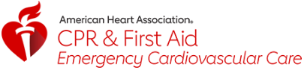

Sunday, April 19th
Frederic C Hamilton Scout Headquarters
10455 W 6th Avenue, Denver CO. 80215
Dobbins/Deitler Conference Rooms

8:00am to 12:00am – AHA 1st Aid Certification
1:00pm to 5:00pm – AHA CPR & AED Certification
Single $35 fee for taking either one or both classes

Includes Adult and Pediatric Care and naloxone (Narcan) administration as part of the curriculum

Everyone aged 14 and over are welcome.
You must Register to ensure there are enough instructors.
Lunch is not included but you are welcome to bring your own.

To Register:
For More Information: Johnston.Brad@Outlook.com

