2026 KLONDIKE II
ICE PLANET HOTH
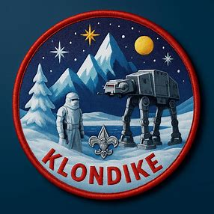
Hosted by FRONTIER, ALPINE, VALLEY DISTRICTS

REVERENDS RIDGE GOLDEN GATE STATE PARK
FEBRUARY 6-8 2026

FOR THE FOLLOWING SCOUTS - Scouts BSA, VENTURES, VARSITY, Arrow of Light/AOL

Webelos Scouts are not permitted to attend per BSA Policy

Contact: Mark Keehn
Email: davetwp@hotmail.com
C: 720-629-4096

INTRODUCTION

Welcome to the Klondike 2026 event for the Frontier/Alpine/Valley Scout Districts

The Klondike is a special winter event for our scouts each year. Scout units will camp out over
the weekend, Friday-Sunday. Arrow of Light will arrive early Saturday morning and spend the day. Please note that for those in the cub scout program, this activity is only for arrow of light scouts with recommendation for attendance during the day only, no other Cub Scouts nor Webelos scouts.

The theme this year is Ice Planet Hoth. This is in no way related to any movie that involves Jedi despite how it appears. Have fun with this! Deck your sled out like a X wing or Tie fighter, wear a Jedi inspired costume. Take on a resistance or empire theme. Be creative and have a fun time preparing your sled!

Troops also have the option of coming just for Saturday if they desire. During the day, Patrols/Dens will participate in events, some tried and true and some new. The events have been designed to test Scouting skills, mentally and physically. All the events will be graded/timed unless otherwise noted to determine King of Klondike. There also will be awards for the Scout Patrol winning the “King of the Klondike” award.

Interested Arrow of Light scouts attend Saturday, as qualification for their Arrow of Light Award, must attend at least one event with a Scout BSA Troop. Arrow of Light (AOL) can also work on the Denver Area Council Akela Award by attending more than one event along with other requirements.

LOCATION: - Reverend's Ridge Campground Golden Gate Canyon State Park
The Klondike Games will be held at Reverend's Ridge Campground (off of Hwy 119), Golden Gate Canyon State Park (west side), northwest of Golden.
- See enclosed map-make copies for your drivers.
- The address for the campground is: 313 Reverends Ridge Rd, Golden, CO 80403
- Map link: http://mapq.st/2fdzX5S
- DO NOT go to the park headquarters.
- GPS coordinates are N 39.87113 W 105.44647

REGISTRATION AND FEES

Note that registration timing and fee schedule is different than in years past!!

Register early in order to:
- Get the best registration fee
- Save your troop $$$
- Let the staff plan the best event for your scouts!

Registration should be completed on-line!

Web Register Here

Regular registration fee schedule
- Scouts BSA Units/parents who are camping - $25 each
- Scout BSA/parents who participate ONLY on Saturday and are not camping - $20 each.
- Arrow of Light scouts and parents will only attend Saturday - $20 each.
- Klondike staff - $25 each

Regular registration - Dec 1st 2025– Feb 1st 2026 - $25

All who attend must pay the registration fee. There will be no walk ups permitted. Registration fees are nonrefundable but are transferable. Transferred participants' fees will be the same as the previously registered scout regardless of the date of transfer.

Registration for the camporee will end on Feb. 1 with no late registrations accepted.

For Scout units who will be camping, campsite selection will be done during registration and is first come-first served. Those units who volunteer to staff an event station will have first choice
of campsites when attending staff meetings.

Once you have registered on-line, John Beattie (jvbeatt@q.com) will contact you to select a campsite. You MUST select a campsite before arriving at the Klondike. By selecting your campsite ahead of time, everyone in your unit should know where to go to set up camp.

MEDICAL AND ROSTER FORMS

EVERY person attending the Klondike must have a completed medical form.

To obtain the most current version of the medical form, Parts A&B go to this link:

https://filestore.scouting.org/filestore/HealthSafety/pdf/680-001_AB.pdf

All Medical forms will be turned in at check-in (see #4 below). Medical forms will be returned with your patches and ribbons, upon departure, on Saturday or after Sunday Scouts Own services. The exception is if a participant is treated by our medical staff.

A roster (see last pages below) must also be turned in listing all participants, youth and adults.

CHECK-IN UPON ARRIVAL (Cabin #2);

• FOR SAFETY REASONS, IT IS VERY IMPORTANT THAT EVERY UNIT CHECK IN AT
HEADQUARTERS, CABIN #2, AS SOON AS POSSIBLE AFTER ARRIVAL AT THE KLONDIKE.
• Please bring your previously paid receipt.
• Be ready to pay for any additional participants, checks or exact cash is required.
• Have medical forms for ALL participants and a unit roster listing the youth and adults that are attending the event. See enclosed form. Troops may arrive after 3:00 PM to set up camp.
• You MUST have previously selected a campsite. Scout Troops are to proceed to their designated campsite, then send one adult to Headquarters (HQ) (CABIN #2) with necessary fees and paperwork.

AOLs are to park first and then have one adult come to HQ (CABIN #2) with necessary fees and paperwork.

Registration is at Cabin #2 and will open at 4:00 PM on Friday.

PARKING AND UNLOADING

• Due to park regulations and the volume of traffic we create, unloading and parking can be a slow process.
• PLEASE, follow the directions of the traffic control people and be patient! Scout Units who are camping, will park at your campsite and vehicles are to be parked on the right-hand side of the road as you enter.
• AOLs and other day visitors will park on the main campground road, not in the campsite loops, on the right side as you enter. Please CARPOOL. Parking is limited. For safety reasons, cars are not to be moved until departure. Each vehicle is to have a Parking Pass, see enclosed form. Please make necessary copies for your drivers.
• Please note that the purchase of a State Park Pass is NOT required unless you plan to visit other locations within the park.
• All vehicles to be parked per park regulations. Vehicles may "tail in" park at campsites. Vehicles park on the right side of the road in all other locations. This will make leaving the Klondike venue as easy as possible in the event of an emergency.

CAMP SET UP AND TAKE DOWN

• Troops may arrive after 3:00 PM on Friday to set up camp. Units should plan to depart by 10:30 AM Sunday.
• There are to be no tents, tarps etc. tied to any trees or structures. It is expected that all participants are to be sleeping in tents. No travel trailers or buses are to be used. If because of unique circumstances (health), it is required, prior arrangements must be made with Eric Lupo 303 809 9298

FIRES AND WATER
• Wood fires are only allowed if they are in the established fire grates. No wood will be available at the campsites. Wood gathering is not permitted. Use of stoves or charcoal for cooking is strongly recommended.
• NO OPEN FLAMES IN TENTS. This includes no cooking in tents.
• ALL ASHES ARE TO BE TAKEN HOME.
• There is no running water available, so please plan on bringing your own. Dehydration can occur just as fast in cold weather as warm weather, so be sure to bring extra water.
• Bring what you will need for the event.
• Arrow of Light Scouts/AOL are to bring at least 5 gallons for their group.

There is no running water available, please bring your own.

FIRST AID (Yurt #1)
• First Aid emergencies should be directed to the First Aid station, located at Yurt #1. The individual unit should handle all minor first aid opportunities. First Aid members will also be walking around the events on Saturday.

DO NOT CALL 9-1-1! CONTACT STAFF FOR ALL EMERGENCIES.

We will have trained medical and other emergency response staff present on site.
They will be able to respond very quickly to an emergency.

Calling 9-1-1 may cause confusion and delay as the responding agency may not be familiar with the camp so getting them to the necessary location will be difficult. On-site resources can respond much more quickly, assess the situation and call-in appropriate additional outside resources as required.

AOLs IN CAMP

• Scout Troops are encouraged to invite Arrow of Lights to the Klondike. Arrow of Light scouts should NOT plan to stay the night for health and safety reasons (despite that this is OK per BSA policy, experience with these events has revealed AOLs tend to have more issues that effect the quality of their experience). All Arrow of Light dens will need to send ONE adult to check in at Headquarters, HQ Cabin #2, upon arrival. Please arrive prior to 8:30 AM. AOL events will start at 9:15 AM, after their flag ceremony

SCHEDULE
• A schedule is included with this packet
• It is subject to change, but it is our best effort currently.
• If changes are made an updated copy will be provided via email after you have registered.

Make copies for ALL of your participants.

AWARDS

• The top 3 patrols/dens for each station activity will be recognized. Please note that the scoring will be separate for the Scouts BSA and AOLs. AOLs recognition will be given out at your district Roundtable.

LATRINES (sanolets)

• Latrines will be provided for all campers to use.
• There will be some designated for ladies, please be courteous.
• Remember no trash is to be put in the latrines.

TRASH

• ALL UNITS MUST TAKE THEIR TRASH HOME!!!
• The trash receptacles that exist in the campsites are NOT to be used. Points will be deducted during campsite inspection. THIS INCLUDES ANY FIRE ASHES. Established fire grates should be cleaned out as well, prior to departure. Remember to leave your campsite in better condition than you found it upon arrival. Remember “Leave No Trace Principles”.

CAMPSITES

Each Troop will be assigned a campsite(s), as noted above after you register, but you still must check in at registration prior to 8:30 AM Sat., to finalize your attendance numbers. If not done, points will be deducted for camp inspection and patches may be held until your district Roundtable.

This is a critical safety issue.

PARTICIPATION RIBBONS AND PATCHES

• Any unit leaving Saturday must check in at Cabin #2 to receive their ribbons and patches. Those who are camping will be given theirs after the church service on Sunday.
• AOLs event ribbons will be presented at your district Roundtable

FOOT PROTECTION

ALL PARTICIPANTS MUST HAVE PROPER FOOT PROTECTION
• ANY PERSON WEARING TENNIS SHOES or inappropriate footwear should not attend and WILL BE SENT HOME

LOST AND FOUND

• Will be located at Headquarters (HQ)- Cabin #2.
EVERYONE LABEL YOUR GEAR SO IF LOST IT CAN BE RETURNED TO YOU!

WE ARE GUESTS OF THE STATE PARK

• A couple of items that need to be adhered to; No tying of tarps, tents, etc. to trees.
• Observe, but do not feed or harass any wildlife.
• Pick up trash regularly, which will help in the amount of trash found when the snow melts, as well as keep the animals from looking for your food.
• Use the portable toilets provided. Park restrooms will be closed.
• No use of snow plows or snow blowers are to be used to clear campsites or roads.

• A VOLUNTEER UNIT IS REQUESTED to perform a community service of checking the campgrounds, on Sunday, to be sure that we have left the area clean. Please contact Klondike Senior Patrol Leader to volunteer.

Arrow of Light/AOL CAMPING AND CROSSOVERS

• It is understood that some AOLs may have already crossed over into a Scout Troop by the time the Klondike is held. It is highly recommended that they participate, however, only during the day and as their prior AOL den/patrol and participate in the AOL events. Typically, AOL have not had enough camping experience to spend the night in below freezing temperatures and hopefully below zero deg weather. We have found that the quality of the experience in this cohort can be extremely limited and find the experience is much better when attended as a day event. This final decision on camping though will be left up to the Scout’s parent(s) and the Scoutmaster of the Troop.

• The events are organized and run by the Scouts BSA on a volunteer basis under the guidance of adult Scouts BSA volunteers. It is requested that adults do not interfere with the Scouts BSA who are running the event. If there is a problem, it should be brought to the attention of the adult advisor at the event or the Klondike Senior Patrol Leader.

WEATHER AND ROAD CONDITIONS

• To obtain weather and road conditions, starting Friday afternoon, please call 720-448-6313 for a recorded message. The message will be updated as the conditions warrant.

MAKE ADDITIONAL COPIES

• Make necessary copies of this packet for your needs. This leader’s guide will also be posted on the Frontier/Valley/Alpine District Website/Activities, a link from the council website.
• Also make copies of schedule, driving directions, parking pass, participant roster, campground map, and registration form. ALL FORMS ARE LOCATED ON PAGES AT THE END

PARADE OF SLEDS

• At 12:30 we will hold the parade of sleds Scout patrols and AOL dens will be judged separately

SCOUT BSA SECTION PROGRAM ACTIVITIES – SCOUTS BSA

• Saturday morning prior to the flag ceremony, patrol registration will take place, located at cabin #2. Each patrol will be assigned a Patrol number. Events will test your Scouting skills. Scouts BSA should bring patrol flags/event flags and bring their great Scouting Spirit.
• You MUST follow the sequence you are given. If not, you will be asked to go to the correct event.
• Upon completion of each event, your Patrol Sheet will be signed, by the event leader.
• This sheet will show in what rotation your patrol is to follow between event stations.
• Your Patrol Sheet MUST be turned in upon completion of all the events, to cabin #2 and prior to 5:00 PM Saturday. Otherwise, no scores will be registered. This enables the staff to know that all patrols are accounted for, again for safety reasons.

SCOUT EQUIPMENT LIST

• EACH Scout is to have their own 10 essentials.
• As groups are participating as patrols, the patrol should have an event flag/Patrol flag, song and yell.
• The Event/Patrol flag must be able to be separate from the sled.
• The Patrols will receive points for having these items throughout the various stations.

SLED RULES

Sled should be decorated to the theme of the klondike – Ice Planet Hoth. The best sled wins the best in show award.

• Sled must be 4’-7’ in length (based upon runner length)
• Sled must be 18”-36” wide, including handlebars.
• Authorized Sled construction materials are wood, metal, rope and a pair of skis between 122cm and 213cm in length. No PVC.
• Due to safety of all, sled made of PVC pipe will not be allowed, due to breakage and splintering when cold.
• Sled should have only 1 pair of skis or rails (not snow boards) as runners.
• Sled must be able to carry at least 1 Scout, who may be required to ride in the sled during the race.
• Sled to be designed to carry patrol gear.
• Patrol equipment will not be carried on the sled during the race.
• The Scouts BSA must pull/push the sled.

EVENTS (To Be Determined) Historically they have included

Have yet to be finalized. Communication of any special requirements will be communicated to you at February Roundtables

- Sled Race-approximately 1/2 mile
- Fire starting
- First Aid
- Compass/orienteering in the frozen tundra of the Ice Planet of Hoth
- Resistance scum search
- Lightsaber hockey
- Obstacle course
- Imperial Ski Race
- Log pull

JUDGING GUIDELINES

• Guidelines for judging are established prior to the event. While time may be a factor, teamwork and the “ten essentials” are included in the scores. At various stations the patrol members will be asked to show one of the essentials (or a Patrol flag/yell/song) that will count towards judging.
• Patrols will not be judged only on their ability to complete the task in a fast manner but also the way it is completed with the Scouting ideals in mind.
• As Scouts BSA, all participants should display a positive and inclusive attitude.
• The adult leaders should also follow these guidelines.

Arrow of Light SECTION

Arrow of Light events
• Will be in a “round robin” format.
• Each AOL den/patrol, by one parent please, must register at Cabin #2 after check-in at Cabin #2.
• Each AOL patrol/den will be assigned a number. This will be done prior to and after the flag ceremony, which will take place by the flags. Events are listed below.
• AOL dens are to bring their patrol/den flag and all their great AOL Spirit. We are trying to have the AOLs finish their events by 4:30PM, so you may head for home after your events are completed, if you like.
• Awards will be presented at your district Roundtable.
• Be sure your event sheets are turned in at HQ, Cabin #1, after you have completed all your events, and prior to checking out. For safety we will then know that you are finished and departed.

SLED RULES

• The only rule is Design what the AOLs like. There will be judging to decide who has the best sled, based upon the Klondike theme. Judging will be done during lunch, around 12:30. There are some limitations.
• Sled must be 4’-7’ in length (based upon runner length)
• Sled must 18”-36” wide, including handlebars.
• Authorized Sled construction materials are wood, metal, rope and a pair of skis between 122cm and 213cm in length. No PVC.
• Due to safety for all, sled made of PVC pipe will not be allowed, due to breakage and splintering when cold.

DAYTIME EQUIPMENT CHECKLIST

a. Water bottle or canteen and bring extra water for your group (5 gal).
b. Sack lunch or lunch at campsites
c. Remember that everyone will be outside all day-no opportunity to run into the house to get warm.
d. Dress in layers.
e. Bring extra socks (miss-matched etc.) Wool blend is the best-not cotton.
f. ALL participants must have proper cold weather footwear. NO tennis shoes. Traction cleats recommended
g. Extra gloves - mittens are the best.
h. Encourage your youth not to roll around in the snow thereby getting wet. If people get covered
in snow, brush off immediately.
i. First Aid facilities located in Yurt #1. See map.
j. Have AOLs/AOL use “buddy system” to check each other for being cold, wet and the drinking of plenty of water. This does include parents as well.
k. Wear outer garments like snow pants to stay dry.
l. The 10 Essentials-see below, for each den/patrol-not by individual.
m. There will be a warming tent to get warm and hot drinks will be available. You must have your own cup, bowl and spoon.
n. Have a FUN and SAFE day.

JUDGING GUIDELINES

• Guidelines for judging are established prior to the event. While time may be a factor, teamwork and the “ten essentials” are included in the scores. At various stations the patrol members will be asked to show one of the essentials (or a den/patrol flag, yell or song) that will count towards judging.
• Patrols will not be judged only on their ability to complete the task in a fast manner but also the way it is completed with the Scouting ideals in mind.
• As AOLs, all participants should display a positive and inclusive attitude. The adult leaders should also follow these guidelines.

• There will be sled design judging, based upon the Klondike theme. Judging will be done at 12:30
• The 10 Essentials for Camping
• As an AOL Den/Patrol these are to be shared among members.
• Each member does not need to carry all of these items.
1. Pocket Knife (to be carried by an adult)
2. First Aid kit
3. Extra Clothing
4. Rain Gear
5. Water Bottle
6. Flashlight
7. Trail Food
8. Matches and Fire Starters (to be carried by an adult)
9. Sun Protection
10. Map and Compass

DEPARTURE

• AOL are to pick up their participation ribbons/patches and medical forms at Headquarters, HQ Cabin #2, prior to leaving on Saturday.
• Be sure to turn in your event sheets.
• All Packs/Dens need to check out to ensure the staff is aware that you have left.

WINTER CAMPING EQUIPMENT GUIDELINES

These guidelines are to allow you to start collecting the necessary equipment you will need for winter camping. Please follow the list carefully and you will experience little discomfort regardless of the temperature. Most of the items listed can be bought at garage sales, flea markets, surplus stores, secondhand stores, etc. Plan now and start looking for the items you need. Items listed with a (W) are also for AOL.
MUST HAVE GEAR LIST
SOCKS (W)
____SOCKS - 2-4 pair, liners or polyester socks
____4-5 pair wool or wool blend (should be at least 65% wool)
SHOES (W)
____ Boots with removable liners "Sorel" or "Caribou" type boots if you already have them.
____2nd pair winter or hiking shoes
____Traction cleats for slippery/icy surfaces (optional but recommended)
UNDERWEAR (W)
____2 changes underwear & t-shirts
____1-2 pair long johns (polyester or poly- blend-try to stay away from cotton
____ (optional) pantyhose - provides an excellent 1st layer in insulation.
SLEEP WEAR
____1 pair jogging suit, warm PJ's or long underwear.
____stocking cap
_____wool socks
PERSONAL GEAR
____compass
____pocketknife with tot'n chip
____nylon cord or rope
____flashlight with extra batteries
____Sunscreen/sunglasses/chap stick (W)
____WATER BOTTLE (W)
____CUP (W)
SHIRTS & TROUSERS (W)
____2 warm, long sleeved, wool is best- flannel is 2nd
____1 wool or warm sweater
____2 pair pants wool or snow pants.
____1 pair suspenders (pants loose around waist)
OUTER WEAR (W)
____Coat - should be warm, wind and water resistant, should be insulted with manmade material.
____Rain suit or Poncho
____Wind suit (optional)
____2-3 stocking hats - one for sleeping in at night.
GLOVES (W)
____- 2-3 pair mittens are best-use glove liners. DO NOT BRING GARDEN GLOVES!
TOILET KIT
____Toothbrush and toothpaste
____soap, washcloth, towel
____foot powder, comb
____partial roll of toilet paper in zip lock bag.
CAMPING GEAR
____tent
____closed cell ground pad
____sleeping bag
____sleeping bag liner (optional) for more warmth
____1-2 ground cloths
____small pillow (optional)
____Plate or bowl and eating utensils (spoon)
2025 KLONDIKE SCHEDULE

FRIDAY FEB. 6
3:00 - 9:00 PM Arrive at Reverend's Ridge Campground
Check-in at CABIN #1&set up camp
9:00 PM Staff Meeting-warming tent
9:30 PM Scoutmaster and SPL meeting-warming tent-followed by a cracker barrel
10:00 PM Lights out-quiet time

SATURDAY FEB. 7
7:00 AM Begin day – prepare breakfast
7:30 AM Scout Troops Late Check-in Registration – CABIN #1
Event registration at CABIN #2
8:00 AM AOL check-in Registration – CABIN #1
Event Registration – CABIN #2
9:00 AM Flag Ceremony for all– main road Flag Poles
9:15 AM All events open – events do not open early
11:30 AM All event close
11:30 AM – 1:00 PM Lunch
12:30 PM Parade of Sleds – sled judging
1:00 – 4:00 PM Events continue
3:00 PM AOL events close (if all are completed)-tubing is open for Scouts BSA
4:00 PM All events close – be sure all patrols have completed events
4:30 – 7:00 PM Dinner
7:00 – 10:00 PM Troop activity
10:00 PM Lights out-quite time

SUNDAY Feb. 8
7:00 AM Begin day, prepare breakfast and clean campsite
9:00 AM Scouts Own Service – amphitheater (behind campground office)
Scout awards/recognition
10:30 AM Check out of camp-remember all trash and ashes go home with you!
AOL AWARDS WILL BE PRESENTED AT THE MARCH ROUNDTABLES

PARKING PASS #1 DISPLAY ON DASHBOARD
FRONTIER-ALPINE -VALLEY DISTRICTS
GOLDEN GATE CANYON STATE PARK FOR REVERENDS'S RIDGE CAMPGROUND ONLY

UNIT #
________________

DRIVER'S NAME
_______________________

CELL PHONE #
_________________________

THIS PASS CANNOT BE USED IN ANY OTHER PART OF THE PARK, AND IS ONLY VALID FOR FEB 6-8, 2026

____________________________________________________________________________

PARKING PASS #2 DISPLAY ON DASHBOARD
FRONTIER-ALPINE -VALLEY DISTRICTS
GOLDEN GATE CANYON STATE PARK FOR REVERENDS'S RIDGE CAMPGROUND ONLY

UNIT #
________________

DRIVER'S NAME
_______________________

CELL PHONE #
_________________________

THIS PASS CANNOT BE USED IN ANY OTHER PART OF THE PARK, IS ONLY VALID FOR FEB 6-8 2026

PARKING PASS #3 DISPLAY ON DASHBOARD
FRONTIER-ALPINE -VALLEY DISTRICTS
GOLDEN GATE CANYON STATE PARK FOR REVERENDS'S RIDGE CAMPGROUND ONLY

UNIT #
________________

DRIVER'S NAME
_______________________

CELL PHONE #
_________________________

THIS PASS CANNOT BE USED IN ANY OTHER PART OF THE PARK, IS ONLY VALID FOR FEB 6-8 2026

____________________________________________________________________________

PARKING PASS #4 DISPLAY ON DASHBOARD
FRONTIER-ALPINE -VALLEY DISTRICTS
GOLDEN GATE CANYON STATE PARK FOR REVERENDS'S RIDGE CAMPGROUND ONLY

UNIT #
________________

DRIVER'S NAME
_______________________

CELL PHONE #
_________________________

THIS PASS CANNOT BE USED IN ANY OTHER PART OF THE PARK, IS ONLY VALID FOR FEB 6-8 2026

Alpine/Valley/Frontier District Klondike 2025
Register here:
TROOP #_________________CREW# _________________PACK #_________________
- Boy/girl Scout BSA units are to be registered separately, not combined.
- Crews and AOL units are to be registered separately.
- AOL register as a den/pack not individually. AOL should register as one group, as a Pack, even though they have separate patrols/dens. Remember parents with the AOLs need to be registered as well.

UNIT CONTACT: (Person attending Klondike)
NAME: _________________________________________________
TEL # ________________________________
EMAIL: ___________________________________________________

Scouts BSA (BOYS/GIRLS)
Total # adults camping X $25.00 ________
Total # youth camping X $25.00 ________
Saturday Day only-and NOT camping
Total # adults_____ X $20.00 ________
Total # youth _____X $20.00 ________
Total Fees Due=_______

AOLs
Total # adults_____ X $20.00 ________
Total # youth _____X $20.00 ________
Total Fees Due= _______

STAFF
Total # staff _______X $25.00 _________
Total Fees Due=

See Registration section earlier in guide for early registration discount and late registration fee

Register via Doubleknot - Register Here

Do NOT submit medical forms when registering online, bring these to check in.
ALL participants must have a medical form.
Turn in all medical forms when your unit checks in at Klondike HQ, Cabin #2.
Turn in roster of attendees (see following) when checking in at HQ, Cabin #2.
All people attending must pay the registration fee.
We are limited to 400 campers!
CAMP ROSTER
 |  | UNIT | PACK | TROOP |  | CREW | #
 |  | CONTACT NAME: CAMPSITE:
 |  | TELEPHONE # |  |  |  |  | EMAIL
 |  | YOUTH NAME |  |  |  | YOUTH BIRTHDAY | ADULT NAME
1
2
3
4
5
6
7
8
9
10
11
12
13
14
15
16
17
18
19
20

Map of Reverend’s Ridge Campground
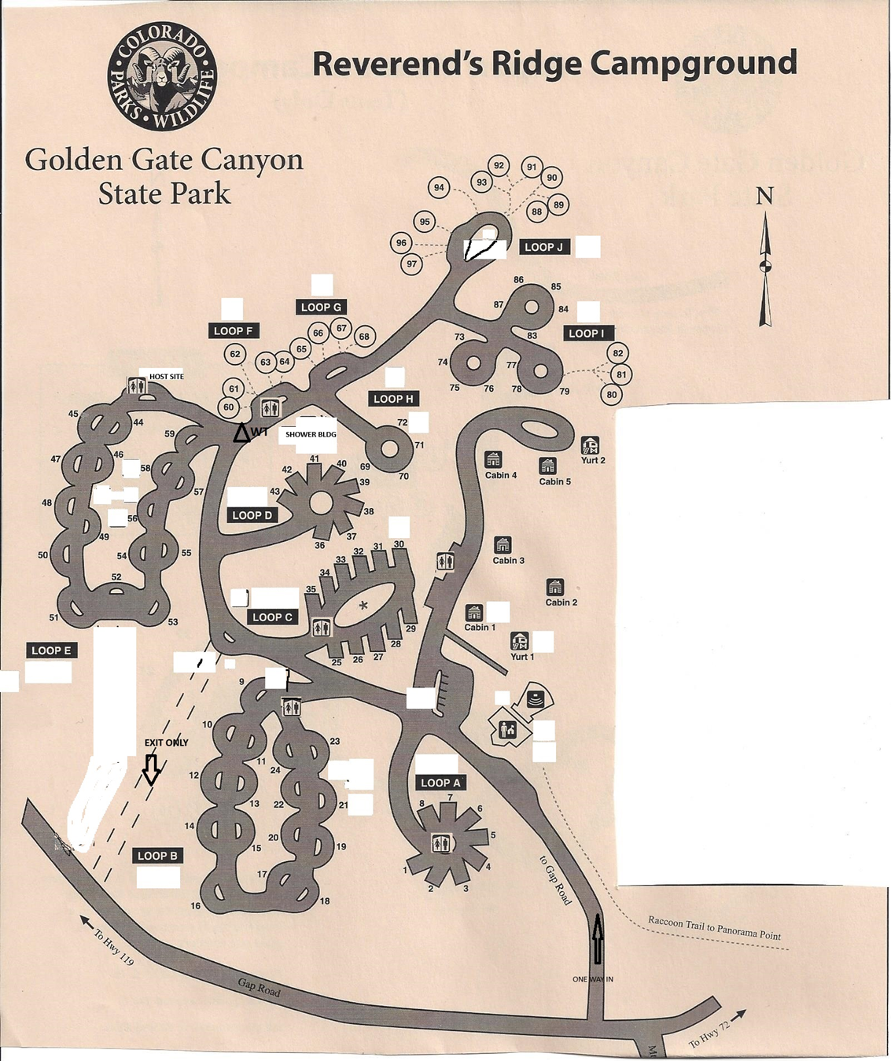
Port-a-poty locations
Loop A 1 regular
Parking area across from Cabin 3 1 regular, 1 ADA
Loop B 2 regular
Loop B 2 regular across from Site 9
Loop C 2 regular at Host Site
2 regulars by Shower Bldg. across from site 61.
This is to allow for plowing and are not to be moved.

