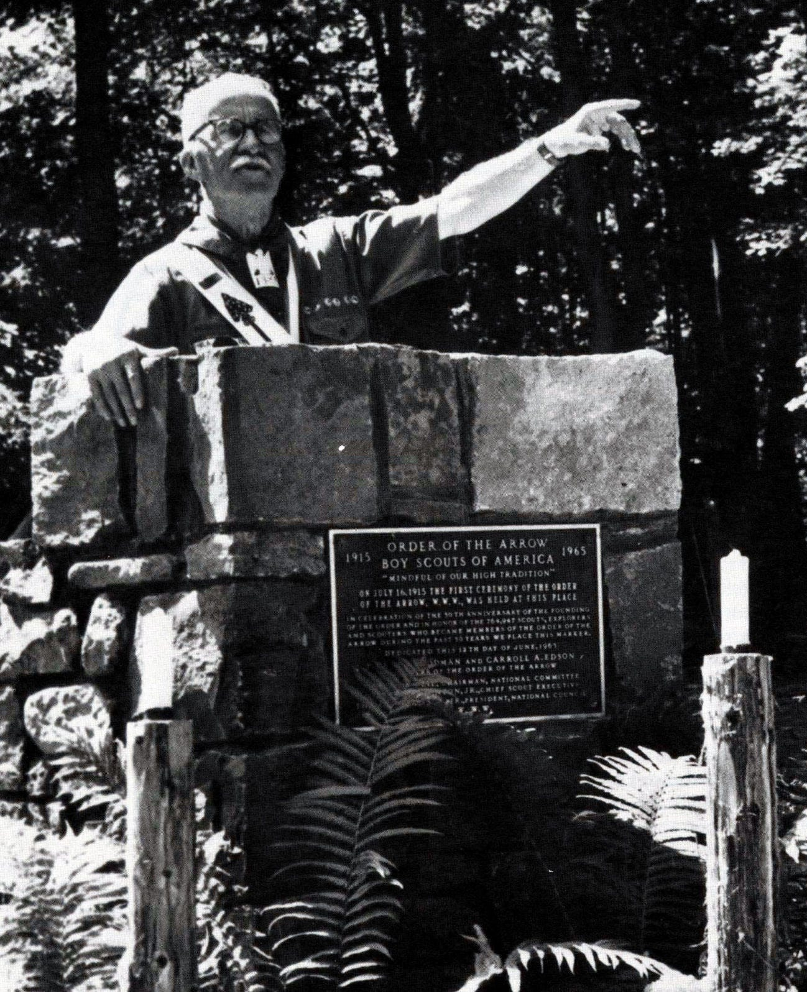*A Simpler Time*

2025 Centennial & Black Feather Camporee

Leaders Guide



Event:

2025 Fall Camporee

Times & Dates:

4:00PM Friday Sept 26

through 11:00AM Sunday Sept 28, 2025

Location:

McNeil Scout Ranch at Peaceful Valley

22799 N Elbert Rd, Elbert, CO 80106

Registration:

Registration Fees:

$35 per Adult

$35 per Scout

$20 per AOL Scouts and their Adult Partner.

All AOL Scouts must be accompanied by their Adult Partner

Early Discount: A $5.00 discount will apply to all

those that register prior to midnight

September 1, 2025

Car Show registration $15, $5 if attending

camporee - lunch provided

No walk-in registrations allowed

Registration closes at midnight on September 19th

Registration fees are non-refundable after September 5, 2025

Contact:

Adrienne Gilmore: Centennial Camporee Chair

[adrienne.gilmore88@gmail.com](mailto:adrienne.gilmore88@gmail.com)

Chris Donovan: Centennial Camping Chair:

[chris@donovanweb.org](mailto:chris@donovanweb.org)

Brian Bell: Camporee Staff Advisor:

[brian.bell2@scouting.org](mailto:brian.bell2@scouting.org)

Executive Summary:

The 2025 Fall District Camporee is the Centennial & Black Feather Districts premier Fall camping event featuring Troop Patrols and Venturing Crews competing in Scout skills, shooting sports and fun events. Troop-sponsored Arrow of Light Scouts are also invited to join by the host unit for the festivities on Saturday. Units for any district are welcome to attend.

The Camporee is a weekend campout for Troops and Crews. It is designed to allow Scouts to participate in one of the oldest traditions in the history of Scouting. Patrols will compete in various competitions testing their Scout skills from the ranks of Scout to First Class, as well as other fun and exciting Patrol teamwork events.

In following the theme, the event will host a classic car show. Entries to the car show will arrive on Saturday, have their vehicles available for viewing and judging. All attendees of the Camporee will be welcome to vote. Adults bringing entries will be required to be registered and current on YPT/SYT.

AOL Scouts:

AOL Scouts sponsored by Troops and their parent/adult partner may attend and participate on Saturday, September 27, 2025. All AOL Scouts and their parent/adult partner must check in at the Camp Headquarters Building upon arrival. Please arrive between 7:30 to 8:30 AM Saturday.

Arrow of Light Scouts can participate and camp at a unit coordinated campout with a Scouts BSA troop they are eligible to join. They must attend as an Arrow of Light den/patrol under the supervision of two deep leadership from their Arrow of Light den/patrol or pack.  All Cub Scout camping requirements still apply, including the Arrow of Light den/patrol must have a BALOO trained adult leader in attendance and all of Scouting’s Youth Protection policies apply.  The Arrow of Light Scout’s parent or legal guardian(s) may attend with the Arrow of Light den/patrol and their child, either alongside the two-deep leadership or as part of it if they are registered with the pack.

Each AOL Scout must be under the supervision of their parent/adult partner at all times.

AOL Scouts and their parent/adult partner must register online.

Overnight Camping:

Participants will sleep in tents.

NO hammocks are allowed as they cannot be tied to any trees or permanent structures.

No travel trailers, RVs or buses are permitted at this event.

Please note that if extending circumstances exist, you must seek and receive prior written approval by emailing the above contact before midnight on September 8th.

Cell phone coverage at McNeil Scout Ranch is very limited and unreliable. Some coverage can be obtained in parts of the campground dependent on the provider. Internet coverage is not available in the campgrounds.

It is recommended that electronic devices, including cell phones be left at home or in a vehicle, especially for Scouts

CHECK-IN

please have one (1) adult check-in at the Camp Headquarters Building. You will receive a campsite location based on the number of registered Scouts/Scouters in your Unit. Check-in on Friday night is on a Unit basis and not individually.

At Check-in have the following items available:

● Unit roster of all attending

● Corresponding BSA Medical Forms

o Parts A&B completed for ALL Scouts, Scouters and any parents attending

o All Adults MUST have a copy of their YPT/SYT (Youth Protection Certificate) attached to their medical forms (Attachment)

● Unit # & Respective Patrol Name(s) for the unit (attachment)

o NOTE: ALL events will be based on Patrols consisting of eight (8) Scouts

● As all registrations are done online, there will be no payments on site

Due to our volume of traffic, unloading and parking can be a slow process. Please be courteous by expediting the unloading or loading of vehicles (<15-minutes).

Only one vehicle and trailer are permitted to be parked at each assigned camp site. All other unit vehicles must be parked in the designated parking lot(s).

Please ensure that any trailers are parked in the appropriate space off the main roads. You may not park on the side of the roads other than to quickly unload or load.

Parking is limited. Therefore, units are encouraged to carpool.

Guide to Safe Scouting:

The Camporee Participants will follow the Guide to Safe Scouting. You can find details at this url:

<https://www.scouting.org/health-and-safety/gss/toc/>

Scout Essentials:

All Scouts/Scouters should always have in their possession their Scout Essentials. You may obtain details via the following url:

<https://scoutingmagazine.org/2013/02/the-10-essentials/>

Medical Assistance:

Every unit should be able to provide basic first aid to all their participants. However, if additional medical services are needed, please come to the Headquarters Building.

For Emergencies dial 911 and alert Camp Staff

The Local Emergency Agency is the Elbert County Sheriff’s Office.

Fires:

No Open fires are permitted at campsites

Water:

Running water may not be available at the campsites. Units should plan on bringing their own water.

Each Scout needs to have a filled water bottle with them on Saturday. We will be at 7000 feet and dehydration is a real thing. What rhymes with Camporee??? Hydration!!!

Food:

Each unit will be responsible for their own meals. If any AOL Scouts and their parent/adult partner are joining a Troop on Saturday, they should plan to eat their meals with their sponsoring Unit. As a result, all Troops must account for any visitors in their meal planning.

Trash:

The trash receptacles for the campsites are not to be used. There will be no trash receptacles on site. UNITS are responsible for removing and taking home ALL trash, including food, wrappers, and fire ashes. Basically, pack it in and pack it out!

TOILETS:

Please use pit toilets and camp latrines. Wash hands after use.

Leave No Trace:

Our expectation is that everyone will practice the Leave No Trace principles.

● Plan ahead & prepare

● Travel & camp on durable surfaces

● Dispose of waste properly

● Leave what you find

● Minimize campfire impact

● Respect Wildlife

● Be considerate of others

Lost & Found:

Lost and Found will be located at the Camporee HQ

Consider labeling all items with a last name and Troop/Crew number with a permanent marker.

Scouts should dress in layers. Synthetic and tight clothing to be worn next to the skin, and water/wind proof on their outer layer. Wool and fleece clothing provide a good warmth to weight ratio. Additionally, do not bring any COTTON clothing! For example, NO cotton jeans or sweatshirts! Cotton will not maintain any thermal value once wet and they will not dry quickly!

CAMPOREE PERSONAL EQUIPMENT:

Wear:

* Field Uniform (Class A) to flag ceremonies
* Activity uniform (Class B) all other times
* Wide Brim Hat
* Insulated Jacket (Water & Wind Resistant recommended)
* Scout Shirt
* Scout Pants
* Scout Belt
* Scout Socks
* Sock Liners
* Hiking Boots

Bring:

* Duffel Bag OR 50 L + Pack
* Fleece, Sweater OR Jacket
* Sleep Clothes in stuff sack or large plastic zip lock
* Long-Johns (Shirt & Bottom) AND Wool Socks
* Extra Clothes in stuff sack or large plastic zip lock
  + Knit Cap (1)
  + Long-Sleeve Shirt (1)
  + Scout Pants (1)
  + Socks (1 extra pair)
  + Sock Liners (1 extra pair)
  + Synthetic Underwear & T-Shirt (1 extra pair)
* Gloves OR Mittens
* Mess Kit
  + Cup
  + Bowl
  + Fork & Spoon OR Spork
* Hygiene Kit
  + Toothbrush & Toothpaste
  + Comb
  + Small towel
* 20° F or less Rated Sleeping Bag with Stuff Sack
* If your sleeping bag is NOT rated to 20 degrees you may use Two sleeping bags (stuff one inside the other) OR add a fleece liner (lowers bag temperature rating by approximately 10 - 20° F) to your sleeping bag’s rated temperature, e.g., 30° F → 20 - 10° F
* Sleeping Pad
* Day Pack (carry at all times while at event stations)
  + Scouts Essentials
  + Headlamp OR Flashlight
  + Compass & Map
  + Water (2-Quarts (32 OZ))
  + Knife (& Totin Chip Card)
  + Rain Gear AND Extra Clothes
  + Waterproof Jacket & Waterproof Pants
    - Ponchos are not recommended
  + Small Personal First Aid Kit
    - Non-Latex Gloves (1 pair)
    - Alcohol Wipe
    - Bandages (Assorted sizes 2 – 3 each)
    - Triple Antibiotic, e.g., Neosporin
    - Moleskin (Blister Prevention/Treatment)
  + Sun Protection
    - Wide brim Hat
    - Sunscreen & Lip Balm
    - Sunglasses
  + Waterproof Matches OR Fire Starter, e.g., Flint & Steel
  + Trail Food, e.g., energy bar, gorp, etc.
* Other Recommended
  + Scout Handbook
  + Gloves (Service Project)
  + Watch
  + Pencil & Paper
  + Camp Chair
  + Bandana
  + Extra shoes

Schedule:

Friday Sept 26th

|  |  |  |
| --- | --- | --- |
| 4:00-9:00PM | Arrival, camp setup | Camp HQ |
| 4:00 PM | Check in Open | Camp HQ |
| 9:00 PM | Check in Closed | Camp HQ |
| 9:00 PM | Camporee Staff Meeting | Dining Hall |
| 9:30 PM | SPL & SM Meeting | Dining Hall |
| 10:00 PM | Taps – Lights Out | Camp Sites |

Saturday Sept 27th

|  |  |  |
| --- | --- | --- |
| 7:00-8:30 | Reveille & Breakfast | Camp Sites |
| 7:30-8:30 | AOL Check in Open | Camp HQ |
| 8:45 | Opening Flags | Flagpoles |
| 9:00-12:00 | Event sessions Group A | Varies |
| 9:00-12:00 | Range Activities & Zip Line Group B | Range and Zip Line |
| 9:00-10:00 | Car Show Check in | Camp HQ |
| 11:00-3:00 | Car Show Judging | Mess Hall East Side |
| 12:00-1:00 | Lunch Break | Camp Sites |
| 1:00-5:00 | Range Activities & Zip Line Group A | Range and Zip Line |
| 1:00-4:00 | Event sessions Group B | Varies |
| 3:45 | Dutch Oven entries due | Dining Hall |
| 4:00 | Car Show Awards | Dining hall |
| 5:15 | Closing Flags | Flagpoles |
| 5:30-7:30 | Dinner | Camp Sites |
| 7:30-9:00 | Awards & Cracker Barrel | Dining Hall |
| 10:00 | Taps – Lights Out | Camp Sites |

Sunday Sept 28th

|  |  |  |
| --- | --- | --- |
| 7:00 | Reveille, Breakfast & Break Camp | Camp Sites |
| 8:30 | Scouts Own Service | Flagpoles |
| 9:00-10:30 | Check out | Camp HQ |

Events:

The following is a list of “tentative” events. Our goal is to make them fun, fast, and interactive. Each event is designed to last no more than 20 minutes to avoid waiting and prevent bottlenecks. Final events, rules, and guidelines will be communicated prior to the event. Each station will have multiple setups as to avoid backlogs. Events with * are the judged events for patrol awards. All events will be located near the dining hall, exact locations will be communicated no later than at opening flags on Saturday.

|  |  |
| --- | --- |
| *Bridge over troubled waters | Pioneering challenge |
| *Forget Me Knot | Timed Knot Tying |
| *Lost and Found | Timed orienteering/compass |
| *Light my fire | Timed firemaking (no matches or lighters) |
| *At least it’s dry | Tent setup & breakdown race |
| *I’ve fallen & can’t get up | First Aid relays |
| Even the adults can do it | Dutch Oven Bake –  troop leadership |
| Best in class | Car Show Judging |
| Free time activities | Zip Line & Range (pending Staff availability) |

Each patrol will complete the 6 * events Saturday. The patrols will be given their event sheet and map of the locations of each event at check in on Friday. Please follow this schedule. Extra points MAY be awarded if you wear 1960’s scout attire.

Awards will be presented to the top 3 patrols for each event and top 3 patrols overall.

Adult leaders are judged separately on their Dutch oven bake and does not contribute to the patrol scores. The entries will be judged by the camp staff and prizes will be awarded (depending on entries)

Awards will be announced at the dining hall Saturday night along with a cracker barrel. Bring your best (appropriate) skit or song

Range activities and zip line may be available Saturday afternoon. Availability of these activities will be dependent on weather conditions and trained staff availability.

All Camporee participants will be the judges for the car show. Please stop by east side of the dining hall anytime between 11:00 – 3:00 to vote. Please only vote once.

At Checkout, please send in one adult leader to the checkout location. You must checkout in order to receive the 2025 Camporee Patches. Please discuss with camp staff at check in if there is a need to receive patches early.

**Staffing:**

If you are interested in staffing, there is a registration link available at the same location as general registration. There will be a separate Sign Up Genius for specific staff assignments. Staff will be expected to be available a minimum of 30 minutes before their shift and be present throughout their entire shift. Camporee staff, if staying through the event, will be expected to provide their own sleeping arrangements. Cabins or other accommodation MAY be available, upon request only and a space allows. There is no charge for staff, and meals will be included.

Patrol Roster

(for patrol competition)

Troop/Crew # _________

Patrol Nickname _______________________

|  |  |
| --- | --- |
| Scout Name | Rank |
|  |  |
|  |  |
|  |  |
|  |  |
|  |  |
|  |  |
|  |  |
|  |  |
|  |  |
|  |  |

Each patrol should have around 8 scouts if possible.

Reproduce as needed.

Bring completed form at check in to receive event station schedule.

Troop Roster

Troop/Crew # _________

District _________________

|  |  |  |  |
| --- | --- | --- | --- |
| Name | Youth/adult | A&B | YPT |
|  |  |  |  |
|  |  |  |  |
|  |  |  |  |
|  |  |  |  |
|  |  |  |  |
|  |  |  |  |
|  |  |  |  |
|  |  |  |  |
|  |  |  |  |
|  |  |  |  |
|  |  |  |  |
|  |  |  |  |
|  |  |  |  |
|  |  |  |  |
|  |  |  |  |
|  |  |  |  |
|  |  |  |  |

Reproduce as needed.

Bring completed form at check in to receive camp site location.