SVMBC BSA, Council Service Center
Phone: (408) 638‐8300, E‐mail: cubcamp@svmbc.org
W Julian, San Jose, CA 95126 and 919 N Main St, Salinas, CA 93906
970
Stevens Creek 1-day

Name | Stevens Creek 1-day
Date | June 1st, 2024
Hours | Saturday, 10:00 AM to 6:00 PM  Please bring a lunch, water bottle, snacks and completed med form for anyone staying.  Dinner will be provided
Address | Villa Maria Picnic Area, Stevens Creek County Park, 11401 Stevens Canyon Rd  Cupertino, CA 95014  * You will see a white ghost bike at the park entrance off Stevens Canyon Road.
Cost | $25
Parent Participation | Parents are encouraged to spend the day with their Scout and enjoy dinner before the  campfire program. All Lion and Tigers must have a parent accompany them
Expected Achievements  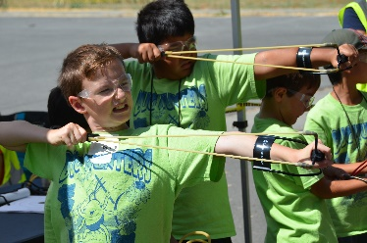  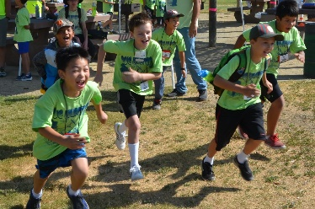 | Welcome to SCOUTCRAFT!  We have merged Minecraft and Scouting so you can enjoy Minecraft themed activities while having a great time in the outdoors. This is event is for registered Lion, Tiger, Wolf, Bear, Webelos and AOL Scouts.  We will have slingshots, scout skills, crafts, games, STEM activities, nature, a hot dog dinner and a camp fire show -all while you explore the biomes of Villa Maria
Parent Meeting & Check-In  Villa Maria Picnic Area  Stevens Creek County Park  11401 Stevens Canyon Rd  Cupertino, CA 95014 | Saturday, June 1st  9:15 AM | Scout Check-In, All Scouts and parents need to bring a completed  medical form parts A&B each.  Paperwork Submission and Completion,  Parent/Guardian Meeting at 10am to make sure we have enough  Adult coverage for each Den.
Volunteer Camp Leadership | Director  Camp Medic  Youth Staff Director | Michelle Ray michelle_blake@yahoo.com (408) 309-3123  Izzy Morrish bizzyizzy2000@yahoo.com (408) 829-2883  Aidan Tabor aidan.taber@icloud.com

