Placer District Cub Family Camp

Leader & Parent Guidebook

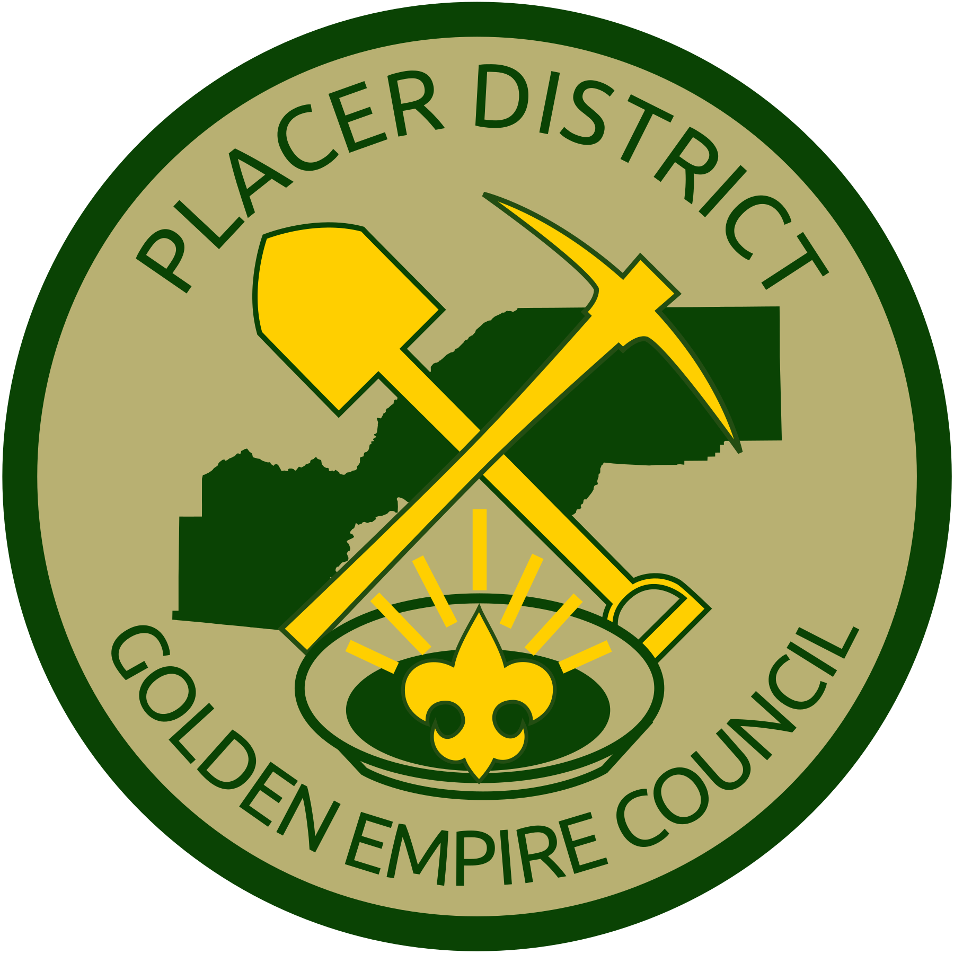

CELEBRATING AMERICA’S 250TH

October 2-4, 2026
NorCal Adventure Area
15356 Oregon Hill Rd.
Dobbins, CA 9592

Welcome to Placer District’s Cub Family Camp, Friday through Sunday, October 2-4, 2026!

Cub Scouts can attend as a den or pack, or with their families and siblings, to enjoy the program. Wild Things, a local animal rescue program, will bring their animal ambassadors for a one-hour show. Youth will rotate between crafts, hikes, scavenger hunt, range and target activities, and games. Besides the fun they will have, each Scout will meet other Cub Scouts and leaders.

The theme this year is “Continuing the Celebration of America’s 250th Anniversary”.

The Cub Scouts will be in mixed rank groups, generally rotating with other members of their pack. This is to keep siblings and parents together during rotations. Tiger Cubs must always have an Adult Partner with them. Dens will need at least 2 adult participants to be with them as they rotate through stations and activities.

Fees for Adults / Station Leaders / Den Chiefs:

- Adults, Youth 4 years and over: $25
- Adult Station Leader / Staff : $15
- Den Chief / Scout Helper (Youth): $0

What’s Included

NorCal Adventure area has campsites, toilets, running water, garbage and cell service. Please bring storage containers with drinking water, and individual water bottles for hydration.

Attendees should bring basic camping gear—tents, sleeping bags, clothes for warm days and cool evenings. See full list at the end of this guide. We will not be providing any food so participants must bring their own food and means of preparing and eating it at the campsite.

There will be a Saturday evening campfire program—bring along a song, skit, or other entertainment for the group.
Registration

Packs are encouraged to register as a unit through their Pack Coordinator via the Black Pug registration system. If your pack is not going to Camp but your Scout still wants to attend, individual parents can register their Cub Scout and family and we will group you with other small packs or families.

Use this link: https://scoutingevent.com/047-119959.

Refund Policy

It is the policy of the Greater California Council, that all fees are transferable but not refundable. However, refunds may be requested in writing, two weeks prior to the event for unforeseen circumstances. Failure to participate in an activity does not warrant a refund.

Forms for Camp

A/B Medical forms—for each adult and youth attending camp.

Range and Target Activity—for each youth to participate in BB gun or archery shooting

Safeguarding Youth (formerly Youth Protection) Training—for each adult attending camp.

Medical Forms and Range and Target Activity Permission forms are available on the registration page for Camp here: https://scoutingevent.com/047-119959.

Pack Camp Coordinators

The Pack Camp Coordinator is an adult/parent from the Pack who:
distributes Camp information and this leader’s Guidebook to pack families.
gathers commitments from families
manages the registration process for the pack
coordinates supervision for participants

Further information and planning materials will be available at the district monthly Connections meetings.

Camp flyers, Leader Guides, Health Forms, Range and Target Activity release forms, and additional information is available on the event page for Family Camp here:
https://scoutingevent.com/047-119959.

Supervision at Camp

Every Tiger Cub must always have an Adult Partner with them.
Camp Standards mandate that we have 1 adult for every 4 youth who attend.
Two registered Cub Scout or Scout leader, parents, or guardians, may serve as chaperones, guiding the youth in the camp den throughout the day, assisting with activities and discipline.
The Pack Coordinator should coordinate a minimum of two parents to chaperone each den for the day.
A parent or guardian must accompany youth not attending with a pack.
Our Family Camp is planned, organized, and staffed by volunteers. The camp cannot operate without pack and parent assistance, thus we have a reduced fee of $15 for staff.

All adult attendees are required to complete Safeguarding Youth Training and submit a current training certificate (even parents who are not registered leaders). Ask your Pack leaders for help with this, or visit my.scouting.org, create an adult account, and visit the Safeguarding Youth Training page to complete the training.

Camp Staff Volunteers

Scouting America is an all-volunteer program. The success of this camp, and all events, is made possible because of the dedication and willingness of the youth and adults who volunteer to help make these programs run.

If you would like to experience the fun of working with Cub Scouts in a program area or administration, we have a place for you. The fee for staff members is discounted to $15. All staff must be registered with Scouting America and are expected to help with a program area for at least part of the day on Saturday.

Scouts, Venture Crew or Explorer Scouts, age 12 and older, may volunteer as a Camp Den Chief. These youth have an opportunity to display leadership skills, pass on useful information to younger Scouts, encourage those younger Scouts to continue in the program, and gain service hours to use toward their rank. The positive influence of older Scouts on our Cubs helps to further build our Scouting program. There is no registration charge for den chiefs.

Transportation

Transportation to/from camp is not provided. It is the responsibility of each parent or guardian. Parking can be limited at some times so carpooling is highly encouraged.

What to Wear / What to Bring

All Cub Scouts, Den Chiefs, and Camp Staff are encouraged to wear some type of Scout or other appropriate T-shirt every day. It is recommended that each Scout carry a drawstring bag or light backpack. Please make sure your child has the following items. Label all items with your child’s name and pack number:

A hat, sunscreen, rain gear (poncho)
Water Bottle
Everyone must wear close toed shoes and socks at all times.
No sandals or open toe shoes (including CROCS) are allowed at camp – this applies to Scouts and Adults.
Cell Phones

While at camp many adults will use their cell phone, but the use of cell phones by Cubs and Scouts BSA is strongly discouraged. Any youth attending camp with a cell phone must inform his/her Camp den leader.

Meals

Participants are responsible for their own meals and snacks for the entire weekend. Drinking water and ice are available at camp. Please add any allergy information to the Annual Health and Medical Record.

Medication

If your child requires medication during camp, only the parent, guardian or the attending adult who has been given permission by the parent, may dispense the medication. No medication (this includes over-the-counter meds) will be given by the Camp Staff – this includes the camp medical officer. Medications shall only be carried by an adult. Exceptions to this are for those individuals who need to carry emergency medication at all times such as asthma inhalers, Epi-Pens, bee sting kits, diabetes kits, nitroglycerin tablets, etc. Any medications brought to camp must be in the original pharmacy or manufacturer’s container with the patient’s name and the medication name clearly labeled with dosage instructions. List all medications on the Annual Health and Medical Record

Special Needs

Please contact the Camp Director in advance if your Scout has any special needs that our Camp staff should be aware of. Scouting America promotes the inclusion of youth with special needs or disabilities. We recognize that each child is unique, and no single plan will work for every scout. We will work together to provide an enjoyable Camp experience for your Scout.

Emergencies

A Camp Health Officer, certified in CPR and basic first aid procedures, is in camp at all times. In case of an emergency or accident involving your child, you will be notified by the camp director. We request that you add any information to the Annual Health and Medical Record form that we may need in case of an emergency. Please notify us if there are any changes or additions to this information prior to camp.

Camp Rules

(Please follow the Cub Scout Oath, Law, and Motto)

- We will be using the buddy system at all times during camp. Buddies must stay together; this includes going to the restroom or medic.
- Scouts will be assigned to a den and are to always stay with their dens.
- Scouts must have their den leader’s permission to leave the den and to sign out ifcamp anytime Camp is in session.
- No running or throwing in camp, unless it is required as part of an activity.
- No climbing, horseplay or fighting on the tables, benches, or anywhere else in camp.
- Stay out of areas not marked for camp use.
- No tobacco, alcohol, or drugs (including marijuana) in camp.
- Practice Leave No Trace skills by disposing of your trash in garbage cans.
- Scouts will be respectful to all staff, adults, other Scouts & their property.
- No disrespectful or rude language will be tolerated during camp.

DO NOT BRING: Pocket knife, matches, portable radio/music player, iPod, handheld video games.

We understand that Cub Scouts sometimes need some quiet time, or time away from their Den/group. We will provide an area where Scouts can enjoy some creative quiet or cool-down time away from their Den. This area and activities will be identified during announcements, and the activities may change during camp as materials and volunteers allow.

Staff and Contact Information

Camp Directors
Mike Thabault, Placer District mthabault@gmail.com
Kathy Neuburger, Placer District istahap@jps.net

District Executive – Placer District
Jim Ford 916-501-2015 james.ford@scouting.org

Camp Schedule

Friday

5:00 – 8:30 PM –Check-in, dinner, set up camp. Table games, activities available.
8:00 PM – Parent orientation

Saturday

7:00 – 8:45 AM – Breakfast
8:15 – 8:45 AM – Parent Orientation
8:45 AM – Gathering, Flags, and Announcements
9:00 – 9:55 AM – 1st Program Rotation
10:00 – 10:55 AM –2nd Program Rotation
11:00 – 11:55 AM – Wild Things Program
12:00 – 12:55 Lunch
1:00 – 1:55 PM – 4th Program Rotation
2:00- 2:55 PM – 5th Program Rotation
3:00 – 3:55 PM – 6th Program Rotation
4:00 – 4:30 PM – Closing flags, Station breakdown
4:30 – 6:30 PM– Dinner
7:00 – 8:00 PM – Campfire
10:PM Quiet Time

Sunday

7:00 – 8:45 AM – Breakfast
8:45 – 10 AM – Pack up, check out

What to Bring to Camp

Personal Gear

Scout field uniform Toiletries—soap, toothbrush, toothpaste, deodorant Pack activity t-shirt Medication, in original container
Long pants, shorts Towels, washcloths
Underwear Insect repellant
Socks, extra socks Sunscreen, hat for sun protection
Shoes, boots Waterless hand cleaner
Coat, jacket Hat or beanie for warmth
Rain poncho

Camping Gear

Tent, tent stakes Camp chairs,
Hammer Sleeping bag, foam pad/inflatable mattress, pillow
Ground cloth, tarp Flashlight, extra batteries

Pack Campsite Equipment

Pack flag, first aid kit Camp stove, fuel
Firewood, shovel Pop-up, rain canopies
Camp tables Cooking gear
Large trash bags Wash basins, dish soap
Cooler, food Lanterns
Rope

