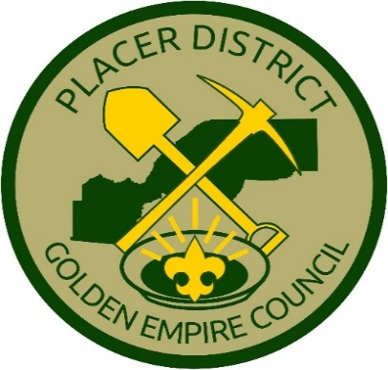**Join us for a great family evening!**

**2023 PLACER DISTRICT DINNER &**

**SECOND ANNUAL PLACER DISTRICT**

**PINEWOOD DERBY CHAMPIONSHIP**

**March 11, 2023**, First United Methodist Church, 6414 Brace Road, Loomis

Doors open for Championship: 4:30; Championship starts: 5:00; Dinner Program: 6:00

Cost: Championship only: Free – do not register (but consider registering and staying for dinner!). Dinner: Adults $10; youth are welcome and free, but should be registered so we get an accurate count for dinner seating, dessert, etc.

Join us for an evening of fun and fellowship at Placer District’s Winter Extravaganza! We’ll have all our most popular parts of this event from past years, plus a new competition and unit recognition! (See details and rules below.)

* The First Place winner of each Pack’s Derby will compete for the Coveted Cub Cup.
* Dinner is a potluck. Please bring a dish to share. Please no desserts as we will provide.
* Please send in your photos for this year’s District movie, *Together We are Brilliant.*
* This year we’re launching a baking competition! Every unit is invited to submit a dessert to

be judged, and compete for the Spoon of Destiny recognition.

* The *Placer Bucks Auction* will return this year. Donations needed!
* During the dinner program, for youth attendees we will be screening the classic movie

*Down & Derby*  in the adjoining room.

* Units should send in their designations for the *Unit Scouter of the Year* recognition. We will

also award the *District Award of Merit, Alan Banks,* and *Trailblazer* adult recognitions.

Details/ Rules

Derby Championship: The First Place winner of each Pack’s Pinewood Derby may participate in the Placer District Championship.

See rules at [PinewoodDerbyGuidelines2023.pdf (placerscouting.org)](https://placerscouting.org/media/PinewoodDerbyGuidelines2023.pdf) Any questions, contact Brandon Zipp,

[brandonjzipp@gmail.com](mailto:brandonjzipp@gmail.com) (530) 864-6418.

Photos Needed: For the movie, *Together We Are Brilliant,* please text a few pictures from your unit to (530) 368-7697.

Dessert Contest: Whether made by an individual or a group effort, every unit is invited to submit a dessert for our contest. Will be judged by Key 3+ based on appearance, presentation and originality. Winning units will receive the Spoon of Destiny recognition - 1st, 2nd and 3rd places will be awarded. Identify dessert and unit on a card. All submissions will be part of a free drawing through the evening, so note you will not be getting your plate back.

Auction: Donations are needed for the *Placer Bucks Auction.* Free Placer Bucks have been distributed through the year, and at this event, for use in bidding.  Examples of needed donations include Scouting memorabilia, useful outdoor items, gift cards, venue passes, event tickets, etc. If you can help with a donation, contact Mike Thabault at [mthabault@gmail.com](mailto:mthabault@gmail.com)

Unit Scouter of the Year: Each unit may designate one or two leaders to receive the *Unit Scouter of the Year* recognition. In this District, the Golden Nugget Bolo is the recognition. This a designation --- not a nomination --- so the person(s) you designate will receive the award. Send your designation(s) to [mhavenfarm@gmail.com](mailto:mhavenfarm@gmail.com). Due to volume of email, if you do not receive confirmation, please send again in a day of two. And make sure you get the recipient(s) registered to attend!

This event is very popular and may sell out! Register today at:

**LINK**