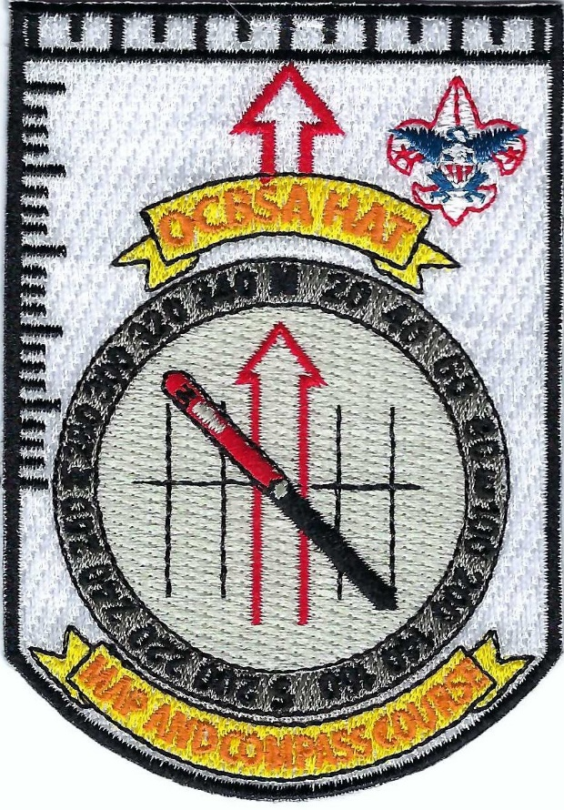
ORANGE COUNTY COUNCIL HIGH ADVENTURE TEAM
ADULT LEADER
MAP AND COMPASS COURSE 101
NOVEMBER 14, 2026

CLASSROOM AND OUTDOOR INSTRUCTION: SATURDAY, November 14, 2026…8:00 am-3:00 pm
IRVINE RANCH OUTDOOR EDUCATION CENTER (IROEC)

Scouts must learn map and compass for First Class Rank…right? How about us as adult leaders? How well do we know the subject? Here is your chance to be the map and compass “North Star” on your unit’s next backpack.

This course will include: (1) choosing a topographic map; (2) reading a topographic map including coordinate systems, datum, scale, and contour lines; (3) route finding with a map; (4) anatomy of a compass; (5) how to measure and plot bearings on a map; (6) how to measure and plot bearings in the field; (7) adjusting bearings for magnetic declination, which includes pre trip preparation of your topo map; (8) practice fieldwork with instructors at the IROEC which will include a half mile round trip hike to the top of Koll mountain.

Bring: (1) 2-3 pencils; (3) day pack with water and snacks for hiking; (4) hiking clothing and footwear; (5) camp chair; (6) sun protection.

OCC-HAT PROVIDES SUUNTO M-D LEADER COMPASS AND TOPOGRAHIC MAPS.

Cost: $50.00...roster limited to the first 25 students who sign up. Additional sign-ups as cancellations occur.

To register online and pay tuition: https://scoutingevent.com/039-HATMapCompass101
OCC-High Adventure Team Website for detailed information: https://occhat.org
Contact Course Director Clark Adams: clark_adams@sbcg

