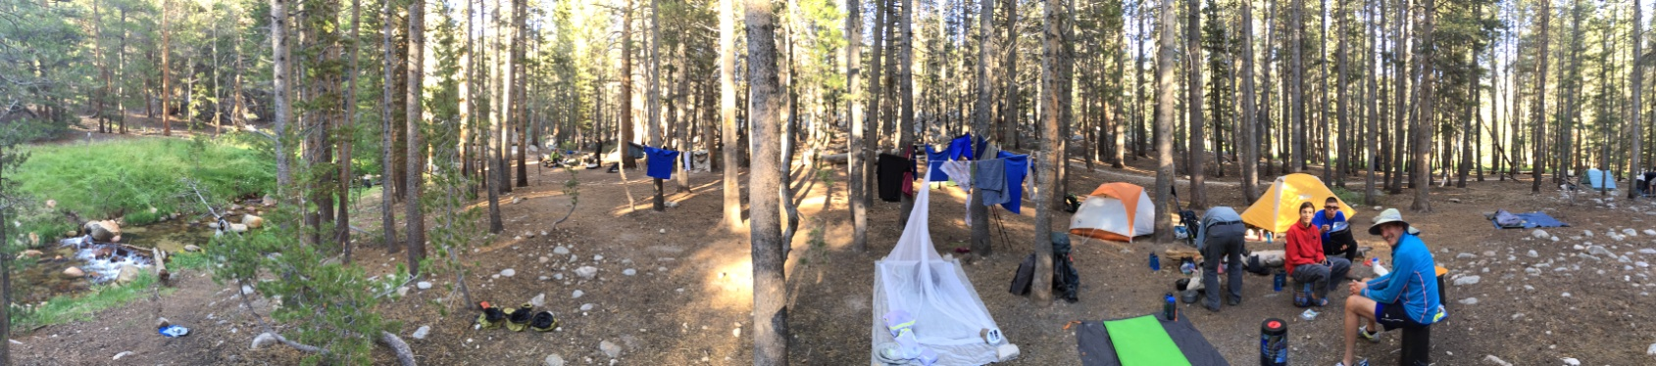
Introduction to Outdoor Leadership Skills (IOLS)
Training for Scoutmasters and Assistant Scoutmasters

Research has shown that units that have trained leaders are more successful, and that the youth in those units benefit far more from the Scouting program. Introduction to Outdoor Leadership Skills (IOLS) training is one of the two courses required for Scoutmasters and Assistant Scoutmasters to be recognized as being “Trained” for the position.

IOLS provides Scouters with the confidence to take youth into the outdoors. Specifically, this hands-on program gives adult leaders a practical introduction to the patrol method of a boy-led troop by teaching many of the practical outdoor skills they need to lead Scouts in the out-of-doors. In addition, the teaching methods, activities, and games model the variety of teaching used in effective and engaging Scouting programs.

The skills sessions presented in IOLS closely follow the Scout Handbook and are meant to serve as an adult training outline. By using these skills sessions in conjunction with the Scout Handbook, trainers can be sure new leaders are proficient in many of the basic outdoor skills through First Class rank and gain exposure to the patrol method and numerous teaching methods and learning games.

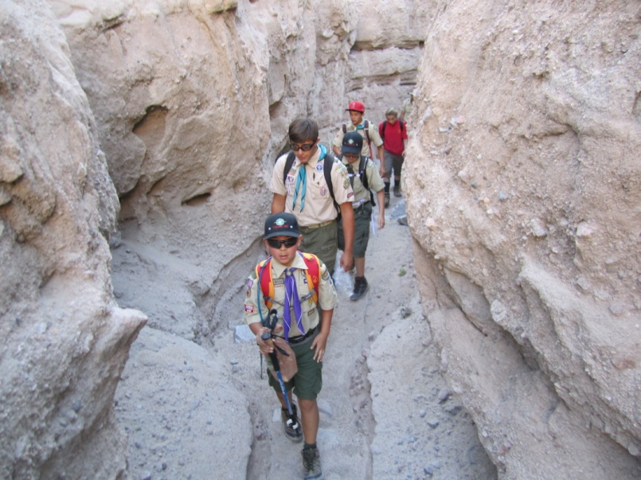
If you have not yet taken this course, this is your opportunity! The program is being offered on October 9-10, 2026. We will meet at 5:00 pm on Friday night, and finish about 6:00 pm on Saturday. Registration opens at 6:00pm. This will benefit those units that need adult leaders for travel and evening supervision, but who are less involved in the daytime activities, which are boy-run.

The course fee is $32. Other requirements (camping equipment, patrol assignments, food needs, etc) will be sent after registration.
Location: Huntington Beach Central Park
Questions may be directed to Course Director Jim Dodds at 714-309-5143 or jdodds92647@gmail.com

