Basic Adult Leader Outdoor Orientation (BALOO)

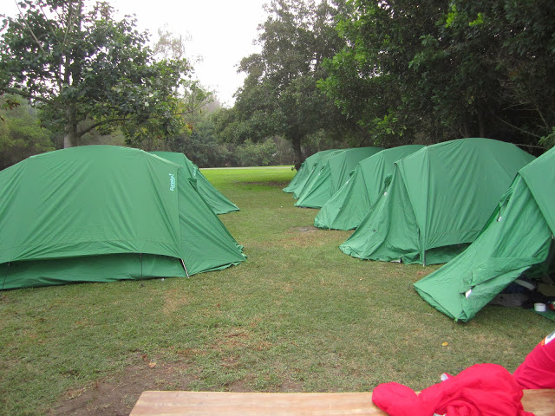
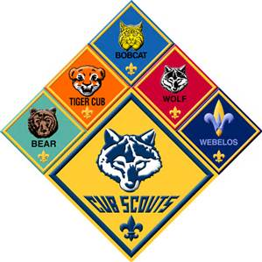
Pack Camping has come a long way and it is one of the strongest reasons for boys and girls to join the Cub Scout program.

For a Pack to go camping however there MUST be at least one registered leader on the outing that is BALOO trained.

This course is the in-person portion of a two-part blended learning format, and the online modules are the first step in the BALOO training plan.
Online Component
The online training modules contain both introductory and basic information. This will be built upon during the
practical training that is completed during an in-person course. The online component must be
completed prior to the practical component. The course facilitator should check this before allowing enrollment
into this part of the course either through a training report, or by certificates of completion from my.scouting.

Overnight Component
The overnight component is design to expand on the Online BALOO component providing hands-on
introduction to the Cub Scout outdoor program for those leaders who are interested in adding a camping component to their Pack activities. The BALOO overnight is an instructor-led course conducted at the District/Council level. Scouting America Cub Scout level camping policies will be taught along with the necessary tools to help units carry out a successful camping experience. This training also reviews guidelines established by the Scouting America and the Orange County Council to help us understand the value of the outdoor program.

What: Basic Adult Leader Outdoor Orientation – Overnight Component
Where: Huntington Beach Central Park – Huntington Beach, CA
When: Friday October 9, 2026: 6:00 pm to Saturday October 10, 2026: 6:00pm, Check in Friday starts at 5:00 pm
Who: All Pack Leaders, Den Leaders & Pack parents
Why: For a Pack to go camping there MUST be at least one registered leader on the outing that is BALOO trained. Training also helps parents better understand the program.
Cost: $45
For information contact: Mark Smilor marks130@verzion.net /714-488-7564

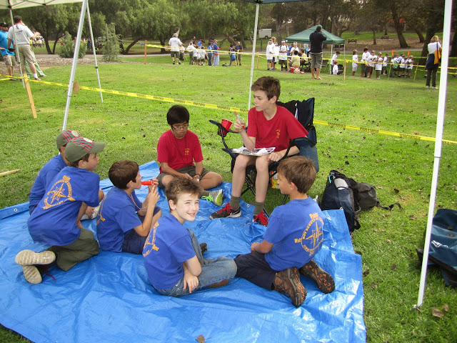
BALOO Learning Objectives
- Explain the focus of the Cub Scout level of the Scouting America camping program.
- Demonstrate the skills and confidence necessary to plan and carry out a successful, first-time Cub Scout–level camping activity.
- Describe the resources available from Scouting America and other sources to carry out this activity.
- Discuss the requirements for successful completion of this activity.

