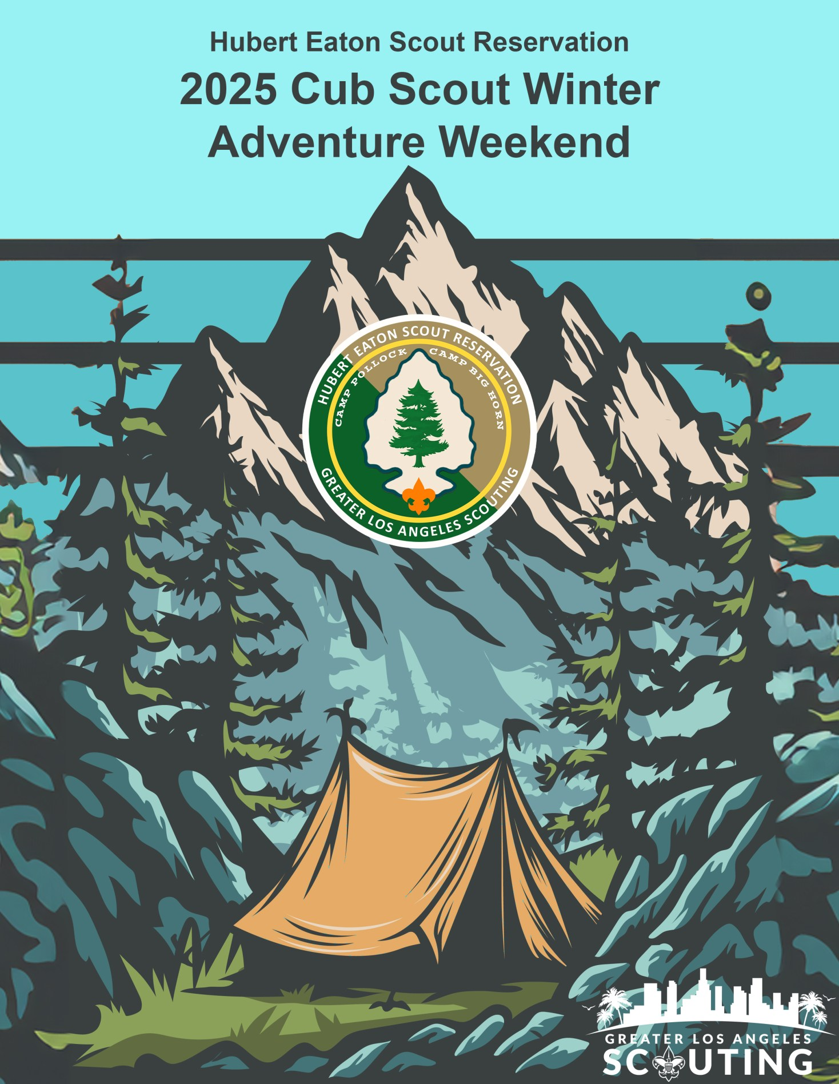

Dear Young Campers,

Prepare yourselves for an extraordinarily Jurassic Journey filled with fun, crafts, and adventure like never before! We are thrilled to extend a warm welcome to the much-anticipated Cub Scout Winter “Dino Camp” for 2026.

Prepare to create memories that will last a lifetime, and forge friendships as strong as the bond between your fellow Scouts. Cub Scout Winter “Dino Camp” 2026 promises a unique blend of winter magic that you absolutely can't afford to miss. Dig through the pages of time as you explore the prehistoric way of life. We welcome you for a weekend that promises to be filled with fun and excitement.

Welcome to our Winter Land Before Time!

Yours in Scouting, Charlie Sheen

Charlie Sheen|CampingDirector

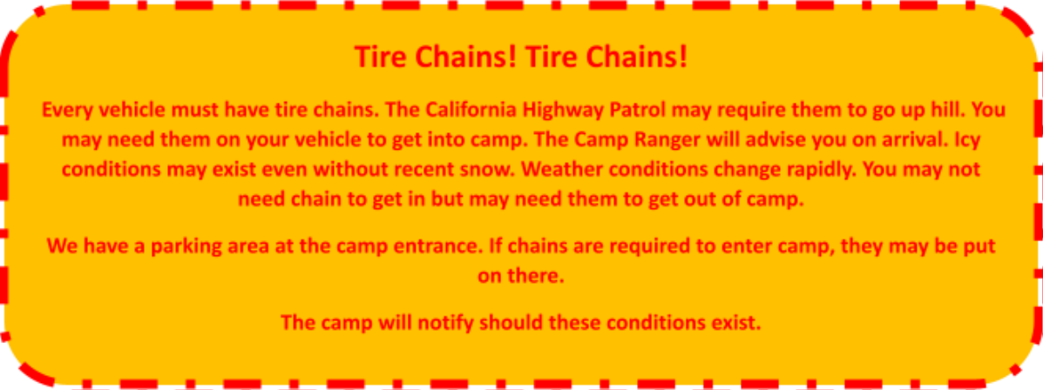
Greater Los Angeles Scouting

TableofContents
Camp Contact Information.............................................................................................................................5

Winter Camp Program...................................................................................................................................6 Additional Courses- AdultsOnly..................................................................................................................7 AdditionalCourses- Campwide.....................................................................................................................8 Dutch Oven Cook Off Extravaganza ...........................................................................................................8 CampFacilitiesTour&Hike........................................................................................................................8 Camp Activities..............................................................................................................................................8 Winter Camp Trading Post .........................................................................................................................8 Campfire.....................................................................................................................................................8 Unit Leader Award of Amazingness ...........................................................................................................8 LeadersMeeting ........................................................................................................................................8 GeneralInformation.......................................................................................................................................9 Check- In Procedure...................................................................................................................................9 Early Arrival................................................................................................................................................9 Health Forms..............................................................................................................................................9 Medications................................................................................................................................................9 Visitors .......................................................................................................................................................9 Transportation ...........................................................................................................................................9 Pet Policy..................................................................................................................................................10 Bikes in Camp...........................................................................................................................................10 WinterWeather.......................................................................................................................................10 Check Out Procedure...............................................................................................................................10 Lodging.....................................................................................................................................................10 Sledding Policy and Procedures ...................................................................................................................11 GeneralPolicy ..........................................................................................................................................11 Examples of what not to bring!................................................................................................................11 Examples of what you can bring!.............................................................................................................11 Speedy Check In Form.................................................................................................................................12 2025 Winter Camp Roster............................................................................................................................13 2025Food Allergies and Intolerances Form.................................................................................................14 Winter Camp Release Form..........................................................................................................................15 Winter Camp Suggestions............................................................................................................................17

Camp Contact Information

Camping Director

Charlie Sheen
Charlie.Sheen@scouting.org
(972) 375-2836

Director of Properties

Matt Thornton
Mthornto1984@yahoo.com

Program Director

Archer Bazaure- Dilts
bazauredilts@gmail.com

Camping Administrative

Andrea Villalobos
Andrea.Villalobos@scouting.org

Cushman Watt Scout Center

2333Scout Way
Los Angeles, CA 90026

Hubert Eaton Scout Reservation

Camp Pollock Winter Camp
29485 Hook Creek Road
Cedar Glen CA 92321
909-337-2121

Program Description Program Structure:

Winter Camp operates from January to February each year. Scouts participate in all activities at their leisure for the weekend.

Range and Targets: Aim your way to a bullseye every time at our Archery and BB Gun Ranges. All Scouts must have signed waivers to participate.

Fossil Journey: Visit our nature center and explore the past at the Schnable Museum. Discovery the lands that surround us all while finding new things at your fingertips through our Nature Center.

Livin in the Land of the Frost: Discover your inner snow camper as you tackle a series of challenges designed to test your skills in creativity, teamwork, and problem-solving. From building snowmen to crafting quirky crafts.

Prehistoric Climb: The Great Climb: Scale the 'Mount Gilmore' peak in an exhilarating climbing adventure. Team up with fellow Scouts to conquer the icy slopes and reach the summit.

Dino Arts and Crafts: Let your creativity shine in our arts and crafts workshops. Design your own mask. Paint something fun. Always something to bring home to show off your skills.

Movie Night: Wind down after a day of adventure with a cozy movie in our home away from home.

Campfire: Join in the circle of warmth as we share campfire stories that will have you laughing, gasping, and feeling the spirit of unity that defines the Cub Scouts.

Farewell Sunrise Hike: Take a page out of history before you leave and end the weekend with a heartwarming sunrise hike. As the sun paints the sky with vibrant colors, reflect on your journey.

Additional Courses

Camp Facilities Tour & Hike: All Scouts and leaders are invited to join us on the Camp Facilities Tour & Hike! The hikes will be held on Sunday mornings. They begin at 6:30am at the Schnabel Family Museum. The hikes should take one hour or less to complete (1 mile). Learn about Nature and the History of our camp all while hiking through the wilderness. Participants will sign up at the Office if interested.

Camp Activities
Winter Camp Trading Post: The trading post will be set up for Scouts and leaders to buy snacks, camp supplies, Winter Camp swag, and other items. The hours of operation will be posted.

Campfire: Scouts will have a chance to see the amazing view from our campfire circle overlooking Firebird Lake. Units and staff members will have the opportunity to perform skits and songs, so come prepared.

Unit Leader Award of Amazingness: Winter camp would not be possible without the leaders who take the time to bring Scouts to camp. To recognize the effort and sacrifice of these leaders, we have the Winter Camp Leader's Award of Amazingness! The requirements for this award will be given upon arrival at camp.

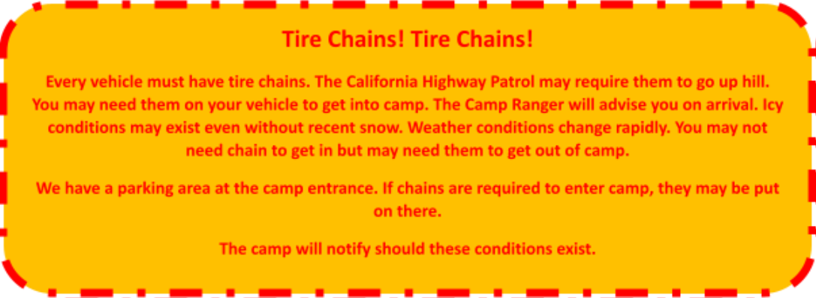
Leaders Meeting: A Patrol Leaders Council (PLC) will be held Friday evening directly after dinner at 7:00pm in the Schnabel Family Museum. This is to include a unit leader.

General Information
Check- In Procedure: The camp staff will be prepared to check in units beginning at 4:00 PM on Fridays. Arriving units will send a representative to the admin to check in. The camp administration will collect medical forms, unit rosters, and any unpaid registration and merit badge fees. Vehicles will be permitted to drive to the lodges to unload gear. Vehicles will not be allowed to remain at the lodges during the weekend. All vehicles will be moved to the parking area and must have a permit displayed. You must have an ADA placard to park in the ADA spaces. If you are unable to arrive on Friday night, you can check-in Saturday morning by 8:00 AM with the understanding that you must let the administration team know in advance and the price will stay the same.

Early Arrival: Early arrival at Winter Camp is not permitted. All participants will check-in on Friday. Check-in will begin at 4:00 PM and close for the night at 9:30PM. The Winter Camp leadership team appreciates your understanding on this matter.

Health Forms: Everyone – youth and adults – must have a current copy of their health form. Please keep the original health form for troop records. Participants staying for the weekend must bring a copy of their BSA Medical Form parts A and B. This form must be signed by the parents. A copy of the insurance card must be attached to the BSA Medical Form. In addition, each person must complete the Health Screening form within 24 hours of arrival to camp and bring it with the other required forms. Anyone attending for a single day only needs parts A and B and a health screening form. All injuries and ailments must be reported to the Camp Health Officer. Scouts or adults who do not have their medical forms or a copy of their insurance card cannot attend camp programs. BE PREPARED. Please
double-check the medical forms for parent signatures and make copies of all medical forms before arrival at Winter Camp.

Medications: Any prescriptions on the camp property must be reported and locked up. Medications should be locked up and administered by the unit leader in camp. In some cases, medications can be locked up and administered by the Camp Health Officer. Emergency medications (epi-pen, immediate allergy relief, inhalers, etc.) should always be kept on the users and will not be locked up.

Visitors: All visitors must check in and out at camp admin. Visitors will be given visitor identification. Visitors to camp are welcome to eat with us. There is a $10-dollar charge for visitors’ meals. This can be paid at Camp Admin or the Trading Post. Visitors are not permitted to stay overnight.

Transportation: While driving in camp, please observe the posted speed limit of 15 miles per hour during the day, 10 miles per hour at night or low visibility. Each unit is responsible for the safe transportation of its members to and from camp. Transporting Scouts or adults in the bed of a pickup truck or trailer, whether covered or uncovered, is against National BSA policy. Some merit badge classes will go off-site to fulfill requirements. Groups that leave on these field trips will be transported by chartered school bus or by camp owned vehicles. The vehicles will be properly registered and in good mechanical condition. Vehicles will be permitted to drive to the Pollock Lodges to unload gear during check-in. Vehicles will not be allowed to remain at the Lodges during the weekend. All vehicles will be moved to the parking area.

Pet Policy: Participants and visitors are not permitted to bring dogs or any other animals to Winter Camp except verifiable service animals for those who require it.

***You must provide proof of training from a recognized service animal training provider. In addition, the animalmusthavevisitedaveterinarianwithin45daysofarrivalatcampandhavecompleteup-to-date medicalandvaccinationrecords.Astatementfromaveterinarianstatingtheanimalhasnoknown zoonoticdiseasesandisoftemperamenttobeunaffectedinitsabilitiestodoitstrainedtaskswhen exposedtothecampenvironmentwhichattimescansubjecttheanimaltovisualandauditoryinput suchascrowdrunning,bikeriders,gunshots,andothernon-typicalstimuli.

Bikes in Camp: Bikes are not permitted during winter camp at Hubert Eaton Scout Reservation

Winter Weather: As you know, the weather in Southern California in January- March is very unpredictable. It could be 70 degrees, or it could be 20 degrees. Most likely it will be in the 30’s or 40’s and snowy. The best thing to do is to “Be Prepared.” When camping in the winter, it is important for the Scouts to be dressed for the weather and to stay dry. They should have layers of insulation. Ensure that the Scouts have what they need. There is an equipment checklist at the end of the leaders' guide to help them pack.

Check Out Procedure: Check-out units and provisional Scouts will be held on Sundays. We will also have a closing ceremony during Lunch on Sundays. There is a lot of work to do to break down and clean up camp. Any help before leaving camp is appreciated! Vehicles will be permitted to drive to the lodges again to pick up equipment. Once the unit is clear from the area, the leaders should inform the staff so that a final inspection can be carried out. The cost of any damage caused will be charged to that unit or provisional Scout. Once the unit or provisional Scout is ready to leave, they must check out at camp admin.

Lodging: Lodges will be assigned by your check in to camp. Each lodge is equipped with 4 rooms, 2 rooms of 12 and 2 rooms of 8. All lodges additionally contain a refrigerator, gas stove, central heating and 3 toilets, and 3 Showers. All Camp buildings and sleeping cabins are heated.

Sledding Policy and Procedures General Policy
1. Only one person per saucer or foam toboggan. Only one person at a time. 2. Maximum occupancy for sledding activity will be limited to 50 participants. 3. Camp issued or approved helmets must be worn while sledding at all times.
4. When riding an approved sledding apparatus, you must ride with your feet first. 5. When returning to the top of the hill walk up the trail and not on the sledding hill. 6. Units should be able to communicate with each other so that the hill is clear.
7. At the top of the hill wait until you are cleared before going down the hill. 8. Only approved sledding apparatus is to be used.
10. There are to be a minimum of two adults always supervising the hill.
11. As soon as you stop at the bottom of the hill move quickly out of the way. 12. Do not build jumping ramps.

II.Policy for Groups/Units Using Facility Other Than Winter Camp
1. Council to inform group/Unit whether they have permission to use or not use the sledding hill. 2. Give the group a copy of the General Policy instructions listed above.
3. A leader from the group/unit signs the information sheet acknowledging their understanding of and commitment to enforce the policy.
4. Prior to using the hill an adult is to walk the trail and sledding hill to ensure that it is safe to use. 5. The group/unit leader is to share the General Policy instructions with all participating youth and adults.

Examples of what not to bring!
Skis, inflatable inner tubes, railed toboggans & snowboards are not allowed on Pollock Camp Sled Hill.

Examples of what you can bring! Plastic saucers.

SleddingTubeRental:
We will have 10 BSA approved snow tubes that are available to rent for $5 per hour. You can rent these from the Trading Post while at camp. Only one person per tube is allowed at a time.

Speedy Check In Form

When you arrive at camp, your first step to checking in is to present the Camp Director your Speedy Check-In Binder. Your three-ring binder will help you organize and assist you as you prepare for your week at camp. Most of these documents can be found in the Appendix. Please use the print-out version of this form for your actual binder.

Please have these items in the order listed below.

CurrentcopyofyourTroop/Crewregistrationandfeespaid.

Attendance Roster

Completed Food Allergies and Intolerances Form submitted in Black Pug (Must be submitted 15 days prior to your unit’s arrival)

Routine Drug Administration Record for each participant who has medications listed in their Annual Health and Medical Record Part B2

California Shooting Sports Parental/Legal Guardian Permission

Scout/Leader Participation Permission Form

SanBernardino County Health Screening Form

BSA Medical Forms A, B

2026 Winter Camp Roster
Dates: / / 2026 to / / 2026 Weekend:

Council: Unit Number: Page Of

Last Name First Name Age Medical Form Shooting Sports

2026 Food Allergies and Intolerances Form
Allergies and special diets are a common concern of our camp participants. Our food service providers are experienced with accommodating most diets, including food allergies, religious restrictions, and other health- related diets. While we work to meet all dietary requirements, food is prepared in an area with milk, egg, peanut, tree nut, wheat, soy, and ﬁsh and cross contamination can occur. Upon arrival at camp, and prior to the ﬁrst meal eaten, it is the participants’ responsibility to identify themselves to our staff, and to cooperate in helping us meet their needs. Refrigerated spaces are provided for those wishing to bring their own foods. No discount will be provided for individuals not eating from the provided menu. Menus will be posted online two weeks prior to this participant’s camp date. This form should be submitted to the camp 30 days prior to check-in. Failure to do so will result in extra charges. Please email it to charlie.sheen@scouting.org. .Scouting of America, Greater Los Angeles Area Council makes every attempt to identify ingredients that may cause allergic reactions for those with food allergies. Every effort is made to instruct our food production staff on the severity of food allergies. However, there is always a risk of contamination. Participants with food allergies need to be aware of all the risks. Food production staff will not assume any liability for adverse reactions to foods consumed, or items one may meet while eating. By signing this, I am certifying I understand the disclaimers contained in this form and I verify the information provided is correct and true.

Participants Information

Name: Unit #: WeekendAttending

Food Allergies:

Pleasedescribe all food allergies that will create dietary restrictions for this participant. Be as specific as possible.

Food Intolerances

Please describe all food intolerances that will create dietary restrictions for this participant. Be as specific as possible.

Dietary Needs Questionnaire

What are the participant’s preferred food substitutions, if any (i.e soy butter for peanut butter, gluten-free breads, soy milk)?

What type of contact will cause a reaction? Airborne TraceCross Contact Ingestion

Isthere any other information you would like to share to help us meet this participant’s needs?

Participant (if over 18)/Parent/Guardian Signature/ Date:

Winter Camp Release Form

Name: Camp dates:

Address: City:

State: Zip: Phone ( ) - Email:

[ ] TALENT RELEASE Parent or Guardian initial

I hereby assign and grant to the Greater Los Angeles Area Council - Scouting America has the right and permission to use and publish the photographs/film/video tapes/electronic representations and/or sound recordings made during my stay for the week/weekend by the Greater Los Angeles Area Council -Scouting America, and I hereby release the Greater Los Angeles Area Council - Scouting America from any and all liability from such use and publication.

I hereby authorize the reproduction, sale, copyright, exhibit, broadcast, electronic, storage, and/or distributionofsaidphotographs/film/video/electronicrepresentationsand/orsoundrecordingswithout limitation at the discretion of the Greater Los Angeles Area Council - Scouting America and I specifically waive any right to any compensation I may have for the foregoing.

Please note that the activities listed below may or may not be available to your child while at Hubert Eaton Scout Reservation Winter Camp and are dependent on weather conditions and staff availability. Parent permission is required.

[ ] WINTER SLEDDING ACTIVITIES Parent or Guardian initial

I hereby grant the above-named permission in the participation of the Greater Los Angeles Area Council organized sledding activities.

[ ] CLIMBING ACTIVITIES Parent or Guardian initial

I hereby grant the above-named permission in the participation of the Greater Los Angeles Area Council

certified instructor-led climbing programs including Climbing Wall, Indoor Rock Wall, High and Low COPE

courses.

[ ] ARCHERY Parent or Guardian initial

I hereby grant the above-named permission in the participation of the Greater Los Angeles Area Council

certified instructor-led Archery Program.

[ ] CUB SCOUT SHOOTING SPORTS Parent or Guardian initial

I hereby grant the above named minor permission as required by California Penal Code Section 12552 to the Scouting America, Greater Los Angeles Area Council, and to the instructors certified by the Greater Los Angeles Area Council meeting the requirements for instructors established by the Scouting America (national,) to furnish a BB Gun (rifle) with BBs to said minor for the purpose of instruction in the safe handling of firearms, safe shooting, and marksmanship.

[] SCOUT FIREARMS PERMISSION Parent or Guardian initial

I hereby grant the above named minor permission as required by California Penal Code Section 12552 to the Scouting America, Greater Los Angeles Area Council, and to the instructors certified by the Greater Los Angeles Area Council meeting the requirements for instructors established by the Scouting America (national,) to furnish a Shotgun, .22 Rifle, Black Powder Rifle, Air Rifle, Pellet Gun, or CO2 gun with ammunition to said minor for the purpose of instruction in the safe handling of firearms, safe shooting, and marksmanship.

[ ] HOLD HARMLESS AGREEMENT: I do further agree to indemnify and hold harmless the Scouting America, Greater Los Angeles Area Council and all officers, members, employees, and volunteers thereof, from all suits of actions brought for, or on account of, any injuries or damages received of sustained by any person(s) by or from the consequences of any negligence, dangerous condition or any act of omission from any of the activities.

Participant (if over 18)/Parent/Guardian Signature:

Date:

Winter Camp Suggestions
1. BODY CLOTHING: Wear many light layers rather than one heavy layer. That way you use the “air layer” in between. To keep this insulation, it is important that your clothing be loose ﬁtting. This layer system might be thermal underwear, cotton shirt, wool shirt, sweater and wind jacket. This is the best way because when you play hard in the snow, you can peel layers off, then when you stop and start to cool off you can just layer them back on.

2. HEADGEAR: Anything will do if it will keep your head and ears warm and will not blow off. Stockings, beanies or watch caps are best because you can wear them when you sleep too

3. YOUR NECK: You lose a great deal of warmth out of your collar. Scarves or dickies are important. A turtleneck sweater is good too. One of the best things is a hooded parka or a sweatshirt with a hood.

4. YOUR WRISTS: Wrist covering are important to your warmth. You lose it at the wrists just as you do at the neck. The cover can be long mitten tops, part of your sleeves or separate knitted wristlets.

5. MITTENS OR GLOVES: Keep those ﬁngers warm. Mittens are best for this, but gloves also work. Highly recommended that you bring 2 pairs if available in case one gets wet.

6. PANTS: Wool is best. It even keeps you warm when it is wet. No matter what you wear, however, you must bring at least two extra pairs. (One to change into when the ﬁrst one gets wet: the second for a warm and dry ride home.)

7. YOUR FEET: You need boots! If you cannot wear any, bring two extra pair of shoes. Tennis shoes are not recommended, but if you have nothing else, bring plastic bags to place over your shoes with rubber bands to hold them on. If you have boots, you should waterproof them with any kind of waterprooﬁng available at surplus or shoe repair stores.

8. SOCKS: BRING SEVERAL PAIR OF SOCKS. Even if you think you don’t need to, you should put on a clean dry pair at night when you undress.

9. YOUR EYES: You must bring sunglasses. The sun reﬂecting on the snow can be strong enough to hurt your eyes.

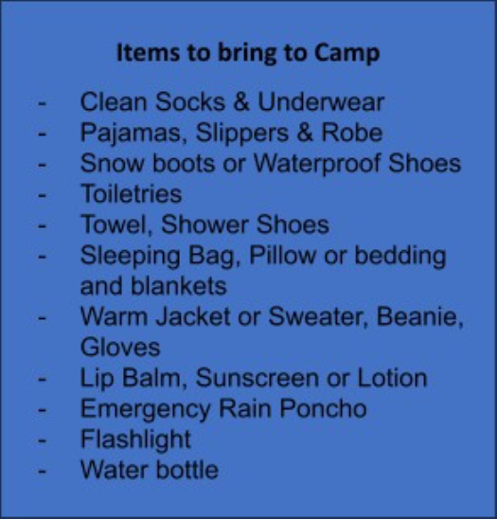
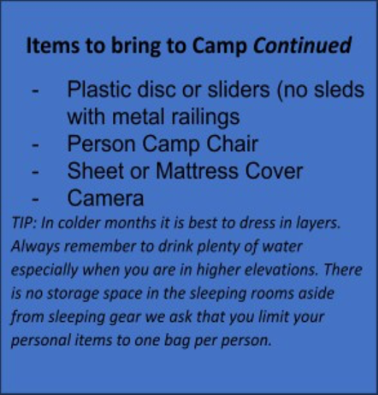
10. SLEEPING COMFORT: We’ll be sleeping on bunk beds with mattresses: Bring a Pillow and sleeping bag or sheets and two to three blankets.

PAGE BLANK FOR CAMP MAP

PAGE BLANK FOR CAMP SCHEDULE

