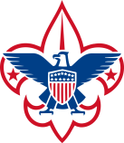
Boy Scouts of America Greater Los Angeles Area Council
Trask Scout Reservation

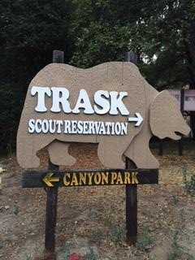
Open Camping Leader’s Guide

Unit/Event Leader:
Check-In Checklist

Please have these forms signed and ready to show/turn in at the Admin Office upon arrival.

- BSA Health and Medical record for EACH PERSON with part A and part B filled out completely. medical form part AB
- Unit Roster- A copy of the linked form must be submitted at check-in and kept updated with any changes throughout your stay. unit roster
- Shooting sports permission form linked for Scout-age youth (not required for cub scouts). shooting permission form
- Parking permit signed and dated with your name, unit number, and vehicle information.

Please print and share forms with all participants to have them available at check-in.

Print, sign, and bring to camp!

Checklist…… see page 2

Contacts/Directions to Trask… see page 3

Check-in and trading post information… see page 4

Parking Permit see page 5

General rules and regulations see page 6-7

Wilderness area warning and First Aid information… see page 7

Camping Etiquette (MUST READ!) see page 8

What to bring to camp… see page 9

Trask Scout Reservation

1100 N Canyon Blvd

Monrovia, CA 91016
Phone: 626-358-5446

Anthony Villalobos, Ranger
Email: anthony.villalobos@scouting.org

Andrea Villalobos, Camp Administrator
Email: andrea.arias@scouting.org

Hours of Operation

Trask Office Hours
Friday: 5:00 pm – 9:00 pm
Saturday: 8:00 am – 6:00 pm
Sunday: 8:00 am – noon

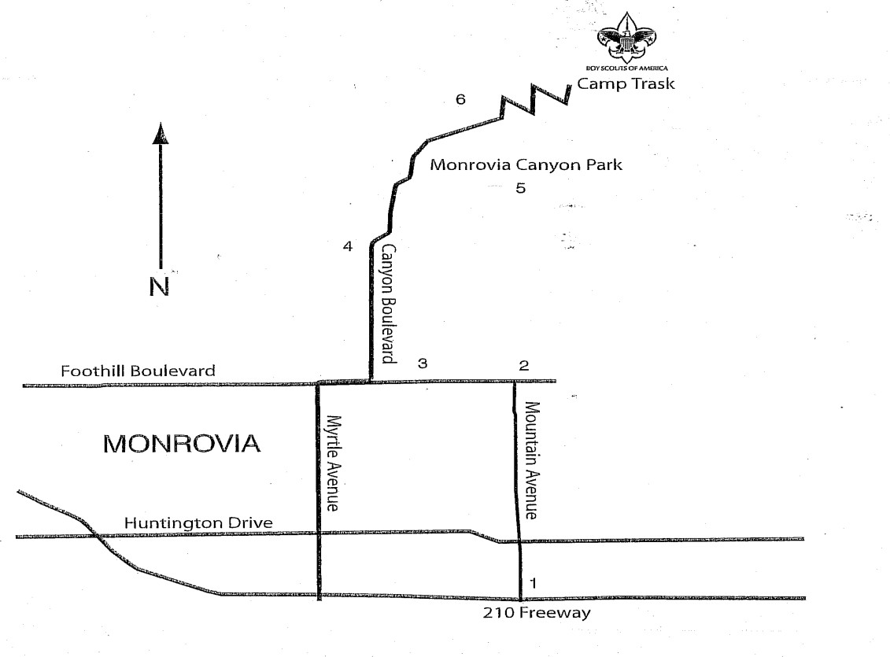
**NOTE: Camp is located 3 miles up Canyon Blvd from Foothill Blvd. The road is paved, but with several sharp turns. The road is very narrow in some parts, so please be extra cautious of other cars, as well as bikers and hikers.

Also, it’s advised to NOT use Siri or some GPS devices for directions. They have directed units another route that is not accessible.

Gate Combo:
will be emailed prior to your stay
Directions to Trask Scout Reservation

Take the 210 freeway to Mountain Avenue offramp in Monrovia. Exit at Mountain and turn NORTH towards to mountains. Follow Mountain Avenue up to Foothill Boulevard. Turn LEFT on Foothill and follow it to Canyon Boulevard. Turn RIGHT on Canyon Blvd. Follow Canyon Blvd up the hill. After crossing Hillcrest Boulevard (stop sign), Canyon Blvd will fork. Stay right and go up the hill. There will be a dip in the road and you will see a sign for Monrovia Canyon Park (Yes, it’s currently closed, but you CAN proceed to gate—tell your families!). Follow through the gate. If it’s locked, you will need the combination provided to enter code on the lock (you MUST push in to release the lock). If a ranger is at guard station, let them know you are going to Trask and you will be directed through. Once you turn the corner, you will see a Trask sign at the start of the camp road. Follow this road up to the top of the mountain and you will see a large arch at the camp entrance. Stay left and follow the road into camp and stop at the admin building (stop sign) to check in. **If you have a trailer or bus, you must notify us ASAP.

CHECK-IN/CHECK-OUT PROCEDURES
CHECK-IN:

We strongly urge the Unit/Event Leader to arrive before the rest of your group/unit to guarantee your group has filed the correct paperwork.
Upon arrival on Friday evening or Saturday morning, Unit/Event Leader must proceed to the admin office next to Humphrey’s Trading Post. It is very important before you go to any place in camp that you check-in. You will need to turn in a Unit Roster and any release forms needed for participation in our Program Activities. We will have additional information there and will be able to answer any questions you may have and get you off to a great start for the weekend.
If you have any medical issues please let us know at check in. It is not required to give us a copy of your medical forms but you must bring them with you and have them readily available. Be sure to always keep your car keys with you in case of emergency and that you fill out and put in your windshield a camp parking permit. Cars must be backed into parking spaces (facing outwards for easy departure).
CHECK-OUT:
On the morning of departure, the ranger or a camp staff member will inspect your campsite for cleanliness and trash removal. Unit/Event Leader must proceed to admin office next to Humphrey’s Trading Post and finalize Check-Out, pay any outstanding balance, turn in any equipment, and collect any release forms.

Humphrey’s Trading Post Store
For your convenience our Trading Post sells a variety of basic necessities, such as:

- Assorted candy
- Snacks
- Water /Drinks
- Ice Cream
- Cup O’ Noodles
- Leathercraft
- Patches
- Handicraft Kits
- And lots more!

Trading Post Hours
(subject to change)

Friday: 5:00 pm – 9:00 pm Saturday: 8:00 am – 6:00 pm Sunday: 8:00 am – noon
Trask Scout Reservation Parking Rules and Regulations:
This permit must be on your dash and legible by Camp Staff.
PLEASE OBSERVE SPEED OF 15MPH IN CAMP
- Drive Safely on ALL camp roads and observe speed limit of 15MPH.
- Park your vehicle “HEAD OUT” in case of emergency evacuation.
- Park in Designated Parking Areas Only.
- Vehicles should remain Parked and not used for Transportation in Camp.
- Any Vehicle Double parked or Blocking Traffic is subject to Towing.
- Special use parking permits will be issued upon request.
- There is no riding in the backs of open truck beds and seat belt must be provided for every occupant.
- The BSA is NOT RESPONSIBLE for items lost or stolen from vehicles.
- ALL DRIVERS MUST KEEP KEYS ON THEIR PERSON AT ALL TIMES

Fold here and place on dashboard with Parking Permit side up

TRASK SCOUT RESERVATION
PARKING PERMIT

Date: ________________________

Owner’s Name:
VEHICLES WITHOUT PERMIT WILL BE TOWED
Unit Type: Unit #: Number of occupants in vehicle:

Disabled or Medical Parking: (Must be initialed by Camp Staff)
Trask Scout Reservation, 1100 N. Canyon Blvd, Monrovia, CA 91016 Rev11/22

General Rules and Regulations

Please help us have a safe weekend by supervising your Scouts and siblings and following the safety procedures and instructions listed below.
- RULES FOR CAMPING
All Scouts and Leaders are expected to wear their field uniforms (“Class A”) for flag ceremony on Saturday.
“Open-toe” shoes (sandals, flip-flops, etc.) are NOT recommended in Camp.
Campers should always use the Buddy System (travel in groups of 2 or more) when at camp.
Make sure you and your scout have a plan in case someone is separated from the group.
Do not run in camp. Don’t let an injury spoil your weekend.
Two-Deep Leadership is required by National council. You must have a minimum of two trained leaders (one who is over 21) with your unit. Leaders MUST camp with their Unit. All Cub Scouts should have one-to-five leadership at all times.
- SECURITY
Canyon Park is currently CLOSED until further notice. You can, however, enter and exit at anytime with provided gate combination. Code changes weekly. YOU MUST LOCK THE GATE AFTER ENTRY!
Ranger lives on property, if an emergency arises. Camp Admin and Program Specialists are also available.
Please leave valuables at home. The Greater Los Angeles Area Council is not responsible for lost or stolen items.
- VEHICLES AND PARKING (Parking Permit) Park in designated areas ONLY!

Cars must be parked for the duration of the stay. No driving around camp.
All vehicles entering the camp area must have a Parking ID Pass. DISPLAY Parking ID pass prominently on dash (Indicate name and Unit Number on permit.)
Vehicles will be allowed access to assigned Campsite for unloading and loading. Otherwise, they must park in designated parking areas. Most parking is very close to campsite.
Park vehicles so they are “Head Out” (Back into your spot)
Cars that are blocking others or obstructing roadways will be towed.
- NO Alcoholic Beverages, Tobacco or Vapes Allowed
Trask Scout Reservation is a No Smoking facility. (any questions, please contact admin)
Alcohol and Scouting do not mix. The consumption or use, or being under the influence, of alcohol or illegal drugs is prohibited at any activity involving participation of youth members. You WILL be asked to leave camp if it occurs.
- FIRE REGULATIONS

Trask Scout Reservation is a No Smoking Facility.

NO WOOD OR GROUND FIRES! NO Fireworks!
No liquid fuels of any kind.
If the fire department is called because of your fire, your pack will be billed for any expenses charged by the fire department.
- Cooking/Food
Campers are responsible for their own food and cooking.
Propane cooking is permitted. Charcoal cooking in above-the-ground containers is NOT permitted at this time, except in designated areas with ranger approval.
BBQs are allowed on campsites as long as they are 6” off the ground. They must be propane only.
Wood burning fires are NOT currently permitted, and must be cleared by Ranger FIRST when available.
- WATER AND TRASH DISPOSAL
Trash Dumpster are NOT readily available.
Please secure ALL trash overnight or take it to the central trash dumpsters. REMEMBER that wildlife would like nothing better than to get at your disposed goodies.
Trash Bags – Please bring plenty of trash bags to bag and dispose of your trash.
Do NOT keep food inside your tent.
Do NOT put trash in restrooms or storage boxes.
A dumpster may not be available for trash disposal. If dumpster is locked, you will need to take trash with you.
- SHOOTING SPORTS RANGES
Please follow all direction given by range masters at any of the ranges. DO NOT enter range without permission from range master.
No running. Please do not go under yellow tape or fences.
You will be asked to leave the range if you do not follow instructions.
If you would like to take pictures, please check with range master where it is safe to stand.

PLEASE DO NOT BRING PERSONAL FIREARMS, AMMUNITION, SLING SHOTS, OR BOWS AND ARROWS TO
CAMP. Only Trask Scout Reservation equipment may be used by Scouts, Leaders, and all other participants.

- Other
Roller skates, skateboards, and roller blades are not allowed in camp.
NO PETS IN CAMP! No exceptions!

No rock throwing!

No tree climbing!

We are in the business of setting examples for our youth; above all, refer to the Scout Oath and Law as a guide. And the most important rule of all is… HAVE FUN!

Wilderness Area Warning

There are, among other things, wild creatures native to this area. Among them are BEARS, foxes, mountain lions, deer, raccoon, spiders, flies, ticks, ants, mosquitoes and mice. These animals are wild and must be left alone.

DO NOT STORE FOOD IN YOUR TENTS!
Bears WILL enter campsites, especially if there is food or food waste present. Some of the smaller animals (squirrels, mice) can get into tents, packs, clothes, or food bags, as well.
Keep all food and items with a scent stored appropriately so as not to attract these animals.

NO OPEN-TOE SHOES!
Wear appropriate shoes.
Remember you will be walking/hiking and the terrain is uneven.
You don’t want to be bitten, stung or injured by anything.

Be prepared to handle:
Seasonal Poison Oak and Stinging Nettles, Bee stings, mosquito/insect bites Seasonal Allergies
Weather – Warm Days & Cool Nights

Cooking cleanup:
All cooking equipment MUST be cleaned properly after using to minimize smells.
NO DUMPING IN CAMP! RANGER WILL TELL YOU WHERE TO DUMP GREYWATER.
After cooking, equipment should be stored properly before leaving campsite unattended.
All food and other items, including trash, should be locked in car (with windows up!) or storage box, if available.

First Aid and Emergency Information

Ensure your unit has your Medical Release Form and Parental/Legal Guardian Permission Release for ALL participants in your group.

First Aid:
All units should be equipped with standard first aid equipment and supplies.
Individual Units are responsible to handle minor injuries.
If there are any questions concerning an injury, or if it is major injury, contact the First Aid Station located at Camp Admin office.
Any injury requiring a band-aid or more, must be noted in a written log and turned into Camp staff daily.
Any serious injuries: Must immediately be brought to the attention of the Camp staff.

Fire and Emergency Alarms:
If the emergency alarm sounds,
All campers are instructed to stop what they are doing immediately and to walk safely to parade ground and assemble by unit.
Leaders will take a head count and inform the Camp Leadership of the status of their unit. If any evacuation is necessary, participants will be given the appropriate instructions.

Camping Etiquette

Unit/Event leaders should “lead by example” when camping and demonstrate the Scout Law:

“A Scout Is Friendly, Courteous, Clean…”

EACH UNIT WILL BE ASSIGNED A CAMP SITE: However, we have a large number of campers that come to Trask, so you may expect to share your campsite with another unit. Also, water spigots are shared by all units. (Currently not available)

Be a good neighbor when camping: Leave room for others to pass by on the way to the water and rest rooms. When passing someone else’s camp site, be respectful and go around rather than straight through. If you need assistance, please contact the Camp Master or a Staff Member.

Storage box: Some sites may have a storage box. Please obtain a key from the administration office. Storage boxes are for cooking equipment and NON-smellable items only. ($10.00 fee for lost key or key not returned)

Restrooms: Campers are responsible for keeping the bathrooms and hand washing areas clean of trash and personal hygiene items. DO NOT dump any food or personal hygiene items down toilets, or use sinks to wash dishes. Report any maintenance issues, such as clogged toilets or running water to administration.

Water: Trask water system is undergoing renovation at this time. Flush toilet and hand washing station are provided in the upper camp areas. It is your responsibility to bring drinking water.

Noise: Excessive noise is not permitted after 10PM. Morning noise should be limited until sunrise.

Clean Up: SET A GOOD EXAMPLE FOR YOUR SCOUT AND HELP CLEAN UP CAMP BEFORE LEAVING.
All principles of Leave No Trace apply. Before departure, each unit will clean its camp site and surrounding area so there is no remaining trash, paper, plastic, etc. Restrooms should also be free of trash and debris. It is ALWAYS good practice to bring plenty of strong garbage bags. We are a” pack it in, pack it out” camp. Dumpsters and trash cans are not always available.

Departure:
Before departure, the Unit/Event Leader should advise the Camp Staff for final walk through of their site. Please be sure your tents and belongings are packed and loaded before the advertised departure deadline. It is not good etiquette to stay in a campsite beyond the Departure deadline.

What to bring to Camp Trask

Personal Equipment:
- Personal Tent
- Sleeping Bag/Pillows
- Light Jacket
- Change of Clothes (long pants, shorts, and shirts)
- Swim Suit (end of April-middle of November only)
- Shoes
- Hat
- Sun Glasses
- Toiletry kit (toothbrush and paste, soap, chapstick, etc.)
- Shower and Swim Towel
- Flashlight (extra batteries)
- Sun Screen
- Insect Repellent
- Water
- Water Bottle
- Completed Forms (Medical and Permission Slip)
- Personal First Aid Kit

Optional Personal Equipment:
  - Spending Money for the Trading Post!
  - Canteen
  - Ear Plugs
  - Camp Chairs
  - Folding Tables
  - Hiking Stick

WHAT NOT TO BRING TO CAMP

  - Weapons (Only council-owned weapons allowed)
  - Fireworks
  - Valuables
  - Alcohol and drugs
  - NO animals/pets

Anyone who brings any of the above listed items is subject to removal

    - CAMP FIRE RINGS: The main camp fire ring will be overseen by Campmasters.
    - No cooking over fire ring.
    - There are NO fire rings in camp sites, open fires are not permitted. No wood fires at all until further notice due to high fire danger.
    - Cooking at Camp: You will need to bring CAMP STOVE’S ONLY (propane).
    - Charcoal Cooking: At this time, no charcoal cooking is allowed. We will update the information as soon as the camp ranger notifies otherwise (subject to LA County and USFS Dept).
    - All food should be stored in a closed container in your vehicle.
    - There are a limited number of picnic tables at camp, please come prepared.

The Greater Los Angeles Area Council is not responsible for any lost or stolen items while you are at camp.
Be Prepared

