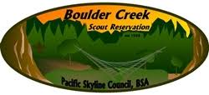
Last update 5/5/2022
Cub-ON Leaders and Parents’ Guide

Table of Contents
Contents
Table of Contents 2
A Message to Cub Scout Leaders and Parents 3
About Boulder Creek Scout Reservation 4
Crew 869 (Cub-ON Staff) 5
Cub-ON Information 6
Registration 6
Getting There 6
Campsites 6
Fire Safety 6
Additional 6
Arrival & Check in 7
PARKING 7
Check in 7
Event & Activity Overview and Rules 7
The Ranges for Shooting Sports 7
Aquatics 7
The Craft Pavilion 8
Other Activities and Special Programs 8
Cracker Barrel and the BIG Giveaway 8
General 8
Parking 8
Allergies 9
Showers and Toilets 9
Medicine 9
First Aid 9
Patches 9
Departure 9
Alcohol, Tobacco, and Drug Policy 10
BSCR site map 11
Activity Schedule 12
Map to Boulder Creek Scout Reservation 13
Directions to Boulder Creek Scout Reservation 14
Packing List / What to Bring 15
ADDITIONAL REMINDERS: 15

A Message to Cub Scout Leaders and Parents

On behalf of the Pacific Skyline Council, thank you for coming to Cub-ON and welcome to Boulder Creek Scout Reservation!

Cub-ON is an event that goes back over thirty years, and we’re glad you’re here! From first-time visitors to veteran Scouts and Scouters, this weekend’s stay is the perfect opportunity for you to get acquainted with our camp, enjoy the outdoors and the fellowship of your fellow Scouting families.

We’ve written this Leaders’ Guide to help you prepare your unit for a fun and unforgettable weekend! Our camp staff is dedicated to providing you with a great Scouting experience! But remember, in Scouting, we all work together. Each adult is required to help with (at least) one Activity Shift in one of our program areas. Show your Scouts how to “Do your Best!” Your Scouts will thank you and always remember the efforts that their leaders and parents put forth to help them have a memorable experience.

Yours in Scouting,

Andrew Wilmes
Cub-ON Staff Advisor
Email Andrew.Wilmes@scouting.org
Office 650-341-5633
Mobile (650) 243-8803
Boulder Creek Scout Reservation
Special note:
- Print t pages 11-15, double sided for use at camp.
- Parking Restrictions implemented see pages 7, 8

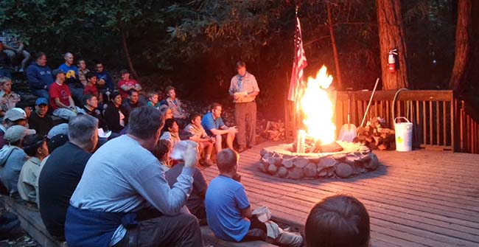

THE VISION OF BOULDER CREEK SCOUT RESERVATION
Is to give every Scout a truly memorable outdoor experience while building Scouting ideals through advancement and mentorship.

GENERAL CAMP INFORMATION
Boulder Creek Scout Reservation (BCSR) covers over 300 acres of varied terrain (three ecological zones) and borders the lush Bear Creek where salmon and steelhead spawn. BCSR also offers a 2.5-mile nature trail and a 3.5-mile historical trail describing the history of early California logging. The camp, which can accommodate up to 200 campers in 23 camping areas, offers a quiet and serene camping atmosphere, a pavilion for crafts and presentations, campfire circle, outdoor chapel, archery and rifle range, kitchen, swimming pool, picnic tables, and shower and restroom facilities. The camp has a full-time resident ranger who can assist you with all your needs.
The camp entrance sign is located at 250 Scout Ranch Rd., a little over 1 mile from the town of Boulder Creek on Bear Creek Rd. If coming from Highway 17 it is 12 miles to the entrance sign on the left. Coming from Boulder Creek or Highway 9 the entrance is located on the right. Follow Scout Ranch Rd. across the bridge and into the parking lot. Allow 1-1.5 hours driving time from most areas on the Peninsula.

ACCREDITATION
Boulder Creek Scout Reservation is fully accredited by the National Council, BSA and operates under the strict health, safety, and management guidelines established by the Boy Scouts of America, the State of California, and the County of Santa Cruz.
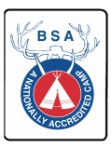
The weather in camp is temperate year-round, but conditions can change quickly. Campers should be prepared and pack accordingly. Bring clothes to layer, hats & gloves, and rain gear. Long-sleeved shirts and pants are preferred to protect against ticks, mosquitos, poison oak and other natural hazards.

Crew 869 (Cub-ON Staff)

Cub-ONs and other events at Boulder Creek Scout Reservation are supported by a co-ed Venturing Crew – Crew 869. Venturing is the BSA’s older youth program and provides additional leadership and high adventure opportunities for youth aged 14 - 21. Please ask our camp staff if you would like additional information about the Crew and how it helps to further camping opportunities in our Council.

Host Scouts BSA Troop

Each Cub-ON is staffed by a different “Host Troop” Scouts BSA Troop, under the direction of their Scoutmaster and with support from Crew 869, are further able to develop their leadership skills by acting as Den Chiefs throughout the weekend. Please ask our camp staff if you would like additional information about this program.

…Do Your Part, Do Your BEST

Scouting runs on volunteer power! All adults are required to perform at least ONE shift in one of our program areas and may be asked to volunteer one kitchen/dining area shift. Please sign up for your shift(s) at Check-in.

Show your Scouts how to “Do Your Best!” Your Scouts will thank you and always remember the efforts that their leaders and parents put forth to help them have a memorable experience.

Youth Protection

The Boy Scouts of America places the greatest importance on creating the most secure environment possible for our youth members.

Required Training

- Youth Protection training is required for all BSA registered volunteers.
- Youth Protection training must be taken every two years. If a volunteer’s Youth Protection training record is not current at the time of recharter, the volunteer will not be reregistered.
- Training to be taken at my.scouting.org

(Feb 2022: https://www.scouting.org/health-and-safety/gss/)

Cub-ON Information

Registration
Register for Cub-ON at https://pacsky.org/activities/cub-scout-activities/cub-on/

The Pacific Skyline Council’s Refund Policy 2/12/2019: All payments are final. Refunds may be requested no less than 30 days prior to an activity or rental reservation. Some activities, such as summer camp, may have additional restrictions that apply. Any refund granted will be less an administrative service charge of 15% of the total fees due for the activity or rental. This includes duplicate registrations/reservations.
Full policy can be found with your registration.

Getting There
Drive to Cub-ON: Boulder Creek Scout Reservation is in the Santa Cruz Mountains and easily accessible from points throughout the Bay Area. A map to camp is included in this Leaders’ Guide.
Directions and general map available on pages 13 and 14

Campsites
Scouts and their families are grouped by pack and assigned to campsites based on availability and the total size of their contingent. Most campsites are equipped with shelters, with fire rings, potable water.

Fire Safety
View video on the proper steps for fire starting and extinguishing your campfire, http://bit.ly/cubonfire

Please bring your own firewood. Only small fuel for tinder and kindling may be picked up off the ground. Do not chop down or break branches off trees.

Before you leave your site unattended at all, you will need to put out your fire completely. This means cool to touch. Please see above link for fire safety video. During certain times of the year with high fire danger, campsite fires will not be permitted.

Additional
If you choose to prepare your own meals at campsites, please notify the Camp Director/Kitchen Director so they can plan accordingly. Be careful with your food, securing it from animals and thoroughly cleaning the areas making sure to avoid the accumulation of food scraps near camp (especially where dishes are washed).

Pack your camp’s trash before you leave and throw away into the dumpster located at the maintenance area.

We can eliminate a large portion of waste if attendees use reusable bottles/cups.

Arrival & Check in

PARKING
Due to ongoing concern about the sustainability of our roads, we have added measures to prevent overuse of our camp roads. BACK IN PARKING ONLY DO NOT BLOCK OTHER VEHICLES IN. PARKING IS PERMITTED IN THE PARKING LOT NEAR ENTRANCE OF CAMP. The only exception to any of these rules is in the event of an emergency.

Check in
Friday: 6:00 pm on Friday until 11pm at the Entrance Gate. Park in the main parking lot and walk up to the check in station.

Saturday: 7:00 am and 12pm at the Entrance Gate. Park at the main parking lot and walk up to the check in station.

You will be given your campsite assignment the Thursday prior to arrival. Each parent must sign up for one activity shift, this helps keep the cost of Cub-ON down. A wristband identifying you as a camp attendee will also be issued at that time and must be worn by all campers throughout the weekend.
BSA Medical Record
A BSA Medical Record (Parts A and B) is required for every camper, youth and adult. The Medical Record should be turned in at check-in. The forms will be returned upon departure. If the forms are not picked up, then they will be destroyed after the event.

If you need to leave camp to run into town, go to a sport event, etc. please let the Camp Director know. Before you go home (before 10am) on Sunday please check out with Camp Director.

Event & Activity Overview and Rules

Cub-ON (Cub-Over Nighter) is a weekend family camping event for all Cub Scouts and their families at
Boulder Creek Scout Reservation. Program areas are open throughout the weekend, and Scouts and their families can participate on a drop-in basis.
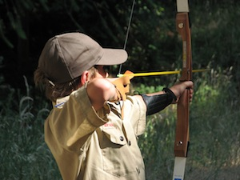

The Ranges for Shooting Sports

Cub Scouts can participate in a variety of Shooting Sports, including Archery and BB Gun Shooting. All ranges are supervised by BSA-certified Rangemasters. Per California Law we are requiring that a Shooting sports permission form is completed for every youth Camper and signed by parents.

Aquatics

Swimming is offered at the pool, weather, and trained staff permitting! Leaders and parents should identify themselves to our Camp Staff if they hold a BSA or Red Cross lifeguard certification.

The Craft Pavilion
Arts & Crafts – examples vary between Cub-ONs: Tie-Dye, Craft kits, Pumpkin Carving (October Cub-ONs) and others may be available in the Craft Pavilion depending on the Cub-ON.

Other Activities and Special Programs
Other activities include Hiking, Whittling Chip instruction, and a Saturday Night Campfire program. Special programs include:

- The Bobcat Rank– NEW Scouts can earn their BOBCAT badge in ONE day!
- Whittling Chip-Knife safety
- BB gun and Archery (shooting sports awards can be earned)
- “Haunted Camp” & Pumpkin Carving (October)
- Aquatics
- Creek Walk
- Campfire
- Campfires are great friendship, fellowship, and Scout Spirit builders. We invite all of our packs to join in the fun by performing their favorite skit, stunt, or song during our Campfire program on Saturday night. Please check with our camp staff for additional information.
- Scout’s Own

Cracker Barrel and The BIG Giveaway
After our Saturday Campfire, campers are welcomed back to the Dining Area for homemade sweets, courtesy of our Kitchen Director, Bob Marozine. Bob first came to Cutter as a Scout in the early ‘70s and has been gracious enough to continue this journey to Boulder Creek Scout Reservation.

Cracker Barrel (krak-er-bar-uh): adj.; suggestive of the friendly homespun character of a country store - “a cracker–barrel philosopher.”
Noun,; in Scouting Cracker Barrel usually denotes desserts and fellowship.

During our Campfire, our camp staff hosts “The BIG Giveaway” – Campers may receive one ticket each at Campfire or may receive one ticket for every $5.00 that they spend in the Trading Post.

General
Do not enter areas marked as “STAFF ONLY.” Only the Camp Director can authorize individuals otherwise.

Parking
BACK IN PARKING ONLY. PARKING IS PERMITTED IN THE PARKING LOT NEAR THE ENTRANCE OF CAMP ONLY. Your vehicle must remain in the parking lot. Due to the season of heavy rain, and ongoing concern about the sustainability of our roads, we have added measures to prevent overuse of our camp roads.The only exception to any of these rules is in the event of an emergency.
ALL CARS MUST BACK INTO SPACES TO ALLOW FOR EASIER EXIT IN CASE OF EMERGENCY. DO NOT BLOCK ANY OTHER CARS IN.

Meals

All meals are freshly prepared and served at the outdoor Dining Area, starting with dinner on Friday and ending with lunch on Sunday. Meals are healthy and hearty, and designed to accommodate most diets. There is some storage space available if you find it necessary to bring your own food (gluten-free, soy-free, etc.) If you have questions regarding our menus, please do not hesitate to contact the Council office at 650.341.5633. You are welcome to bring your own snacks and store them in your campsite; please make sure that they are secured and not stored in a manner that allows access for animals.

Allergies
We take food allergies seriously. If you have an allergy, such as nut allergies, let the Camp Director know at least one week prior to arrival. We will then be able to plan food accordingly, i.e. nut free dining hall (as needed).

Showers and Toilets

There are showers located in the Shower House. Flush toilets are located at the Cubland Campsite as well as the Shower House and Porta Potties are available by the pool.

Medicine

Prescription medications should be secured and stored in campsites and administered by a parent or guardian. Please talk to the camp staff if you have any other medical concerns. If you are taking prescription medications with the potential of impairing any functioning or judgment, you will not engage in activities that would put Scouts at risk, including driving or operating equipment.

First Aid

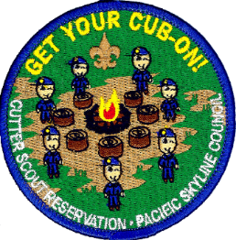
There is a First Aid Station located at the Medic Area just up the hill from the Dining Area and numerous First Aid kits located around camp. Should you need medical assistance, notify the Camp Director on site. Leaders, Parents, and Guardians should identify themselves to Camp Staff if they have medical training.

Patches

Each youth participant will receive a commemorative patch for attending!

Departure

You may leave camp based on your personal schedule. Please notify the camp staff if you are leaving prior to Sunday breakfast or lunch so that we may plan meals accordingly. If ready and available, patches will be given to your unit leader for distribution. Before you go home on Sunday please check out with Camp Director.

Trash clean up
Pack your camp’s trash and throw it away in the dumpster located at Maintenance Area prior to your departure.
Did YOU Forget Something?
The Camp Trading Post sells snacks, drinks, t-shirts, souvenirs, crafts, outdoor supplies, toiletries, and other miscellaneous items. You’ll receive a BIG Giveaway raffle ticket for every $5.00 that you spend! Most families usually spend $30-$50 in the trading post. Cash is preferred, check and credit card accepted.

Alcohol, Tobacco, and Drug Policy

As outlined in the Scouter Code of Conduct, Scouting activities are not a place to possess, distribute, transport, consume, or use any of the following items prohibited by law or in violation of any Scouting rules, regulations, and policies: alcoholic beverages or controlled substances, including recreational or medicinal marijuana.
In addition, the Code of Conduct specifies that if you are taking prescription medications with the potential of impairing any functioning or judgment, you will not engage in activities that would put Scouts at risk, including driving or operating equipment.
https://www.scouting.org/health-and-safety/gss/bsa-scouter-code-of-conduct/

Tobacco

Adult leaders should support the attitude that they, as well as youths, are better off without tobacco in any form and may not allow the use of tobacco products at any BSA activity involving youth participants.

All Scouting functions, meetings, and activities should be conducted on a smoke-free basis, with smoking areas located away from all participants.

(Feb 2022: https://www.scouting.org/health-and-safety/gss/)

Cutter site map

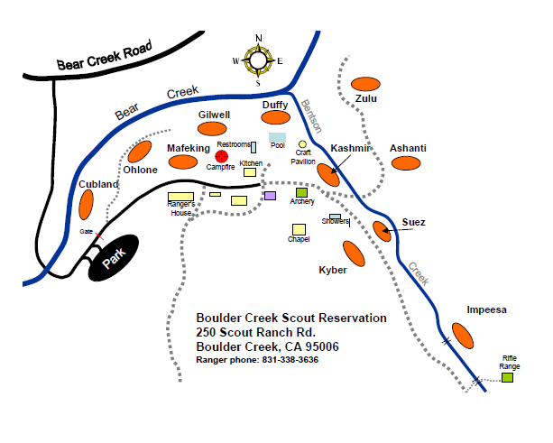
First Aid Medic Area
PARKING HERE ONLY

SPEED LIMIT IN CAMP 10MPH

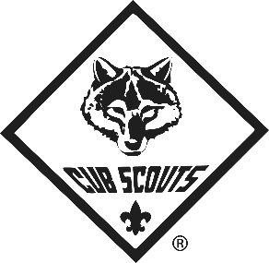

Activity Schedule

(Not All Areas May be Open Due to Supervisory Availability)

6:00 pm-10:00 pm | Check-in Starts
7:45 pm-8:30 pm(app) | Dinner
9:45 pm | TAPS – Quiet and Lights Out!
7:00 am-9:20 am | Check-In
8:00 am-9 am | Breakfast
9:30 am-9:45 am  9:45-12 pm | Opening Flag Ceremony  Check-in
10:00 am-12 pm | Program Areas Open
12:00 pm-1 pm | Lunch
1:30 pm- 5 pm | Program Areas Open
6:00 pm-7 pm  7:30pm-8 pm | Dinner  Fire Building & Safety
8:00 pm(app.)-8:45 pm(app.) | Evening Campfire & Big Giveaway
8:55 pm-9:30 pm (app.) | Cracker Barrel
9:45 pm | TAPS – Quiet and Lights Out!
8:00 am-9 am | Breakfast
9:30 am | Scouts’ Own
10:00 am-11 am | Program Areas Open
11:30 am | Lunch (Take Away)

Thank you all for your help to make Cub-ON successful!
See the White Board by the Dining Area or listen to announcements at meal-times regarding the following special programs:

- The Bobcat Trail (first rank earned in Cub Scouts except Lion Scouts)
- First Aid
- Whittling Chip (knife safety)
- Haunted Trail (October Only)
- Nature Hike
- Adult Training Classes (usually October for BALOO training)
Andrew Wilmes, Cub-ON Director
650 243-8803

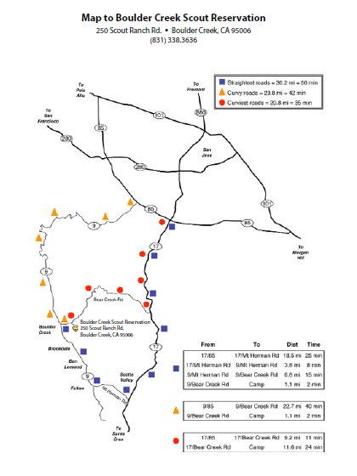
Directions to Boulder Creek Scout Reservation

Boulder Creek Scout Reservation
250 Scout Ranch Rd.
Boulder Creek, CA 95006
Ranger phone: 831-338-3636

It is suggested to print driving instructions from Google Maps or other map service. GPS has been known to cut out for some folks traveling to camp.

The camp entrance sign is located at 250 Scout Ranch Rd., a little over 1 mile from the town of Boulder Creek on Bear Creek Rd. If coming from Highway 17 it is 12 miles to the entrance sign on the left. Coming from Boulder Creek or Highway 9 the entrance is located on the right. Follow Scout Ranch Rd. across the bridge and into the parking lot. Allow 1-1.5 hours driving time from most areas on the Peninsula.

Packing List / What to Bring
* = available in Foster City Scout Shop

Camping Equipment
- Family Tent*
- Sleeping Bag*
- Pillow*
- Sleeping Pad or Air Mattress*
- Flashlights / Head Lamps*
- Camp Lantern*
- Rope (paracord at Scout Shop)*
- Mess Kit (optional)*
- First Aid Kit*
- Wood (for campfire)
- Matches*
- Water Bottle*
- Reusable cup*

Clothing
- T-Shirts* (3) & Pants (2)
- Sweater or Sweatshirt* (1)
- Underwear (3)
- Jacket or Poncho* (1)
- Rain Gear*
- Sturdy Shoes/Sneakers
OPEN TOE SHOES/SANDALS NOT permitted in camp except the pool/shower area
- Socks* (3 pair)
- Water shoes for the Creek walk
- Swimsuit (if pool is open)
- Knit Cap*
- Baseball Hat*
- Uniform* (optional – check w/your Leader)

Toiletries
- Toothbrush
- Toothpaste
- Soap
- Sun Block
- Bug Repellent*
- Personal Medications
- Towel*
- Medical Forms for Youth & Adult Participants Parts A&B
And Shooting Sports Permission Form

Did YOU Forget Something?
The Camp Trading Post sells snacks, drinks, t-shirts, souvenirs, crafts, outdoor supplies, toiletries, and other miscellaneous items. You’ll receive a BIG Giveaway raffle ticket for every $5.00 that you spend! Most families usually spend $30-$50 in the trading post. Cash is preferred, check and credit card accepted.

The weather in camp is temperate year-round, but conditions can change quickly. Campers should be prepared and pack accordingly. Bring clothes to layer, hats & gloves. Long-sleeved shirts and pants are preferred to protect against ticks, mosquitos, poison oak and other natural hazards.

There are showers located in the Shower House. Flush toilets are located at the Cubland Campsite as well as the Shower House and Porta Potties are available by the pool.

There is minimal to no cellular service in camp. Potable well water is stored and treated for our use. In case of emergencies, there is a landline telephone located at the Ranger’s house.

ADDITIONAL REMINDERS:
- PARKING AT MAIN PARKING LOT ONLY, UNLESS OTHERWISE INSTRUCTED BY CAMP STAFF.
- CHECK IN AT DINING AREA UPON ARRIVAL.
- NO ALCOHOL, NO TOBACCO, NO CONTROLLED SUBSTANCES, NO Recreation or Medical MARIJUANA PERMITTED. (Full policy page 11)
- NO OPEN TOE SHOES/SANDALS in camp except in pool/shower areas
- CONTACT THE CAMP DIRECTOR FOR ANY EMERGENCIES 24-7.

