
2026 Eagle Scout Scholarship

APPLICATION FORM FOR ELECTRONIC SUBMISSION ONLY

2026 Eagle Scout Scholarship
Honoring the Class of 2025 Eagle Scouts
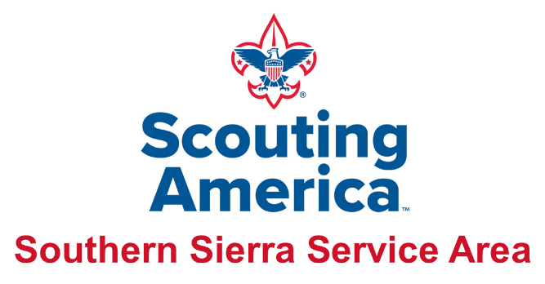

About the Scholarship: The Southern Sierra Service Area is pleased to present a college scholarship for the Class of 2025 Eagle Scouts, which will be a highlight of the annual Eagle Scout Recognition Dinner. This generous scholarship is awarded by the Southern Sierra Service Area through Eagle Scout Dinner sponsorships.

Applicant Eligibility:
- Be a current or past registered member of the Southern Sierra Service Area.
- Must be a member of the Southern Sierra Council 2025 Class of Eagle Scouts.
- There is no age requirement for this scholarship.
- The scholarship may only be used for higher education (college or trade school). All funds will be paid directly to the recipient’s selected school upon their enrollment and request for payment. All funds will be kept in a custodial account until the funds are requested.
- Candidate must apply for scholarship using this application.
- Complete the application and return along with the specified write-ups. A personal interview may be requested.

Submit applications by email to andrew.a.kao@gmail.com by Thursday, February 19, 2026.

Procedure: The Eagle Scout applying for a scholarship must complete the electronic application personally.

- Fill out the application form completely and submit via email.  - Email the complete packet to andrew.a.kao@gmail.com  and copy a parent or guardian.  - No paper submissions will be accepted. |  | - Essay – “What Being an Eagle Scout Mean to me” – Minimum 250-words.  - Eagle Scout Project – Minimum 200-word description of your Eagle project.  - Your Life’s Goals & Aspirations – Minimum 200-words.
Applicant’s Information:

Name: __________________________________________________Troop/Unit #______________________________

Home Address: ____________________________________________________________________________________

City: ________________________________________________ State: _____________ Zip: ______________________

Phone: (_______) _____________________________ Year of High School graduation: ___________________________

Date of Birth: ____________________________ Eagle Scout board of review date: ______________________________

Name of parent/guardian: ___________________________________________________________________________

Address (if different): _________________________________________________________________________________

City: ____________________________________________State: _____________ Zip: ____________________________
Scouting Record (check all that apply)
☐OA Vigil Honor
☐OA Brotherhood
☐Philmont Trek Participant
☐National Jamboree
☐World Jamboree
☐NYLT Training Completion
☐NAYLE Completion
☐Religious emblem

Merit badges - # earned _________
☐Bronze palm - # earned _________
☐Gold palm - # earned _________
☐Silver palm - # earned _________
☐Other Scouting Recognition (please specify)
___________________________________

POSITIONS HELD (Check all that apply)
☐Patrol Leader
☐Assistant Senior Patrol Leader
☐Senior Patrol Leader
☐Troop Guide
☐OA Troop Representative
☐Den Chief
☐Scribe
☐Librarian
☐Historian
☐Quartermaster
☐Junior Assistant Scoutmaster
☐Chaplain Aide
☐Instructor
☐Webmaster
____Outdoor Ethics Guide
☐Summer Camp Staff
☐National Camp Staff
☐NYLT Staff
☐OA Member
☐OA Lodge Chief
☐OA Chapter Chief
____Other Scouting positions/awards
(Please specify)
_________________________________________________________________________________
Have you served in a staff position for any of the following? (Check all that apply)

School Activities
Name of current school ____________________________________________________ GPA:____________________
Address____________________________________________City__________State_____Zip______________________
List school activities including sports and clubs you belong to and leadership positions (e.g. Honor Society, Debate Club etc.) ______________________________________________________________________________________________________________________________________________________________________________________________________________________
__________________________________________________________________________________________________________

____Other Scouting positions/awards
(Please specify)
_________________________________________________________________________________
Have you served in a staff position for any of the following? (Check all that apply)

“What Being an Eagle Scout Means to Me”
Use this space to submit your minimum 250-words essay.

Eagle Scout Project
Please provide a description of your Eagle Project.
(Be sure to include number of hours)
(minimum 200-words)

Your Life’s Goals & Aspirations
In the space provided, share your life’s goals & aspirations.
(minimum 200-words)

Authorization:
I hereby authorize the Scholarship selection committee to request and obtain any further information it deems necessary.

On My Honor as a Scout, all information on this form is true and correct. I hereby authorize the Southern Sierra Service Area to obtain any further information deemed necessary.

_______________________________________________ Signature of Applicant (Digital Signatures Accepted)
Click or tap to enter a date.
Date

I have read this application, and it has my approval.

_______________________________________________
Click or tap to enter a date.
Date
Signature of Parent/Guardian (Digital Signatures Accepted)

Questions: Contact Eagle Dinner Chair, Andrew Kao – (661) 903-1117 or andrew.a.kao@gmail.com
ELECTRONIC SUBMISSION ONLY andrew.a.kao@gmail.com

Please copy a parent or guardian on ALL submissions

