WELCOME TO
CLUB CHAWANAKEE

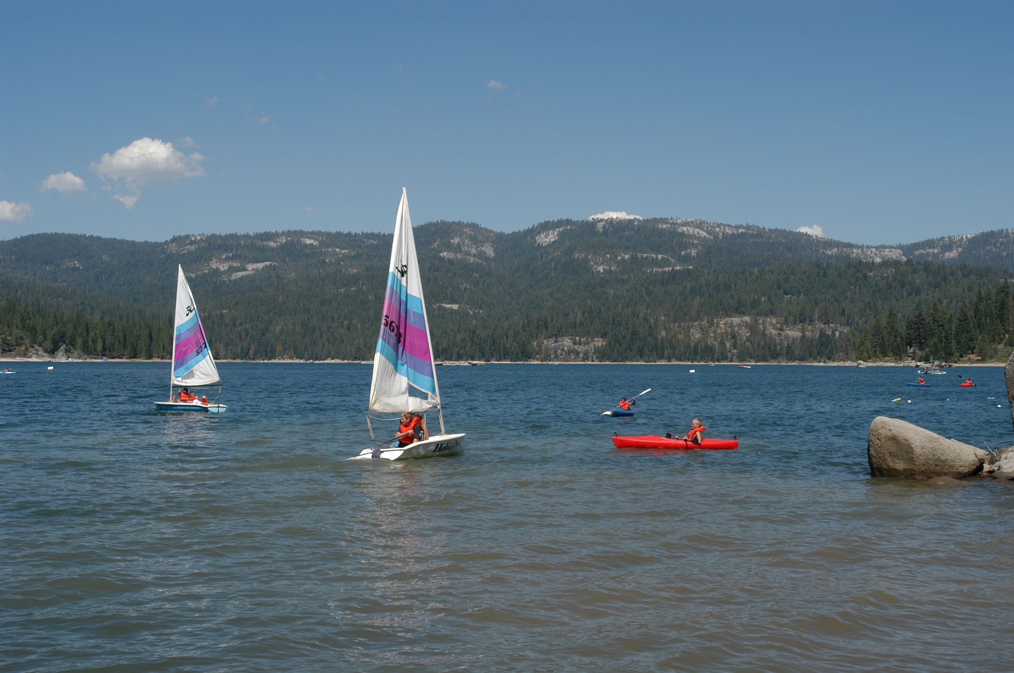

FAMILY VACATION
CAMP
2022





2022
Dear Club Chawanakee Attendee:
Thank you for choosing Club Chawanakee for your family vacation. Our program staff has done an outstanding job with the program that you will enjoy throughout your stay at Club Chawanakee. Now, if you are looking for peace and quiet, we can also accommodate you. Please read the information in this booklet carefully. If you have any special requests or needs let us know as soon as possible. We are looking forward to meeting you all, both returning and new families to Club Chawanakee.

Make sure to complete the attached medical information and the BSA Pre-Event Medical Screening Checklist form prior to coming to camp. Each family member will need to have one completed. You only need to complete parts A and B. Complete the form as completely as possible regarding your health and the health of your family.
If you should have any questions, please feel free to call me at the Fresno Service Center at (559) 320-2100.

Yours in Scouting,

Greg
Greg Ferguson

Camp Chawanakee: Summer Address 43485 Dinkey Creek Road Shaver Lake, CA 93664
Sequoia Council, Boy Scouts of America
6005 N. Tamera Avenue · Fresno, CA 93711-3911 · (559) 320-2100 · Fax (559) 320-2114

Registration Fees:
Camp Fees are: $115 per person age 15 or older, $95 per person age 6 to 14
Children 5 years and under are free. Meals are included with your registration fees.
First meal is Saturday breakfast.

Campsites will be assigned on a first come first served basis. Campsites requests will be taken into consideration but please be aware due to reservation constraints not all campers may receive their requested site. Not all campsites will be available


Check-In/Check-Out Procedures: Check in begins at 6:00 pm on Friday. Check-in will be at the camp office, located just north of the camp parking lot. At check-in guests will pay the remainder of their balance due and will be assigned a campsite. Guests and their luggage will be directed to their campsite.
All guests are requested to check out by 12:00 p.m. the day of their departure. There are no activities scheduled in the afternoon on the final day.


Fires:


- Fires are only permitted in the fire rings and barbecue stands in each campsite.
- New fire pits may not be constructed in any camp area.
- Fire control tools are located near the restrooms. Please feel free to use them but remember to return them after use. Open flames are not allowed in any tent. This includes propane or gas heaters and lanterns

What to bring to camp: Guests are welcome to bring items to help make their stay more enjoyable. Please review the list of recommended items to bring.

Program Area Information:

Schedule: – You will be provided with a schedule upon arrival at camp. The basic schedule for camp run activities and food service each day will be:

7:30 a.m. – 8:30 a.m. Open Breakfast
9:30 a.m. – 11:30 a.m. Program Session
12:00 noon – 1:00 p.m. Lunch
1:30 p.m. – 4:30 p.m. Program Session
5:30 p.m. – 6:30 p.m. Dinner
Schedule subject to change without notice.

General Information: The camp program areas will be open each morning from 9:30 a.m. to 11:30 a.m. and from 1:30 p.m. to 4:30 p.m. Program areas will close at 11:30 am the final day of camp. All program areas are certified under B.S.A. National Camp Standards and are subject to operate under these standards for your protection and safety.

Waterfront: Our waterfront activity area provides opportunities for the entire family to take advantage of beautiful Shaver Lake. Program staff will help direct you and your family in swimming, sailing, rowing, and canoeing. All guests wishing to use the waterfront must submit to a swim check of swimming proficiency. All guests will also be required to have a “buddy” (i.e. friend, parent or relative) who will participate with them while at the waterfront activity area. Waterfront staff cannot be used as guest’s buddy. Our waterfront activity area is located north of the Camp Office and Trading Post. Campers are not to enter the water surrounding the camp or to climb on the rocks. Swimming is only allowed in designated areas.


Personal Watercraft: In accordance with B.S.A. National Camping Policy, all privately owned boats must be kept at the designated waterfront area. The use of jet skis and wave runners are not authorized for use in any B.S.A. program or B.S.A. run facility. Personal boats must comply with current B.S.A. Safety Afloat regulations and must be launched from the Marina. Owners must provide proof of insurance.

Handicrafts: The handicraft area will be the place for guests interested in leatherwork, woodcarving, and other craft ideas.

Field Sports: Both the archery and the rifle range will be available to all guests and will be run under B.S.A. National Camp Standards. The rifle range features both BB guns and .22 rifles. The archery range features several sizes and strengths of bows to accommodate every guest’s ability.



Parents should be aware of their children’s ability and maturity in using either the rifle range or archery range. Guests who are not registered Boy Scouts/Venturers and/or under the age of 11 will only be able to use the BB guns.

To participate in the rifle range each participant must have a State of California Consent form filled out and attend a safety briefing at camp. The consent form will be sent with pre-camp documents. There will be a general attendance safety briefing announced at camp. If you are unable to attend the general audience one, you will have to go through it at the range prior to participating.

Trading Post: The trading post will be open daily with morning and afternoon hours as posted.

Evening Events: Events may include games for families, campfires, and other events.

Telephone Service: Personal cellular phones may be used but not all companies provide service in the Shaver Lake area. In case of an emergency, the following phone number may be used to contact camp:



Camp Chawanakee Office Phone
(559) 841-2117

Parking: Parking is available in designated areas only. Please note that there are no RV hookups available.
After you check in at the office, you may drop off equipment at the campsite, but then you must return your car to the parking lot. All cars will be required to be parked in the parking lot.

When leaving at the end of camp you may drive your car into camp to pick up equipment.

Your Family Campsite: In each campsite, your group will be provided enough tents, cots, and mattresses to accommodate every person. Each campsite is also provided with a picnic table and a barbecue grill. All other items will need to be brought with you. It is recommended that you bring folding chairs for relaxing. There are campsites available for disabled campers and those with special needs. Check with the Camp Director if a special needs campsite is required. Shower and restroom facilities are located near each campsite. All latrines and showers are unisex and available to youth and adults. Simply lock the door upon entering. Full garbage liners can be placed by the road no later than 5:00 p.m. each evening for pick-up.

- Please leave your family pet at home.
- Please respect the space and property of others around you.
- No alcoholic beverages or illegal drugs are permitted. If any are found in your possession you will be asked to leave immediately, and the authorities may be called.
- Smoking is only permitted in the dumpster area behind the dining hall. Please clean up after yourself.
- Fireworks are strictly prohibited.
- Personal firearms of any caliber are not permitted. The same is true of personal archery equipment.

Meal Service: All meals are included with your camp registration fee. Meals will be served in the Camp Dining Hall. Guests requiring special dietary needs must notify the Sequoia Council Office at (559) 320-2100. Although we try to accommodate special needs for diets, we follow the same rules as the BSA Scout Jamboree and Philmont Scout Ranch. If you have special needs, please bring those food items with you and we will help you prepare and store these items.

Personal Equipment:

SLEEPING BAG OR BED SHEETS AND BLANKET
PILLOWS
PERSONAL TOILETRIES
TOWELS
CAMERA
LIP CARE
TRADING POST MONEY
SUNGLASSES
JACKET OR SWEATSHIRT
SWIMSUIT
CHANGE OF CLOTHES
LONG PANTS
FLASHLIGHT
INSECT REPELLENT
SUNSCREEN
HIKING BOOTS OR STURDY WALKING SHOES

Optional Campsite Equipment:

CHARCOAL BRIQUETTES
BARBECUE UTENSILS
PLATES, UTENSILS, CUPS, ETC.
DISHWASHING LIQUID
SMALL SHOVEL
FIRST AID KIT
ICE CHEST
MATCHES
LAWN CHAIRS
WATER JUG
LANTERN

Our Family Activity Plan

_________________________________________________________________________________________

_________________________________________________________________________________________

_________________________________________________________________________________________

_________________________________________________________________________________________

_________________________________________________________________________________________

_________________________________________________________________________________________

_________________________________________________________________________________________

_________________________________________________________________________________________

_________________________________________________________________________________________

_________________________________________________________________________________________

_________________________________________________________________________________________

_________________________________________________________________________________________

_________________________________________________________________________________________

_________________________________________________________________________________________

_________________________________________________________________________________________

_________________________________________________________________________________________

_________________________________________________________________________________________

_________________________________________________________________________________________

_________________________________________________________________________________________

_________________________________________________________________________________________

_________________________________________________________________________________________

_________________________________________________________________________________________

