
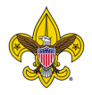
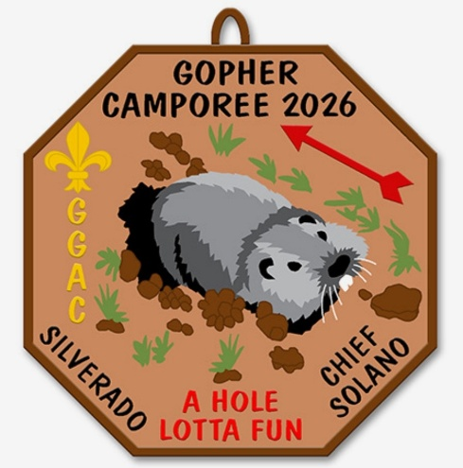
Camporee Location and Times
Skyline Wilderness Park
2201 Imola Avenue, Napa, CA 94559
Friday, April 24, 2026 thru Sunday, April 26, 2026
Check-in & Setup 5-8:30pm

General time is Friday 5pm & Sunday noon
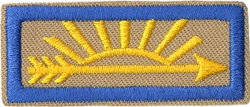
(Final Schedule will be provided at Event)

Event Planned & Run by:
Order of the Arrow Chapters of Yerba Buena Lodge
Sem-Yeto - Swegedaigea
All Welcome
- Arrow of Light Scout Only & Parent (Webelos not allowed by national camp standards)
- Participation in the Camporee is by Patrols
- Patrols are usually 8 or fewer members. Please adjust if larger
- The Patrol Leader will lead the Patrol during the entire Camporee
Adult leaders are to observe and provide safety!
Registration Register Here
- Scouts and Adult Leaders $40 / $30 early bird thru April 10th
- Arrow of Light Scout and Parent $40 / $30 early bird thru April 10th for both
- NEW Please register your Patrol(s) on the registration site for shooting sports time slot. (45min)
  - Only register the Patrol Leader with the Patrol Name NOT the whole patrol.

Contacts:
Camporee Advisers
Steve Rodriguez: srodriguez.scouting@gmail.com
Ken Miller: SemYetoAdviser@oa-yerbabuena.org

Arrival & Check-in
- All Units will offload gear at the parking lot
  - NO vehicles in campsites.
- Scouts & leaders will backpack all of their personal gear needed for the weekend to their designated campsite
  - The staff will direct you to your camping site.
- If you have special needs, please make arrangements with Camporee Advisers.
- The UNIT should check-in when ALL members are present.
- Sign up for target sports time slot in advance. First come, first serve after registration is completed.
- Sign up for totin chip and fire -n- chit times on Friday evening while patrol is checking in.
- Cars and Trailers will park in designated areas.
Registration check-in – Please have these prepared to hand in at registration check in before coming up to the table.
As a Unit –
- Unit Medical forms Parts A, B1/B2 printed out and signed by parent for all participants. Given to Camporee Medic at Headquarters
- Patrol Roster with all Scouts listed for each Patrol (see appendix)
- Adult Roster with all registered Leaders (see appendix)
- 1 Copy of target and range sport permission form for each scout. (see appendix)
Campsites:
- Each Patrol will receive their campsite assignment at registration.
  - NO open fires are permitted in campsites.
- Stoves or Charcoal grills are permitted in accordance with Scouting America Safety Guidelines
- Dishwashing and the cleaning of pots and pans MUST be done in your campsite.
- Faucets near the bathrooms are for washing hands ONLY (NO dumping in the sink or cleaning dishes)
- Scouts should follow the principles of “LEAVE NO TRACE”
- Bring your own garbage bags and take waste home with you.
- Campsites suggestions:
  - No flames in tent
  - Camp gadget(s) i.e. wash basins, garbage receptacle
  - Entry / Gate way
  - Flags
  - Meal plan, duty roster posted
  - First aid kit
  - Proper camp layout
First Aid:
- First Aid is available at the Medical Tent located at Camporee Headquarters.
  - Only go to the medic if you or another troop member can’t treat the injury.
- Troop first aid kit
- Your Medical Forms will be with the Medical Staff in case of an emergency!
- Everyone should carry and drink water, wear a hat, and wear sunscreen.
- There are ticks, snakes, and poison oak in the area. Stay in designated areas and check for ticks frequently.

Uniform:
- Field Uniform (Class A) is required for:
  - Friday Night Registration
  - Saturday Morning Flags
  - Sunday Morning Flags
  - Interfaith Service
  - Camporee Closing Ceremony.
- Non-Scout-related and/or inappropriate clothing is not permitted.

Conduct:
- Everyone is expected to conduct themselves in a Scout-like manner, living the Scout Oath & Law. Follow the Outdoor Code & Principles of Leave No Trace.
- Stay within camp boundaries
- Keep bathrooms clean
- Trash should be in personal trash bags and brought home with you
- Respect others and be quiet after TAPS
- INAPPROPRIATE LANGUAGE WILL NOT BE TOLERATED.

Visitors:
- Camporee is open to visitors, family, and friends, but NO overnight camping allowed.
- Please check in with Camp Headquarters if you visit.

Camporee Scored Activities by Patrol:
- Check-in
  - Uniform inspection form, Patrol Flag, 10 essentials, Patrol Spirit, Patrol yell!
- Campsite ideas
  - Entry / Gate way
  - Camp gadget(s) i.e. wash basins rack, garbage receptacle
  - No flames in tent signs
  - Unit Flags
  - Meal plan, duty roster posted
  - First aid kit
  - Proper camp layout
- Gopher Hole / Obstacle Course
- Gumby
- Pipe and ball challenge
- Orienteering
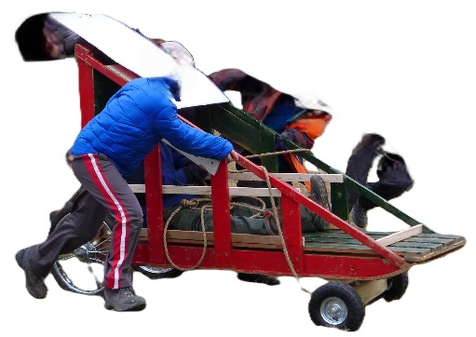
- Gopher Karts (Troop must provide Kart)
  - Build Kart ahead of time with wheels. Ready to go!
  - Sized to what a normal dog sled might be.
    - 1 rider, 1 pusher and 1 puller only
    - Must provide a helmet for rider (bike style ok)

Cooking Competition:
- There will be a Patrol as well as an Adult Cooking Competition. Prize for each!
- You will prepare a cooked meal with a dessert of your choosing
- No secret ingredient this year. Dazzle us with your Top Chef entry
- Bring your food to the Camporee Headquarters area at the designated time to be judged
  - You will be judged on Originality, Taste, and Presentation

Checkout:
- If any Scout needs to leave early, please notify Camporee Headquarters as soon as possible in advance.
- Each Unit will be asked for help to take down Camporee
- Your campsite is to be clean, neat, and returned better than your arrival. Leave No Trace
- Your campsite is to be inspected by a Camporee staff member
  - Staff will sign your evaluation form showing you are clear to depart.
  - This form is to be turned in to Camporee Headquarters to receive your Camporee Patches and Medical Forms.

There is NO shade
We have Portable Toilets - Please use and keep clean
Observe signs for different gender restrooms
Do not tie or attach anything to Fence
Tips for your Unit
- Bring Chairs & Tables  - Bring gloves  - Bring flashlights | - Know your six basic knots  - Know basic First Aid  - Know how to use a compass
A Scout is Always Prepared
Bring your Scout Spirit!
Save the Date!
2027 Camporee is April 23-25

Patrol Roster

Patrol Name: _____________________________________ Unit Number: _______________

1- Patrol Leader: _________________________________________________

2- Assistant Patrol Leader: _________________________________________

3- Patrol Member: _______________________________________________

4- Patrol Member: _______________________________________________

5- Patrol Member: _______________________________________________

6- Patrol Member: _______________________________________________

7- Patrol Member: _______________________________________________

8- Patrol Member: _______________________________________________

Leader Roster

Unit Number: _______________

1- Head Leader: __________________________ Cell phone #______________________
2- ASM: _________________________________ Cell phone #______________________
3- ASM: _________________________________ Cell phone #______________________
4- ASM: _________________________________ Cell phone #______________________
5- ASM: _________________________________ Cell phone #______________________
6- ASM: _________________________________ Cell phone #______________________

Evaluation & Checkout Form

Patrol: _______________________ Unit Number: _______________

Patrol Leaders: Complete the following information and take it to the Camporee Headquarters. A member of the staff will go with you to your campsite for inspection. Return the signed sheet to the Camporee Headquarters and receive your patches. You may then hike out as a patrol to the parking lot.

Things we liked about this year's Camporee:
________________________________________________________________________ ________________________________________________________________________ ________________________________________________________________________
Things we would like to see different for next year’s Camporee:
________________________________________________________________________ ________________________________________________________________________ ________________________________________________________________________
Names of scouts that would like to be on staff next year:
________________________________________________________________________ ________________________________________________________________________ ________________________________________________________________________

Campsite checked & approved for dismissal:
_______________________________ _________________________________
Print Staff Member Name Signature

