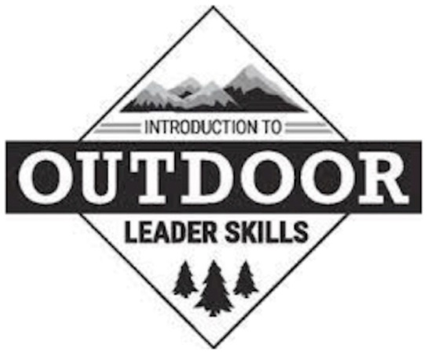
Introduction to Outdoor Leader Skills (IOLS)
For Scouts BSA leaders to be fully trained

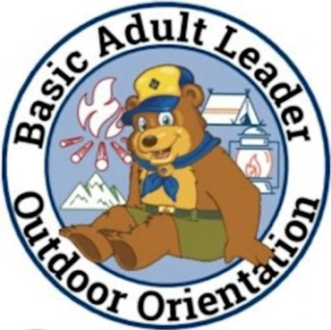
AND

Basic Adult Leader Outdoor Orientation (BALOO)
For Pack and Den Leaders conducting Pack Campouts

Friday, March 4, 6 PM through Saturday, March 5, 6 PM
Double V Scout Ranch, Ramada Grande,
3801 S Kinney Rd, Tucson, AZ 85719
In person with outdoor training and social distancing!
Cost: $20 – Registration at <LINK>
Saturday Breakfast & Lunch Included
This is an overnight camping experience. All participants should plan to bring:
Tent
Backpack
Water bottle
Cup, plate, bowl, knife, fork, spoon
Sleeping bag and sleep pad/air mattress
Scout Uniform
Warm clothes in layers, including a hat and gloves
Notebook, pen/pencil
Pocketknife
Flashlight
Personal First Aid Kit and personal medications
Personal care kit (toothpaste, toothbrush, soap, etc)
Folding chair (recommended)
Face Mask
Training presented by the Sky Islands Training Team
Contact: Fran Kearney, 520 257-7415 (please leave a voicemail)
or email fkearney1@cox.net with any questions or concerns.

