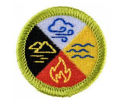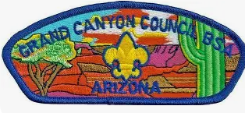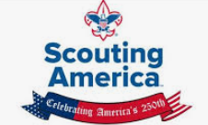

NOTES: American Indian Culture Merit Badge
Grand Canyon Council Virtual Merit Badge Class
This virtual merit badge session will be offered October 21 6:30-8:30 p.m. MST.
NOTE that Arizona does NOT use daylight savings time... Check your time zone!
(Pre-req (DELIVERABLE Req #2 DUE October 21st)
If you cannot finish your essay by this date, please email the MBC with what tribe you have chosen. Questions ?, Charles Daschbach, charles616@aol.com

This Merit Badge honors the traditions, cultures, and heritage of American indigenous tribes that lived in North America 5000-10,000 years before Columbus discovered the New World and the subsequent founding of our American colonies at the beginning of the United States of America 250 years ago.
Today there are over 575 separate U.S. American Indian tribes federally recognized as sovereign states on 326 designated reservations, speaking over 175 languages.
This Merit Badge reflects a shift towards a greater respect, accuracy, and engagement with the Native American tribal histories and cultures, focusing on authentic learning, a change discussed for years in Scouting at many levels. Native American cultures and individuals have significantly influenced Scouting America since our 1910 founding, helping to shape our core philosophy, honor societies, and educational programs.
The MB Requirements emphasize learning about different cultural areas, specific tribes, their governments, languages, common and contemporary life, moving away from more romanticized historical generalizations.
We will spend time in this session reviewing the five requirements:
#5…American Indian geographical and cultural areas in the United States.
#3…Common Terms and Languages and Five Well-Known American Indian Leaders
#4…Contributions made by American Indians to settlers and colonists in our modern life.
#5…(Pick one of these.) Visit a museum or gathering or a Pow Wow in person or on line
In the MB session we will take a virtual tour of the National Museum of the American Indian and view ten artifacts together and discuss...!!
Review http:americanindian.si.edu/
#2…The Req #2 should be done by October 19th and sent to charles616@aol.com.
If you cannot finish your essay by this date, please email the MBC with what tribe you have chosen.
The Requirement asks the Scout to conduct “Research on American Indian tribe, group, or nation.”
It gives a list of 17 cultural aspects for a tribe and the workbook gives a checklist for each element with a short space to fill out... …(Traditional dwellings, a way of life, tribal government, religious beliefs, family and clan relationships, language, clothing styles, arts and crafts, food cultivation, foraging and preparation, means of getting around, games, customs and warfare, and where and how they live today)
You may select any tribe, clan, or nation from the 575 federal tribes... It can be one in your area, where you visited once, or one you're curious about from reading or the movies.
You may fill out these items on the workbook...
or I might suggest you write a 250-300 word narrative about your tribe's story... that includes most of these elements you can find.
All tribes have a story! And their story tells who they are. All stories have certain themes or common elements that include, in no order of importance
- Their land.
- Their origin
- Their spirituality and beliefs.
- Their families and especially the role of mothers and women
- There are ceremonies in spirituality.
- Their connection to their animals
- Their values of honor, respect, and tradition
The central goal of this BSA merit badge is to learn the STORY OF A TRIBE…
and appreciate the culture and values of these Native American people.

