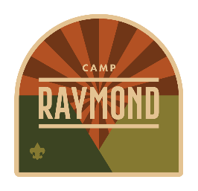

Cub Scout Family Camp
Camp Raymond, Parks Az
Parents’ Guidebook



2026 Cub Raymond Adventure Camp
PASSPORT to ADVENTURE
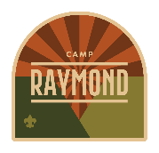


Let’s Travel to Adventure
Grab your Passport and get ready for an exciting trip around the world for the entire family at Camp Raymond!

Cub Raymond Adventure Camp is open to all family members. We welcome all youth, siblings, parents, grandparents and relatives.

Your family can travel the world and experience fun and interactive activities. Enjoy the trip and visiting unique areas of the globe.

Tips For Your Trip
We recommend registering early. When registering please be sure to complete all the registration questions to let us know important information on all the travelers in your family. Updates will be on the GCC Calendar / Registration site on the Event Details page.

Travel Accommodations
Families experience the great outdoors while enjoying the comfort of well-equipped camping sites. Bring your own tent and set up in scenic flat sites with running water, shelters, and latrines. All meals are served in our state-of-the-art dining hall, also known as the Bistro.

You can learn more about what makes Camp Raymond Family Camp special and all your options in our easy-to-follow Parent Guidebook. We look forward to seeing you on this amazing trip!

Ambassadors – Your Questions
We are here to guide you on your travels. If you have questions, please contact us at GCC.Program@ScoutingAZ.org or call us at (602) 955-7747.

Jennifer Hess Rick Brown
Camp Director Raymond Camp Ranger


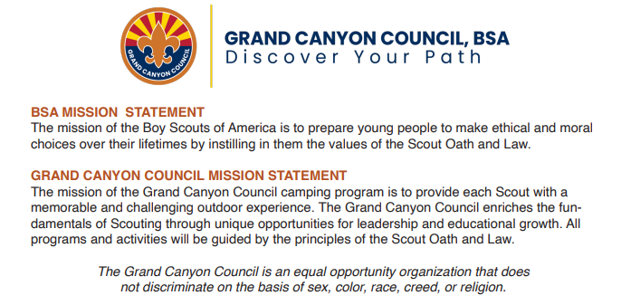



Table of Contents
Welcome to Camp Raymond 1
Two Worlds – Cub Scout Advancement & Fun Activities 1
Booking your Trip (Registration on GCC Calendar) 1
Arrival – Thursday Evening 1
Adventure Camp T-Shirt 2
Payment Deadlines 2
Registration 2
Last Chance for Camp – Late Registration 2
Refund Policy 2
BSA Annual Health and Medical Record (Required) 2
Trading Post 3
Arrival 3
Campsite Assignments 3
Meals / Dietary Needs 3
Health Lodge / Headquarters 3
Camper Care – Drinking Water 3
Camper Care – Washing Hands 3
Scout Uniform / Camp Attire 4
Label your Belongings 4
Lost & Found 4
Leaving Camp 4
Camp Check-Out 4
Caring For Your Campsite 4
Wildlife Safety 5
What To Bring 6
Items Not To Bring 6
Items Not Allowed 6
Directions to Camp Raymond 7
Camp Raymond Map 7



Welcome to Camp Raymond
Welcome to the amazing Camp Raymond located between the Kaibab and Coconino National Forests and is only 30 miles from downtown Flagstaff. Raymond is surrounded by some of the most beautiful terrain in Arizona.

From the east meadow, the morning view of the majestic San Francisco Peaks is glorious, and often the peaks are still covered with snow. Watch elk, pronghorn antelope, and deer graze as your day begins, then enjoy the 160+ acres of Camp Raymond.

We want to thank you for taking the time to explore the official 2026 Parents’ Guidebook, a comprehensive resource providing essential information to help you plan and prepare for an unforgettable summer camp experience. We strongly encourage all adults attending camp to read this guide in its entirety. For your convenience, the latest version of the Guidebook https://scoutingevent.com/010-CubRaymond2026

Two Worlds – Cub Scout Advancement & Fun Activities
We offer the best of both worlds – Cub Scout Advancement and Fun Activities. And the entire family is welcome – cub scouts, siblings, parents, grandparents, cousins or any other relative.

Families stay together at their beautiful campsite and while traveling to our amazing destinations.

Booking your Trip (Registration on GCC Calendar)
Please be sure to fill out the entire registration form with your contact information, Pack number, participant information, sibling or rank information, dietary needs and special needs.

2026 Family Camp Registration
We have three weekend sessions, each session is for three days, two nights of camping and includes seven meals.

Itinerary 1 – Weekend Session | Friday, June 5 through Sunday, June 7
Itinerary 2 – Weekend Session | Friday, June 12 through Thursday, June 14
Itinerary 3 – Weekend Session | Friday, June 19 through Sunday, June 21

Within the family registration, youth must be accompanied by at least one parent or an adult family member (over 21 years of age). All family members must be registered participants.

 | Early  Registration | Regular  Registration  Starts Feb. 5, 2026 | Late  Registration  Starts May 2, 2026
Youth – Cub Scout / Sibling | $220 | $235 | $285
Adults | $200 | $215 | $265

Cub Scout Summer Camp registration closes Wednesday, May 20, 2026.

Arrival – Thursday Evening
You can join us on Thursday evening, the day before your session starts. The early arrival fee is $10 per person. You can check in any time after 4 p.m. There are no meals offered that evening so please plan accordingly. The next day, enjoy breakfast in the morning at the Bistro and relax until camp orientation.


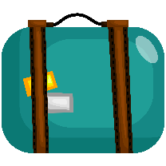

Adventure Camp T-Shirt
Look fabulous in your Adventure Camp T-Shirt. In April, you can ensure you have a camp shirt by pre-ordering your families’ camp shirts. Check the registration for more details. There will be a limited number of camp t-shirts at the Trading Post.

Payment Deadlines

Registration
Secure your spot with a $100 deposit per person.
The final balance is due on May 1, 2026.

Last Chance for Camp – Late Registration
Register on Saturday, May 2 through Wednesday, May 20, 2026.
Entire Camp Fee due per person at registration.

Payments are due by 11:59 p.m. on the “by date”.

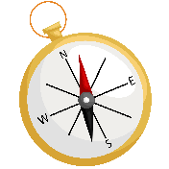
Refund Policy
It is important to remember that all camp fees are nonrefundable at each payment stage. In the case of death of an immediate family member, sickness, or injury prior to attending camp, or military transfer, we will give a partial refund when verified by a physician, military commander, or such official. Reasons such as vacation schedule, summer school, and last-minute changes of mind are not acceptable reasons for refunds.
Participants that leave camp during the session, for any reason, will not receive a refund. This is to help our council camps provide the very best program, since we sign contracts with our staff and vendors long before your family arrives on the property. All refund requests must go through the camp registrar. The staff at camp are not authorized to make refund decisions.

BSA Annual Health and Medical Record (Required)
The event does not require a medical professional signature on the Annual Health and Medical form.

On arrival at camp, all campers must submit a BSA Annual Health and Medical Record – Part A, B1 & B2 with immunization records written on B2 or attached and a copy of the family insurance card. The health form used for all scouting events is on the BSA website at:

Annual Health and Medical Record | Scouting America (scouting.org)
www.scouting.org/health-and-safety/ahmr/

This record is provided as a fillable PDF, and members are encouraged to fill it out on their computer, then print the record (rather than printing the record and filling it out by hand). Doing this will improve the readability and accuracy of each member’s medical information.

While you may have other types of health forms, the only form accepted at camp is the BSA Annual Health and Medical Record.



Trading Post
Adventure Camp has a Trading Post filled with clothing, souvenirs, camp essentials, snacks, drinks, and treats. If you forgot anything from home, check out the Trading Post. We have a lot of items to help you with those forgotten items.

Arrival
For a few days, this will be your home away from home and we want to make sure you enjoy your time on your adventure.

Check-in is from 9:00 a.m. to 10:30 a.m. on Friday. Upon your arrival, you will be greeted by camp staff, and you will receive directions on your check-in procedures. Late arrivals must notify camp management at Headquarters/Health Lodge to receive check-in instructions.

At Check-In you will receive
- Your Campsite Assignment
- Your Adventure Camp Family Schedule
- Camp Raymond Map
- Wristband for each Camper for Meals
- Meals – Food Allergy / Dietary Restrictions Procedures (if applicable)

Campsite Assignments
During the registration process please include your Pack number or indicate the families you would like to camp with during summer camp. We will try to accommodate your camping requests. Upon arrival at camp, you will be given your campsite assignment.

Meals / Dietary Needs
All meals are provided in our camp dining hall starting (Bistro) with lunch on day one and all campsites have drinking water. Additional snacks, treats and drinks are available for purchase in the Trading Post.

Campers with special dietary needs, including allergies, must be noted during the online registration process so the proper accommodation can be made. You will receive your food allergy / dietary restrictions procedures at check-in.

Health Lodge / Headquarters
The Camp Health Lodge is staffed 24 hours a day by qualified medical personnel. For insurance purposes and for the health and safety of all participants, all accidents and illnesses, no matter how minor, must be reported to the Health Lodge and recorded. Arrangements have been made with the local medical services to handle any medical emergencies.

Camper Care – Drinking Water
Camp Raymond has an elevation of over 6,700’. It is important that everyone drinks lots of water each day and stays hydrated.

Camper Care – Washing Hands
It's vital for every camper to wash their hands regularly. All participants are required to wash their hands before meals. We strongly encourage everyone to utilize our centralized hand washing station behind the dining hall.
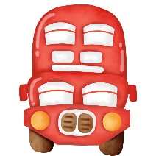

Latrines / Bathrooms / Showers
Latrines are located in each campsite as well as at the main field area. The latrines are stocked with toilet paper. If you run out of toilet paper, please notify Headquarters. Campers need to keep the seats down and use the water bucket for rinsing Latrine. Please, no trash or items should be thrown into the latrine; this causes problems when pumping out the latrines.

There are also flushing bathrooms on the northeast side of the dining hall, the pool shower house and the north shower house.

Scout Uniform / Camp Attire
For Cub Scouts, the official Scout uniform is encouraged to be worn for evening flag ceremonies, evening meals and campfire. The full field uniform consists of a Scout shirt, Scout belt, Scout pants or shorts with Scout socks. Cub Scouts wear the neckerchief for their den – Tigers, Wolf, Bear, Webelos and Arrow of Light, and they can wear their den hat too.

During the day, a Scout t-shirt and Scouts shorts or pants are great. For non-BSA members, we ask that attire be family appropriate and conservative.

Label your Belongings
Prior to arriving at camp, please be sure to clearly mark all personal items with your first and last name. This will help us return items to their owners prior to your departure. Remember, the Cub Scouts have the same uniforms and families have similar items.

Lost & Found
Lost and found is located at the Health Lodge / Headquarters. Any items left at camp will be kept for two more weeks and then donated to local charities.

Leaving Camp
Any time you would like to leave camp, please be sure to check out at Health Lodge / Headquarters (24 Hour Staffing). It is important we know when you are gone.

Please be sure to check out at Headquarters so we know you are no longer on the property.

Camp Check-Out
At the end of camp, check-out is after the final morning scheduled activities. The check-out time for all families is by 3:00 p.m. If you need a special check-out time, please schedule in Headquarters.

Please be sure to check out at Headquarters so we know you are no longer on the property.

Caring For Your Campsite
By taking care of your campsite, it will help us to take care of the camp.
- No Litter in campsite or camp. All trash in trashcans.
- Ground cover (pine needles and leaves) removed only around fire areas.
- Please do not cut or damage the trees or plants at camp.
- Do not use the sinks to rinse food out as it can clog the drains.
- Hammocks must use straps that shield trees from abrasion.


Wildlife Safety
Campers have an opportunity to observe many types of wildlife that includes deer, bats, raccoons, birds, skunks, turkey, snakes, coyotes, and amphibians. It is wise to remember that these animals are the permanent residents of the backcountry. Please make sure all campers remember to:

- Treat all animals with respect and observe from a distance.
- Do not follow, feed, tease or handle wildlife.
- Store all food in a secure place: personal vehicle, bear proof storage container, cooler that is strapped shut or 5-gallon bucket with screw on lid.
If you store food in your tent, in a bag or backpack, the critters will find the food and chew through the bags to get to the food.
- Keep your campsite clean! All trash should be removed from your campsite or secured each time you leave the campsite.
- If you decide to cook at your campsite, clean up immediately after the meal and pour your grey water (strained to remove food particles) into a nearby sink and rinse the sink with clean water. Please do not scatter your grey water near camp or dump it in a latrine. Food scraps will attract animals.
- If you discover a snake or an animal that is behaving strangely, please notify the camp staff immediately.


What To Bring
Please label belongings (last name) so we can help get them back to you.

Required Documents

- Medical Form
Parts A, B for every participant
- Copy of Family Insurance Card

Personal Gear

- Day Pack (carry stuff during the day)
- Water Bottle or Hydration System
- Field Uniform (aka Class A)
(Cub Scout shirt, shorts or pants, belt and socks)
- Activity Uniform (aka Class B)
(Cub Scout T-shirt)
- Rain Jacket or Poncho
- Warm Jacket (fleece or sweater)
- Hat (ball cap and stocking cap)
- Underwear & Socks
- Pajamas
- Scout appropriate T-Shirts for All
long sleeve & short sleeve
- Pants/Shorts (jeans or Scout pants – long, short or both)
- Tennis Shoes / Extra Pair is Handy
(Closed Toed Shoes for safety - Crocs are not considered safe for the outdoors.)
- Toiletries (Soap, Toothbrush & Toothpaste, Deodorant, Shampoo)
- Washcloth & Towel
- Sunscreen, Chapstick
- Sunglasses
- Bug Spray
- Flashlight or Head Lamp & Extra Batteries
- Whistle
- Medications (if applicable)
- Spending Money

Family Equipment

- Tent(s) for Family
- Tarp or ground cover for tents
- Sleeping Bags for each Camper
- Extra blankets in case it’s cold
- Sleeping pad, air mattress or cot
- Pillow
- Camp Chair (one per camper)
- Small First-Aid Kit
- Lantern / Flashlight
(For Campsite & Nighttime Activities)

Items Not To Bring

- Electronic Games and devices
- Radios, iPods, etc.
- Matches & Lighters
- Hot Sparks
- Laser Pointers
- Personal archery/shooting sports equipment
- Any questionable item

Items Not Allowed

- Fireworks
- Alcoholic beverages or illegal drugs
- Flames in tents
- Sheath knives
- Personal firearms
- Projectile items like Wrist rockets
- Pets
- Bicycles

Use or possession of tobacco products by anyone under the age of 21 is illegal in Arizona. All camp buildings are smoke and vaping free. The only authorized location for adult smoking or vaping is in your personal vehicle.

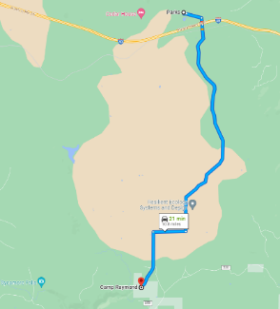
Directions to Camp Raymond
Camp Raymond is located approximately 10.8 miles outside of Parks, AZ – west of Flagstaff. From I-40, take exit 178 Parks Rd. and go south. Continue on S. Garland Pr. Rd. This road turns slightly right and becomes Garland Prairie Rd./E. Garland Prairie Rd. Turn left onto Boy Scout Camp Rd.
Latitude: N 35° 8' 18.8". Longitude: W 111° 58' 23.3".
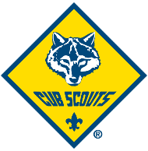

Camp Raymond Map
7709 S. Boy Scout Camp Rd., Parks, AZ, 86018
