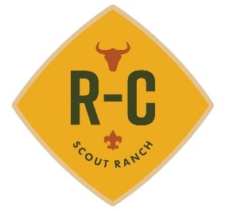
Directions to R-C Scout Ranch
R-C Scout Ranch
19887 E. AZ Hwy 260
Payson, AZ 85541-9215
GPS: Latitude: N 34° 18’ 42”
Longitude: W 111° 2’ 60”

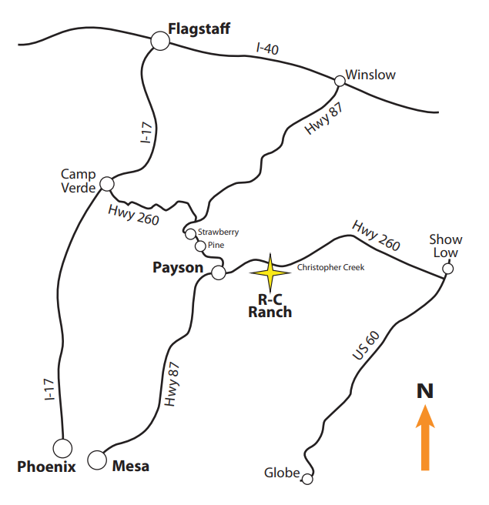
R-C is on Highway 260 approximately 19.6 miles east of the intersection of 260 and Highway 87 in Payson, Arizona. The entrance is between mile marker 271 and 272 on the South side of the road. If you get to the small township of Christopher Creek, you’ve gone too far – approximately two miles past R-C Scout Ranch

