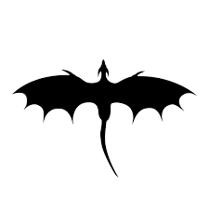

**CUB SCOUT & WEBELOS SCOUT**

**RESIDENT CAMP 2025**

**BSA CAMP MAUBILA MOBILE AREA COUNCIL**

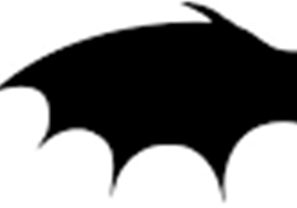

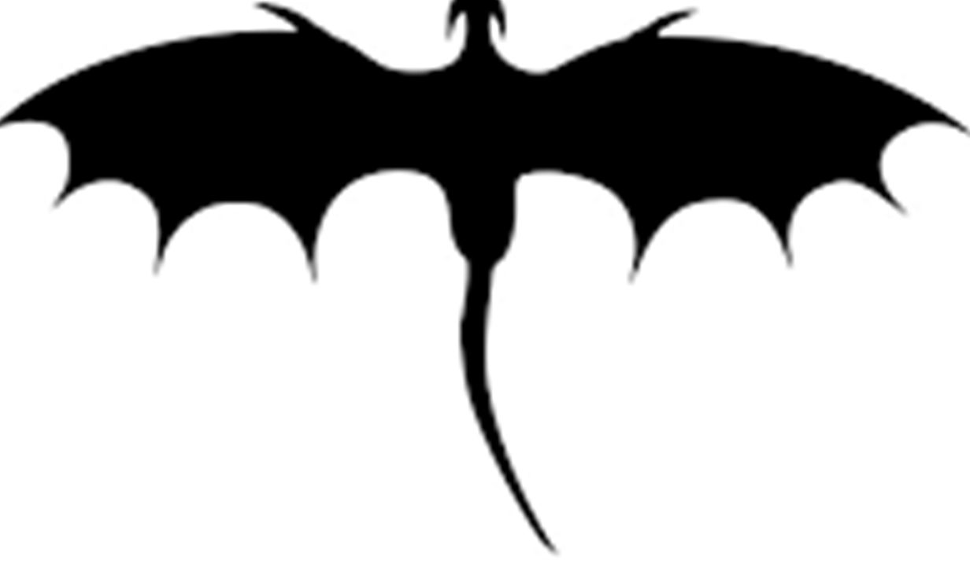**STAFF**