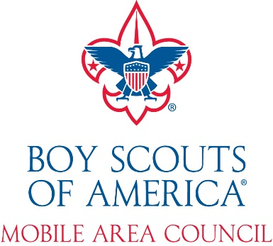

Permission to Participate in Shooting Sports for all Cub Scouts, Scouts BSA, Venturers, Sea Scouts, and Explorers

This permission form must be completed by the participant’s parent or legal guardian prior to any shooting activity.
Name of Participant:

I, (print your name), grant my consent to Mobile Area Council and to its representatives including Range Officers and Instructors and others serving in these positions to furnish my child with archery equipment, firearms and ammunition, and provide instruction as to their safe and proper use. I further certify that I am the parent with full parental rights or the legal guardian of this child. I understand that this document will be kept and maintained by the Mobile Area Council or its representatives including Range Officers and Instructors. I further understand that any modification of this form will result in its not being accepted by Mobile Area Council, Range Officers and Instructors.

Signature of Parent or Legal Guardian: _____________________________
Date: __________________Unit Number: __________

2587 Government Blvd. Mobile, AL 36606 * 251-476-4600

