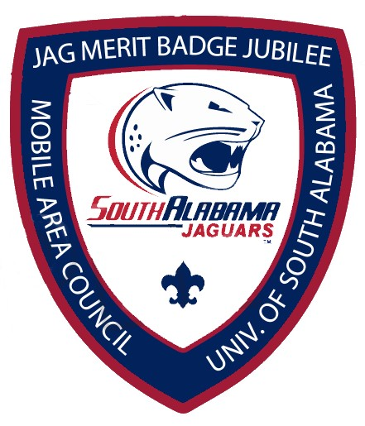

March 25, 2023
University of South Alabama
Registration from 7:30-8:00 am
Classes begin promptly 8:15 am
Engineering & Electricity Chemistry
Archeology & Indian Lore Law
Journalism Communications
Programming Citizenship in the Nation
Public Speaking Hiking
Fish & Wildlife Management
Registration is open for these classes on Black Pug @ $25.00 ( this includes lunch & patch)
Oceanography is being offered @ Dauphin Island Sea Lab, lunch not included. Bring your own lunch. This class is $ 35.00
Short-Term Camp Administrator course: For Adults only. This person is responsible for ensuring that the planned camp complies with the NCAP Short-term Camp Standards. This means walking the property to ensure that it is appropriate for the event; ensuring that paperwork is filed and any written BSA approvals are completed and obtained through the council; confirms facilities and program are safe and in good order before starting operation; and that appropriate health, safety and sanitation provisions are made. This individual also ensures that all activities at the short-term camp comply with the applicable BSA National Camp Standards. This Class is $ 65.00 ( includes lunch, certificate and patch)

