2025 Spring Camporee
March 20-22, 2026

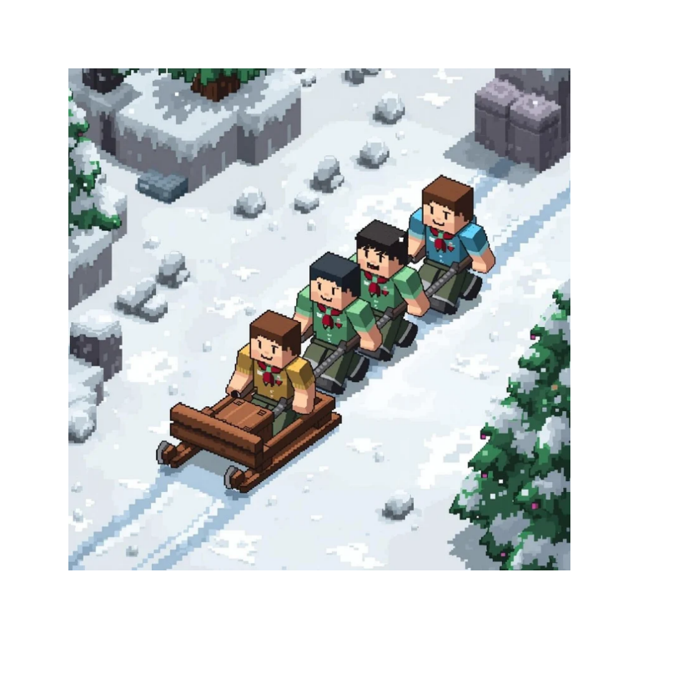

Alabama- Florida Council- Heersink Scout Reservation
Camp Alaflo
Hosted by Menawa District, Crew 150 and Ship 571

The 5TH. Annual Klondike Adventure held at Alabama Florida's Camp Alaflo. This year's theme is:
Minecraft

Please pay careful attention and read the following pages carefully and completely! This is a FRIENDLY competitive event, and rules govern many small details that our Scouts, Venturers, and Sea Scouts must adhere to so that we may have a safe and fun time. There is information in this guide specific to the youth leaders of the units as well as other information for the adult leaders. The Klondike Adventure is expected to be executed by the youth leaders,
with the adult leaders being the event's support and safety net

The Klondike Adventure will be held at:

Heersink Scout Reservation-
Camp Alaflo, 830 Co Rd 156, New Brockton, AL 36351
Check-in will begin on Friday, March 21 at 5:00 pm.

Contents
Registration and Sled Teams 3
The Klondike Adventure 3
The Course 3
Course Preparation, Rules, and Scoring 4
Sled Specs 5
Sled, Personal and Unit Gear 6
Scouts Own Service 7
Camping 7
Meals and Cracker Barrel 8
Tentative Schedule 9
Appendix A - Sled Resources 10
Appendix B – Map of HSR- Alaflo 11

Registration
This 3-day event is open to all Crews, Ships, and Troops. Registration may be accomplished online:
https://scoutingevent.com/003-86227

All units must be registered no later than March 16, 2026, to complete our plans.
The fee for each participant is $15. Late fee $20 after 3/11/26
The price includes awards, patch, and the feast Saturday evening. Units are expected to be prepared with their tents and warmest (if necessary) of camping gear. Adults will need to camp with their units for adult supervision and youth protection.
Units may register as many Sled Teams as they wish. Keeping the teams between 4-6 participants

Sled Teams
Troops, Crews, and Ships may register as many 4-6-person sled teams as they wish. Provisional sled teams are allowed, yet every team member must be 10 years or older and a registered youth participant of a Troop, Crew, or Sea Scout unit. Each sled team will be responsible for their sled and gear. Teams may not share equipment on the course. Teams will be running the course concurrently and will not be readily available to one another. One Scout on the team shall be designated as their Team Leader. At any given time, there will be 4-5 team members pulling the sled, and one driver called the musher. It is suggested this position be rotated throughout the course. It is essential to understand that the musher steers and guides the sled and is the only one calling commands. Sleds should be decorated following this year's theme. All sled teams should have a team name, team flag, and team yell. Please be inventive and imaginative as it will count towards team points.

The Klondike Adventure
Like all great adventures, the Alaflo Region Klondike Challenge is made up of several obstacles that are on a trail. Teams can choose their own adventure by choosing their obstacle order and the path taken; however, all teams must complete all the obstacles before they continue to traverse the sand. As each sled crew reaches the obstacle entrances, they will be greeted by the instructor. A cheerful and spirited reply will be expected. The instructor will explain the event or activity to take place within their gym and any special rules or requirements of the obstacle. Some obstacles may be timed events, and others may be judged on the degree of completion. All obstacles are judged on teamwork. Scoutmasters, Crew Advisors, Ship Skippers, random adults, dads, moms, siblings, pets, etc., are not allowed to escort or follow the teams on the trails. For safety purposes, sleds are not authorized from the Trading Post to The Dining Hall. This zone is referred to by the locals as Heart Attack Hill, and for obvious reasons, it is steep. Sled parking IS allowed at Victory Road or the grassy area of the Trading Post.

The Course
The course will run on the westside of the Region of Alaflo, on Saturday, focusing on Scout Challenges. This race will NOT be Iditarod style. The teams choose their own adventure. Teams may be running portions of the course in opposite directions from each other, in the same direction, and maybe even on different sides of the camp. Sled inspection will be at Victory Road pavilion (parade field pavilion). All teams will start in the morning, take a lunch break, and then complete the day's adventure.

Course Preparation
The course is a test of team building, problem-solving, outdoor skills, and adventure. Noting the wide youth age range, we realize that there may be variation due to each unit's focus and group identity. It is recommended that each sled team practice the following skills prior to hitting the Klondike Trail:
- Fire building
- First aid
- Entertainment
- Projectiles (e.g, archery skills, rifle/shotgun/pistol skills, knife throwing, etc.)
- Miscellaneous skills everyone should try at some point in their life (e.g., juggling, balancing, first aid, illusion and memory games, the alphabet song, special)

Scoring
Each gym challenge will be worth a certain number of points. Each team will have the opportunity to earn extra points through Scout spirit with their teamwork and enthusiasm. This begins upon arrival at each obstacle, and it will be awarded at the instructor's discretion at each gym.

IMPORTANT LOCATIONS:
- Alaflo Region Scout Challenge encompasses the west side of Camp Ala/lo
- Alaflo Dining Hall for Cracker Barrel and Theater
- Ballfield Pavilion (across from Parking Area) is known as Victory Road
- Flagpole is located in the Ballfield near Victory Road
- The Health Lodge is building no.9, north of the parking area

Obstacle and Information Rules
There will be a team orientation on Friday night at 8:00 pm in the dining hall. Maps, event descriptions, etc., will be publicized. All team members should be at this meeting. A movie and refreshments will begin after the meeting.
All obstacle requirements will be explained at each gym by the gym instructor. Make sure the gear list is followed precisely. All gear will be useful on the trail and will be verified at the first event. Teamwork is a keyword on the trail. The instructor will keep an eye on the trails and how well the teams work together on it.
Sleds requiring repair should pull off the trail and not impede the progress of other teams. The sled must return to Victory Road at lunch break and at race completion with the whole team. Slower sleds about to be passed by a faster team should make room to the right for the faster sled. Faster sleds will pass to the left. Do not obstruct the faster sled: no rubbing fenders or trading paint.

Sleds
The Klondike sled is the main transportation tool for the teams. Therefore, it must be strong enough to carry all the team's gear or possibly an adult and durable enough to handle the hills and valleys of the Region. There are a variety of websites on the Internet with sled plans. Choose whichever one you like. All sled teams must pass their sled inspection at Victory Road on Saturday morning.
***TEAMS MAY NOT BEGIN THE CHALLENGE UNTIL THEY PASS INSPECTION***
The inspectors will use the following specifications:
- Sleds should resemble Fig. 1 on Appendix A.
- Sleds may be made of wood or PVC.
- Sleds must measure a minimum of 60" to a maximum of 84" in length.
- Sleds must measure a minimum of 18" to a maximum of 24" in width.
- Sleds must measure at least 36" in height.
- Sleds must have a tow rope attached to the front end of the sled. Do not use eye bolts/screws or any metal
hardware to attach the rope.
- Sleds must have a brake rope attached to the front of the sled. Do not use eye bolts/screws or any metal hardware to attach the rope. (A break rope is attached to the front of the sled and runs to the back, for the musher to use to pull the front of the sled off the ground to aid in stopping.)
- Sled runners should be made of a strong wood such as ash or oak, but not mandatory. These hardwoods will last much longer on the trail than softwoods like pine. Sled runners may also be a set of skis.
- Sleds may be assembled using glue and/or lashings. No metal hardware or metal "l" brackets or metal supports may be used.
- Do not assemble sleds using nails or screws. There is a time and place for everything, but not now. Attachment of skis or skids is the only exception.
- There should be no sharp objects protruding from the sled, such as screws or sticks. The only exception is the team flagpole.
- All sleds and team gear may be lashed to the sleds. Bungee cords are not permitted.
- Sleds may be decorated, painted, or stained. The Troop, Crew or Ship number, team name, and team flag must appear on the sled.
- Sleds are not authorized to use any form of wheels, rollers, tracks, levers, motors, or any other feats of engineering that are inherently designed to provide a mechanical advantage and detract from the spirit of the race.
- Resources for Sleds are provided in Appendix A.
Note: the rules above apply. The resources are only for ideas/references to make things go simpler!
- All sleds and personal gear will be inspected at Victory Road. Corrections must be made before the beginning of the adventure. As previously stated, all sleds must meet these standards plus, the personal gear listed in the following paragraphs must also be on the sled. This is a scored event, and missing sled or personal gear or a sled that does not meet the outlined specs will not be allowed to run until all deficiencies are corrected.

Sled, Personal and Team Gear
Each team must have all of the listed items on their sled. The team may use anything on the sled to complete any given task. If there is a change to any obstacle task or material needed for the sled, the Scoutmaster, Crew Advisor, or Ship's Skipper will receive a call from the activities chair advising of the change.
PLEASE NOTE: the events are designed for sled teams of 4 to 6 members. All gear on the sled is expected to support the number of members on your sled team. You are encouraged to have at least 5 Scouts per sled partially because it can be tough to pull a sled with only 4 Scouts, and also, if you have an injured Scout, this will leave you with only 3 to pull the sled. Teams smaller than four are not allowed, and anyone younger than 10 and not registered with a Crew, Ship, or Troop is not permitted at this event.
Sled Gear
Personal (per scout)
- Full water bottle for each team member
- Mess kit and cup for each team member
- Extra pair of socks for each team member
- A complete extra set of warm, dry clothes for each team member, including pants, long sleeve shirt or sweatshirt and raingear (or what the predicted weather requires)

Team (per sled - not person)
- Team flag, Troop, Crew or Ship number, and team name
- Team Roster (Teams will receive at Check-in; it must be filled out for event)
- Pencil and paper
- Watch, compass, flashlight, pocketknife, blanket, trash bag
- 1 First-aid kit and knowledge to treat car accident victims
- Flint and steel, hot spark kit, or other fire making materials
- Fire starters (tinder - no enhanced wood products)
- Rope and duct tape for sled repairs

Leaders: make every effort to ensure your sled team members are properly dressed on the trail. At Victory Road, all Scouts will be inspected for proper clothing based on the predicted weather for the day. All scouts must be properly dressed and wearing adequate footwear (e.g.-hiking boot-style footwear, not sneakers, not muck boots).
Wear clothing in layers. Layers can be removed and carried on the sled. They can be put back on if the sun goes down or it begins to get cooler on the trail. Since Scouts will be racing around the course, it is possible for them to build up a sweat. Therefore, cotton clothes should NOT be worn close to the body.
WE CANNOT STRESS CLOTHING ENOUGH!!!! THE CONDITIONS AT KLONDIKE ARE VARIABLE AND ALMOST ALWAYS WET, WETTER, OR SOAKED DOWN DEEP TO MY BONES WET! STAYING WARM IS ESSENTIAL TO SAFETY AND TO COMPLETING THE COURSE! WHILE FIRST AID IS A SKILL THAT WE NEED FOR COMPETETION -WE DON'T WANT TO USE IT IN A REAL-LIFE SCENARIO AT KLONDIKE!

Not to be carried on the sled but required gear:
e Tent or shelter for each sled crew member and adults
  - Sleeping bag rated for expected temperature

Pre-Event Communication
- All forms required for the event must be completed before arrival for quick turn-in at registration.
- Instructions for participant drop off will be communicated before the event.

Registration
- Staff will be limited to only those that have a specific job at the event.
- Pre-registration will be required. There will be no walk-on registration.
- No walk-on registration so no money will be required to be collected.
- All forms (ABB Medical / Consent Form) will be required to be completed in advance and simply turned in
upon arrival. All forms will be destroyed after the event. None will be returned.
- Check-in will end on Friday evening at 9:00 pm and resume on Saturday morning between 7-8 am.

Meals
- None other than staff shall be allowed in the kitchen during The Feast.
- Feast meals may be served on paper plates using individually wrapped cutlery, if necessary.
- The Dutch Oven Competition is back on this year!

Failure to Comply
- Non-compliance of rules or instruction will result in dismissal from the event.
No walk-on registration will be allowed

Scouts Own
After the units finish breakfast in your Campsites, we will gather at Victory Road one final time for a short service before our departure.

Camping
Local Troops, Crews, and Ships are granted use of their owned campsites but may be hosting out-of-town units in their sites. Ground fires will be allowed in the campsites, but must be in a firepit. Scoutmasters, Advisors, and Skippers are responsible for two-deep leadership as well as co-ed camping. ALL CAMPSITES MUST BE CLEARED NO LATER THAN 11AM ON SUNDAY.
Troops, Crews, and Ships are asked to help by making the best use of the camping space so all scouts can be
accommodated.

SPECIAL NEEDS – Contact
Melody Shaffer @ makw110S@aol.com
to arrange for any SPECIAL NEEDS.

Cracker Barrel
Scouts and Scouters, if they wish,
Your presence is required at my Cracker Barrel (movie and popcorn) at the Dining Hall. There will be superior snacks (popcorn), delicious drinks (sweet tea and bug juice) but the most entertaining of all, movies. You will have fun.

Dutch Oven Challenge
Saturday evening, we will have a Feast event with yard games and great food from The Dining Hall. Each Team will bring a prepared Dutch Oven-type meal to the Feast. Plan for 10-12 servings in your Dutch Oven. Possibilities are endless with main course options of lamb, beef, pork, chicken, vegetarian, etc. Your meal can incorporate veggies and/or fruits. Judges will choose their favorites for the competition! An index card with all ingredients and seasonings shall be submitted with your Dutch Oven for allergen purposes. Extra points if your meal goes with the theme. UNLIKE YEARS PAST THIS YEAR YOU WILL RECEIVE A SECRET INGREDIATE THAT YOU MUST USE IN YOUR DUTCH OVEN DISH- THIS CAN NOT BE A DESSERT, AND MUST BE ABLE TO FEED AT LEAST 10-12 PEOPLE. Your team can pick this up at the start of the designated Lunch period at the Ball Park Pavillion. ADULTS are free to do DESSERTS again this year in an ADULT DESSERT competition.

Units are self-responsible for all other meals in their campsites.

Saturday Lunchtime, plan a picnic lunch or quick preparation meal will be between 11:30 and 1pm and can be eaten at Victory Road or Handicraft area.
Cracker barrels and (if cold enough) hot drink stations are planned to help make the trek a bit less grueling.

Schedule (Tentative)

The following schedule is a guideline, and we will do our best to stay on target.

·
Schedule Spring Klondike
Time |  | Event | Location
Friday
1:00PM | 4:45PM | Staff check in | (camp and station set-up)
5:00PM | 7:30PM | Check-in (camp set-up) | Victory Rd (ballpark)
 |  | Staff dinner | Dining Hall
-  8:00PM | 8:30PM | Sled Meeting | Dining Hall
8:30PM | 10:00PM | Popcorn and Movie | Dining Hall
11:00PM |  | Lights out | Campsites
Saturday
6:00AM | 7:00AM | Breakfast  Staff breakfast | Campsites
6:00AM | 7:00AM | Breakfast  Staff breakfast | Dining Hall
7:00AM | 7:30AM | Last minute Check-in | Victory Rd (ballpark)
7:30AM | 8:30AM | Safety Inspections | Victory Rd (ballpark)
8:30AM | 8:4S AM | Flag raising/Opening Ceremony | Victory Rd (ballpark)
8:45AM | 9:00AM | Final Safety Check-Head to Stations | Victory Rd (ballpark)
9:00AM | 11:30AM | Derby | West side
11:30AM | 1:00PM | Lunch-picnic | Victory Rd or Handicraft
1:00PM | 3:00PM | Derby | West side
3:00PM | 5:45PM | Sled/Team clean up and Dutch Oven | Campsites  Victory Rd (ballpark)
5:45PM | 6:00PM | Flag Lowering | Campsites  Victory Rd (ballpark)
6:00PM | 7:30PM | Feast/ yard games/ award pres. / closing | Dining Hall
7:30AM | 8:30l'M | OA presentation | Dining Hall
8:30PM | 9:45PM | Popcorn and Movie | Dining Hall
11:00PM |  | Lights Out | Campsite
Sunday
5:30AM | 9:00AM | Breakfast & Camp Pack Up
9:00AM | 10:00AM | Scouts Own Service- Victory Rd

Appendix A -Sled
Remember! Surf the Internet safely! These links have been pursued, yet we cannot guarantee that they will not change and that links from the pages are safe. Use adult guidance and good judgment when searching!

Sled Plans
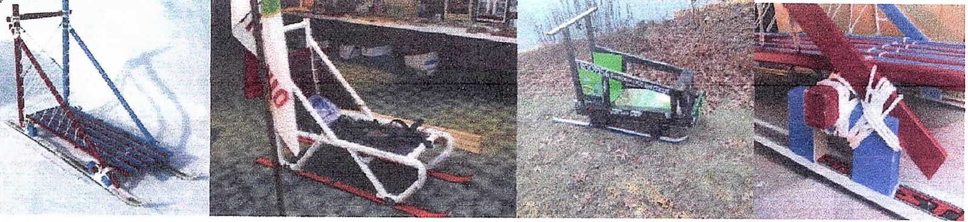
https://scoutdocs.ca/Klondike/Klondike_sled_plans.pdf

https://youtu.be/1euwUPcP-co?si=Du5PPdNdoPmbQqsJ

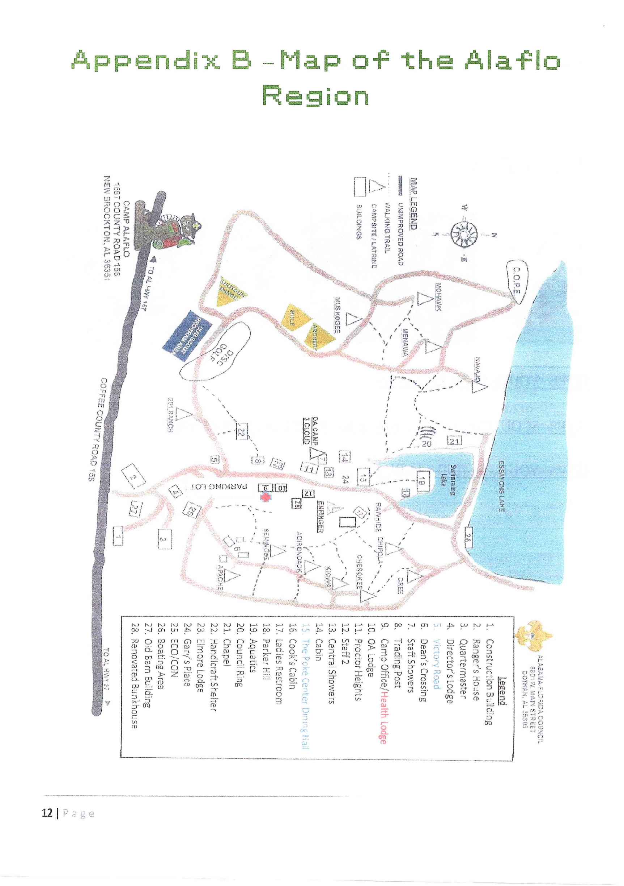

15. Dining hall

'

,...

