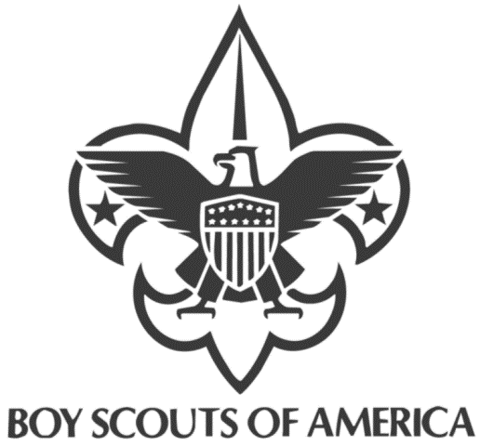 | Grand Canyon Council 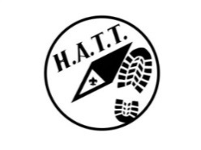  High Adventure Trek Training
* FUN * EDUCATION * ADVENTURE * * BACKPACKING * TRAINING *
Learn to Plan and Execute a High Adventure Trek for the Youth
Sharpen your outdoor skills Enhance the Outdoor experience
Have Fun Practice safety and awareness in the field
Learn and use Leave No Trace principles Learn to anticipate and plan ahead
Learn to handle emergencies in the outdoors See and do more outside
Who: Any registered Adult Scouter
Must have all applicable training completed for the current scouting volunteer position
When: Indoor sessions 10/2/2019 and 10/9/2019 6:00pm - 8:30 pm each night
Where: Heard Scout Pueblo 1901 E. Dobbins Rd. Phoenix, AZ 85041
Outdoor session 10/12/2019 - 10/13/2019 3 + mile Backpacking in Superstition Wilderness Area (near Second Water Trail)
Cost: $25 per person includes class materials and food. Students will supply their own camping gear (menus will be discussed in class)
Prerequisites: Be registered with BSA.
Proof of completion of all required BSA training.
Current BSA medical form.
Be able carry your gear for an overnight 6 mile round trip hike
A desire to help deliver a fun high adventure program to the youth who you all serve.
ALL THREE SESSIONS ARE REQUIRED
Class size is limited sign up soon
JOIN US TODAY – Register at http://www.grandcanyonbsa.org

Contact
Dale Lewis delewisaz56@gmail.com /602-526-0612 for more information

