Sun City Grand Fly Fishing Club and Trout Unlimited are proud to host
2019
Scout Fishing & Fly Fishing
Merit Badge Event
All Scouts are welcome to attend
Scout Masters requested

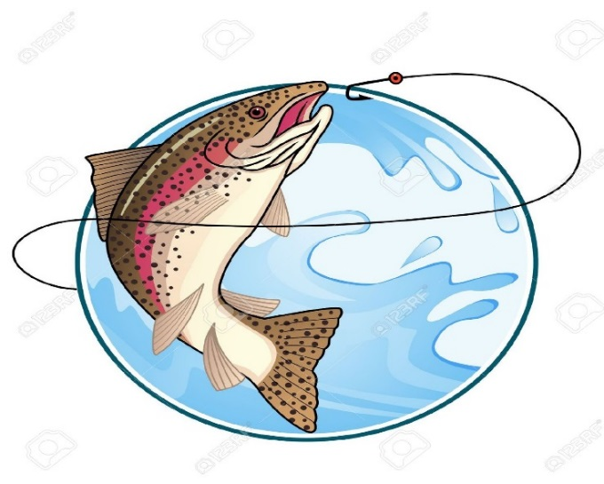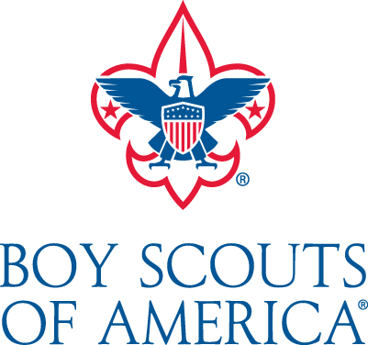

Stations will be available for knot tying, fly tying, review of safety and equipment, insects, and techniques
Where: Sun City Grand Community Center
19753 N. Remington Drive, Surprise, AZ 85374

When: March 30 & 31
9 am – 4 pm Saturday
9 am – Noon Sunday
Saturday BBQ hosted by Sun City Grand Fly Fishing Club & Trout Unlimited

What to bring: Fly rod, fly fishing equipment, sun glasses, sun screen, hat

Child supervision is not included.
A supervising adult must accompany each scout

Registration Required! Contact us for a registration form
flyfishingscouts@gmail.com

