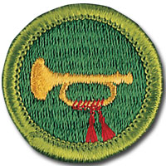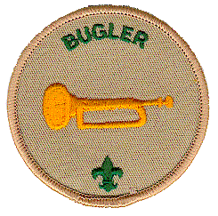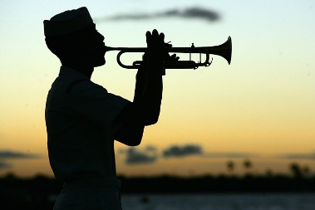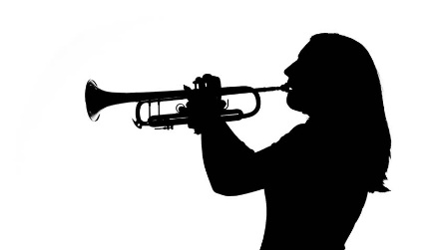

**Audition to become a registered bugler for *Bugles Across America.* Play *Taps* at military funerals. Auditions on clinic day will take 10 minutes. Schedule an approximate time by sending an email stating interest to:**

**bhsbugleclinic@gmail.com**

For the Bugling Merit Badge Clinic Bring your own Trumpet or Bugle or any other brass instrument. Clinic open to all boys, girls, women and men 11 and up.

**Registered Boy Scouts can work on requirements toward a Bugling Merit Badge.**

**Register for merit badge portion of the clinic** <https://www.grandcanyonbsa.org/meritbadgeclinics>

**Or send questions to bhsbuglingclinic@gmail.com.**

**BAA auditions will require a trumpet, cornet, flugelhorn or bugle.**

**Volunteer for Bugles Across America-Audition required**

**Audition on clinic day: 1/20/2018- walk ins welcome, but scheduled preferred**

**Or Visit** <http://www.buglesacrossamerica.org>

**to set up an audition at another time with state directors.**

Bugling MB Clinic/BAA Auditions

Basha High School

5990 S. Val Vista Drive, Chandler, AZ 85249

Date: Saturday 01/20/2018

Time: 8-11:30 am