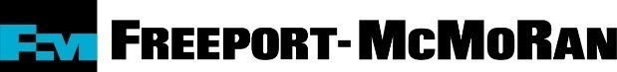

PHOTO RELEASE FORM

I, (print name) _______________________________________, hereby authorize
Freeport-McMoRan Inc. and its subsidiaries, successors, predecessors, and affiliated entities (collectively “Freeport-McMoRan”) and their employees and agents to use, for non-commercial purposes related to Freeport-McMoRan and its business purposes, images of me, without compensation or royalty, whether in the form of film or photographs, taken during an event or photo session which will occur on __________________________, 2016.

I, for myself and for my heirs, executors, administrators, representatives, agents, and assigns, hereby forever release Freeport-McMoRan and its officers, directors, agents, employees, shareholders, attorneys, and representatives, from any and all claims, demands, liabilities, obligations, suits, charges, actions, and causes of action, whether known or unknown with respect to Freeport-McMoRan’s use of these photographs for the purposes described above.

Name (print) : _____________________________________________________

Signature : _____________________________________________________

Date : _________________________

Witness Name : _____________________________________________________

Witness Signature : _____________________________________________________

Date : _________________________

PHOTO RELEASE FOR A CHILD UNDER 18 YEARS OF AGE

Child’s Name : _____________________________________________________

Parent/Legal Guardian Signature : _______________________________________

Date : _________________________

